Moduldokumentation

Modul Verteilte Systeme (vesys)

Simon Wächter

2017

Inhalt

1 Einleitung 10

1.1 Einleitung 10

1.2 Lernziele 10

1.3 Prüfungen 10

2 Woche 1 11

2.1 Definition of Distributed Systems 11

2.1.1 Definitions 11

2.1.2 Classification 11

2.1.3 Pros and Cons 12

2.1.4 Interaction Models 12

2.1.5 Client/Server Model 13

2.1.6 Communication Models 13

2.1.7 Communication Styles 14

2.2 Challenges of Distributed Systems 15

2.2.1 Heterogeneity 15

2.2.2 Latency 15

2.2.3 Security 15

2.2.4 Scalability 16

2.2.5 Failures 16

2.2.6 Concurrency 17

2.2.7 Consistency 17

2.3 Networking 17

2.3.1 Protocol & Network Levels 17

2.3.2 IP Socket Connections 18

2.3.3 IP Addressing 18

2.3.4 TCP/UDP Common Port Numbers 19

2.3.5 InetAddress 19

2.3.6 Network Interfaces 20

2.4 Sockets 20

2.4.1 Sockets 20

2.4.2 TCP Sockets 21

2.4.3 Java Socket 21

2.4.4 Sample Client (Echo) 22

2.4.5 Sample Client (Mailer) 22

2.4.6 ServerSocket 23

2.4.7 Echo Server 24

2.4.8 Concurrent Echo Server 24

2.4.9 Concurrent Echo Server (Threaded) 25

2.4.10 Concurrent Echo Server (Limitierter Threadpool) 26

2.4.11 Concurrent Echo Server (Dynamischer Threadpool) 27

3 Woche 2 28

3.1 Input and Output Streams 28

3.1.1 OutputStream 28

3.1.2 InputStream 28

3.2 Filter Streams 29

3.2.1 FilterOutputStream 29

3.2.2 DataOutputStream 30

3.2.3 DataOutputStream with writeInt 30

3.2.4 DataOutputStream with writeUTF 30

3.2.5 PrintStream 31

3.2.6 FilterInputStream 31

3.2.7 DataInputStream 31

3.2.8 DataInputStream with readFully 32

3.2.9 Filter Streams 32

3.3 Object Streams & Serialization 32

3.3.1 ObjectStream 32

3.3.2 Serialization with ObjectStream 33

3.3.3 Serial Version Number 34

3.3.4 Serialization Customization 35

3.3.5 Serialization Hints 35

3.4 Sending and Receiving Data 36

3.4.1 Framing 36

3.4.2 Example of Framing 36

3.5 Summary 36

3.5.1 Whole Picture of Input Streams 36

3.5.2 Whole Picture of Output Streams 37

3.5.3 Reading and Writing Text (Unicode Strings) 38

3.5.4 Whole Picture of Reader 38

3.5.5 Whole Picture of Writer 38

3.6 Controlling Socket Behaviors 39

3.6.1 Blocking and Timeouts 39

3.6.2 Send and Receive Buffer Size 40

3.6.3 Package Delay 40

3.7 Closing Connections 40

3.7.1 Closing Connections 40

3.7.2 Example of a Close Test 41

3.7.3 Example of a Compression Server 42

3.8 UDP Sockets 42

3.8.1 UDP (User Datagram Protocol) 42

3.8.2 Java Classes for Datagram 43

3.8.3 DatagramSocket 43

3.8.4 DatagramPacket 44

3.8.5 Example of a UDP Server and Client 45

3.8.6 UDP Implementation 45

3.8.7 Reliable UDP 46

4 Woche 3 47

4.1 HTTP Protocol 47

4.1.1 IETF RFC 47

4.1.2 HTTP Protocol 47

4.1.3 HTTP Request 47

4.1.4 HTTP Response 48

4.1.5 HTTP Protocol 48

4.1.6 HTTP Sample 48

4.1.7 HTTP 1.0 Request Methods 50

4.1.8 HTTP Response Codes 50

4.1.9 HTTP Request Headers 50

4.1.10 HTTP Response Headers 51

4.1.11 MIME Types 51

4.1.12 HTTP Request/Response Sample 52

4.1.13 HTTP 1.1 Enhancements 52

4.2 HTTP Web Server 53

4.2.1 A simple Web Server 53

4.2.2 Java internal Web Server 55

4.3 HTML Forms & URL Encoding 56

4.3.1 HTML GET Form 56

4.3.2 URL Encoding 57

4.3.3 HTML POST Form 57

4.4 HTTP Requests from Java 58

4.4.1 URL 58

4.4.2 Sending GET Requests from within Java 58

4.4.3 URLConnection 58

4.4.4 URLConnection Tips & Tricks 59

4.4.5 Sample 1: URLConnection GET 59

4.4.6 Sample 2: URLConnection POST 60

4.4.7 Sample 3: Currency Converter 60

4.4.8 Other Libraries 62

5 Woche 4 63

5.1 Servlets 63

5.1.1 Dynamic Content 63

5.1.2 Servlets 63

5.1.3 Servlet Packages 63

5.1.4 Servlet Life-Cycle Methods 64

5.1.5 HttpServlet 64

5.1.6 HttpServletRequest 65

5.1.7 HttpServletResponse 65

5.1.8 Servlet Example 65

5.1.9 Webapplication Structure 66

5.1.10 Annotation WebServlet 67

5.1.11 Webapplication Structure 67

5.2 Tomcat Servlet Server 68

5.2.1 Tomcat 68

5.2.2 Tomcat Directory Structure 68

5.2.3 Tomcat Scripts 68

5.2.4 Tomcat Startup Screen 69

5.2.5 Tomcat Managers 69

5.2.6 Debugging 69

5.2.7 Tomcat Architecture 70

5.2.8 Configuration of a Host 70

5.2.9 Configuration of a Context 71

5.2.10 Deployment while development 72

5.2.11 Eclipse and Servlets (JEE Eclipse Version) 72

6 Woche 5 74

6.1 Motivation XML-RPX 74

6.1.1 Services over HTTP (Currency Converter) 74

6.1.2 XML-Remote Procedure Calls 75

6.2 SOAP und JAX-WS 75

6.2.1 SOAP 75

6.2.2 JAX-WS 76

6.2.3 JAX-WS HTTP Request 82

6.2.4 JAX-WS HTTP Response 82

6.2.5 SOAP Message Structure 83

6.2.6 Tools for SOAP 83

6.3 WSDL 84

6.3.1 WSDL 84

6.3.2 WSDL Examples 84

6.3.3 WSDL Structure 84

6.3.4 WSDL Definitions 85

6.3.5 Message Exchange Patterns (MEP) 86

6.3.6 WSDL Definitions 86

6.3.7 Web Service Styles 87

6.3.8 RPC/Encoded 88

6.3.9 RPC/Literal 89

6.3.10 Document/Literal/Bare 90

6.3.11 Document/Literal/Wrapped 91

6.3.12 Web Service Styles 92

6.4 Resources 92

7 Woche 6 93

7.1 REST Concepts 93

7.1.1 Representational State Transfer (REST) 93

7.1.2 REST Principles 93

7.1.3 REST Short Primer 95

7.1.4 SOAP versus REST 95

7.1.5 REST Common Patterns 95

7.1.6 Example Doodle 96

7.1.7 REST versus SOAP 97

7.1.8 Client Side 97

7.1.9 Web Client Plugins 97

7.1.10 Client Side via curl 98

7.2 REST Server Implementations 98

7.2.1 Server Side 98

7.2.2 JAX-RS Services 99

7.2.3 JAX-RS HTTP Methods 99

7.2.4 JAX-RS Injection 99

7.2.5 JAX-RS Content Negotoation 101

7.2.6 JAX-RS Content Handlers 102

7.2.7 JAX-RS Responses 102

7.2.8 JAX-RS Conditional GET 103

7.2.9 JAX-RS Cache Control 104

7.2.10 JAX-RS Optimistic Locking 105

7.2.11 JAX-RS Deployment 105

7.2.12 Deploy Stand Alone via Jersey 106

7.3 REST Clients 107

7.3.1 JAX-RS Client API 107

7.4 Resources 109

8 Woche 7 110

8.1 REST Data Binding 110

8.1.1 JAX-RS Data Binding 110

8.1.2 XStream Provider (Reader) 110

8.1.3 XStream Provider (Writer) 110

8.1.4 XStream Example 111

8.2 Java Spark 112

8.2.1 Java Spark 112

8.3 JAXB 114

8.3.1 JAXB Java Architecture for XML Binding 114

8.3.2 XML Schema 115

8.3.3 Schema Compiler & Generator 115

8.3.4 JAXB Marshaller 116

8.3.5 JAXB Unmarshaller 116

8.4 REST API Description Languages 116

8.4.1 Swagger 116

8.4.2 Swagger Doodle 117

8.4.3 Swagger Java Annotations 118

8.4.4 Swagger GUI 118

8.5 REST Easy Client Proxy Framework 118

8.5.1 RestEasy Client Proxy Framework 118

8.5.2 RestEasy Example 119

8.6 Resources 119

9 Woche 8 120

9.1 RMI Overview 120

9.1.1 Communication Technologies 120

9.1.2 Communication Architectures 120

9.1.3 Excursion: Proxy Pattern 120

9.1.4 Proxy Layer Stub and Skeleton 121

9.2 RMI Step by Step 121

9.2.1 Using RMI 121

9.2.2 1.) Remote Interfaces 121

9.2.3 2.) Implementation 122

9.2.4 2.) Example 122

9.2.5 3.) Create Stubs and Skeletons (Deprecated) 122

9.2.6 3.) Dynamic Stubs since Java 1.5 123

9.2.7 4.) Server 123

9.2.8 4.) Example 123

9.2.9 4.) and 5.) Naming/Registry 124

9.2.10 5.) Example 124

9.2.11 6.) Start of RMI Registry & Server 124

9.2.12 6.) Example 125

9.2.13 Example: List of all registered objects 125

9.3 RMI Marshalling 126

9.3.1 Marshalling 126

9.3.2 RMI Stubs 126

9.3.3 Remote Reference Applications 127

9.3.4 Callback 127

9.3.5 Example: Quote Server 127

9.4 RMI Architecture 128

9.4.1 Summary of the RMI Architecture 128

9.4.2 Remote Reference Layer 128

9.4.3 Transport Layer 129

9.4.4 RMI Server Properties 129

9.4.5 Client behind a Router/NAT 129

9.4.6 Conclusion 130

10 Woche 9 131

10.1 UnicastRemoteObject & Proxies 131

10.1.1 RMI Object Implmentation Revisited 131

10.1.2 FileRef Server 132

10.1.3 FileRef Client 132

10.2 Export and Unexport 133

10.2.1 Exporting and Unexporting 133

10.2.2 Migrating Objects 133

10.3 RMI & Threading 135

10.3.1 RMI & Threads 135

10.4 Remote Class Loading 135

10.4.1 Dynamically Loaded Classes 135

10.5 Socket Factories 136

10.5.1 Socket Factories 136

10.5.2 Example of a Socket Factory 136

10.5.3 Example of an XOR encoding 137

10.5.4 RMI over SSL 140

10.5.5 RMI over SSL in JSE 5.0 140

10.5.6 Example of a SSLClientSocketFactory 141

10.5.7 Example of a SSLServerSocketFactory 141

11 Woche 10 142

12 Woche 11 143

13 Woche 12 144

13.1 Asynchronous Communication 144

13.1.1 Asynchronous Communication 144

13.2 Java Message Service 145

13.2.1 Java Message Service API 145

13.2.2 Point to Point Messaging Domain 146

13.2.3 Publish/Subscribe Messaging Domain 146

13.2.4 JMS Destinations 146

13.2.5 JMS Architecture 147

13.2.6 JMS API: Destinations 147

13.2.7 JMS API: Overview & Programming Model 148

13.2.8 JMS API: JMSContext 148

13.2.9 JMS API: Producers & Consumers 149

13.2.10 Message Consumption 149

13.2.11 JMS API: Messages 150

13.2.12 Message Sending 151

13.2.13 JMS API: Overview & Programming Model 151

13.2.14 Simple Example Sender 152

13.2.15 Simple Example Receiver 152

13.2.16 Sending & Receiving a Message 152

13.3 HornetQ & Echo Example 153

13.3.1 HornetQ 153

13.3.2 Example: Echo 153

13.3.3 Echo Client 154

13.3.4 Echo Server 154

13.4 Guaranteed Messaging and Transactions 155

13.4.1 QoS Properties: Delivery Mode 155

13.4.2 QoS Properties: TTL and Delay 155

13.4.3 QoS Properties: Priority 155

13.4.4 Message Selection 156

13.4.5 Durable Consumers 156

13.4.6 Message Acknowledgement: Transacted 157

13.4.7 Message Acknowledgement: Manually 157

13.5 References 157

14 Woche 13 158

# Einleitung

## Einleitung

Dieses Dokument stellt die Moduldokumentation für das Modul vesys dar. Allfällige Unterlagen sind im Modulordner zu finden.

## Lernziele

Das Modul beinhaltet folgende Lernziele:

* Erstellen einer Verbindung zwischen zwei Rechnern mittels Sockets
* Wissen über http Protokoll und Webserver
* Implementieren einfacher Servlets
* Prinzipien und Programmierung von RMI
* Prinzipien von Webservices und Programmierung mittels JAXWS
* Verwendung von Webservices mittels WSDL
* Prinzipien und Programmierung von REST und deren Unterschiede zu SOA und ROA
* Prinzipien der asynchronen Programmierung mittels JMS und Akka
* Entscheidung, welche der Technologien für eine Situation geeignet ist

## Prüfungen

Die Modulnote setzt sich aus einer Semesterprüfung zu 50% und einer Modulschlussprüfung zu 50% zusammen. Zusätzlich müssen 4 von 8 Übungen erfüllt werden.

# Woche 1

## Definition of Distributed Systems

### Definitions

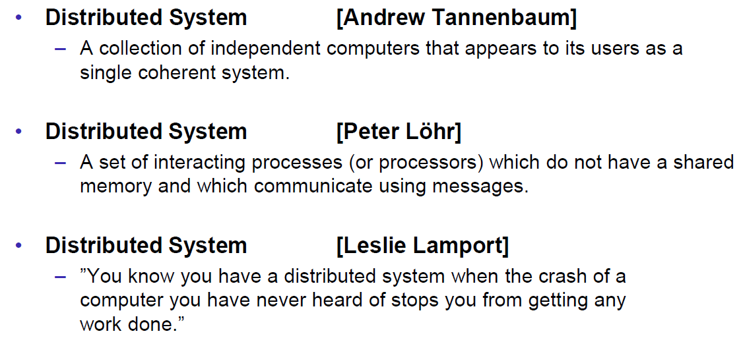

### Classification

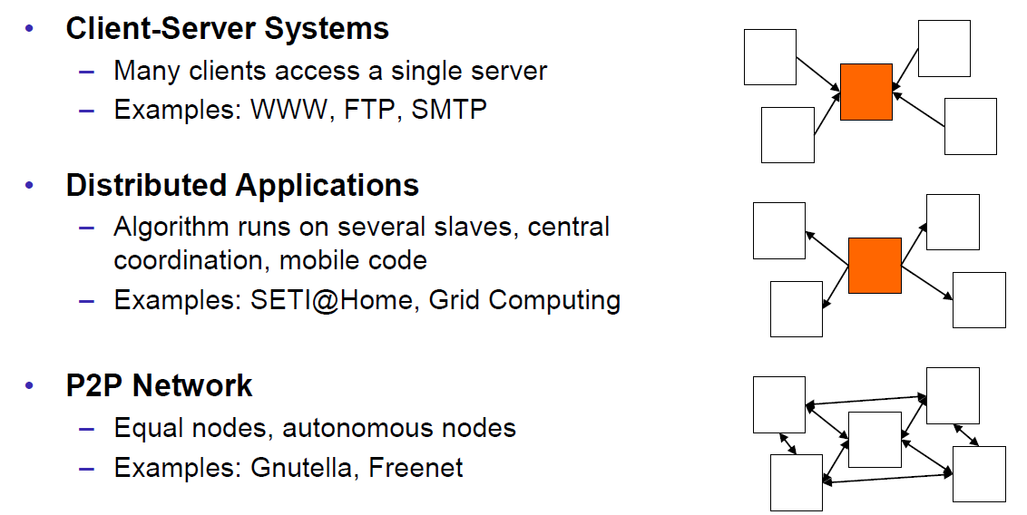

### Pros and Cons

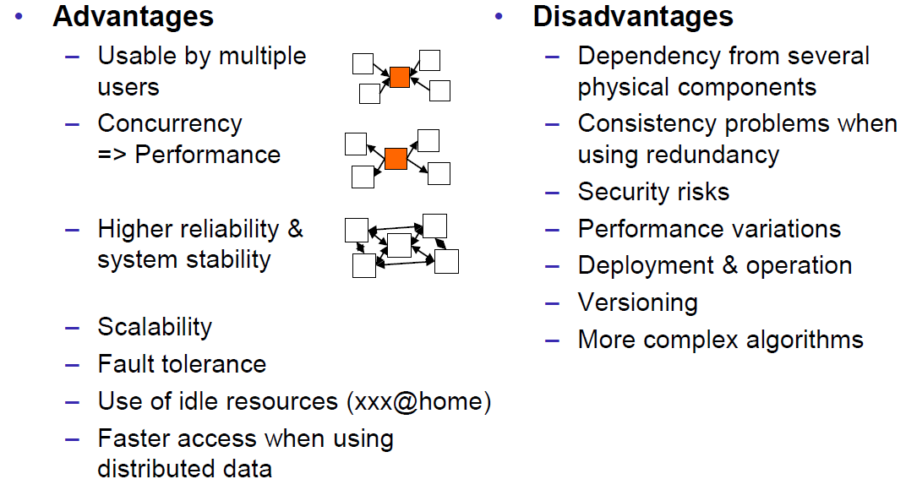

### Interaction Models

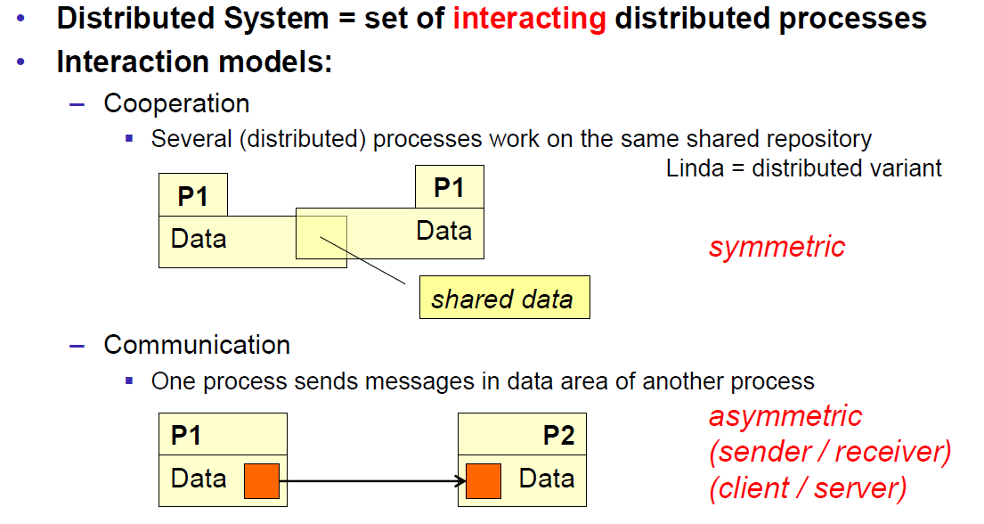

### Client/Server Model

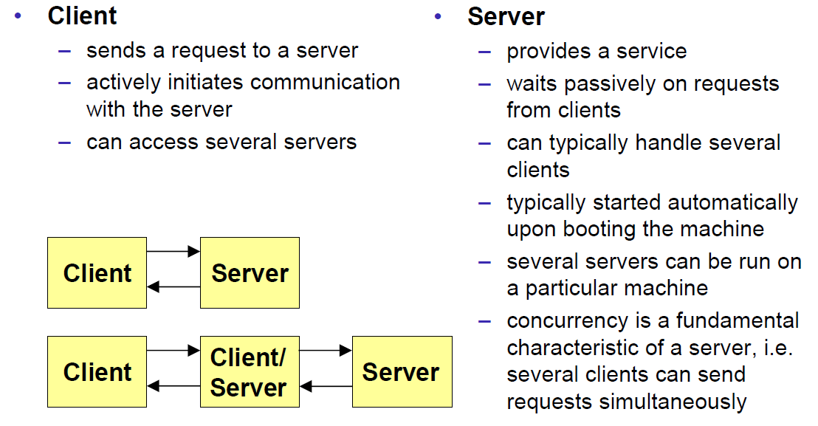

### Communication Models

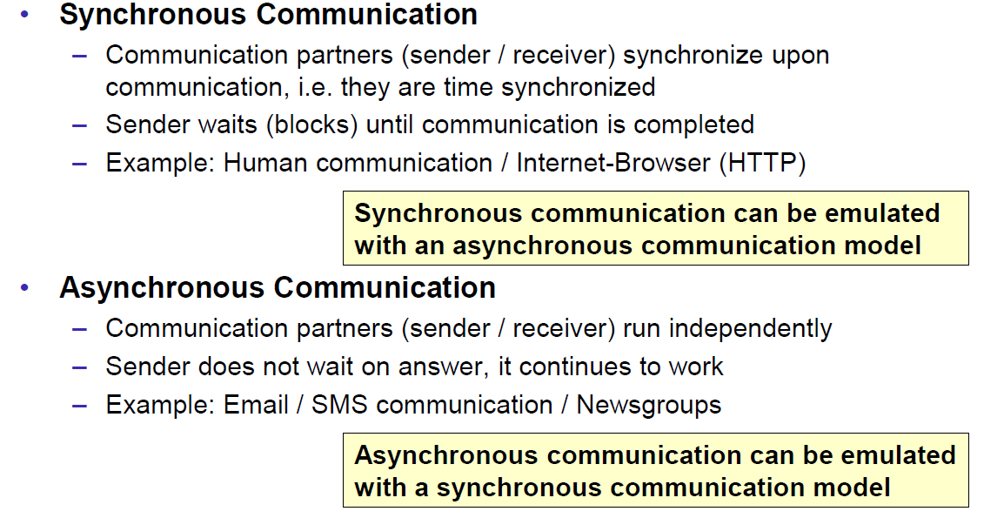

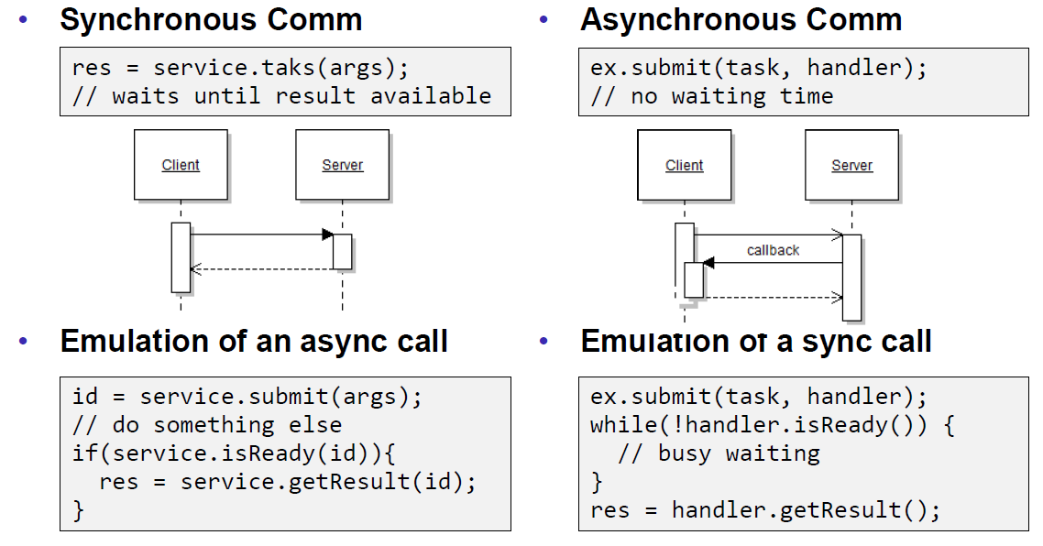

### Communication Styles

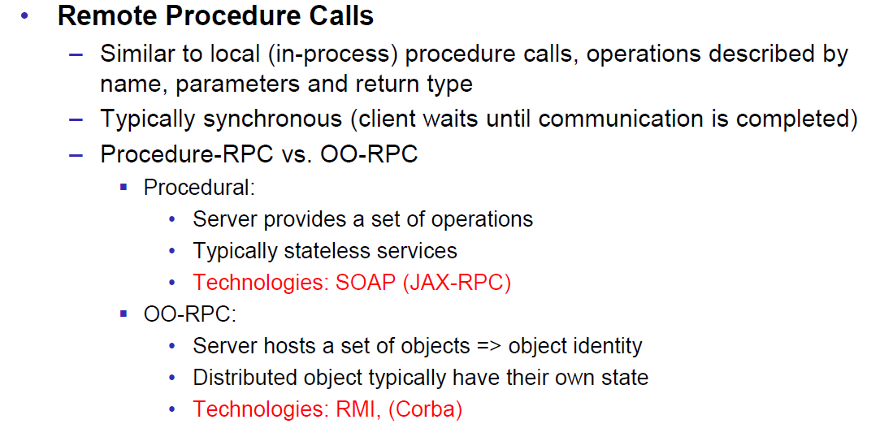

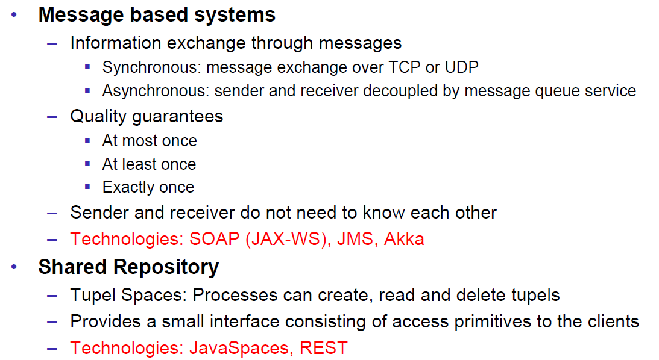

## Challenges of Distributed Systems

### Heterogeneity

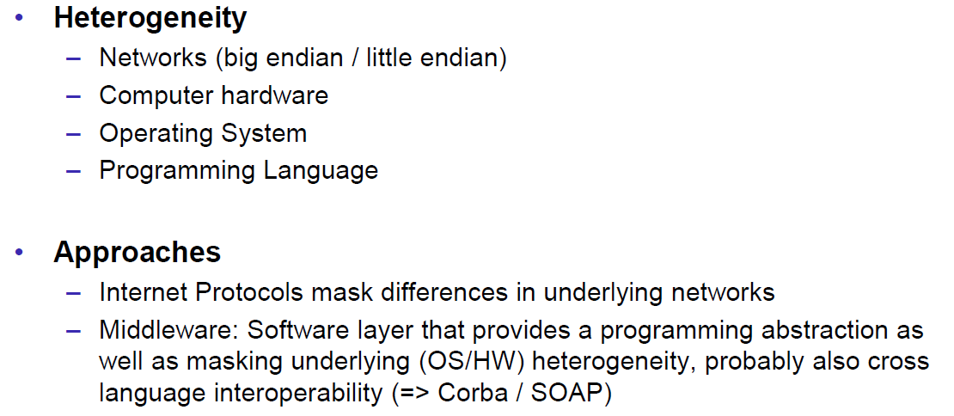

### Latency

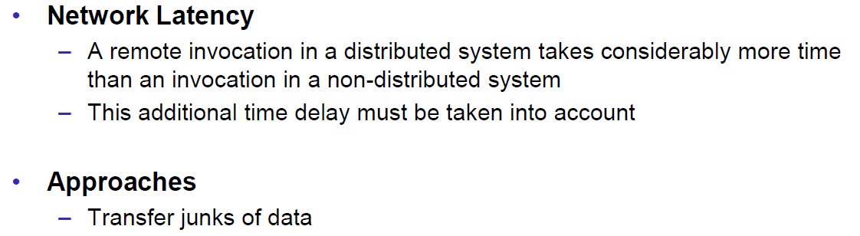

### Security

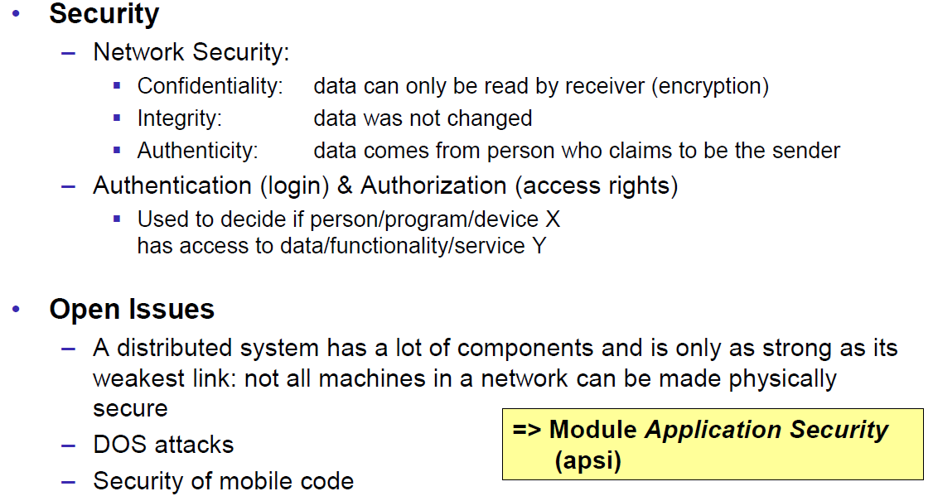

### Scalability

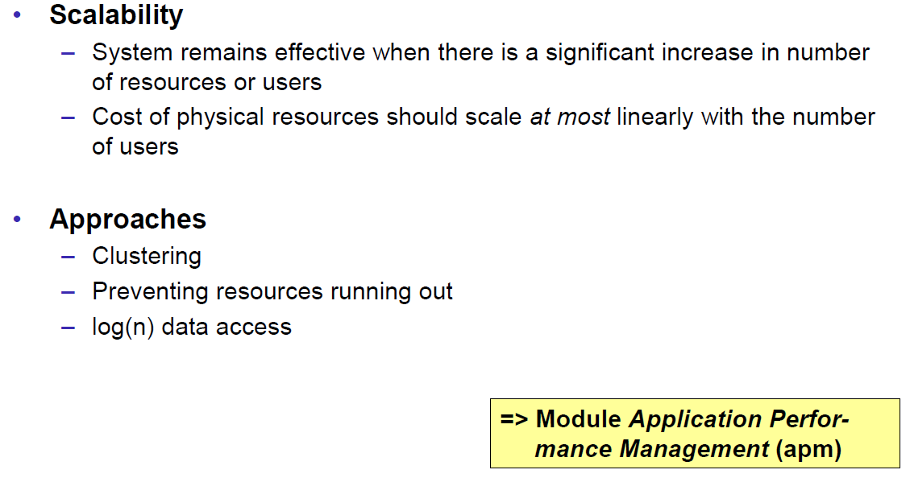

### Failures

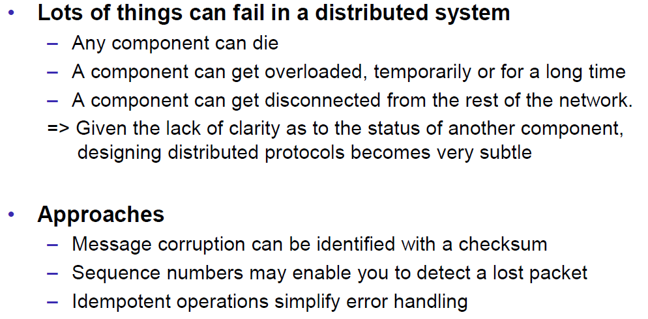

### Concurrency

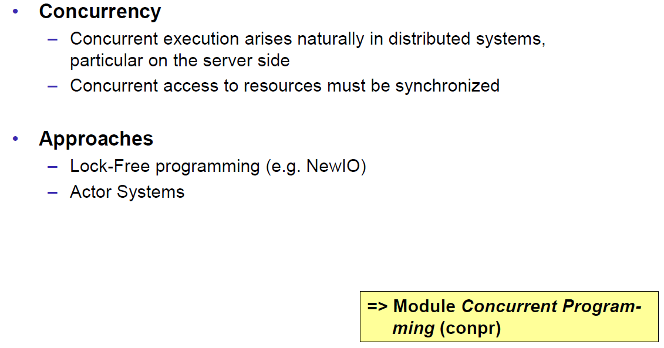

### Consistency

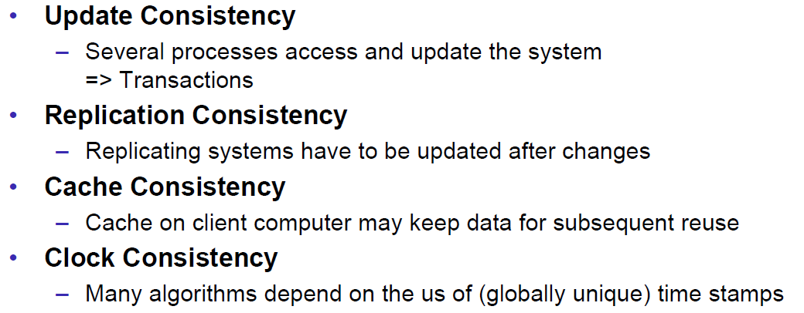

## Networking

### Protocol & Network Levels

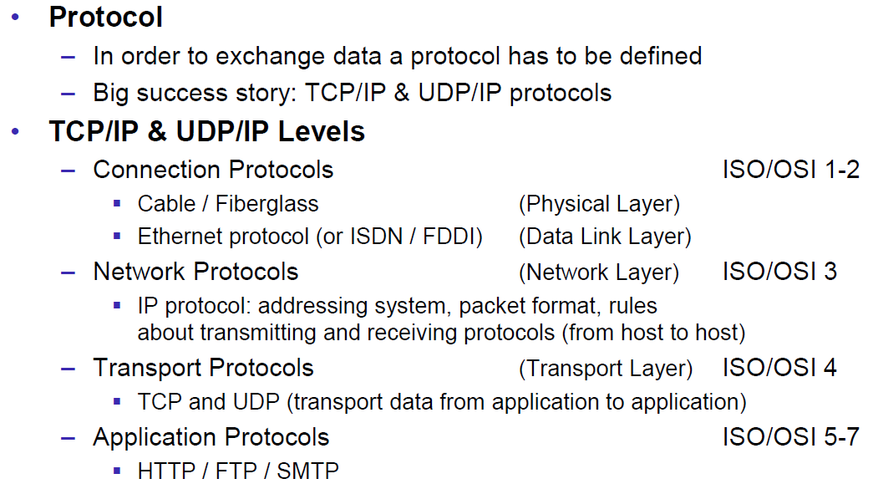

### IP Socket Connections

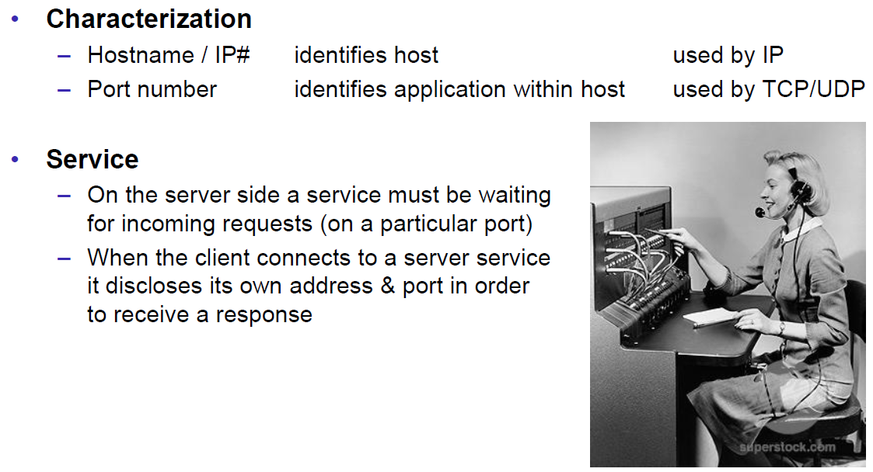

### IP Addressing

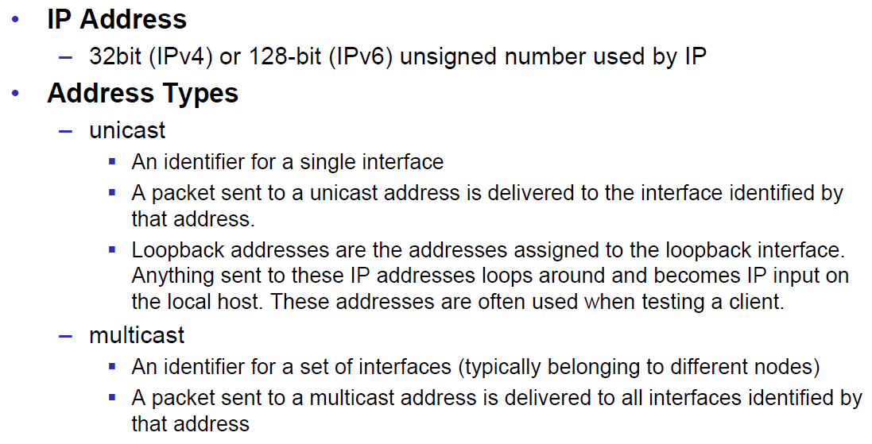

### TCP/UDP Common Port Numbers

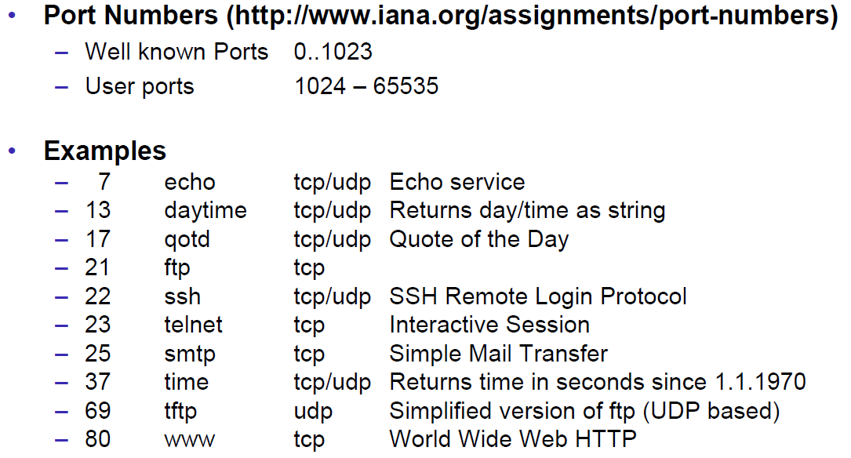

### InetAddress

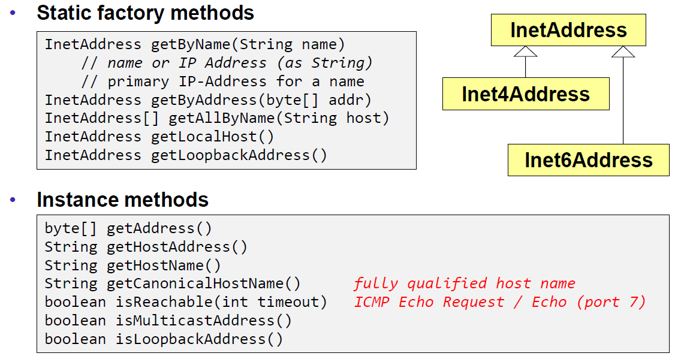

### Network Interfaces

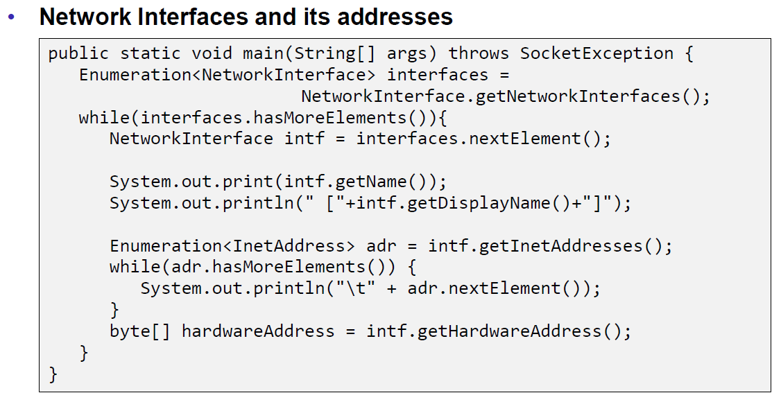

## Sockets

### Sockets

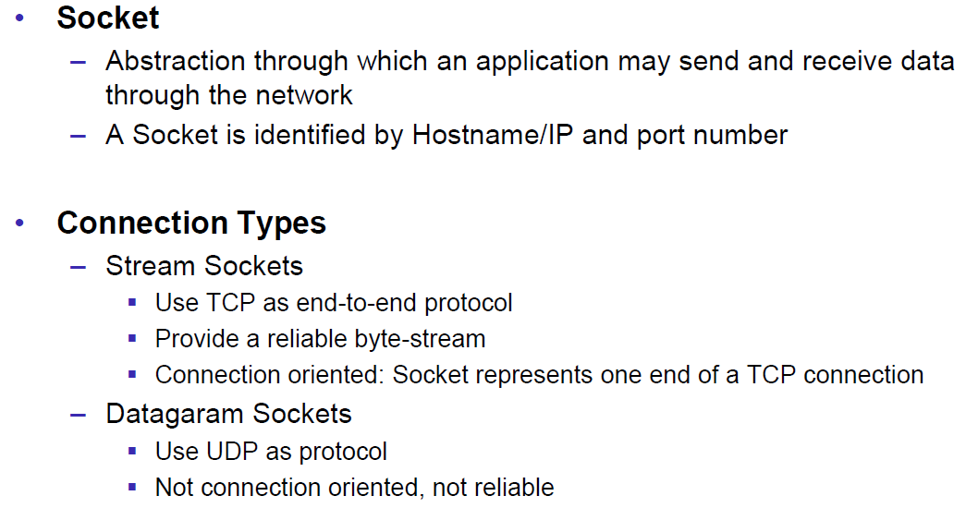

### TCP Sockets

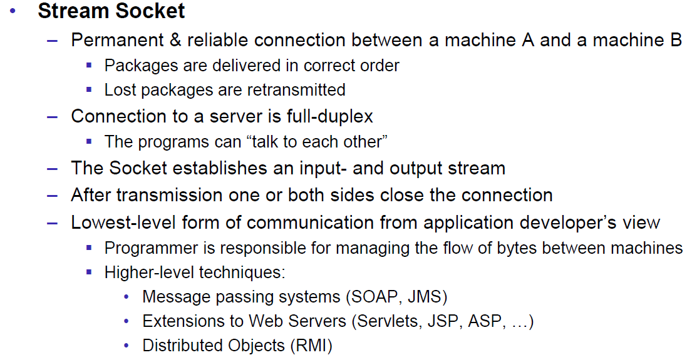

### Java Socket

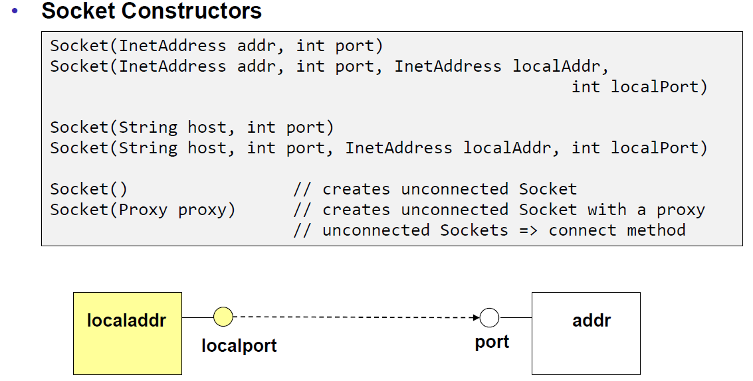

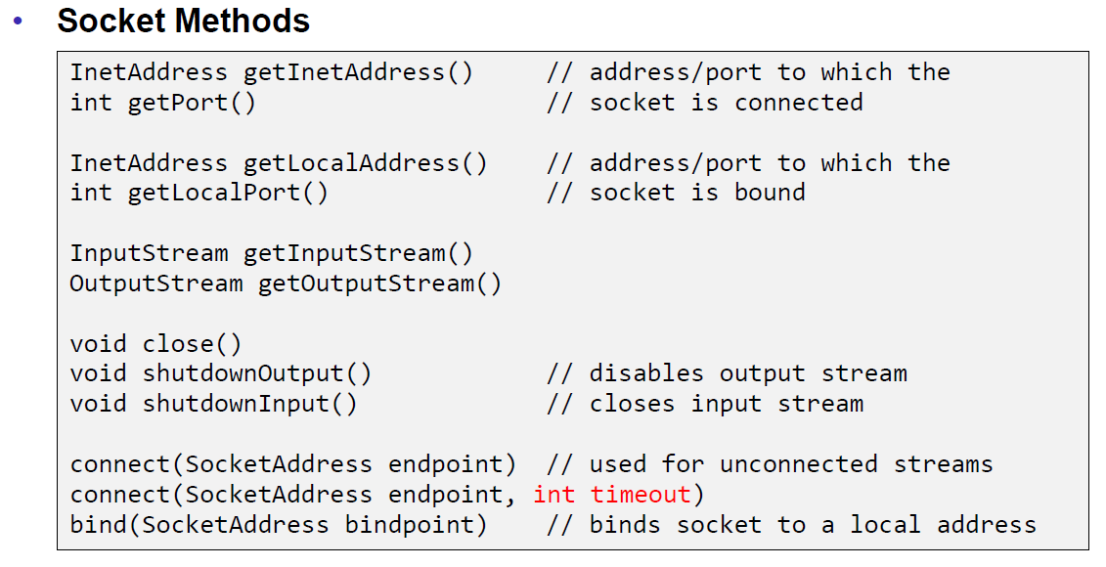

### Sample Client (Echo)

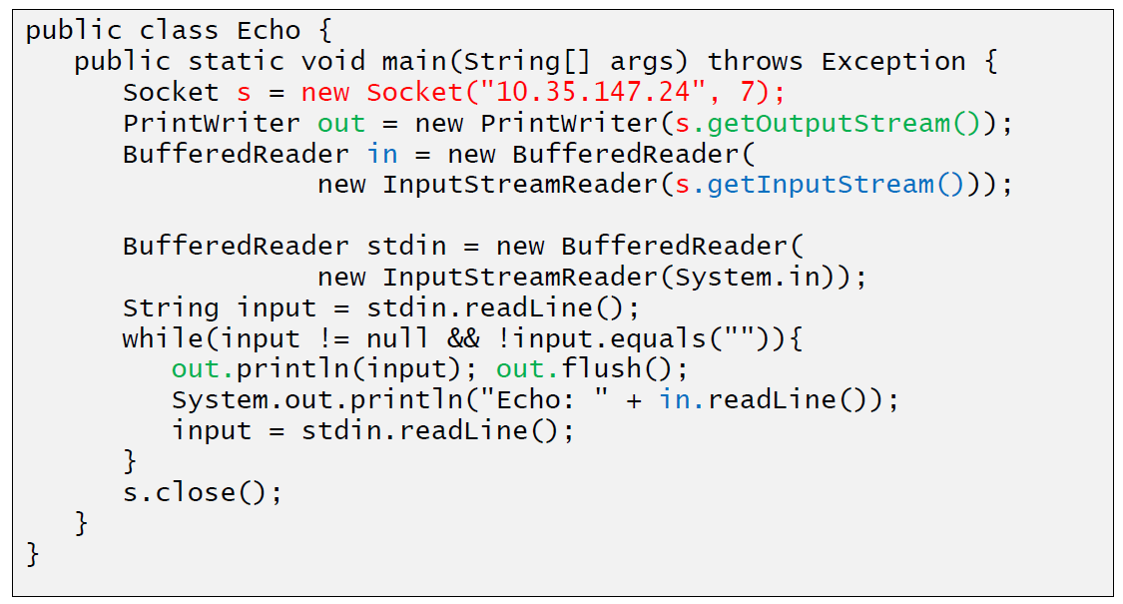

### Sample Client (Mailer)

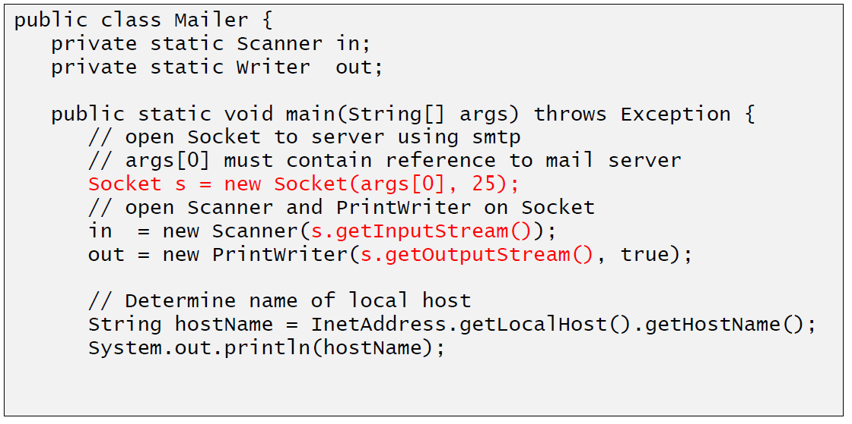

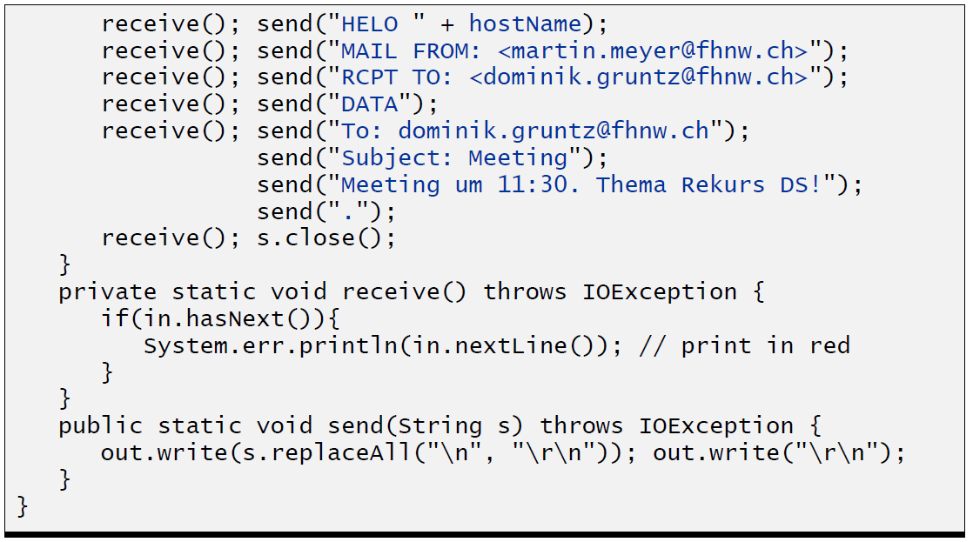

### ServerSocket

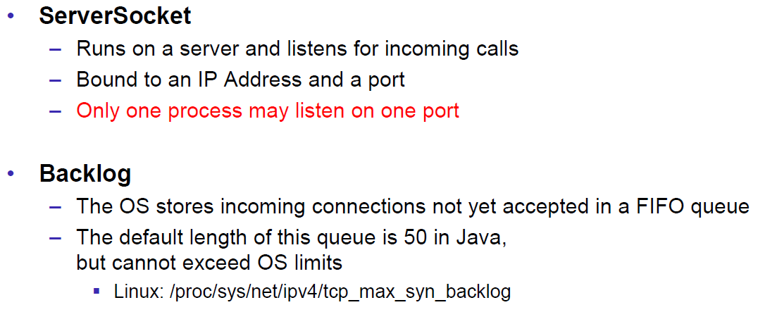

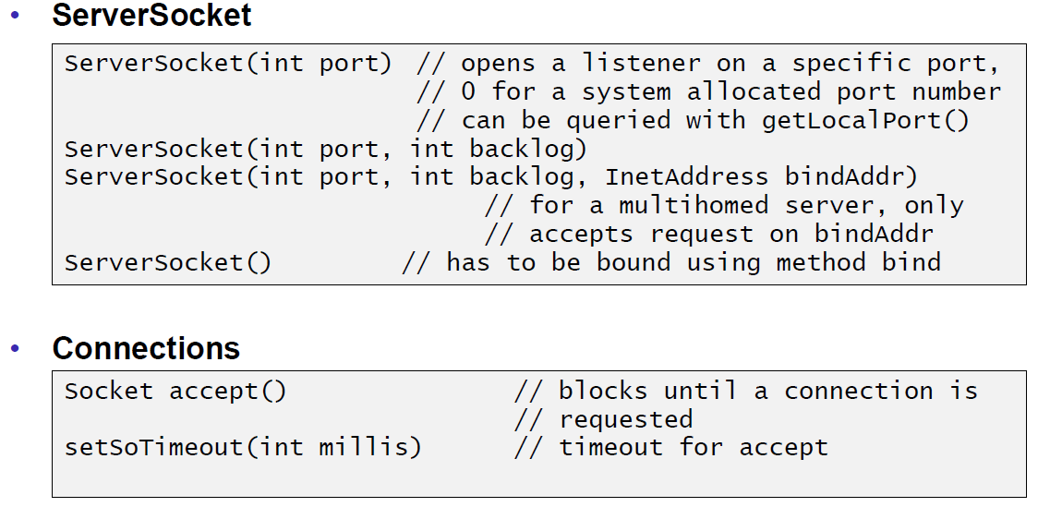

### Echo Server

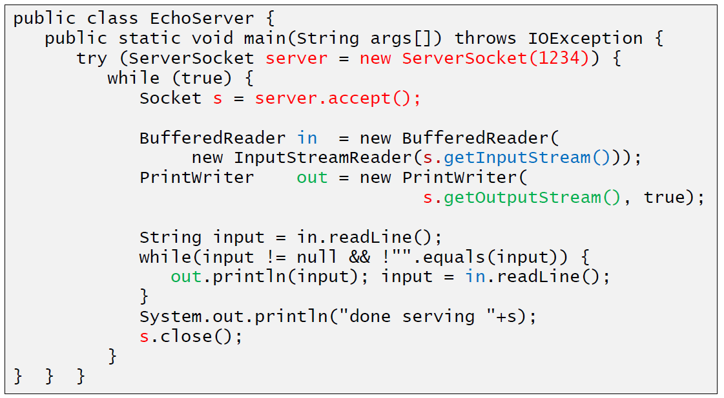

### Concurrent Echo Server

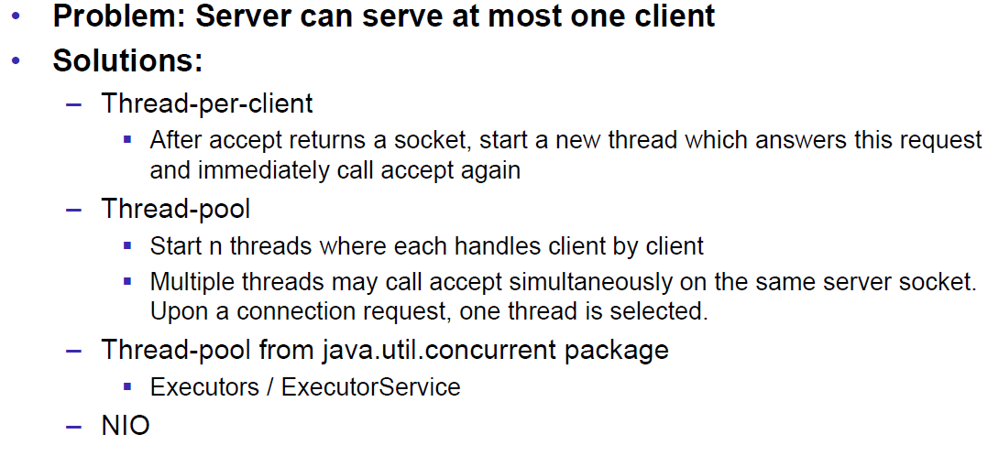

### Concurrent Echo Server (Threaded)

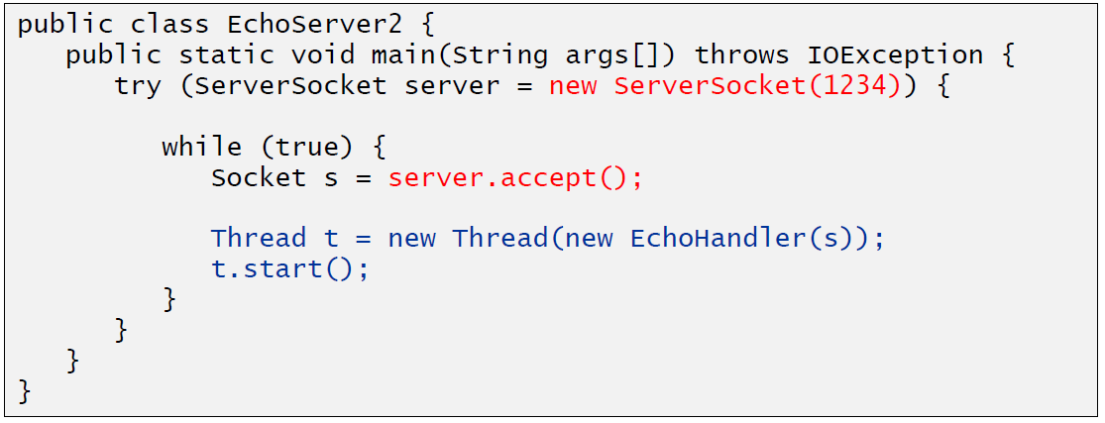

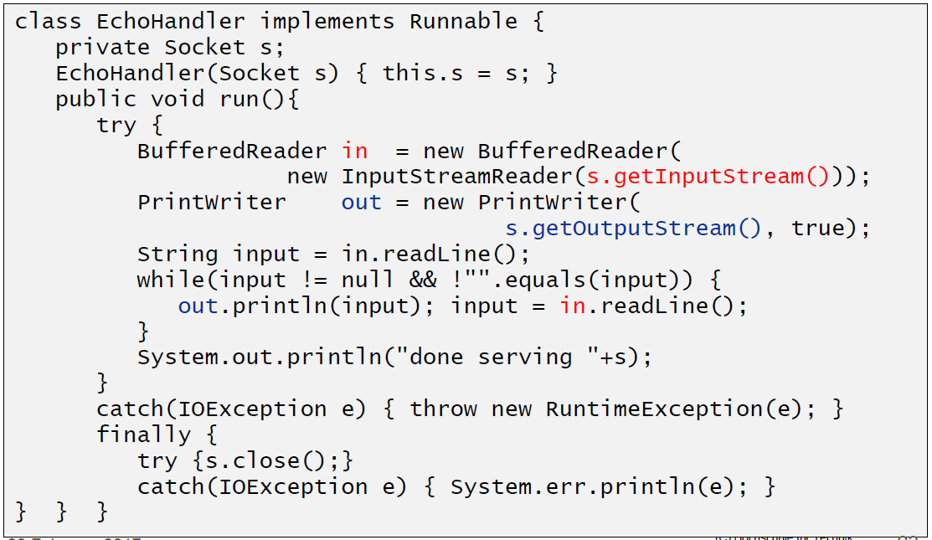

### Concurrent Echo Server (Limitierter Threadpool)

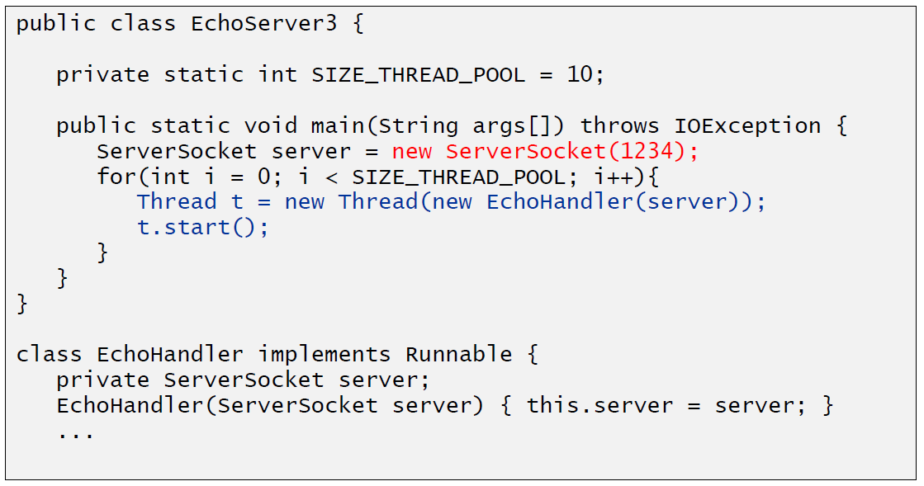

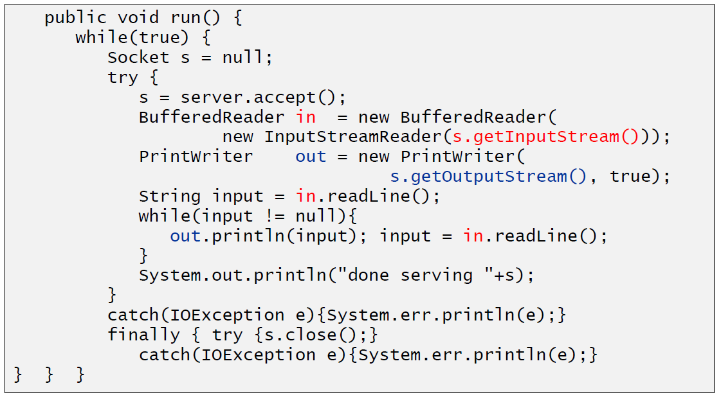

### Concurrent Echo Server (Dynamischer Threadpool)

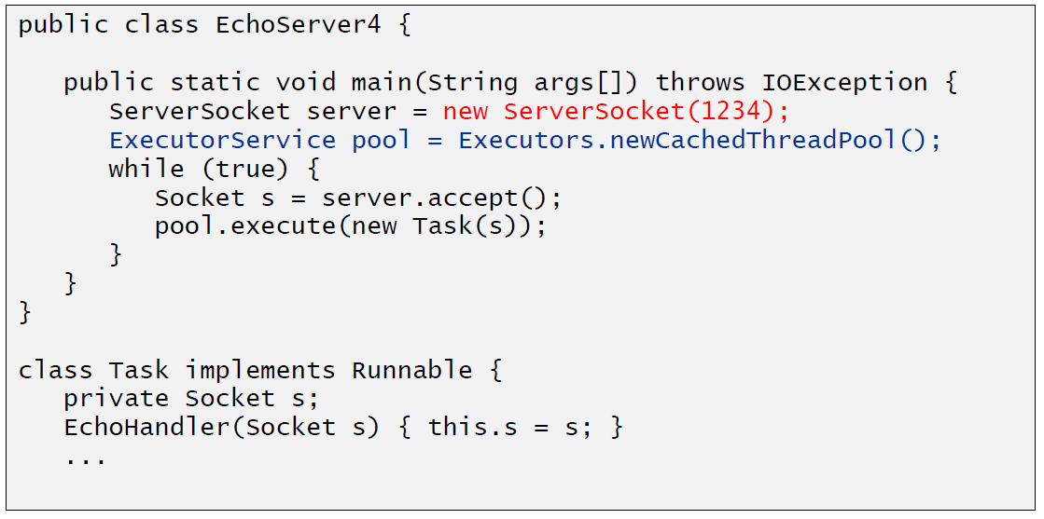

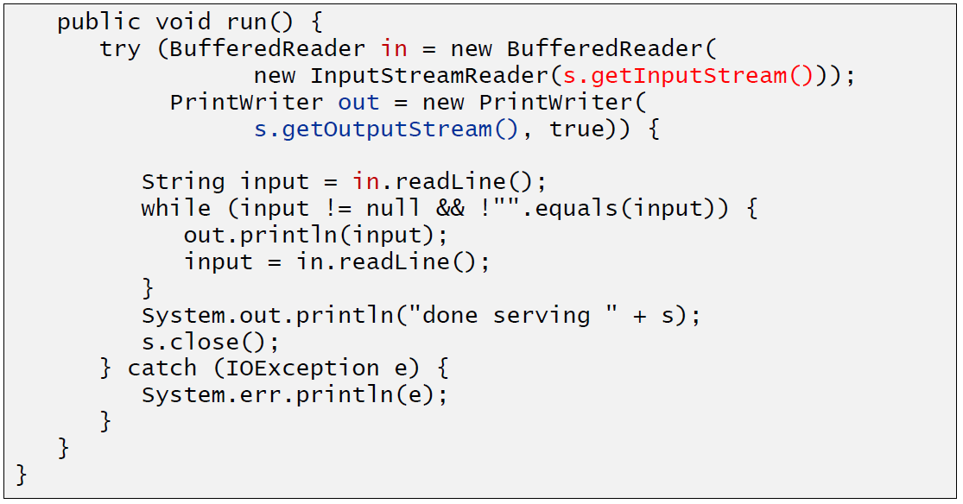

# Woche 2

## Input and Output Streams

### OutputStream

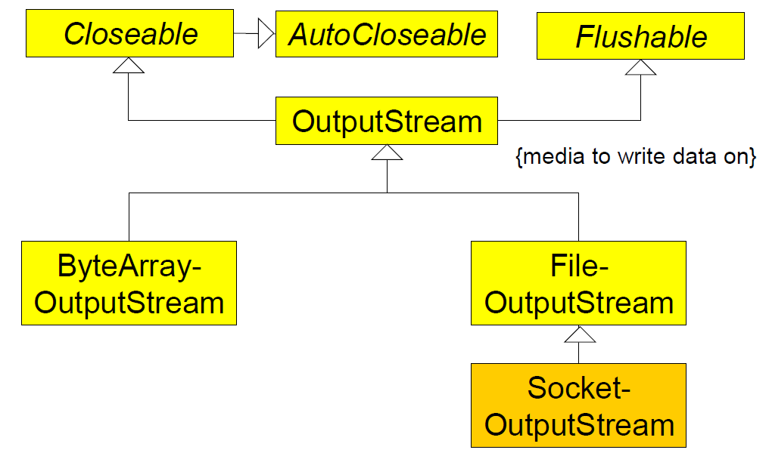

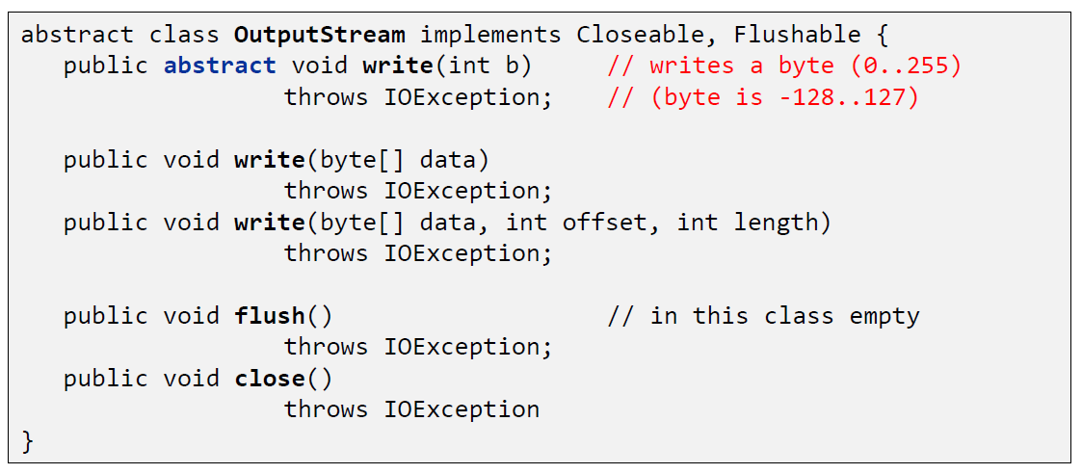

### InputStream

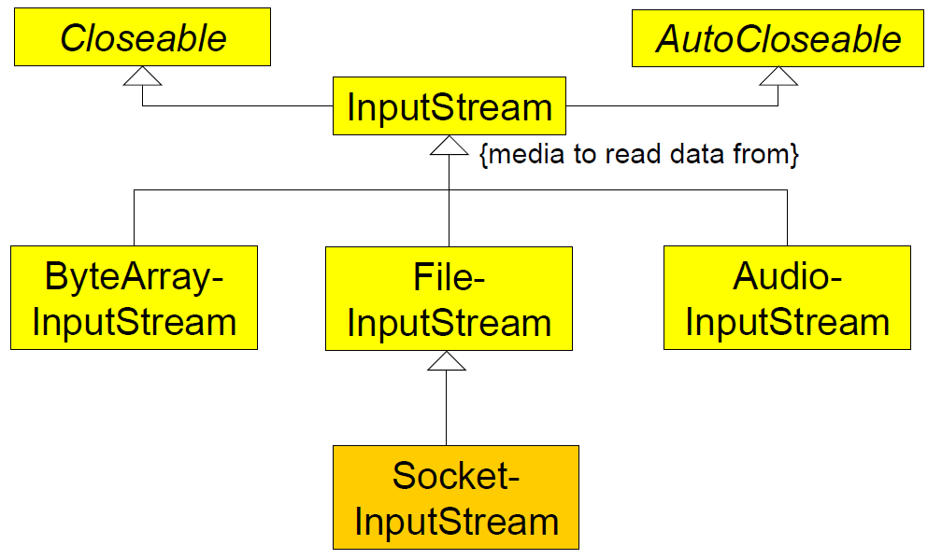

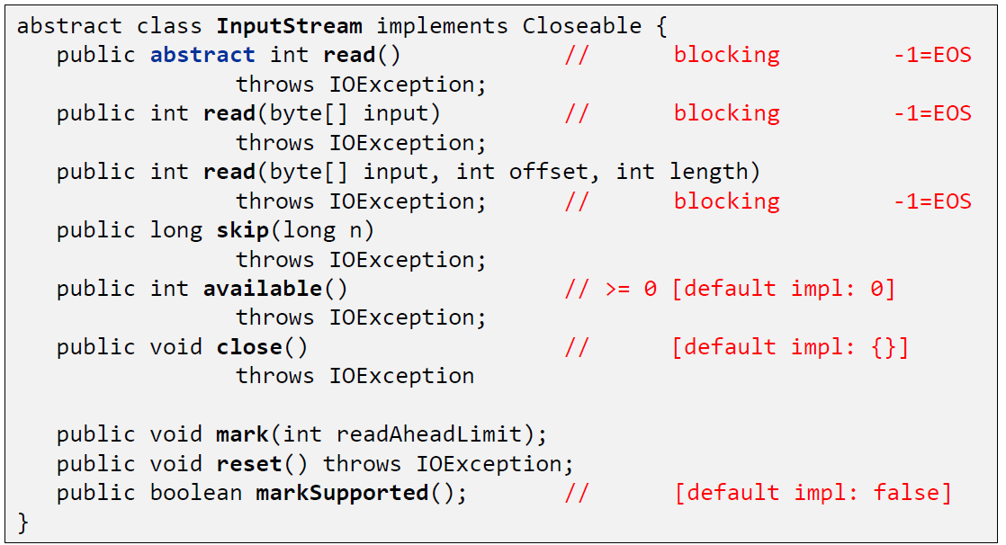

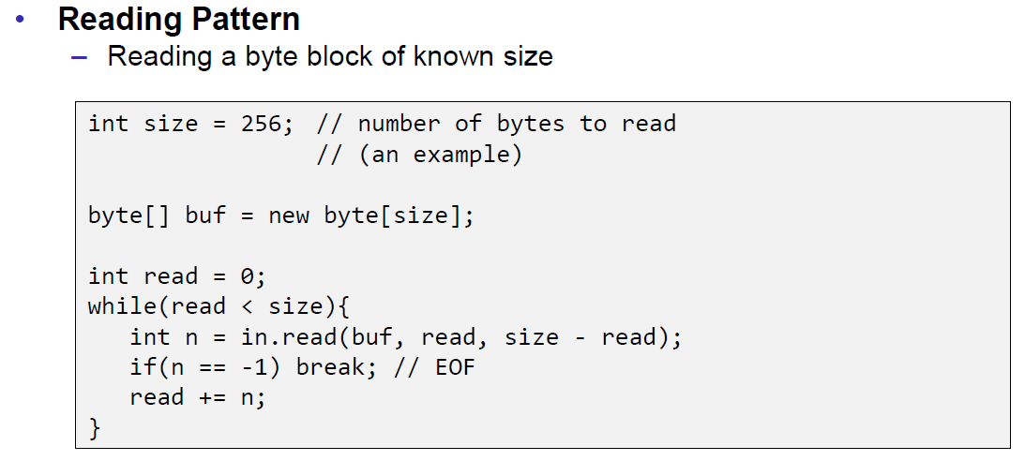

## Filter Streams

### FilterOutputStream

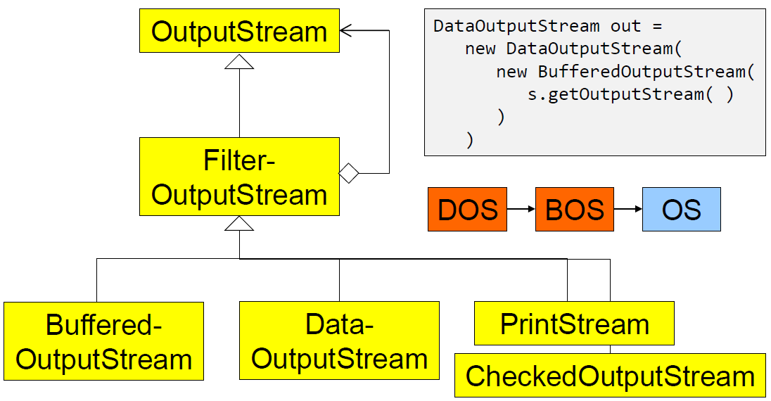

### DataOutputStream

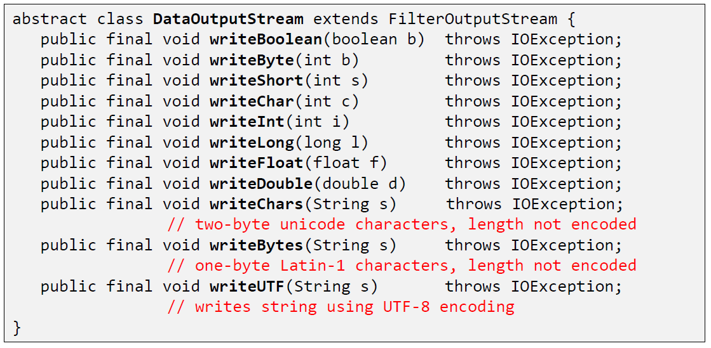

### DataOutputStream with writeInt

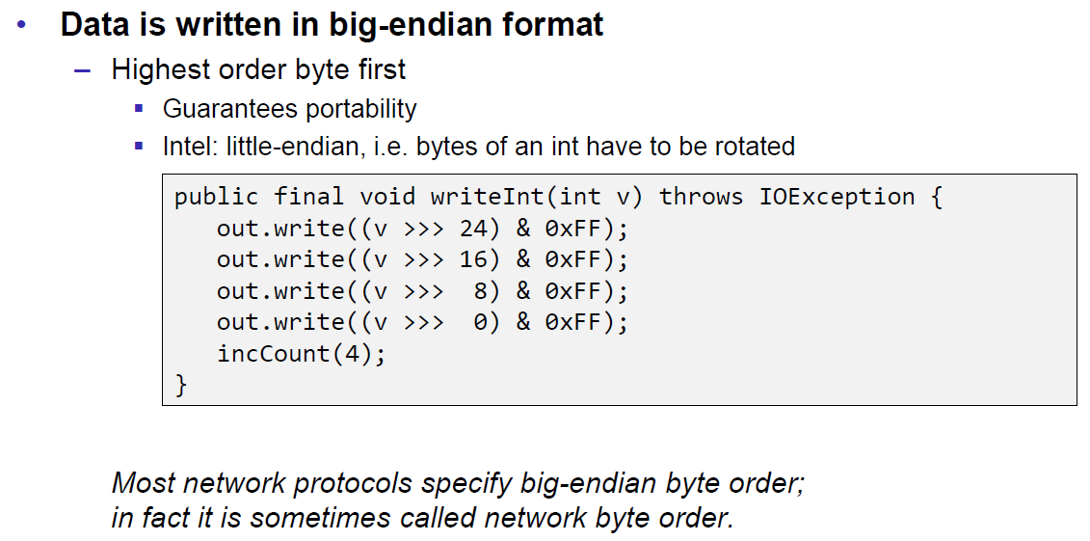

### DataOutputStream with writeUTF

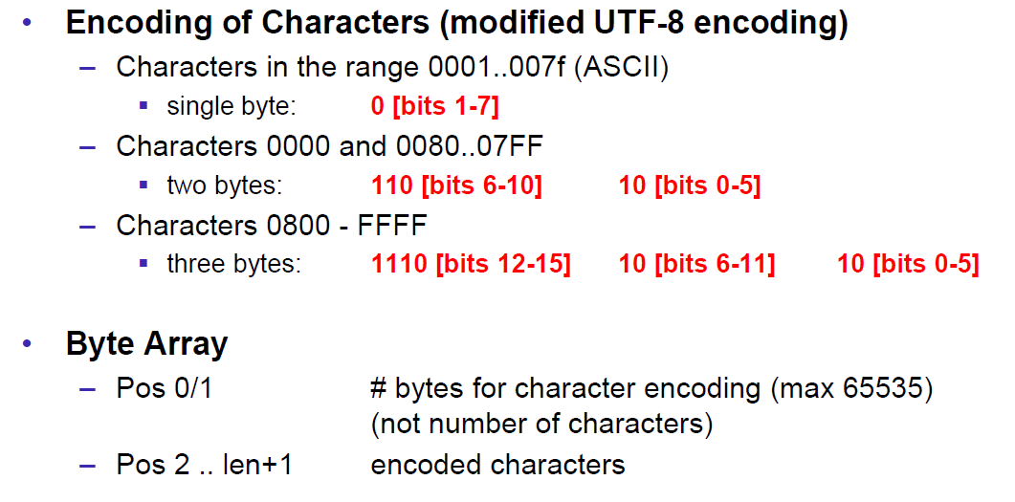

### PrintStream

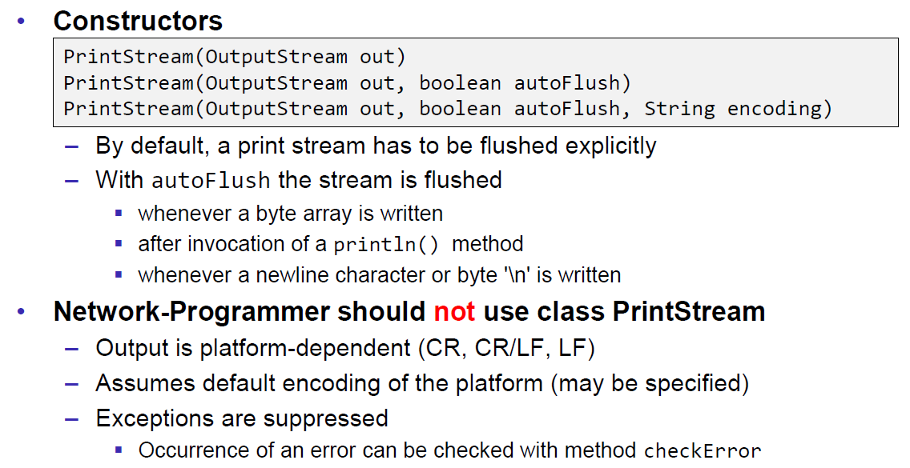

### FilterInputStream

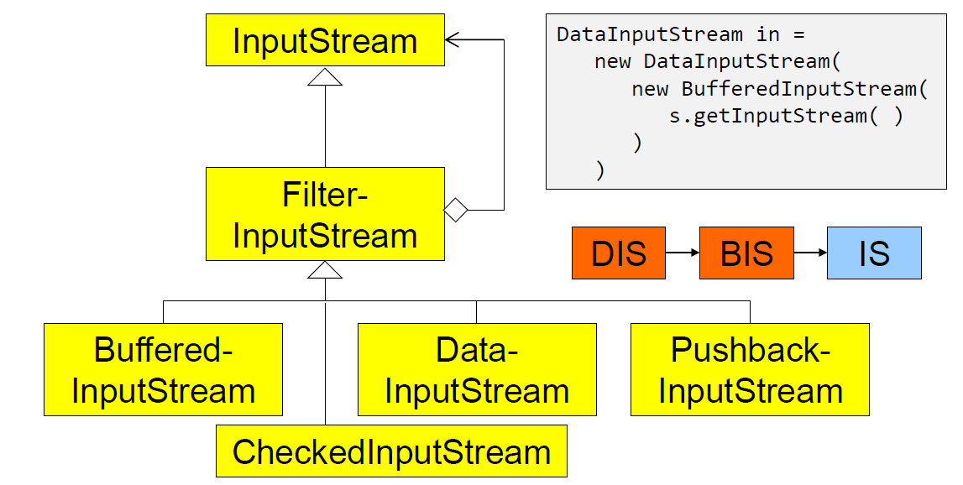

### DataInputStream

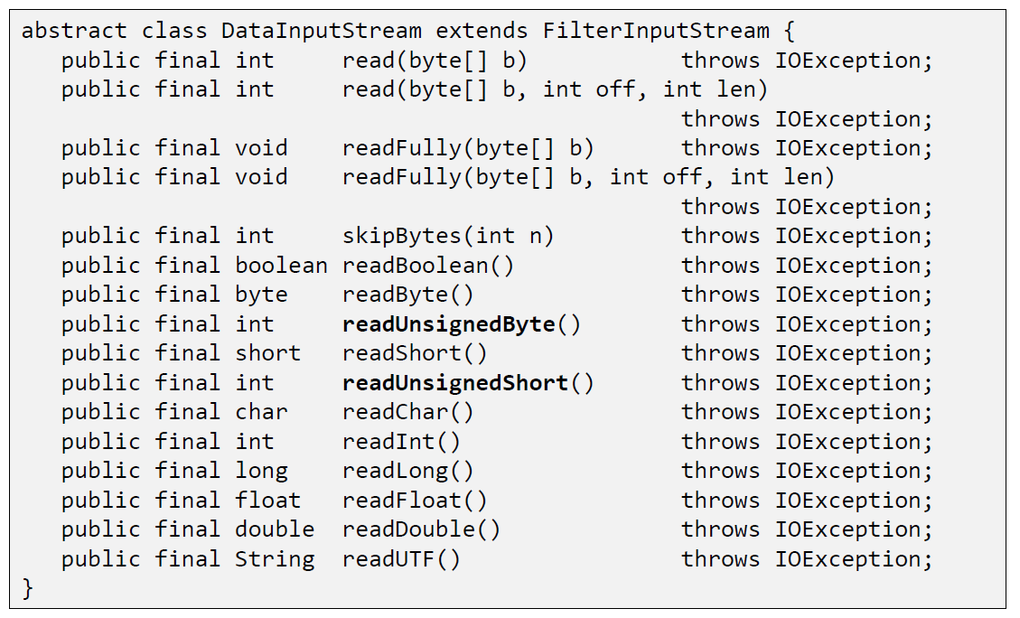

### DataInputStream with readFully

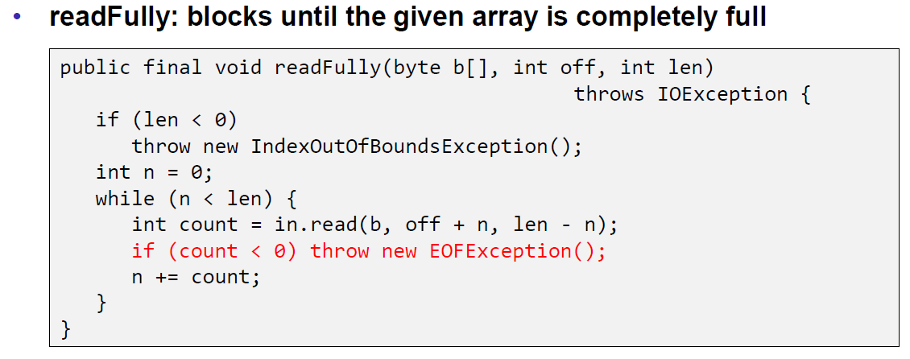

### Filter Streams

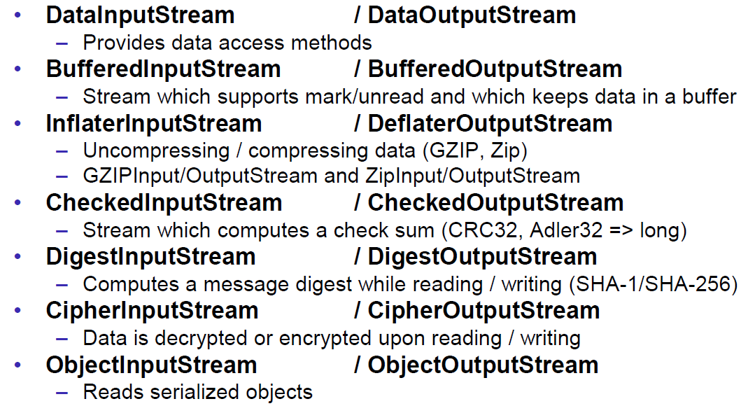

## Object Streams & Serialization

### ObjectStream

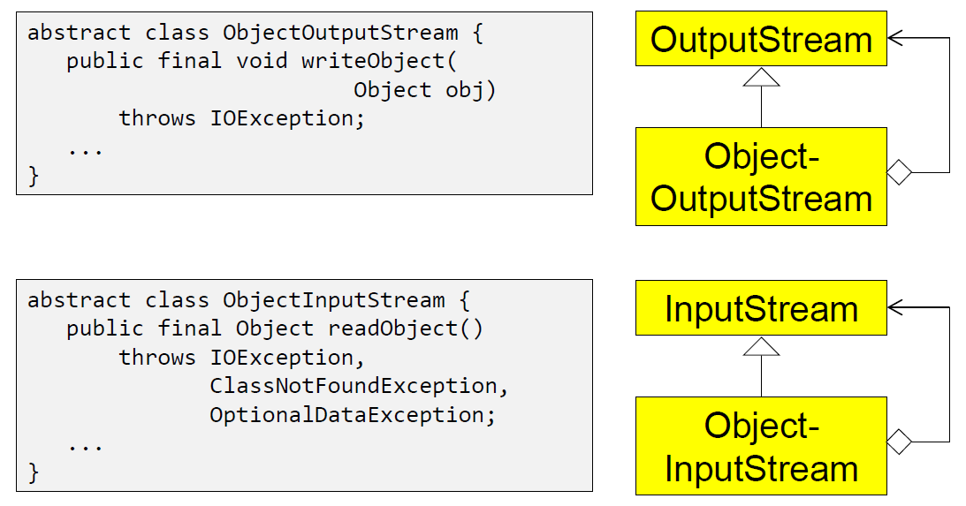

### Serialization with ObjectStream

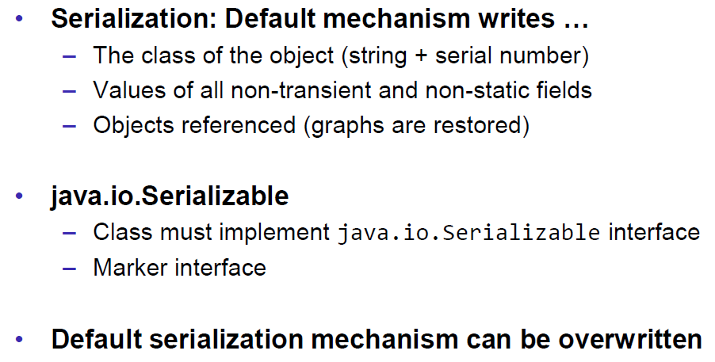

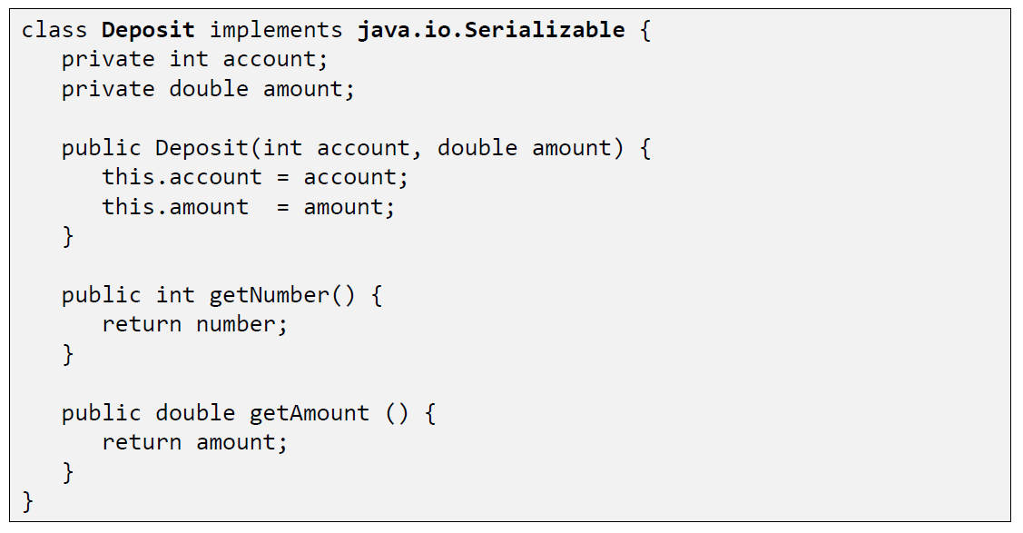

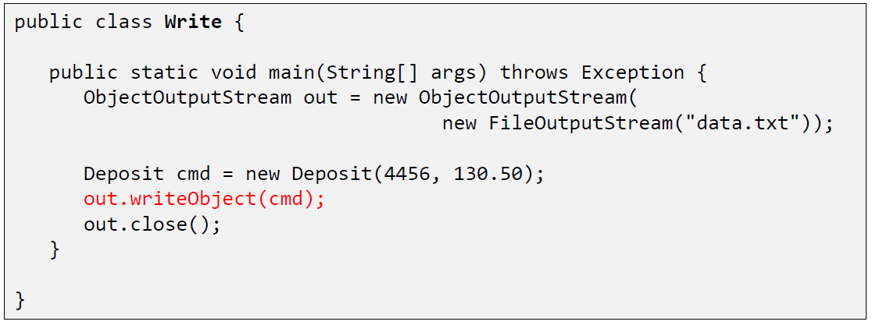

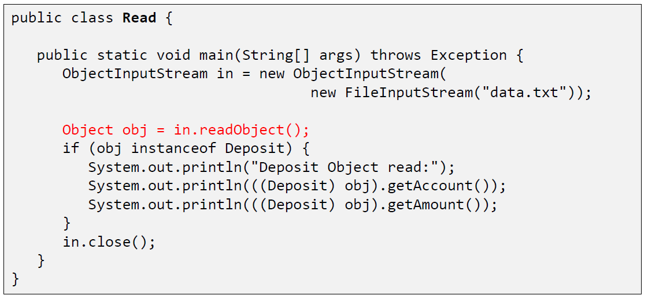

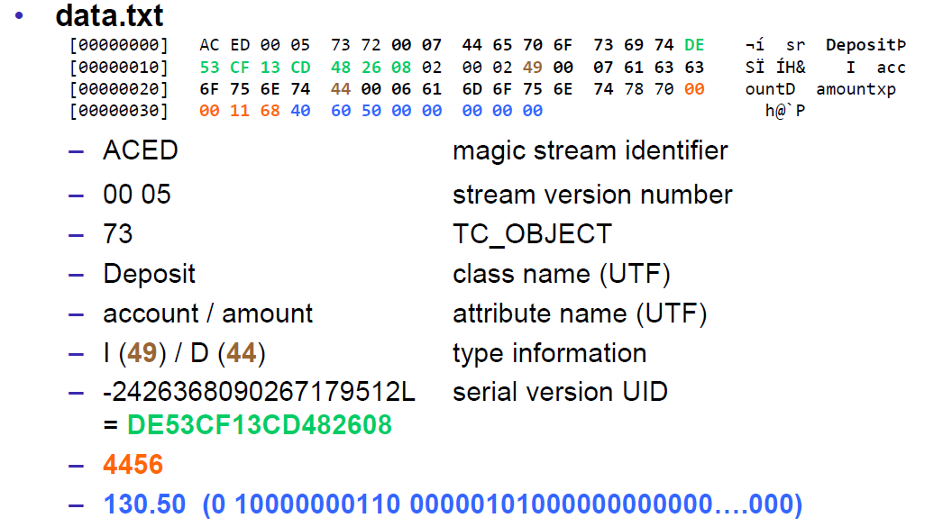

### Serial Version Number

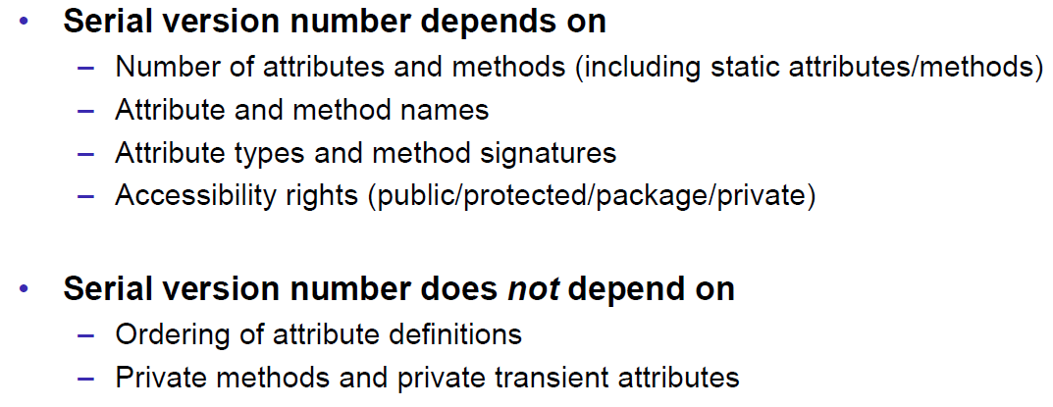

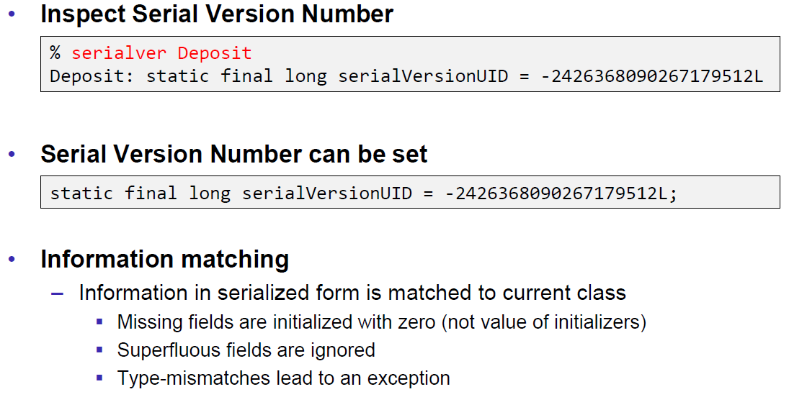

### Serialization Customization

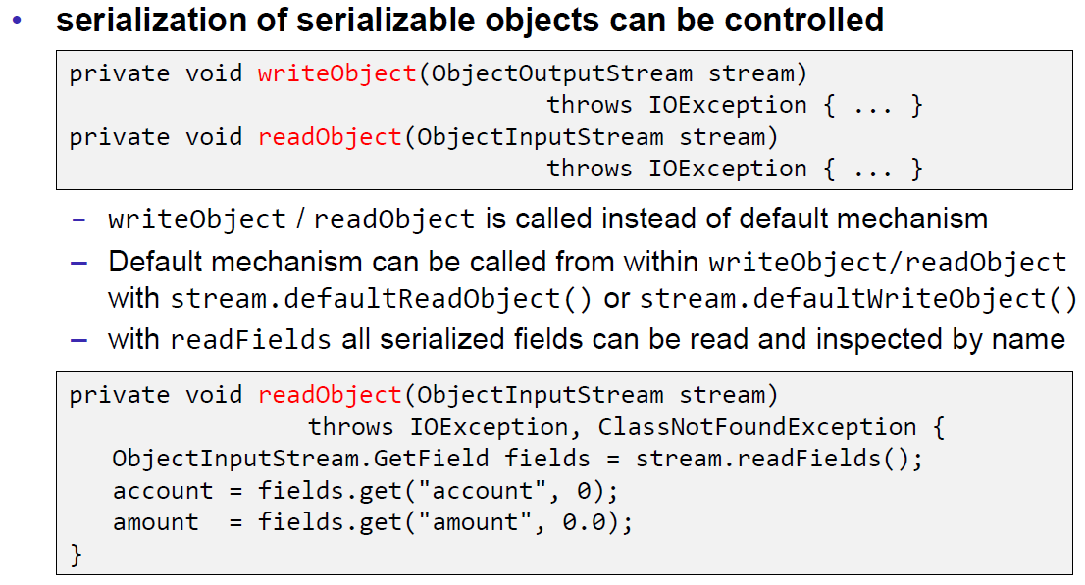

### Serialization Hints

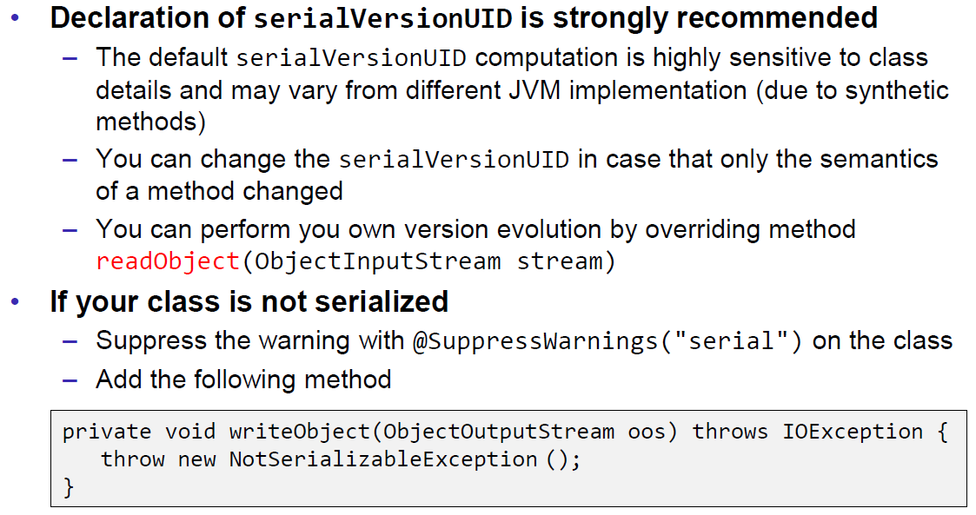

## Sending and Receiving Data

### Framing

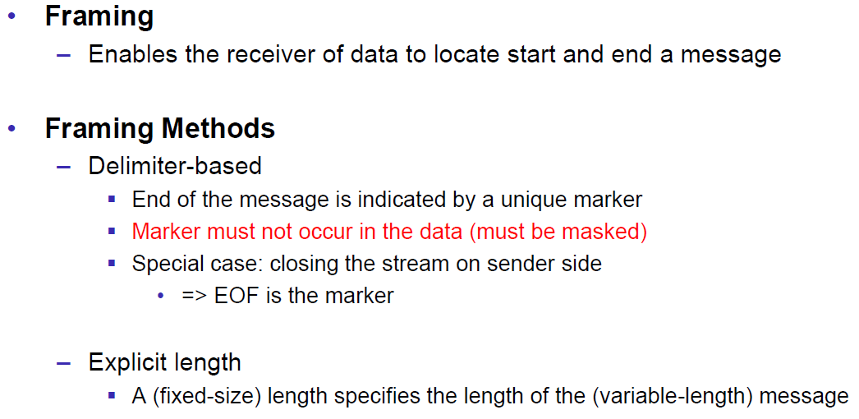

### Example of Framing

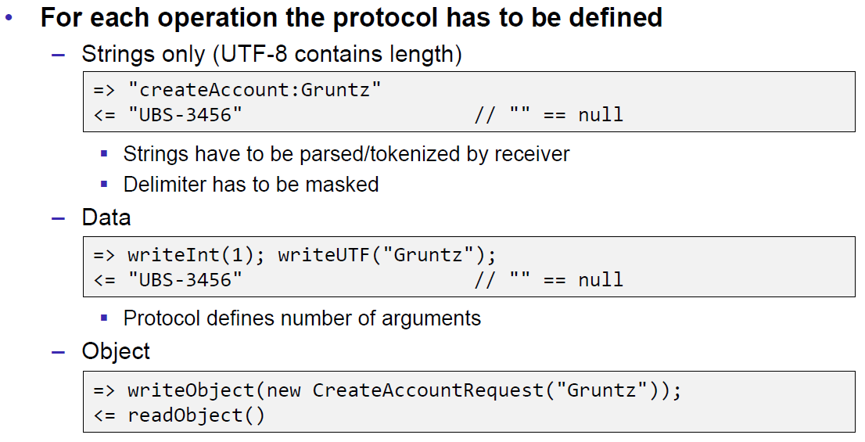

## Summary

### Whole Picture of Input Streams

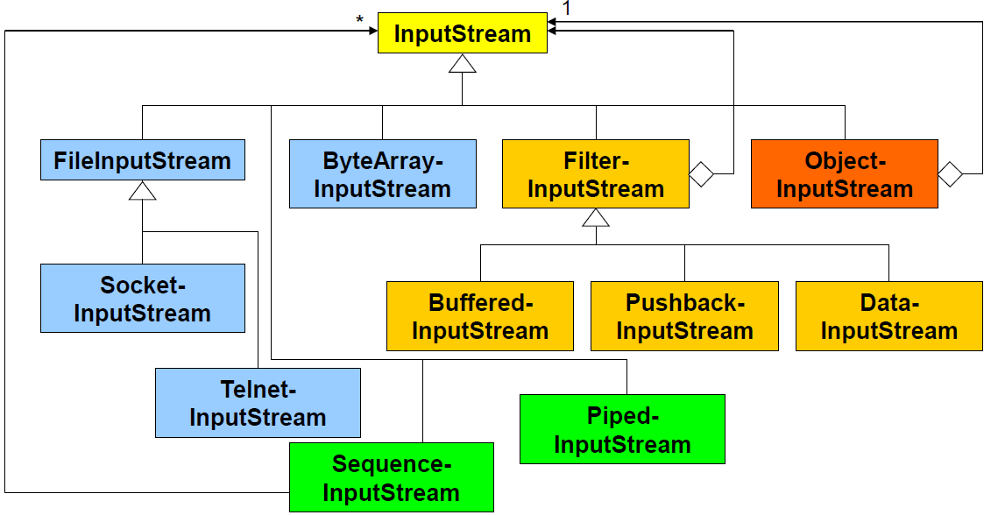

### Whole Picture of Output Streams

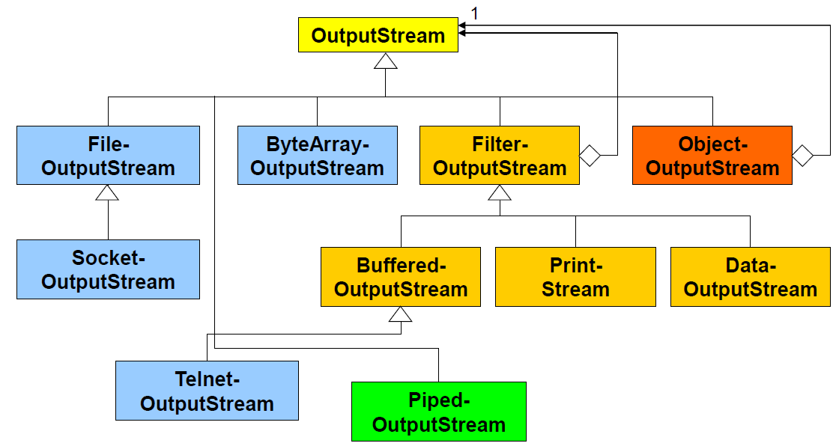

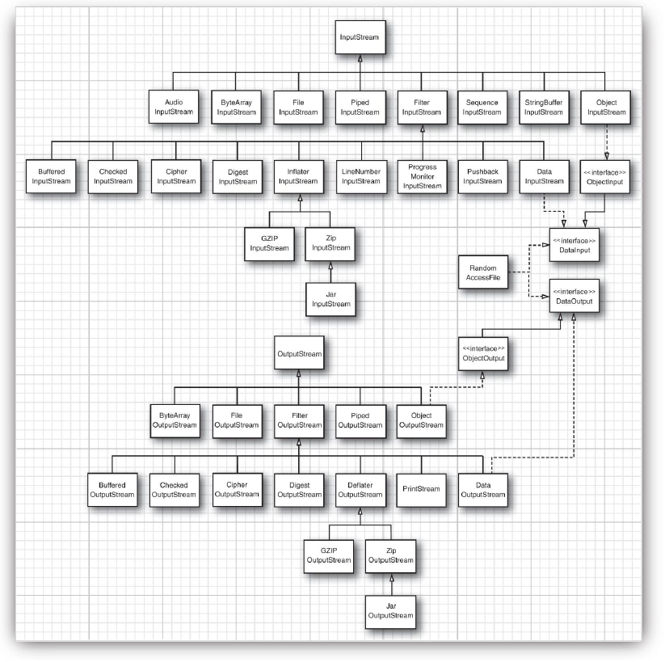

### Reading and Writing Text (Unicode Strings)

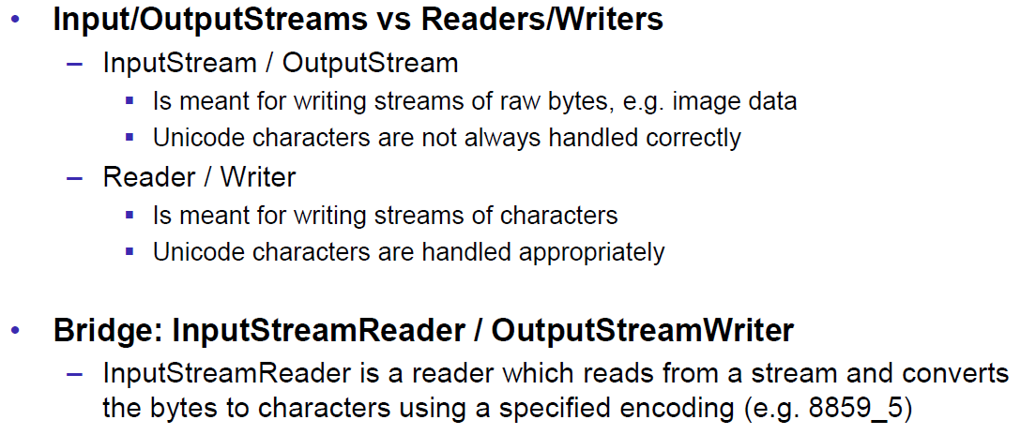

### Whole Picture of Reader

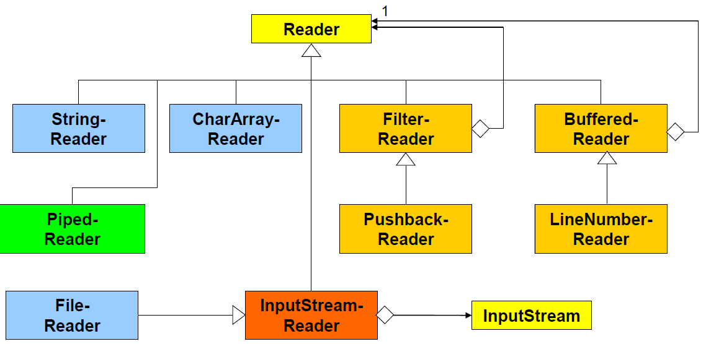

### Whole Picture of Writer

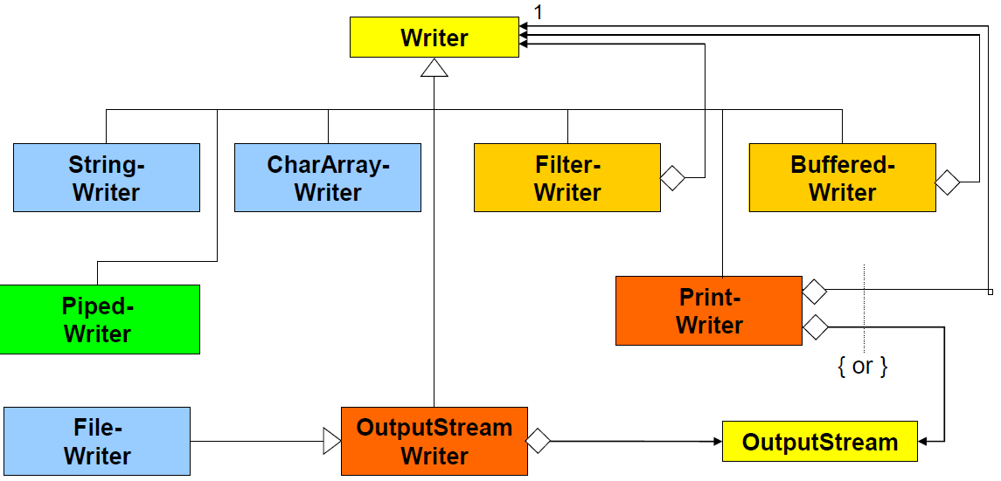

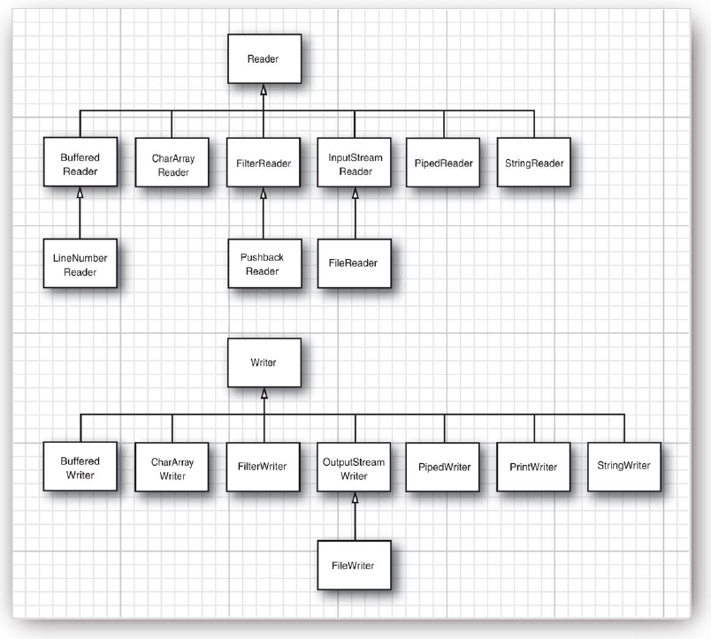

## Controlling Socket Behaviors

### Blocking and Timeouts

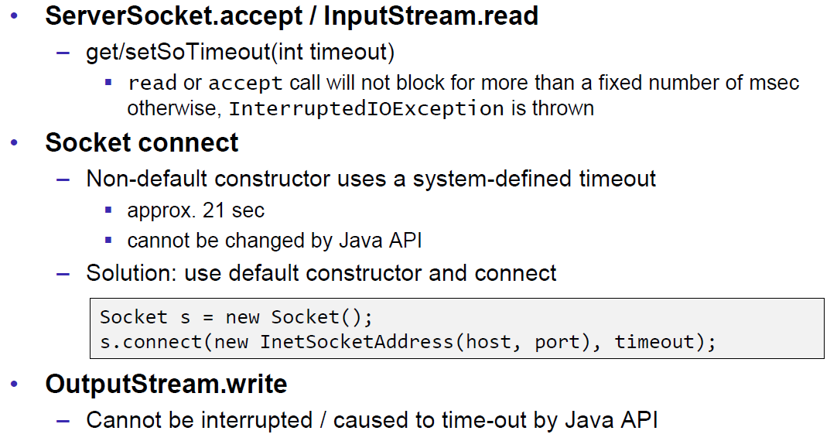

### Send and Receive Buffer Size

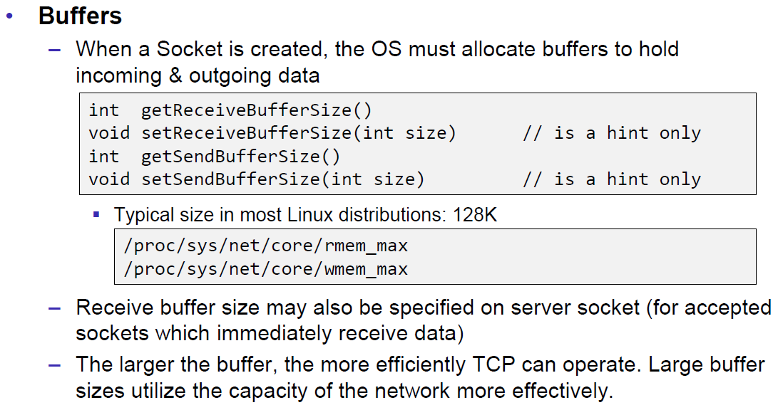

### Package Delay

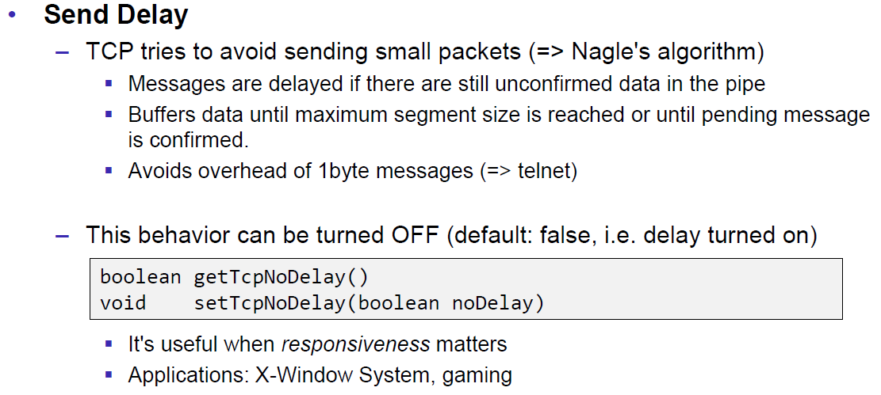

## Closing Connections

### Closing Connections

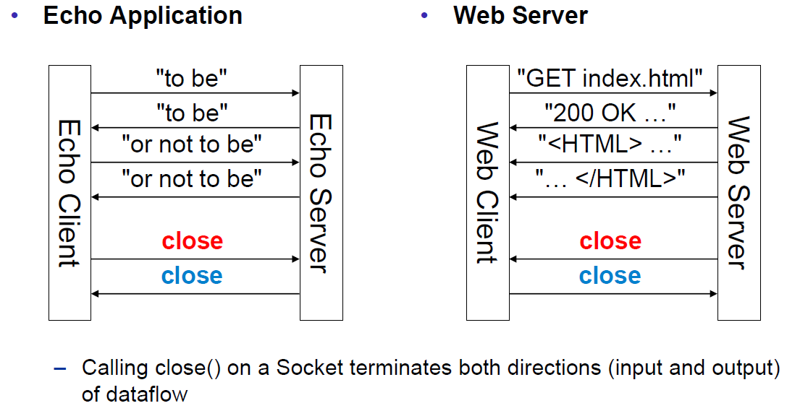

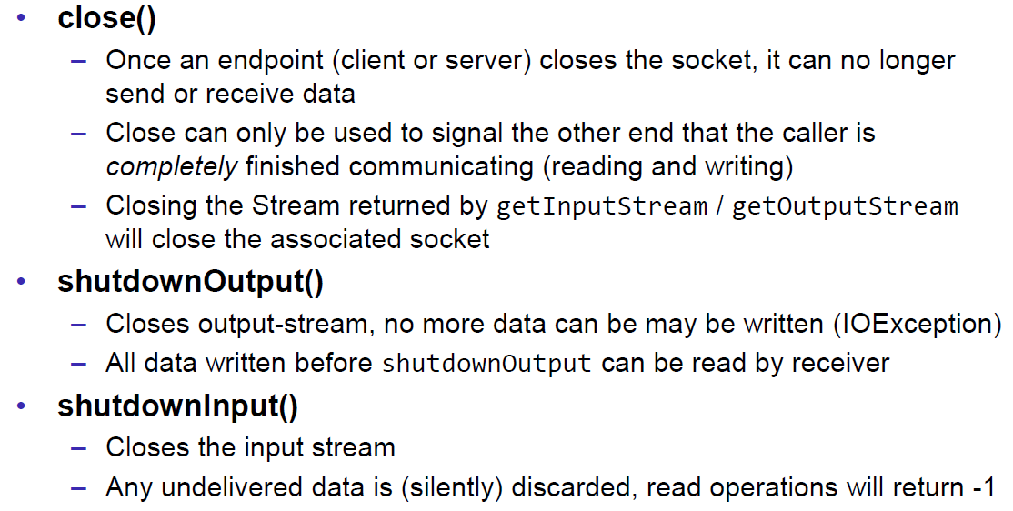

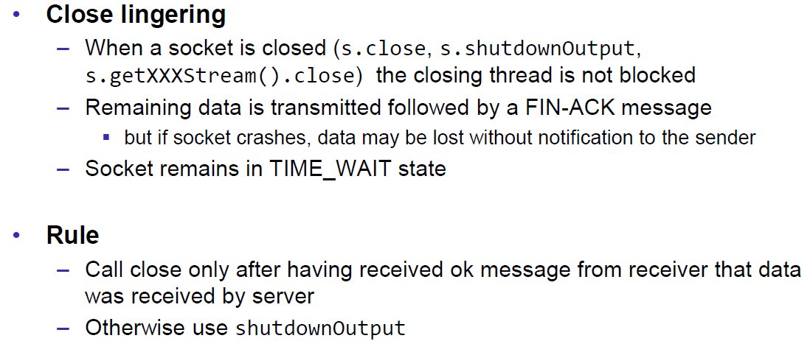

### Example of a Close Test

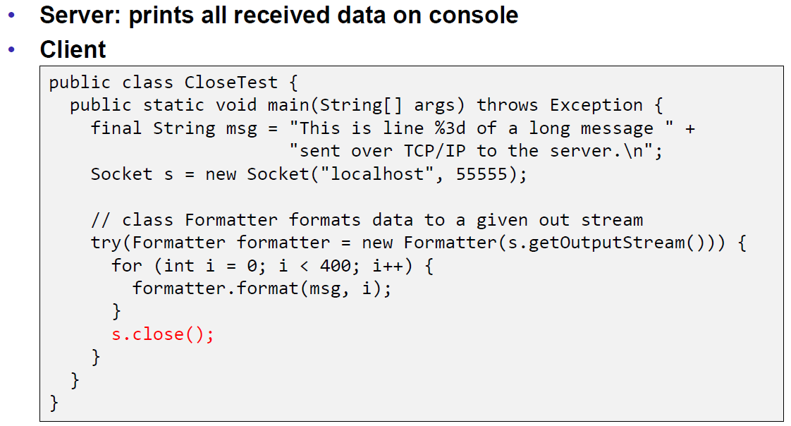

Problem: Some content of the formatter is not received by the server.

Solution: Flush the formatter before you close the socket, otherwise the buffer of the formatter won’t be sent.

### Example of a Compression Server

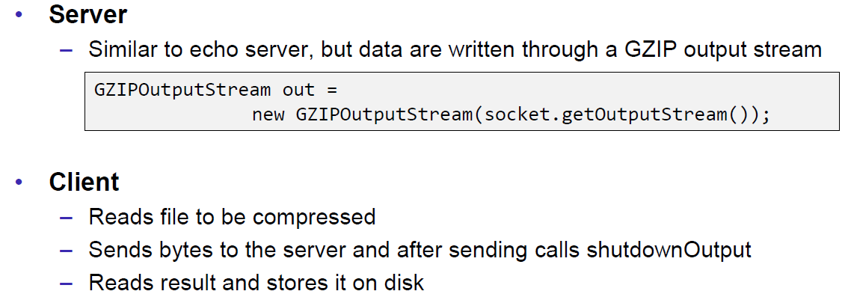

Problem: At some point, the server hangs up and doesn’t reply anymore.

Solution: Don’t send all content before you start reading. Otherwise you will fill up the outgoing (sending) cache of the server (because no one is reading it) and the write process of the server becomes blocking (this prevents a data loss because the outgoing buffer is full). A solution to this problem is to write and read block by block or to start the send process in a separate thread (Both happens in the client), so the client is able to immediately read the result and prevents a full sender buffer of the server.

## UDP Sockets

### UDP (User Datagram Protocol)

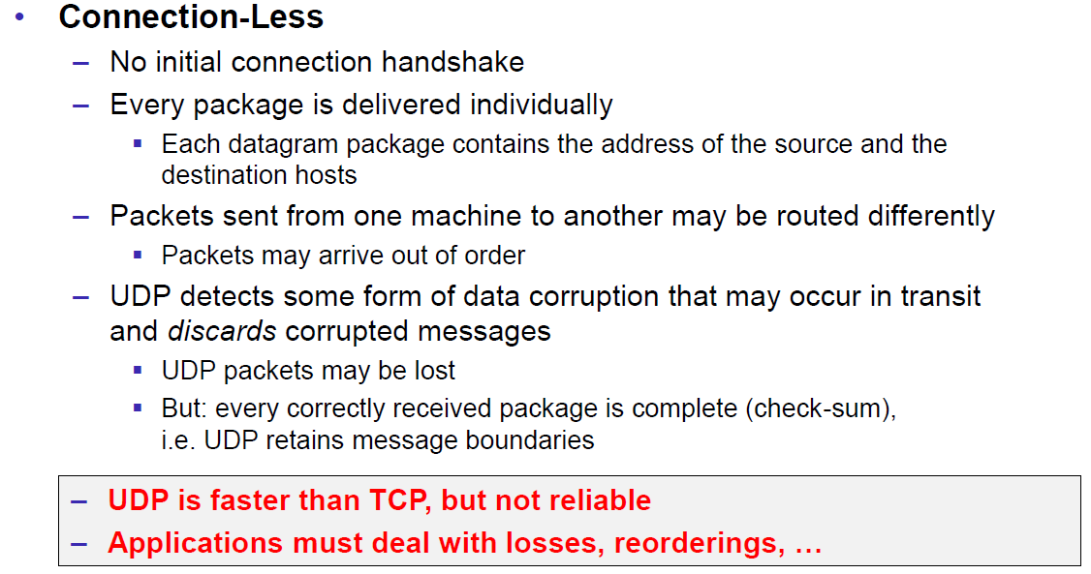

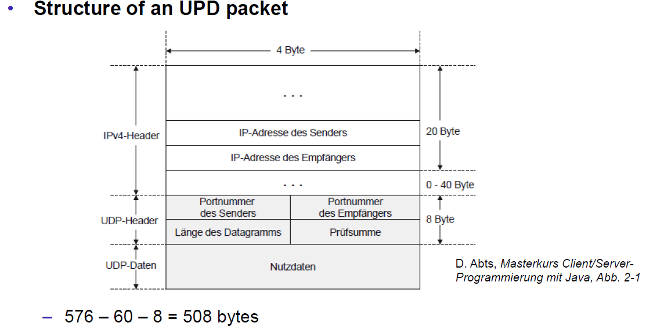

### Java Classes for Datagram

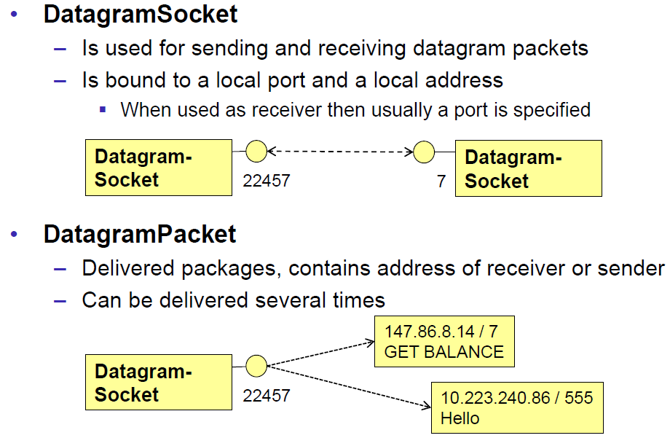

### DatagramSocket

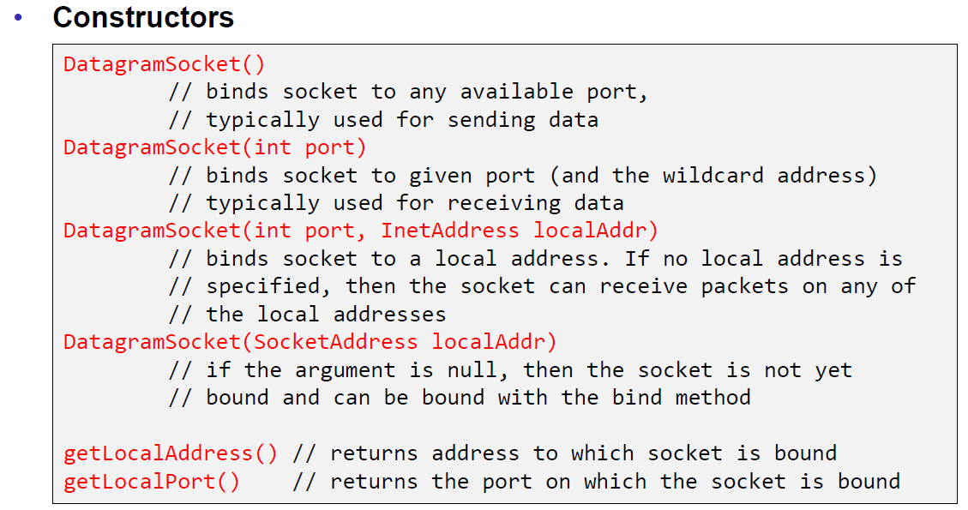

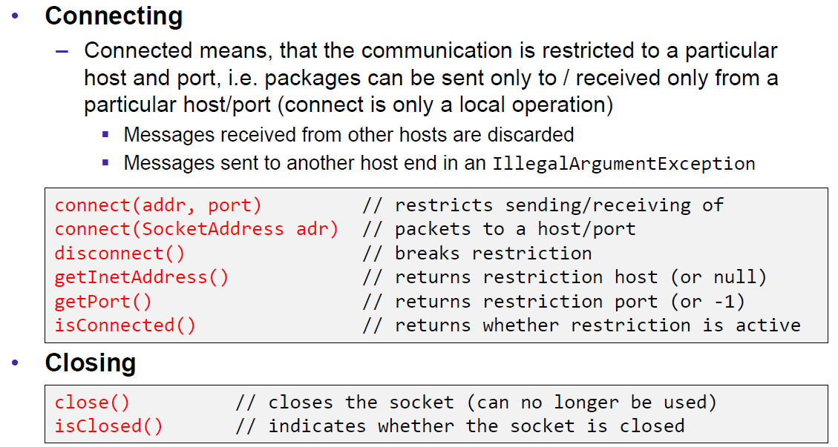

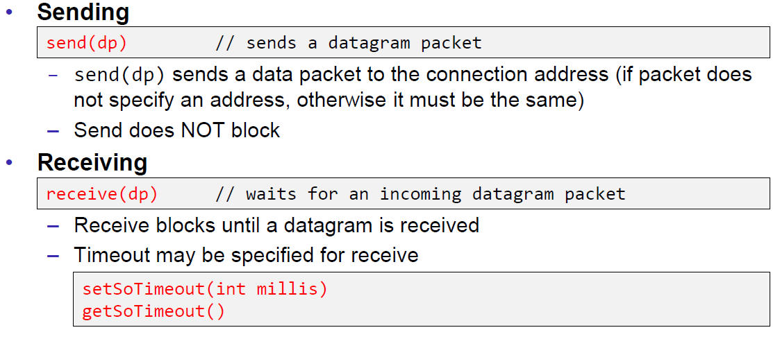

### DatagramPacket

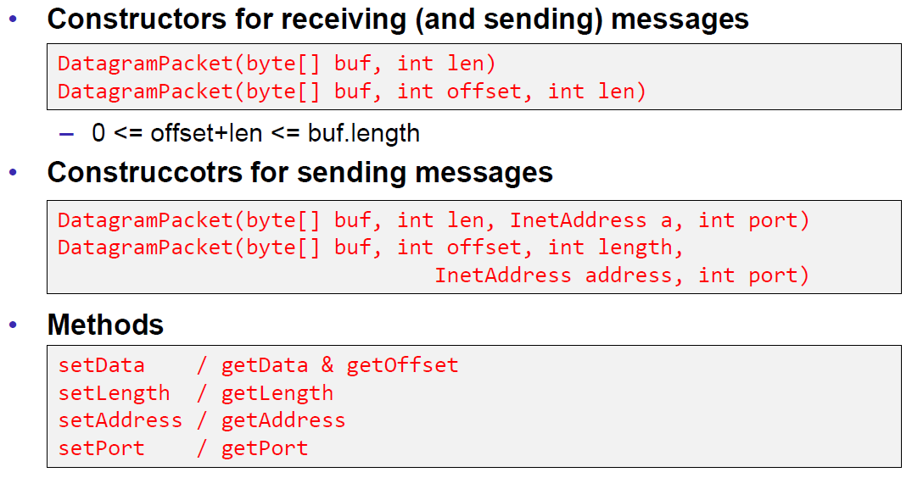

### Example of a UDP Server and Client

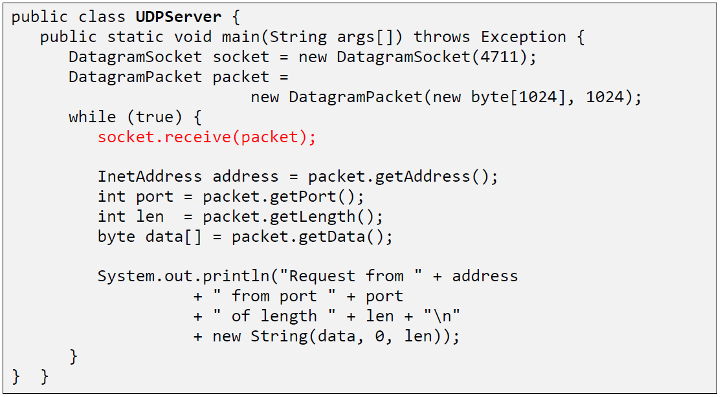

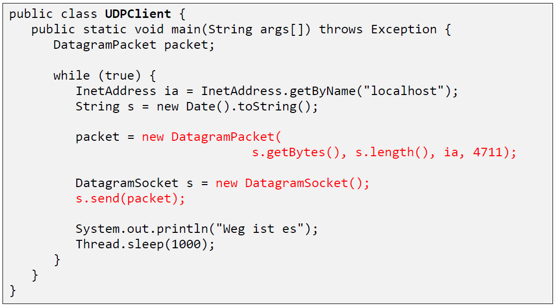

### UDP Implementation

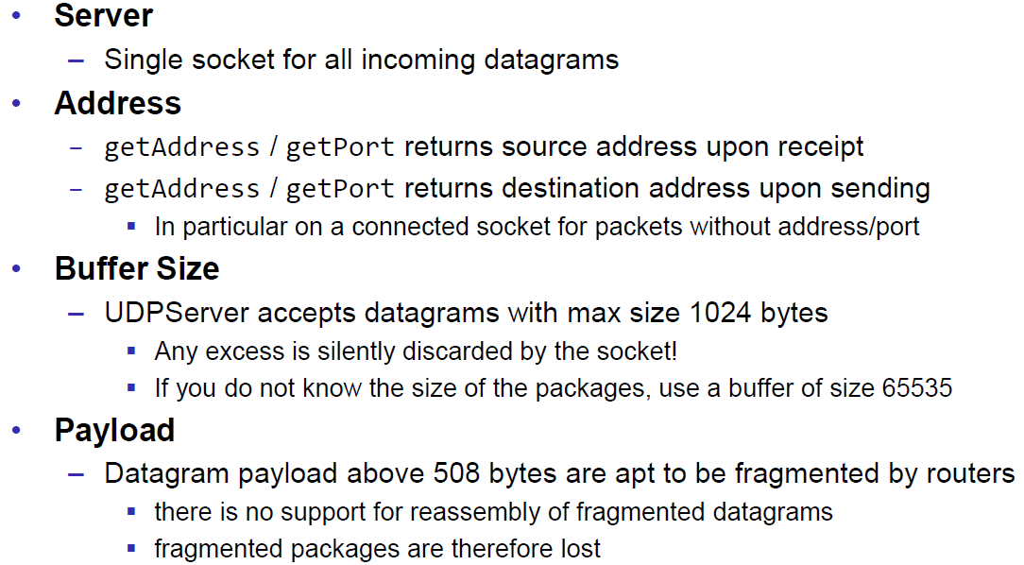

### Reliable UDP

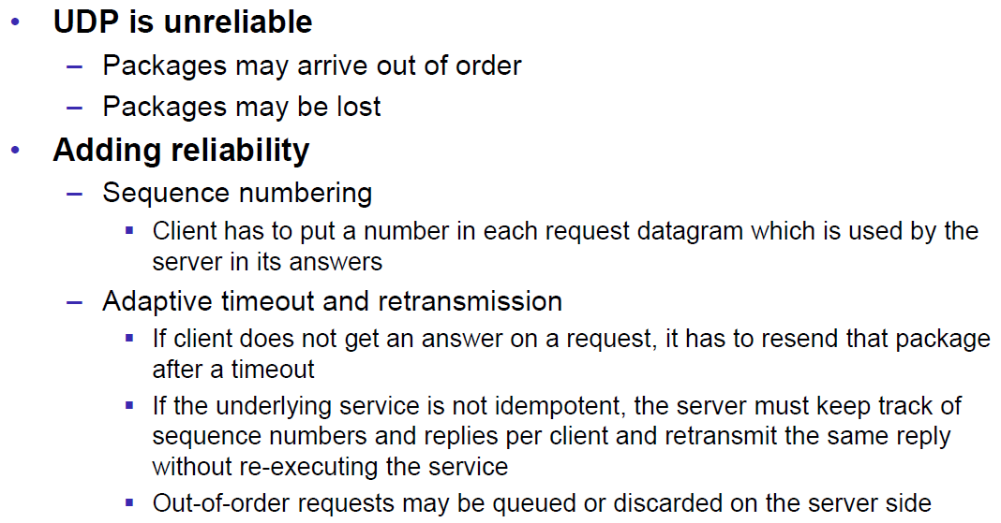

# Woche 3

## HTTP Protocol

### IETF RFC

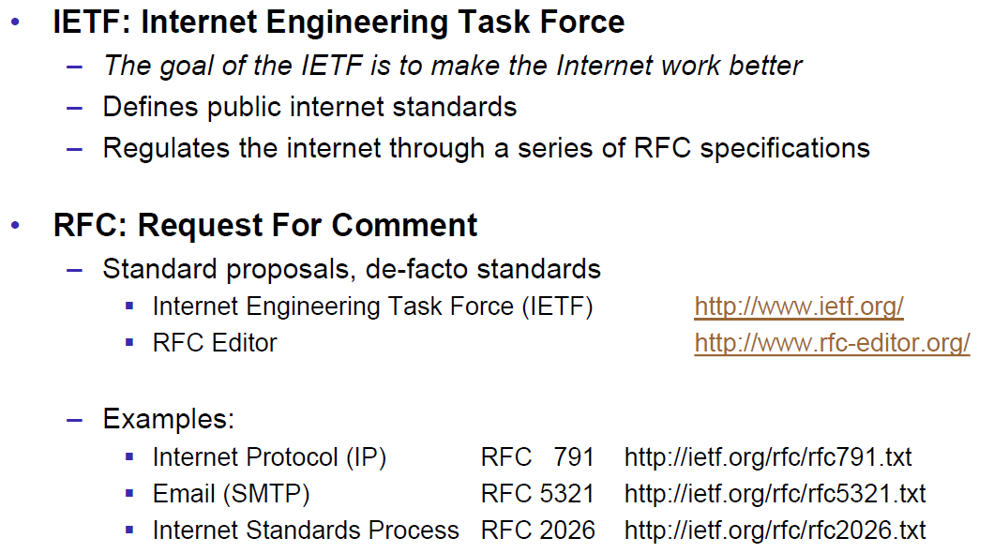

### HTTP Protocol

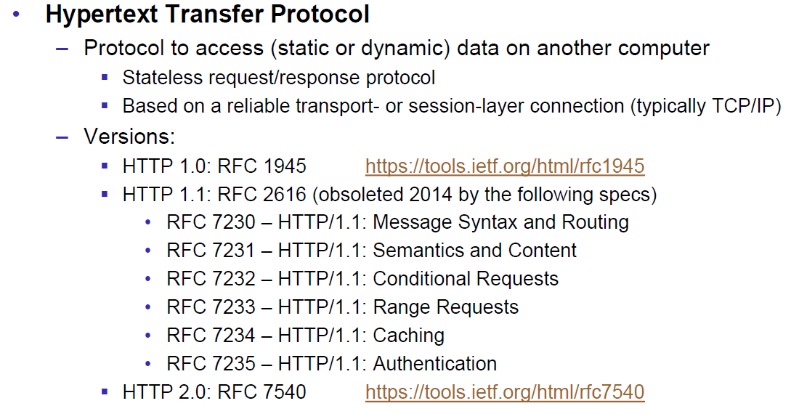

### HTTP Request

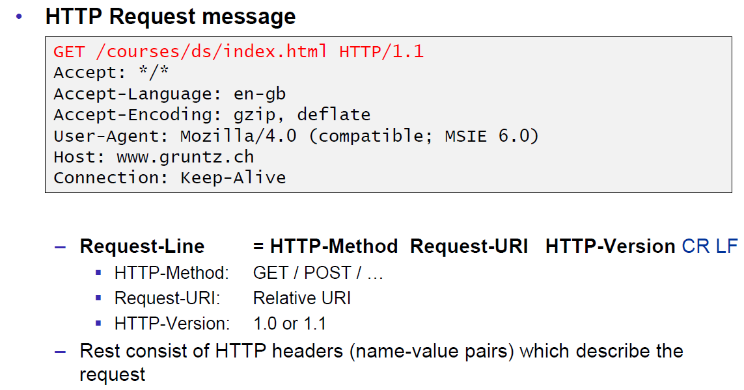

### HTTP Response

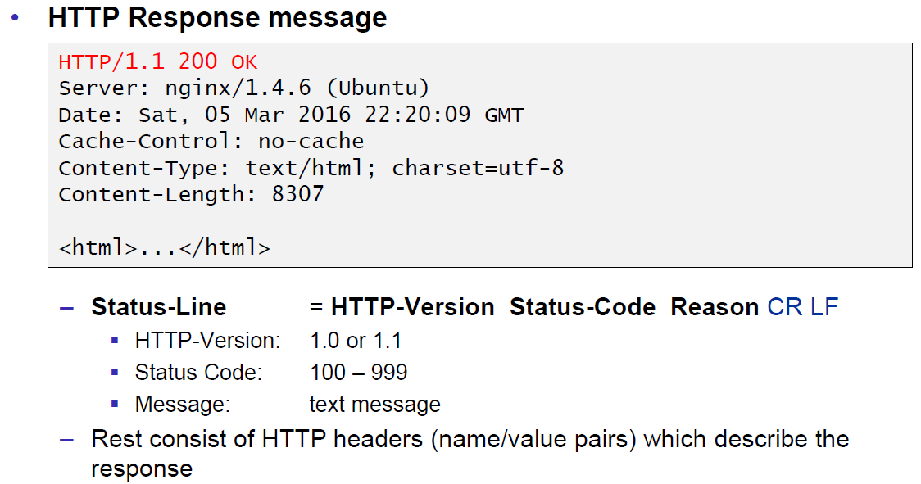

### HTTP Protocol

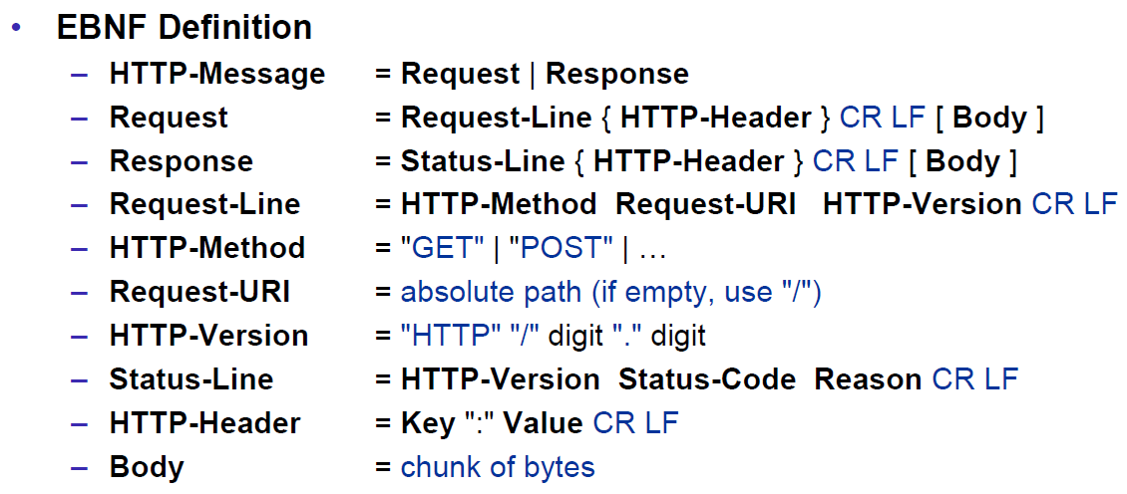

### HTTP Sample

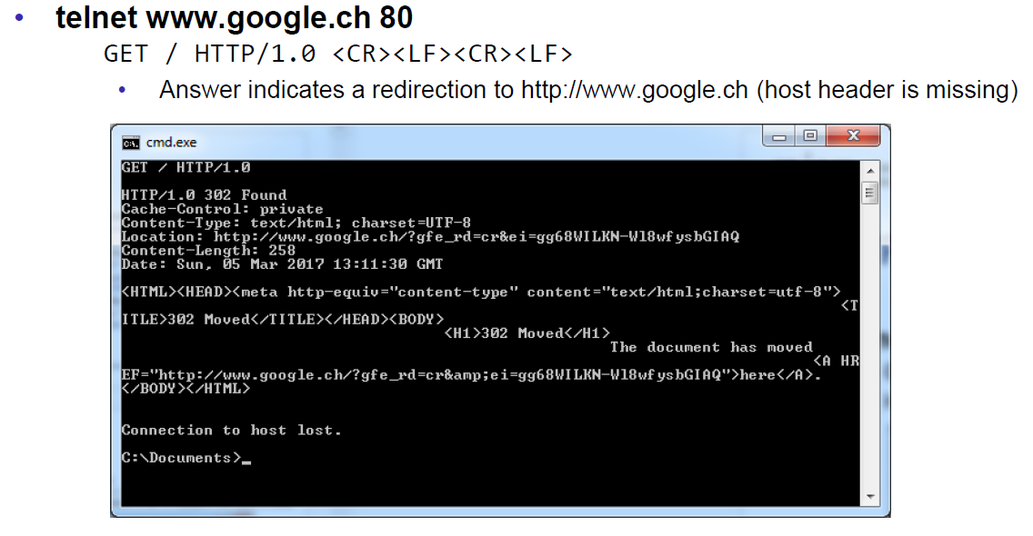

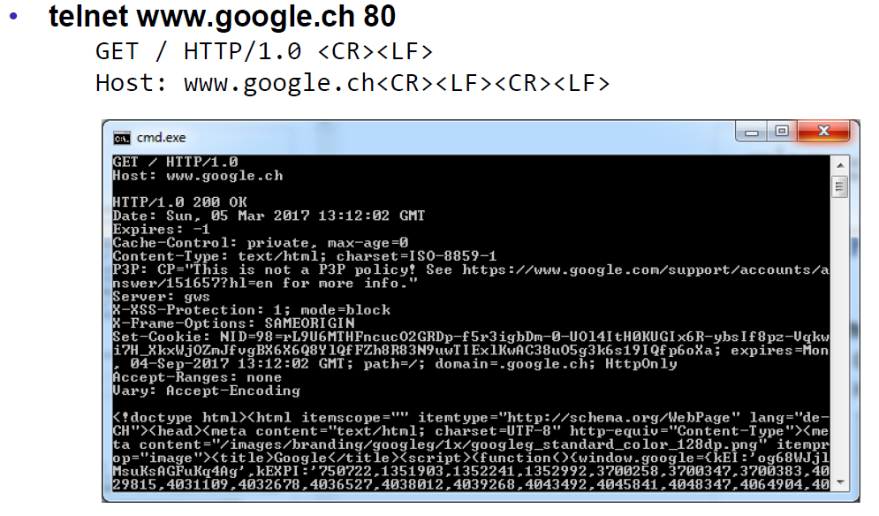

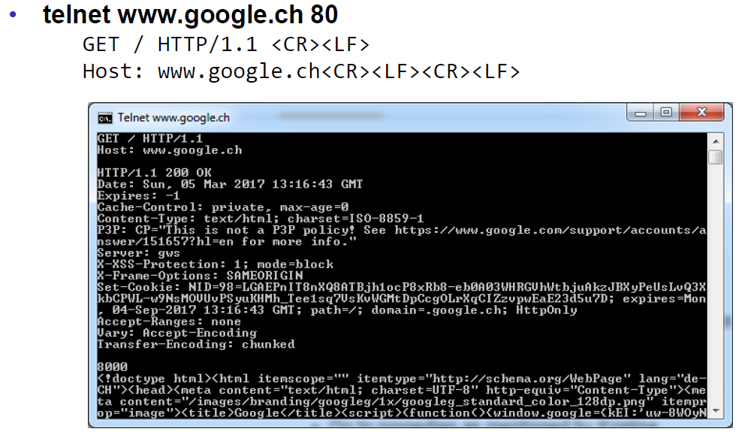

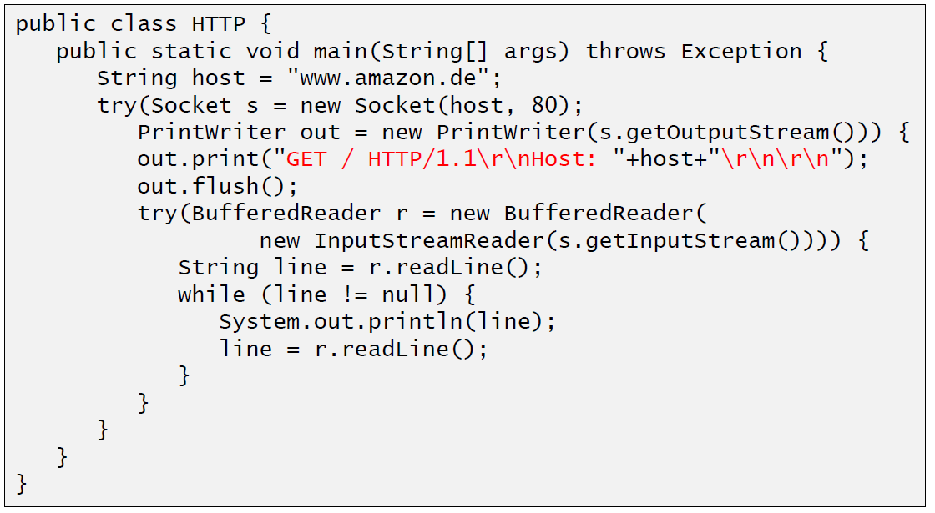

### HTTP 1.0 Request Methods

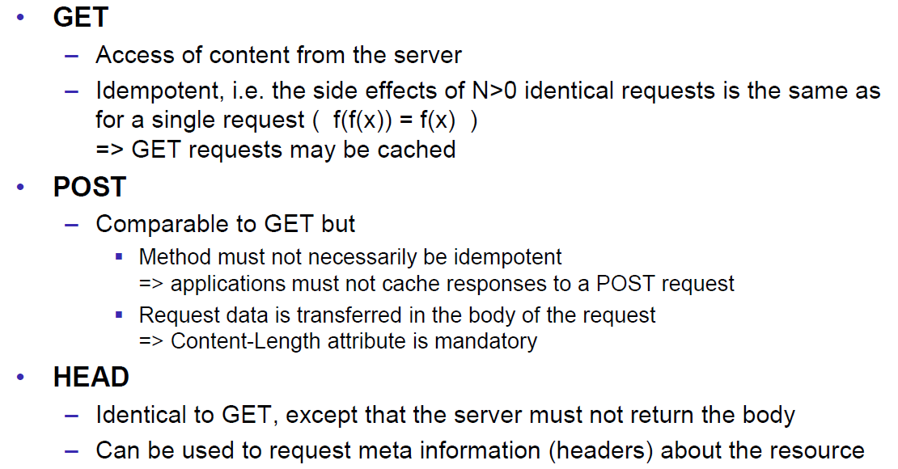

### HTTP Response Codes

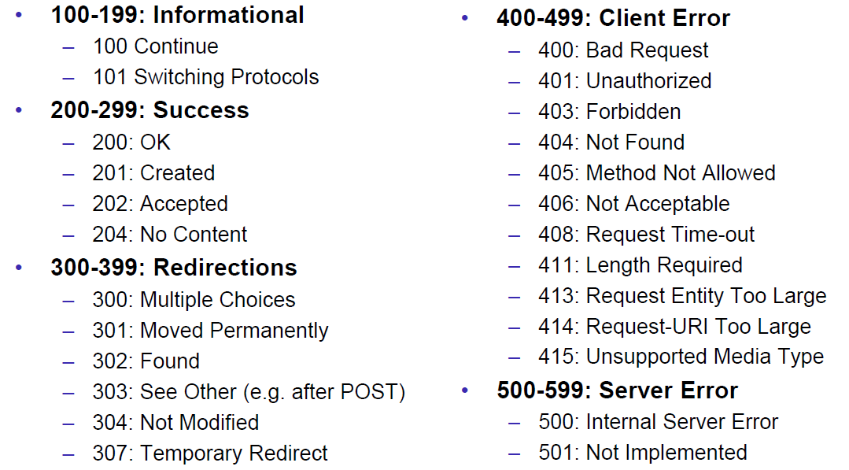

### HTTP Request Headers

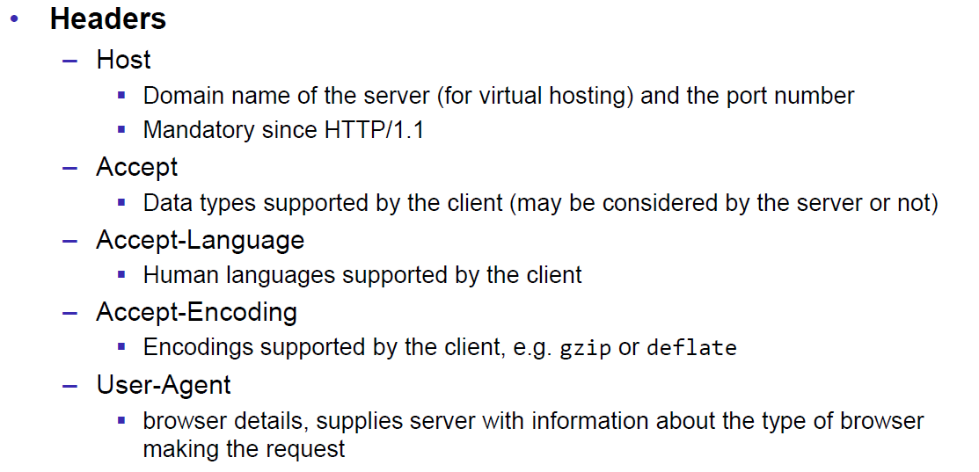

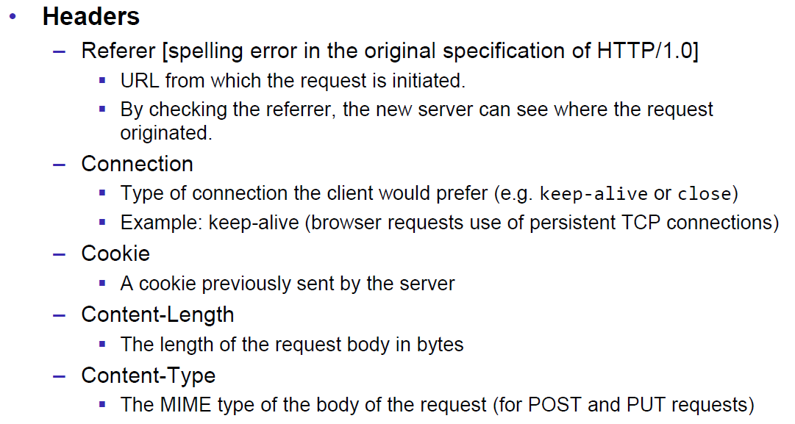

### HTTP Response Headers

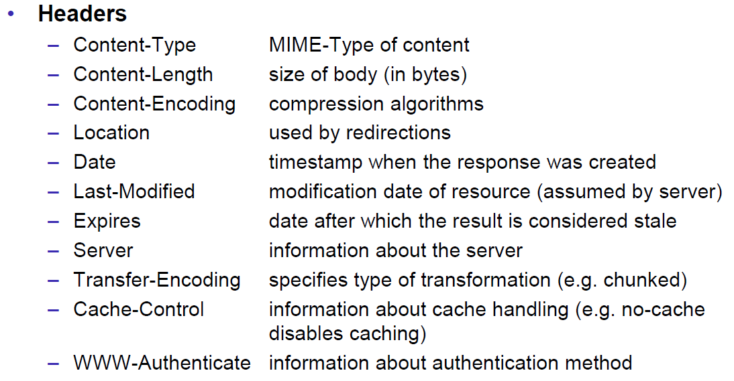

### MIME Types

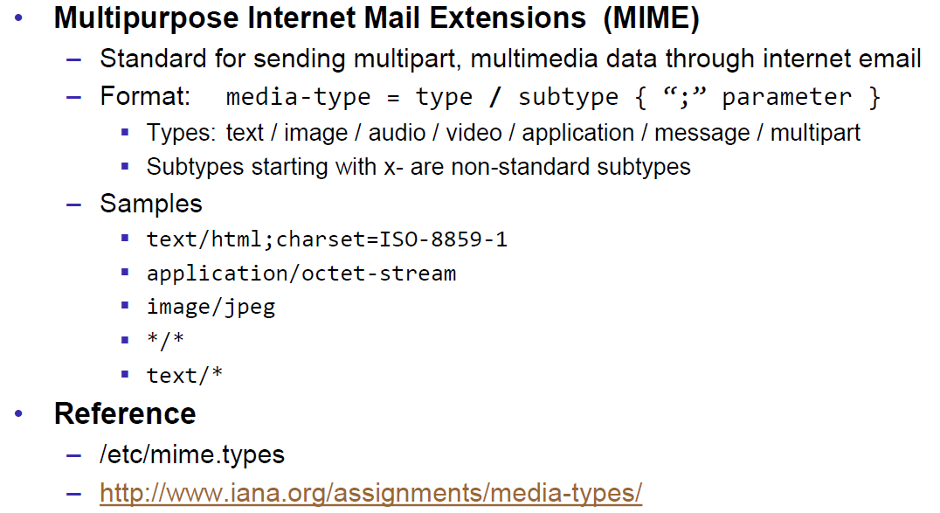

### HTTP Request/Response Sample

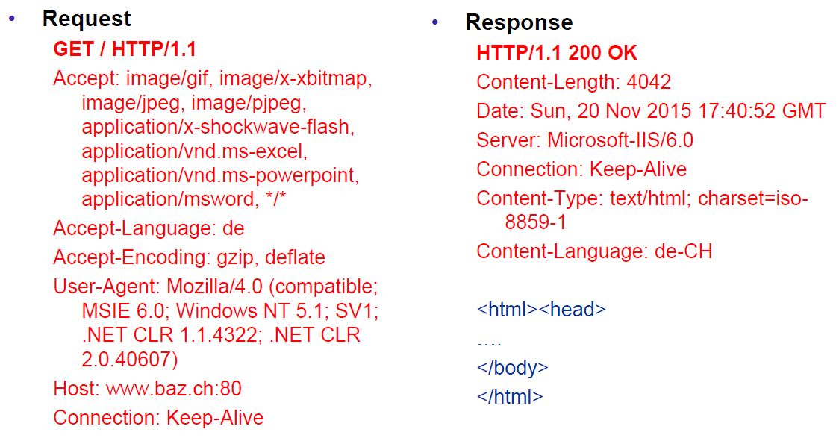

### HTTP 1.1 Enhancements

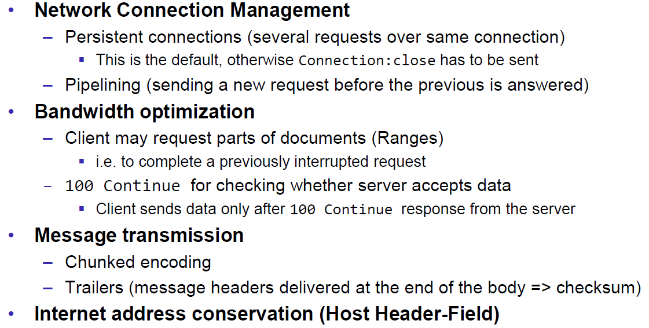

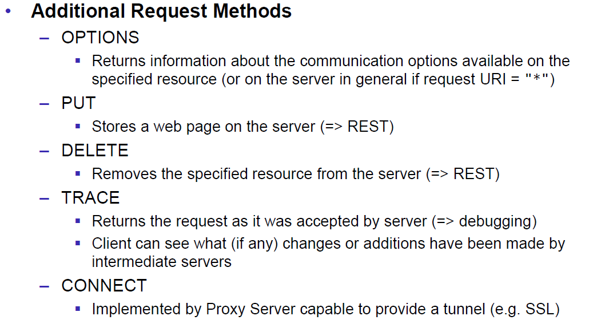

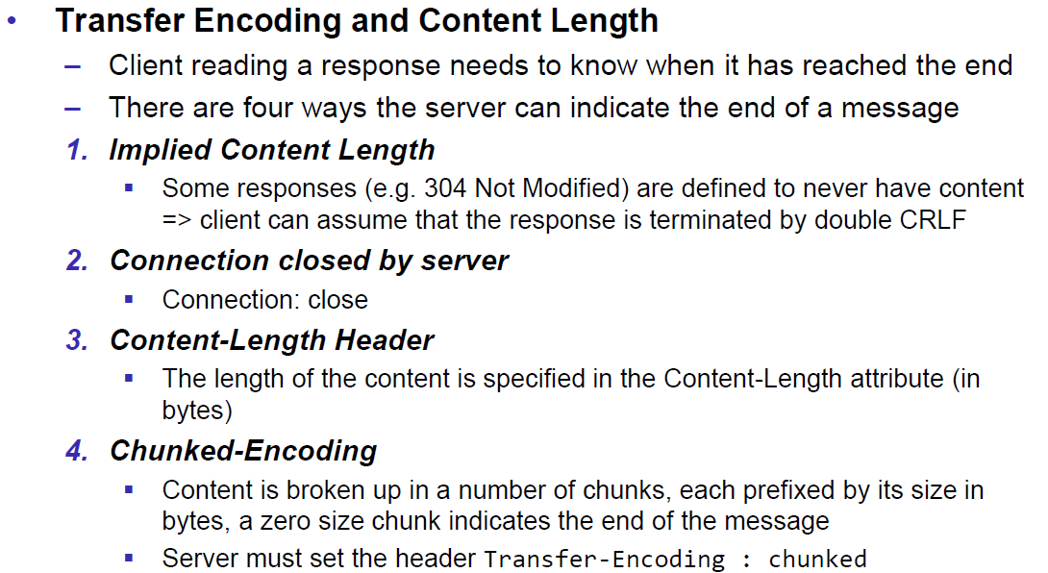

## HTTP Web Server

### A simple Web Server

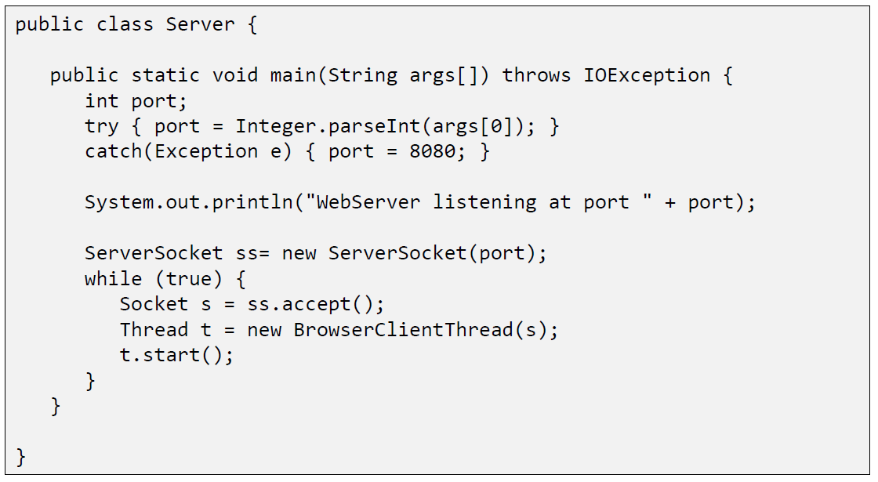

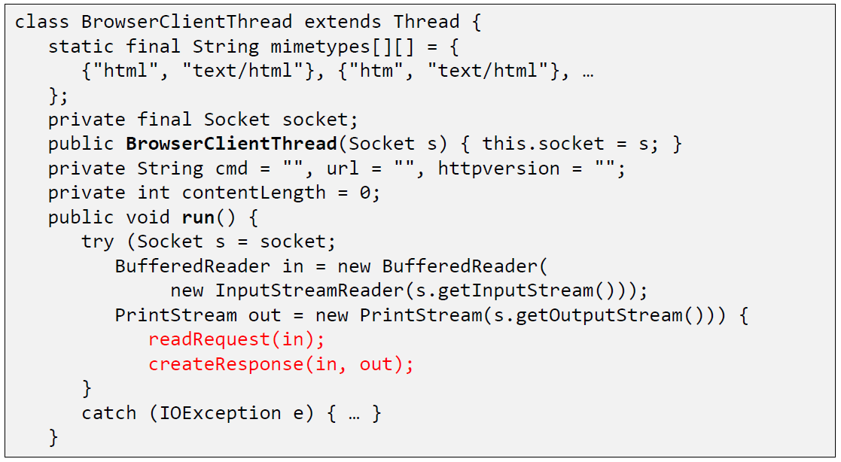

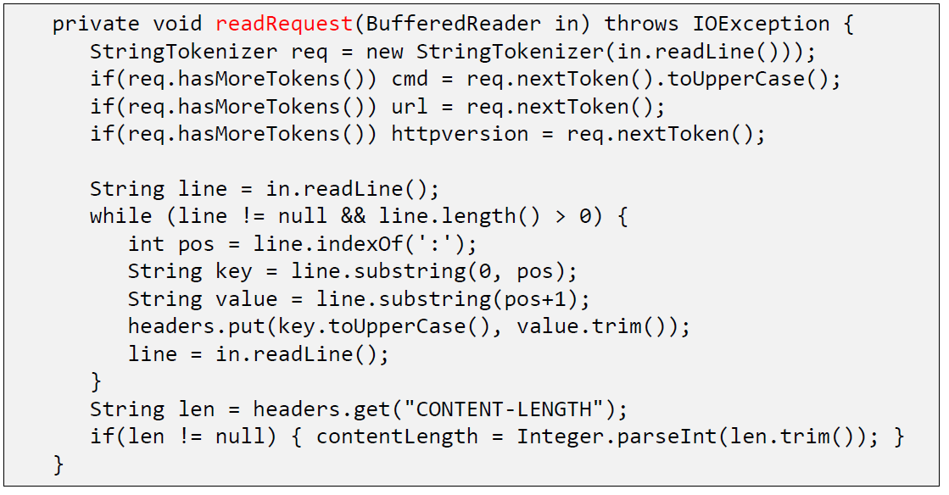

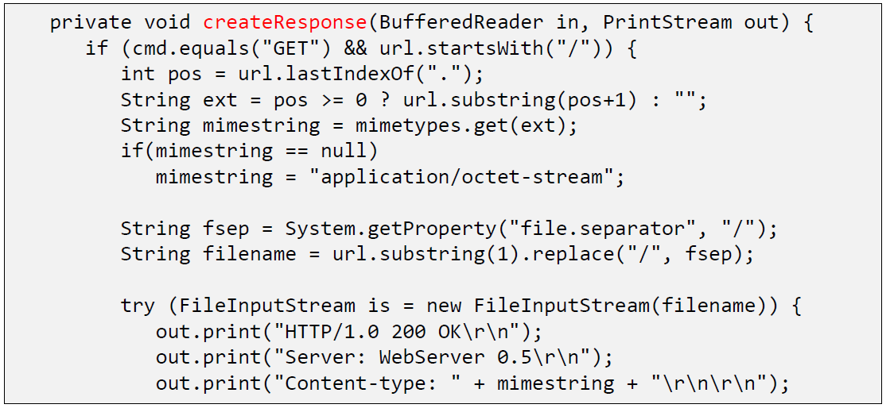

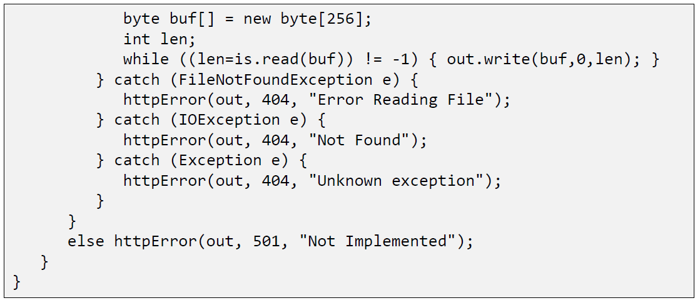

### Java internal Web Server

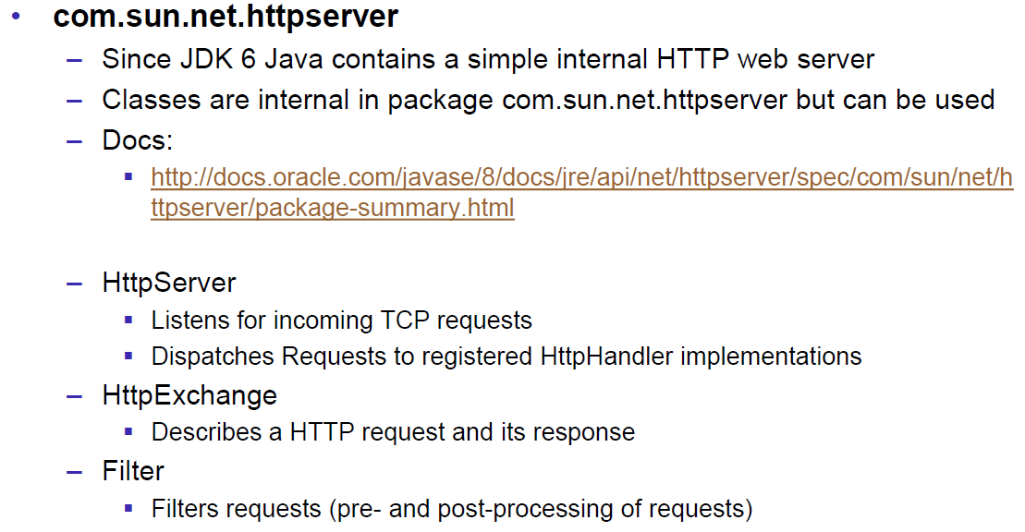

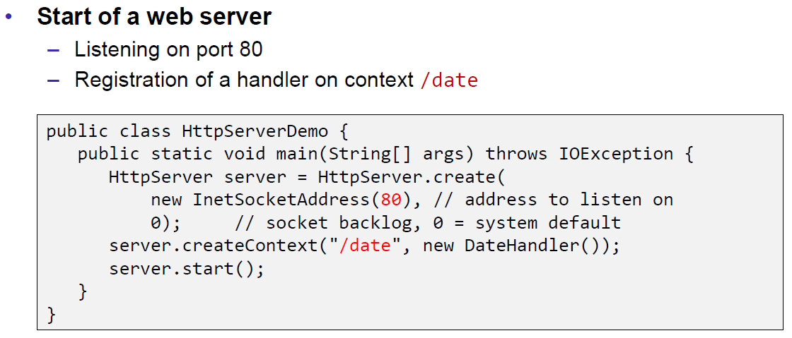

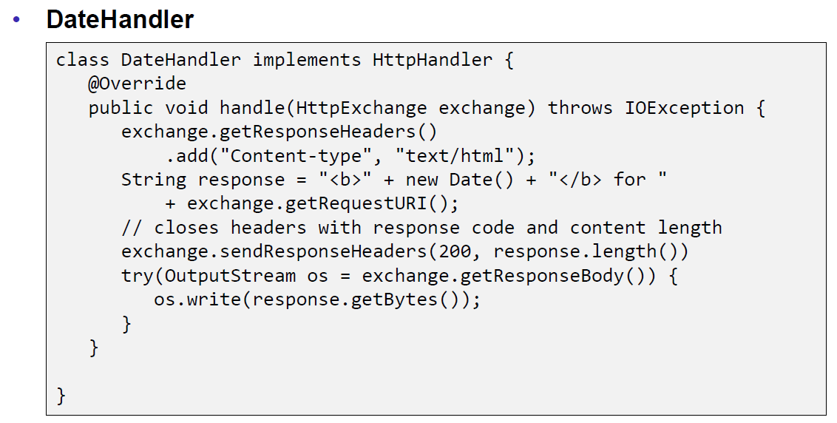

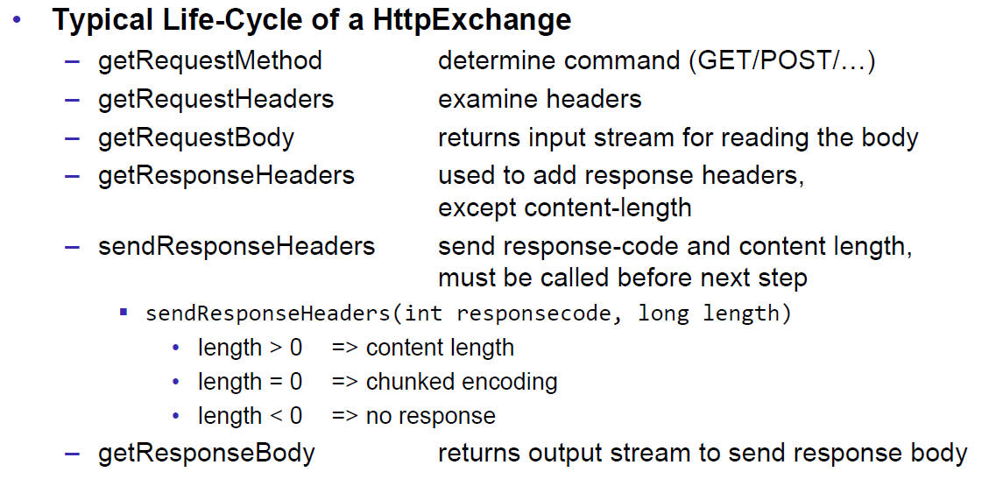

## HTML Forms & URL Encoding

### HTML GET Form

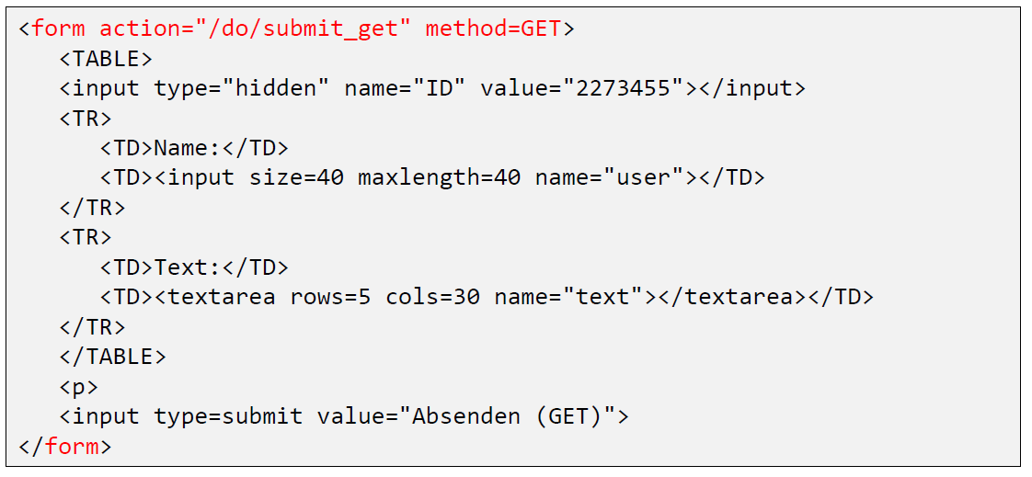

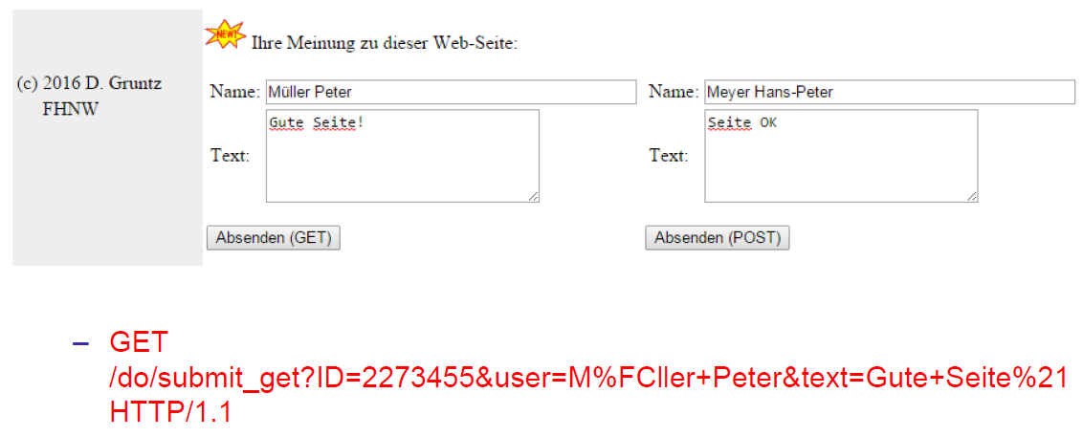

### URL Encoding

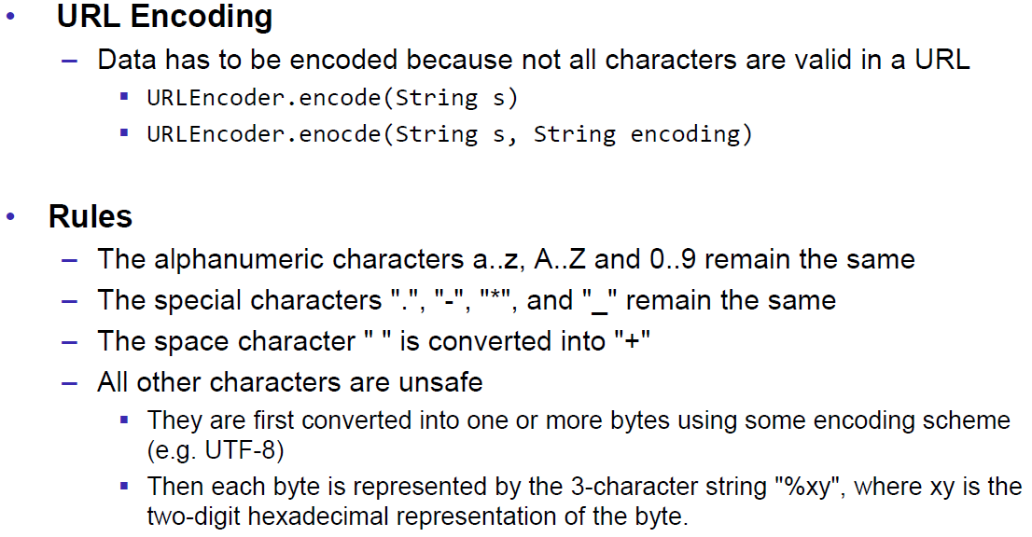

### HTML POST Form

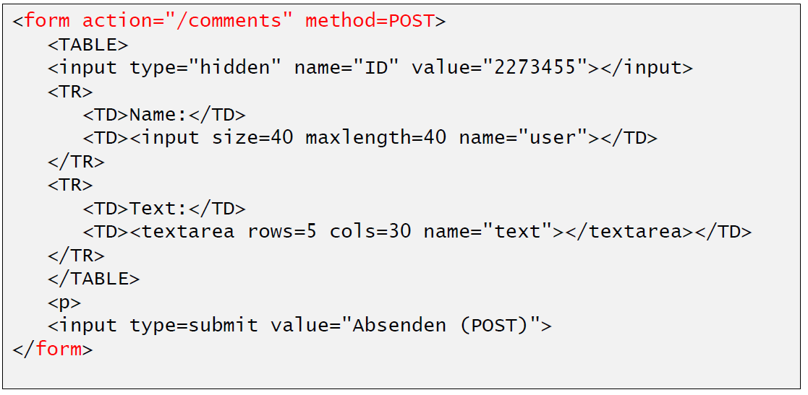

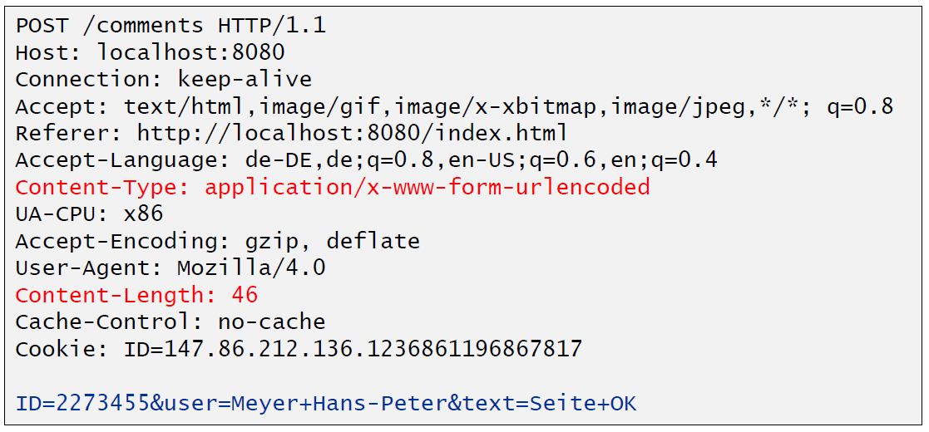

## HTTP Requests from Java

### URL

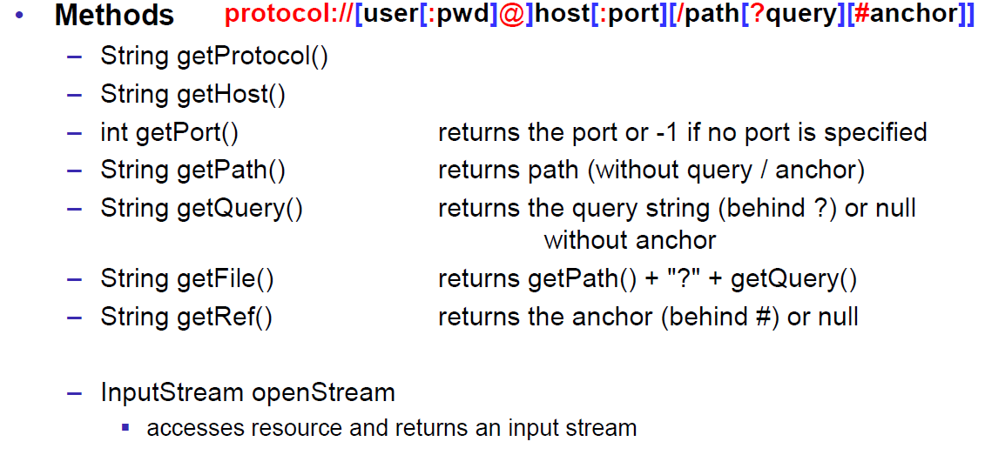

### Sending GET Requests from within Java

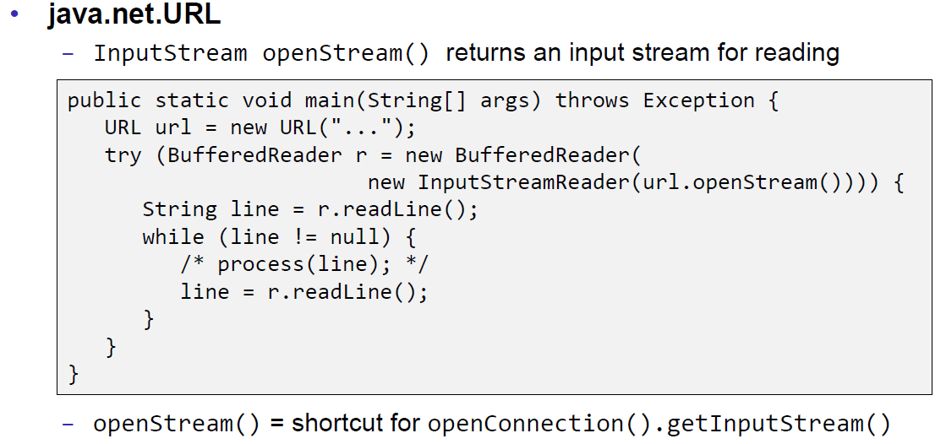

### URLConnection

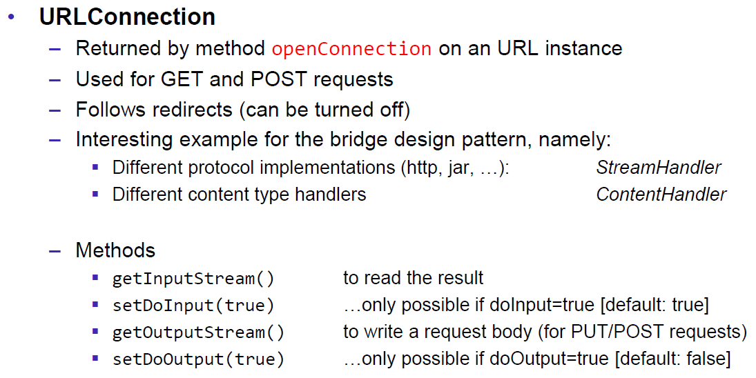

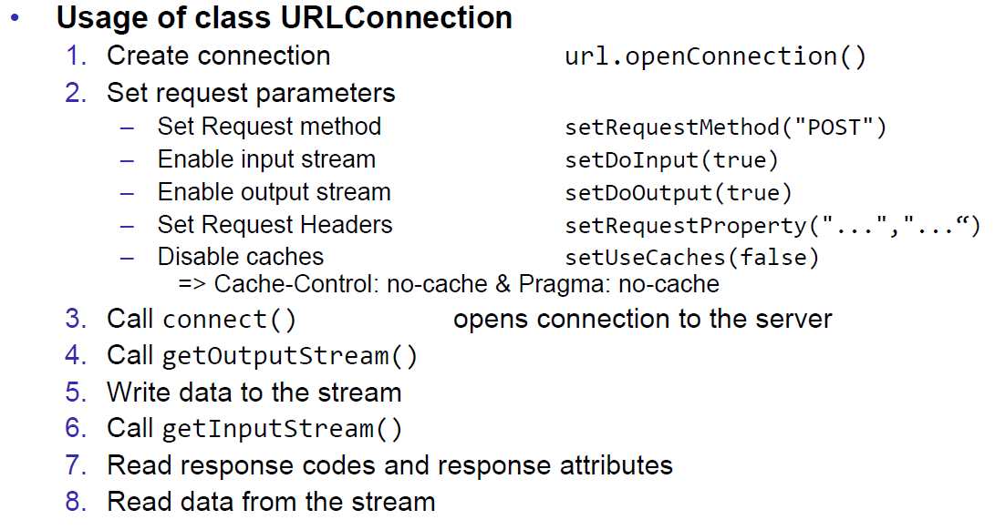

### URLConnection Tips & Tricks

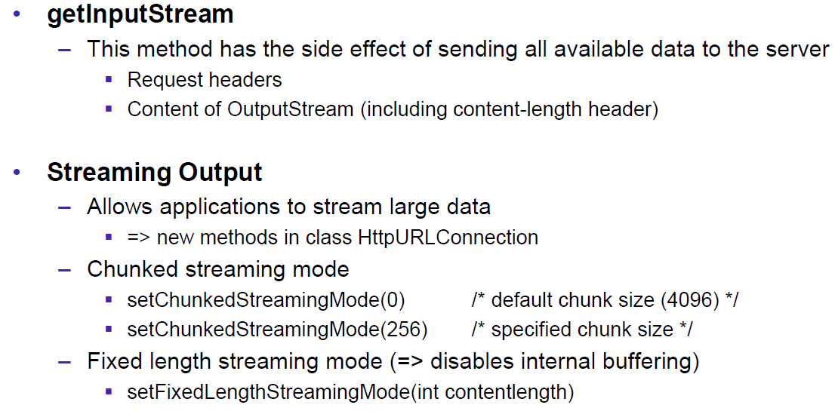

### Sample 1: URLConnection GET

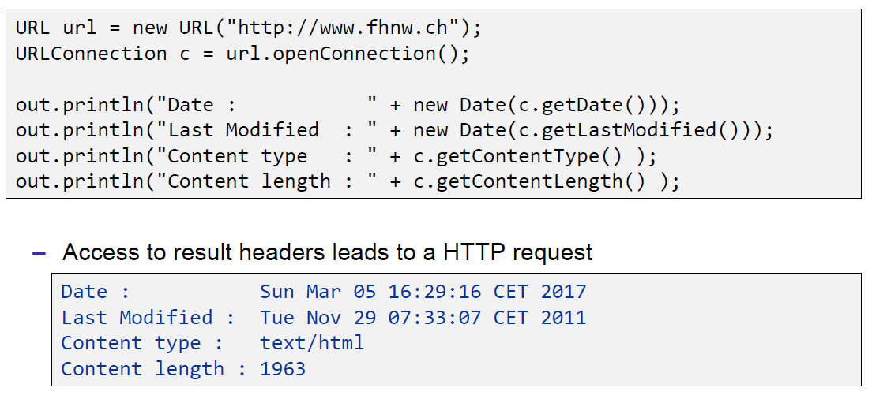

### Sample 2: URLConnection POST

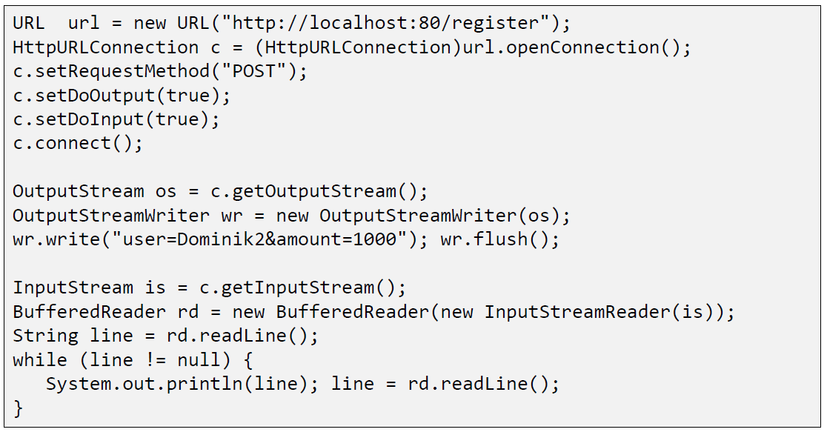

### Sample 3: Currency Converter

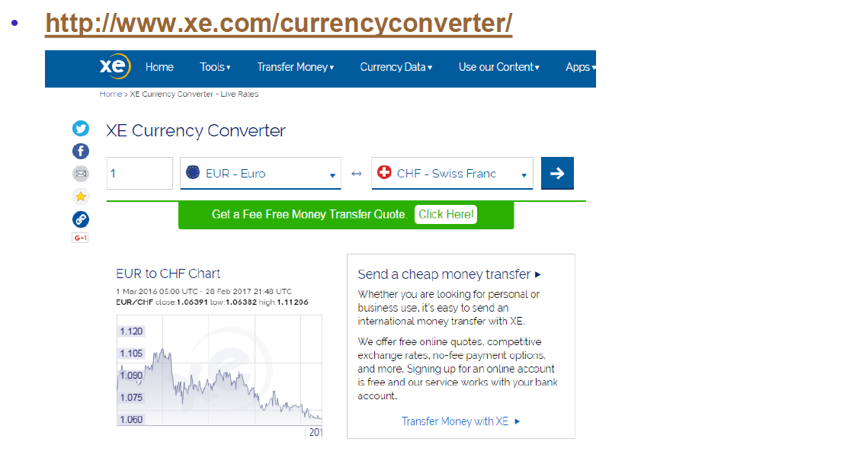

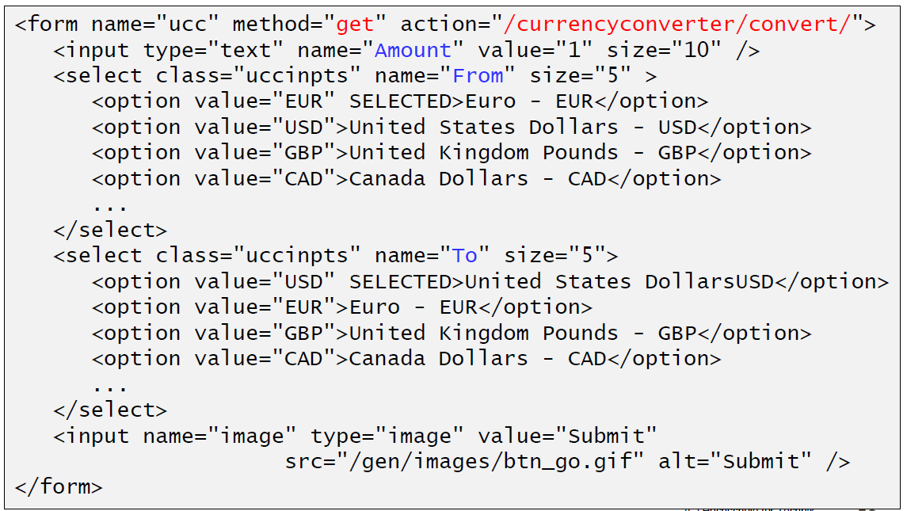

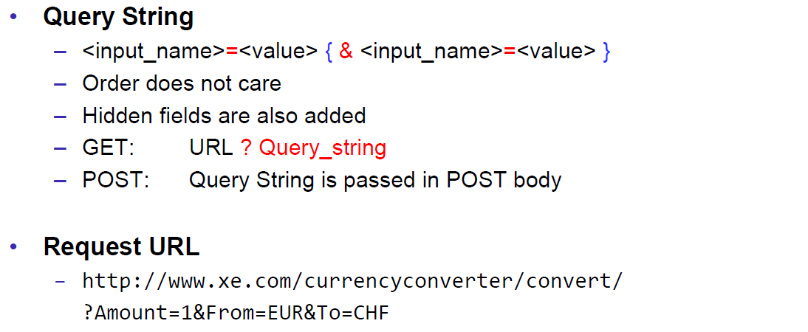

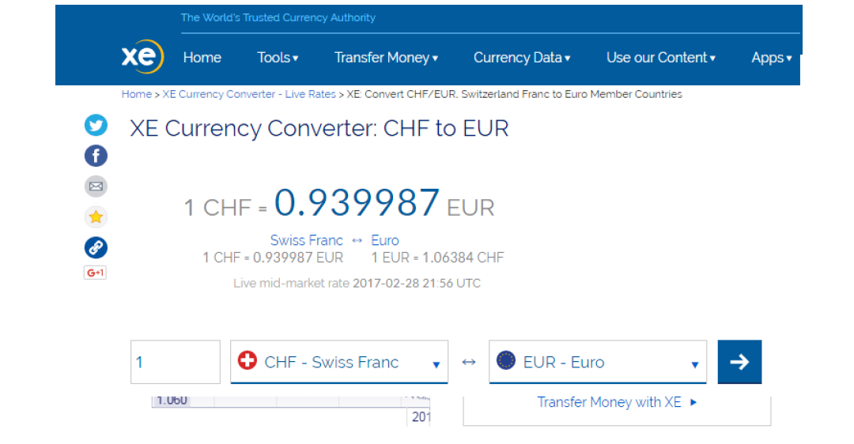

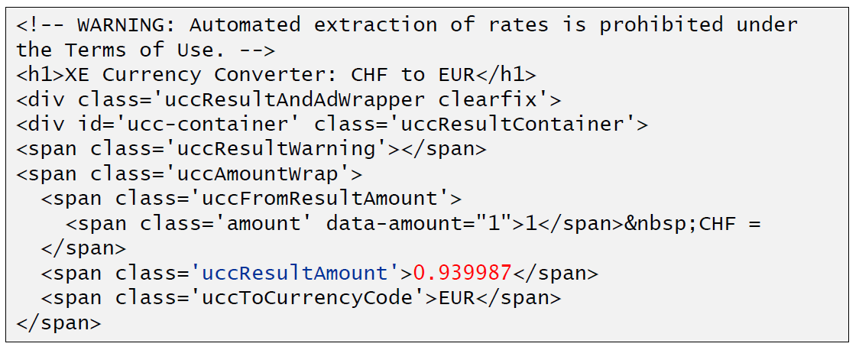

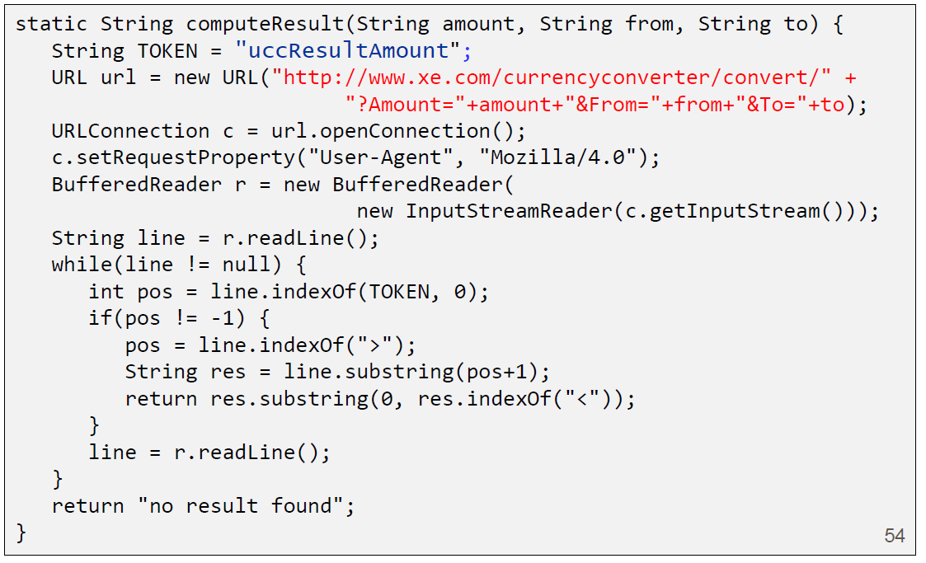

### Other Libraries

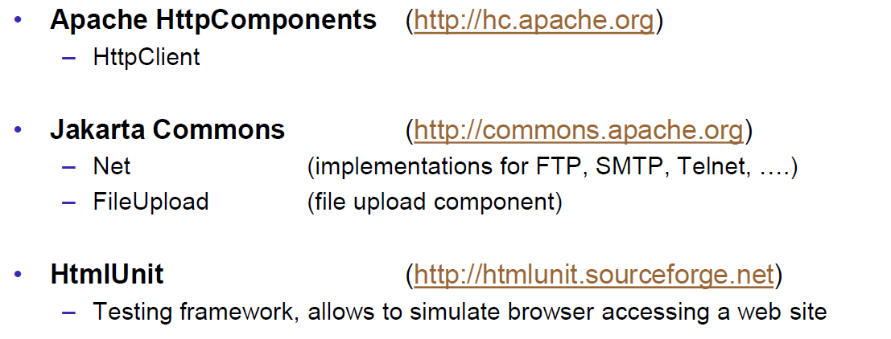

# Woche 4

## Servlets

### Dynamic Content

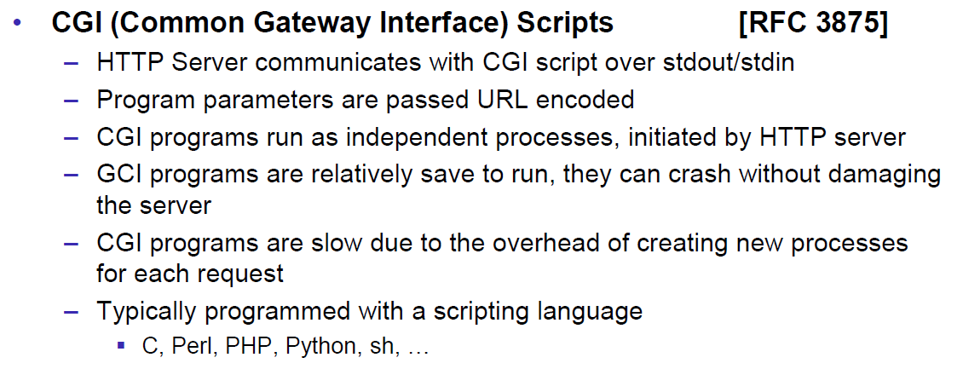

### Servlets

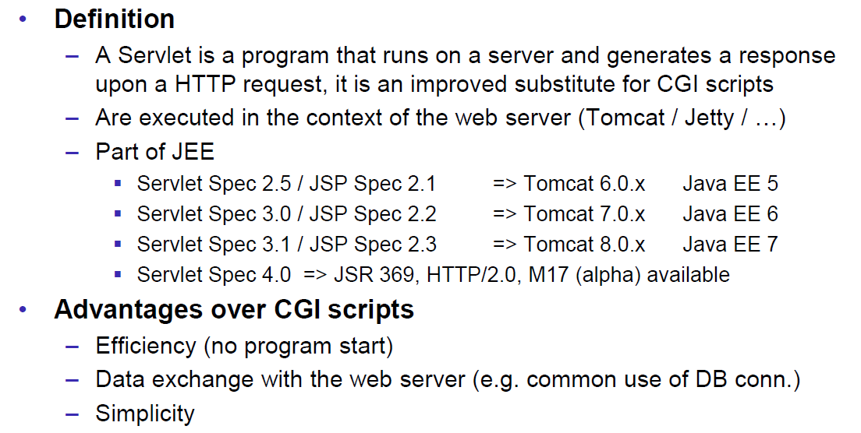

### Servlet Packages

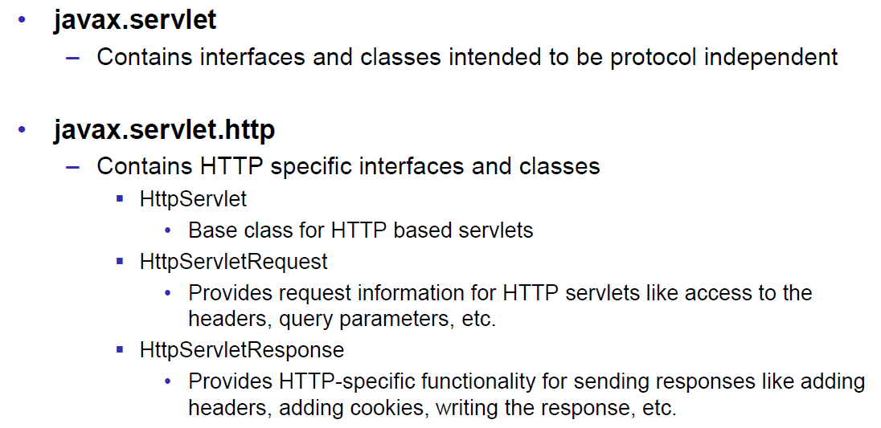

### Servlet Life-Cycle Methods

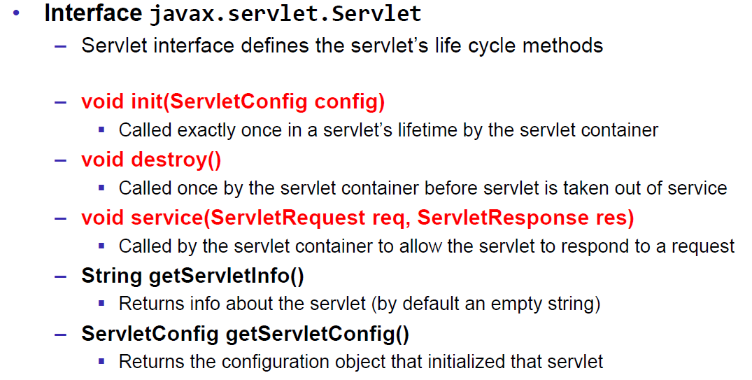

### HttpServlet

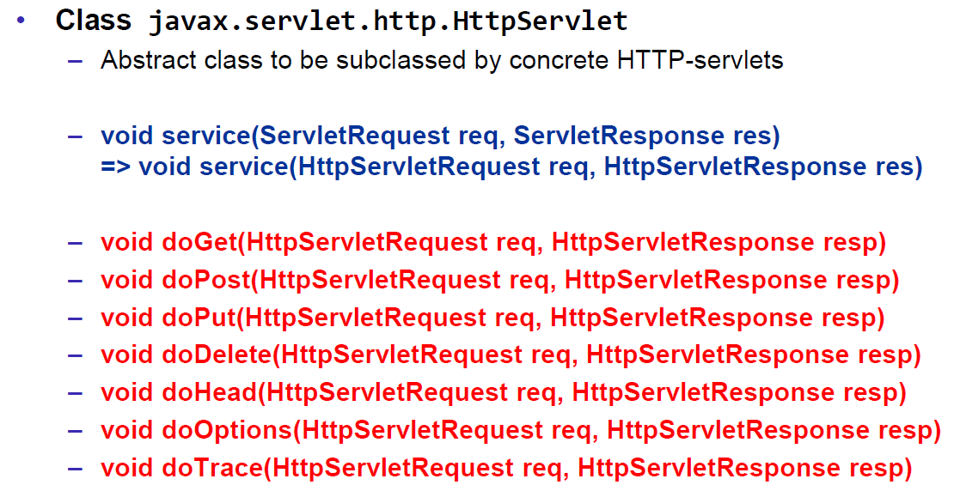

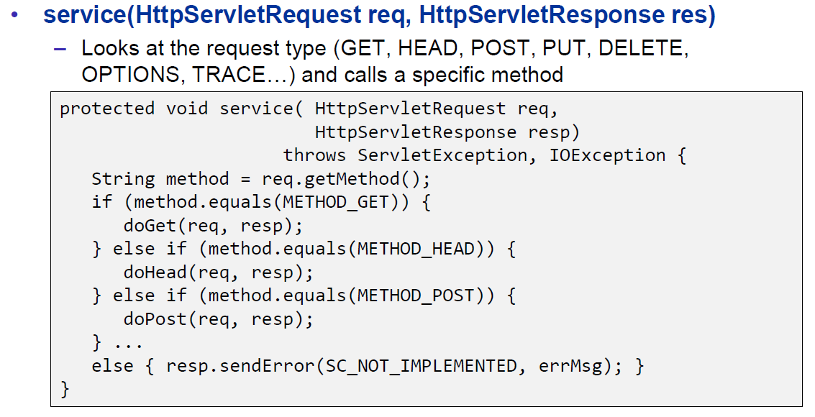

### HttpServletRequest

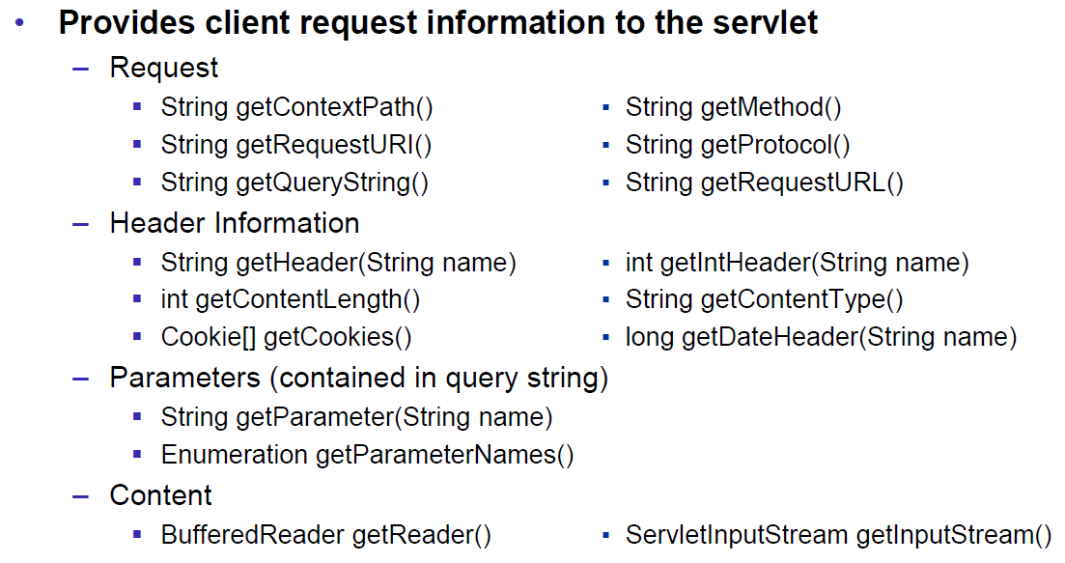

### HttpServletResponse

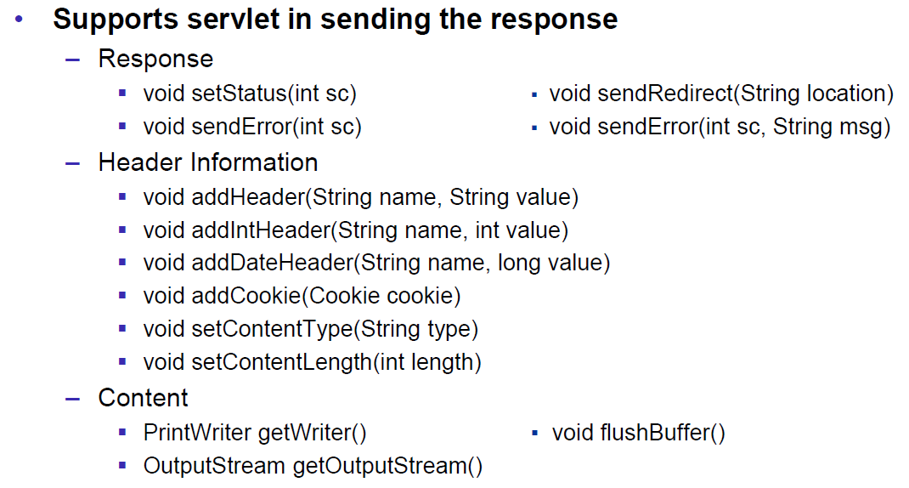

### Servlet Example

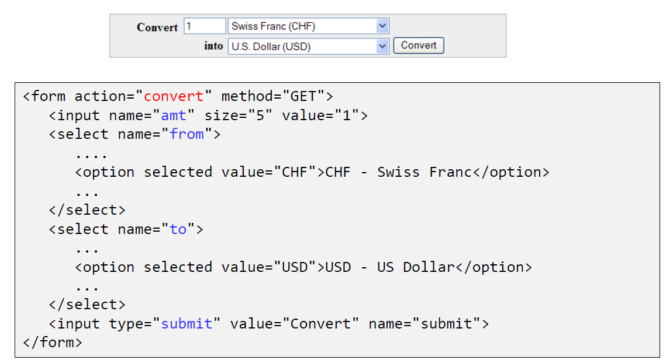

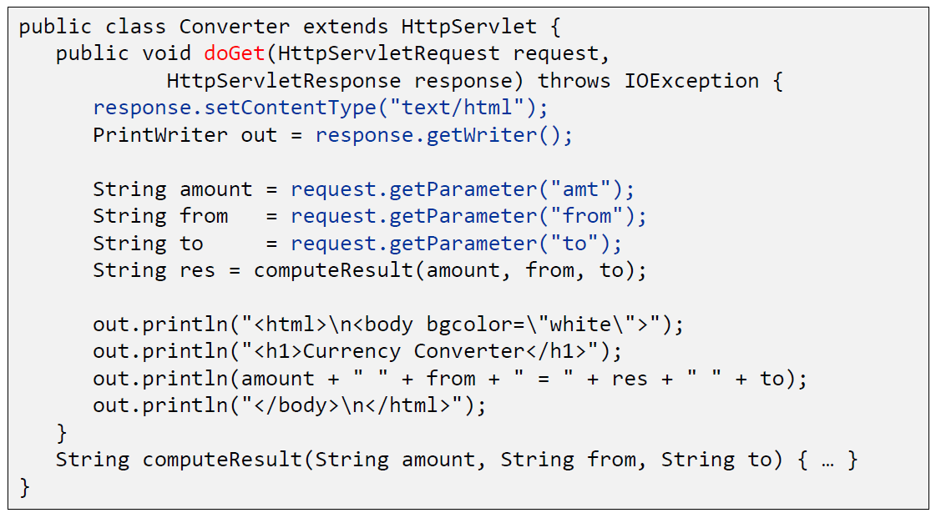

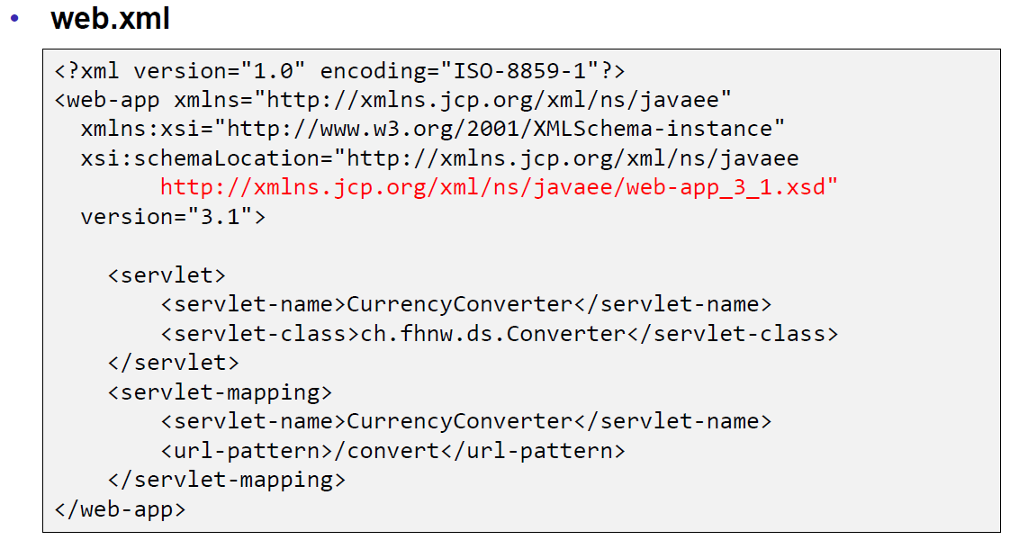

### Webapplication Structure

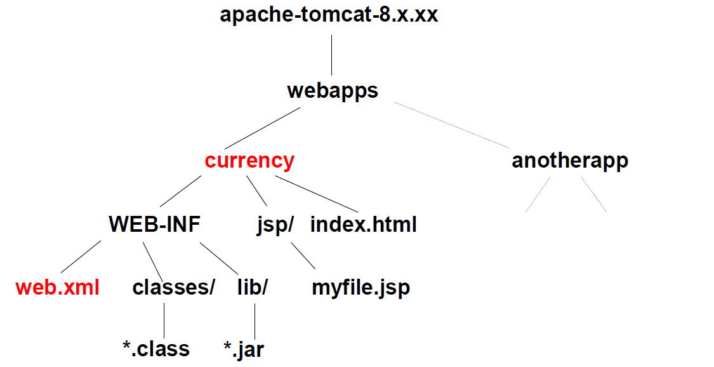

### Annotation WebServlet

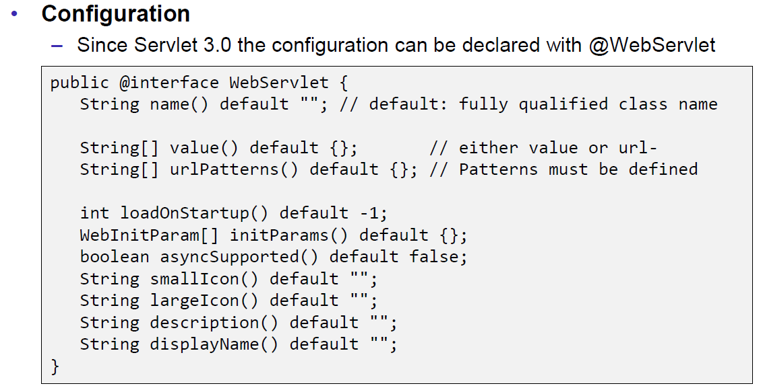

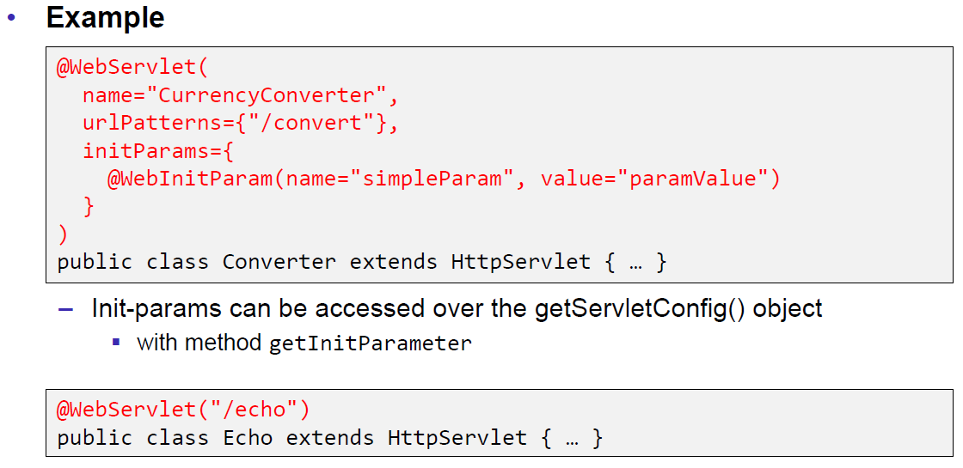

### Webapplication Structure

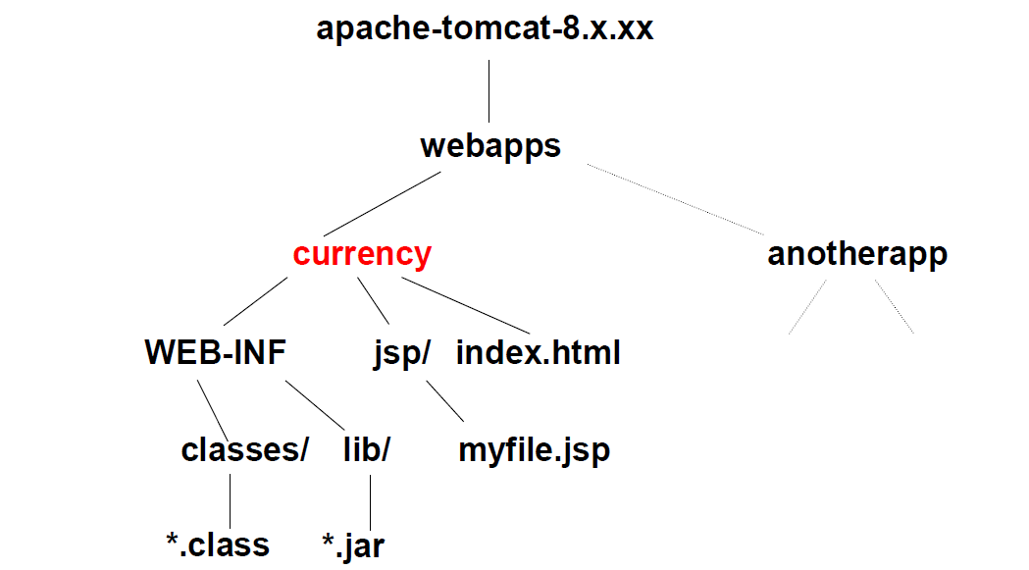

## Tomcat Servlet Server

### Tomcat

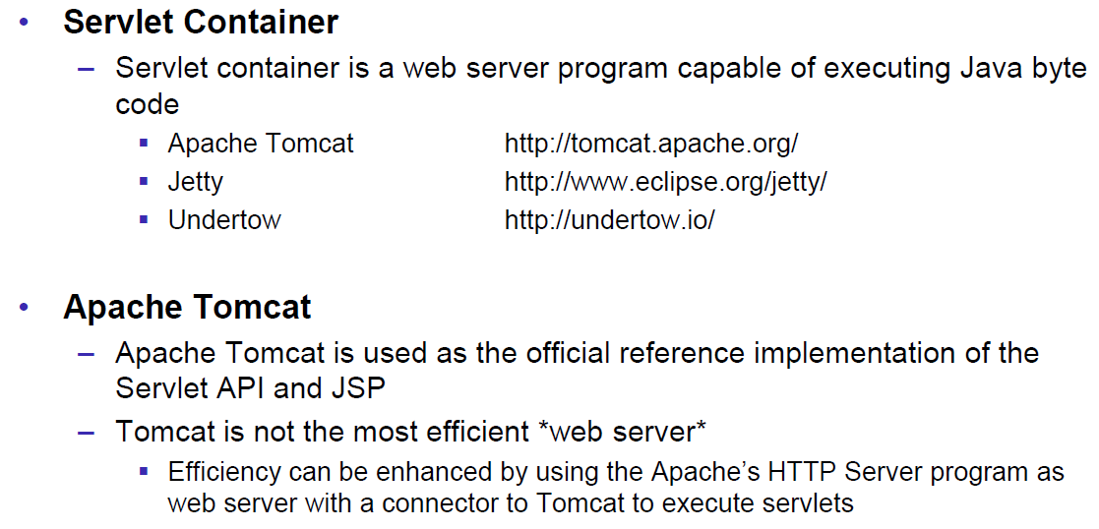

### Tomcat Directory Structure

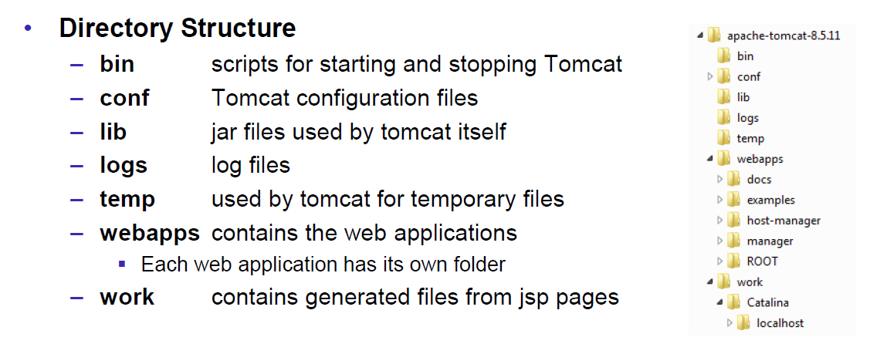

### Tomcat Scripts

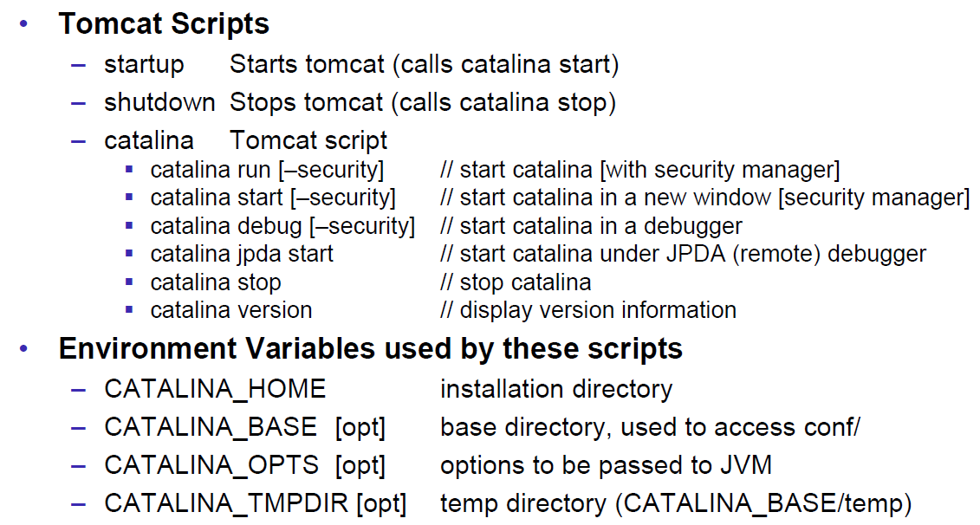

### Tomcat Startup Screen

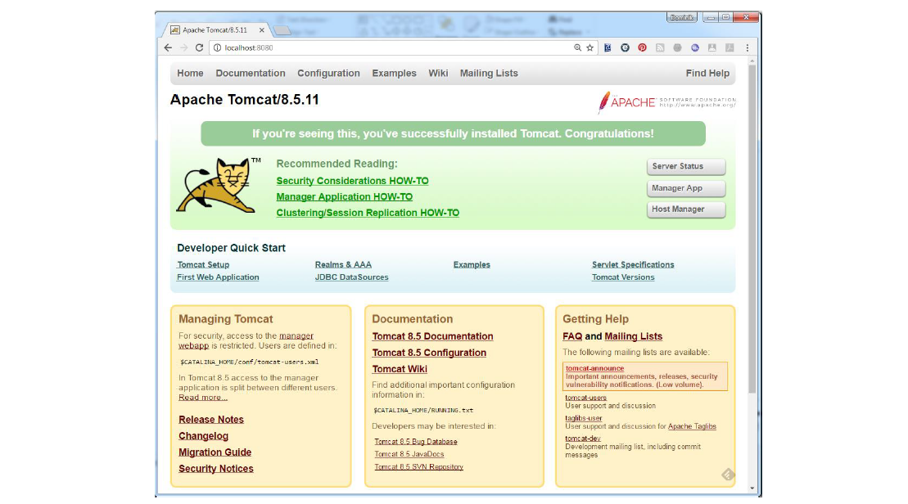

### Tomcat Managers

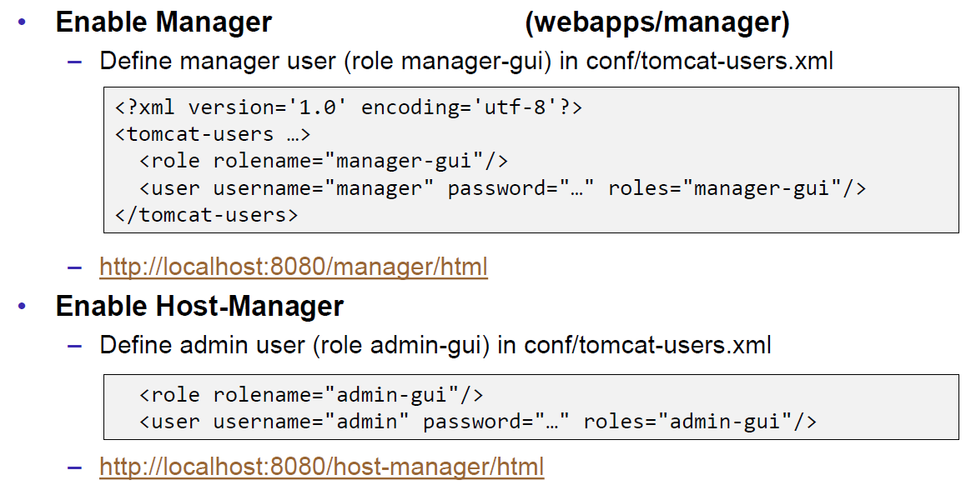

### Debugging

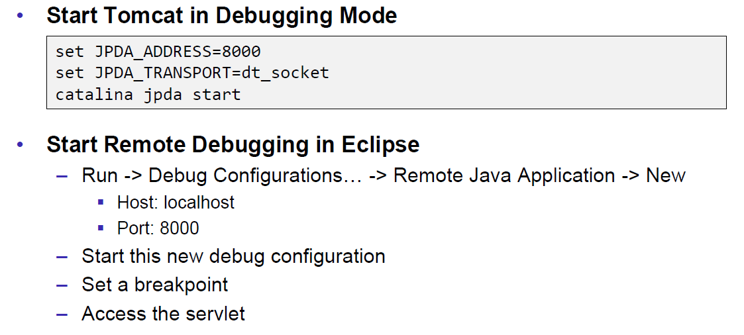

### Tomcat Architecture

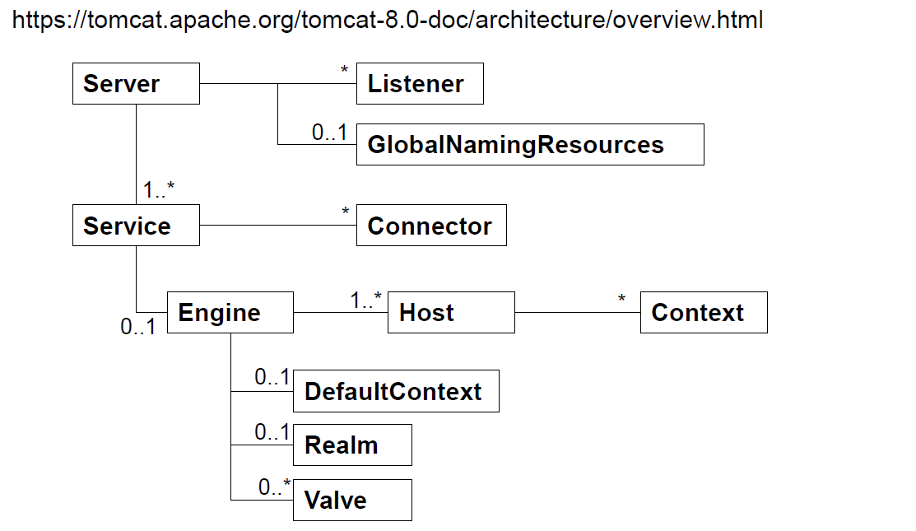

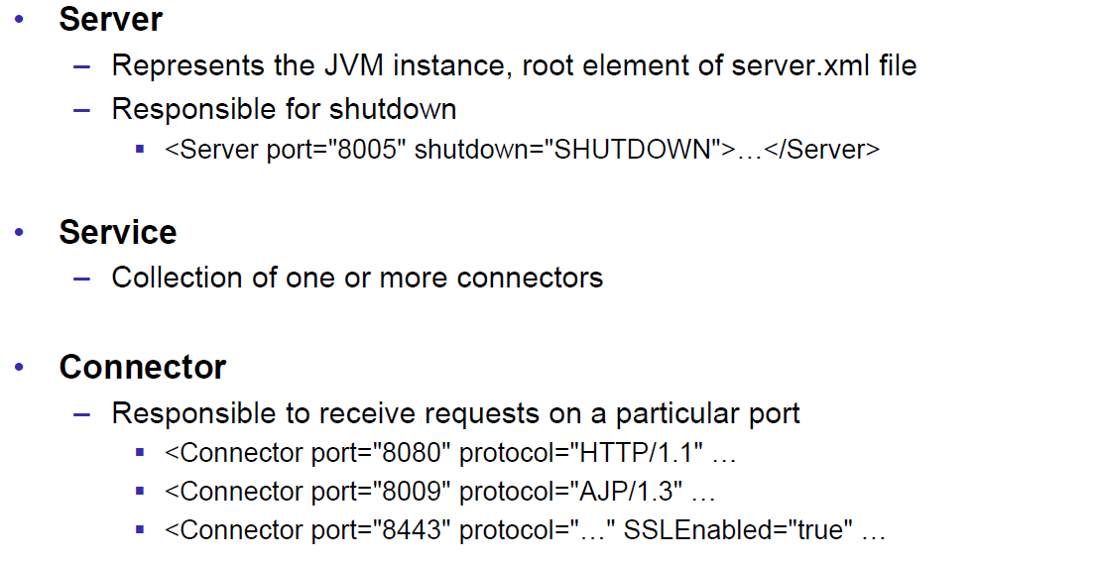

### Configuration of a Host

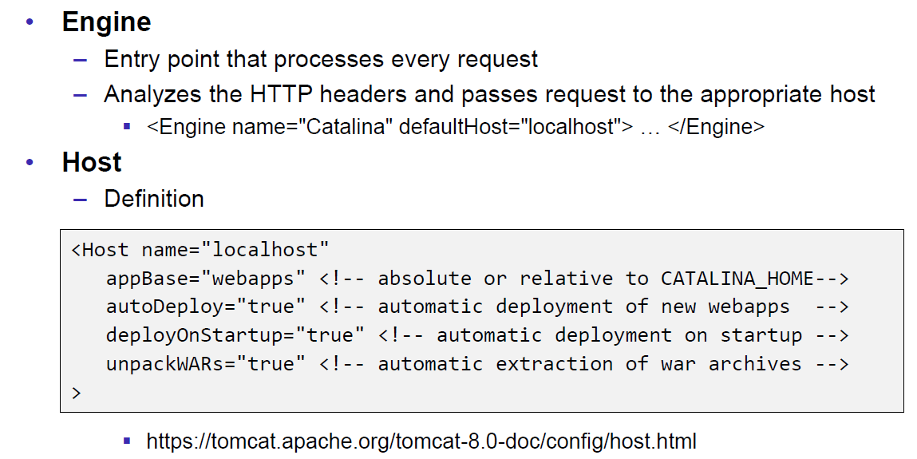

### Configuration of a Context

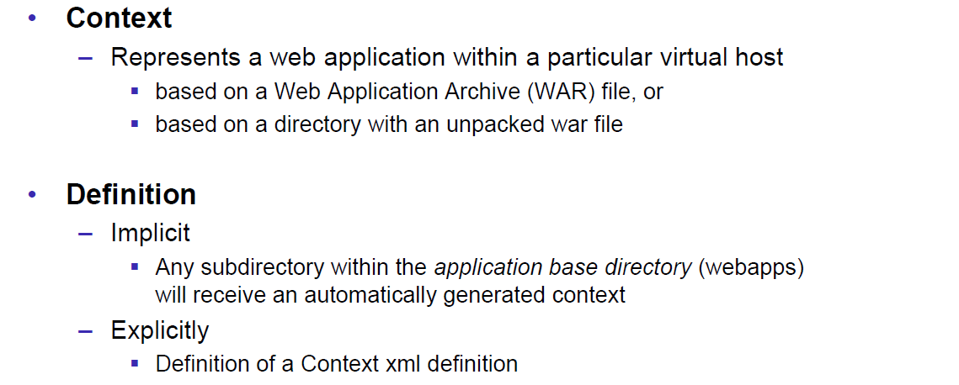

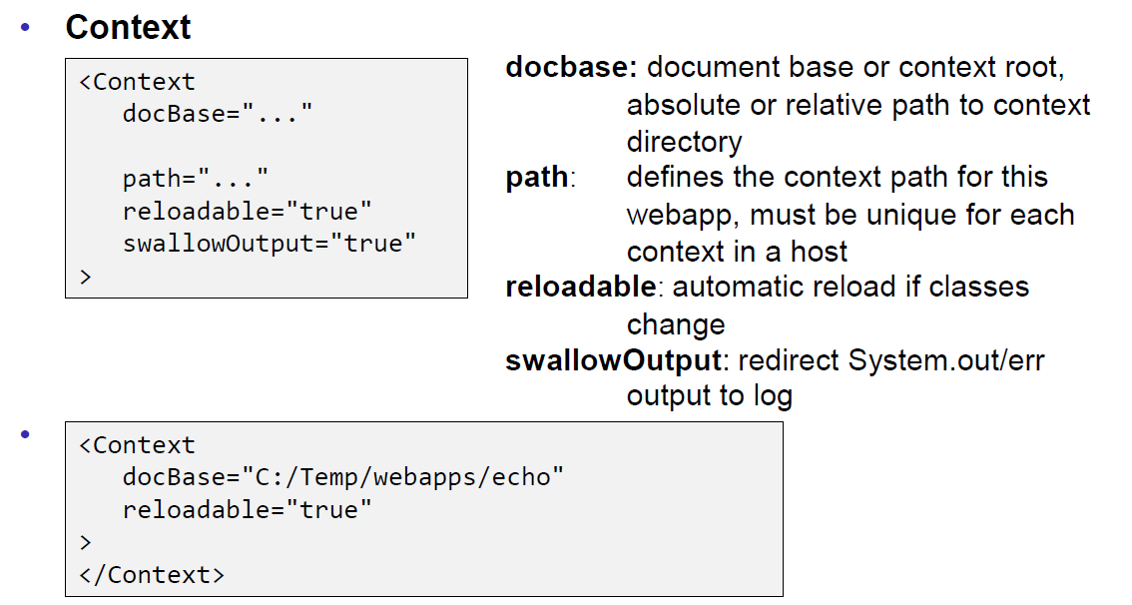

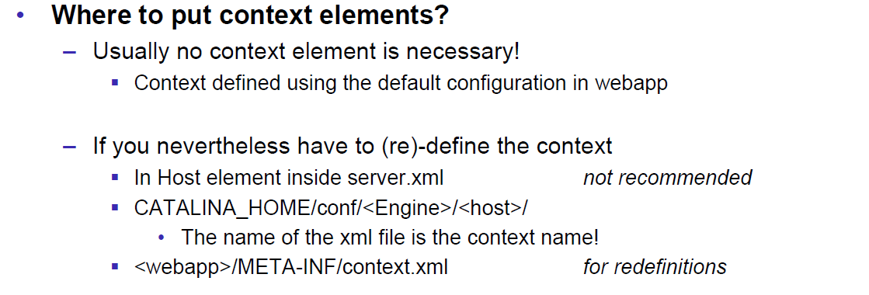

### Deployment while development

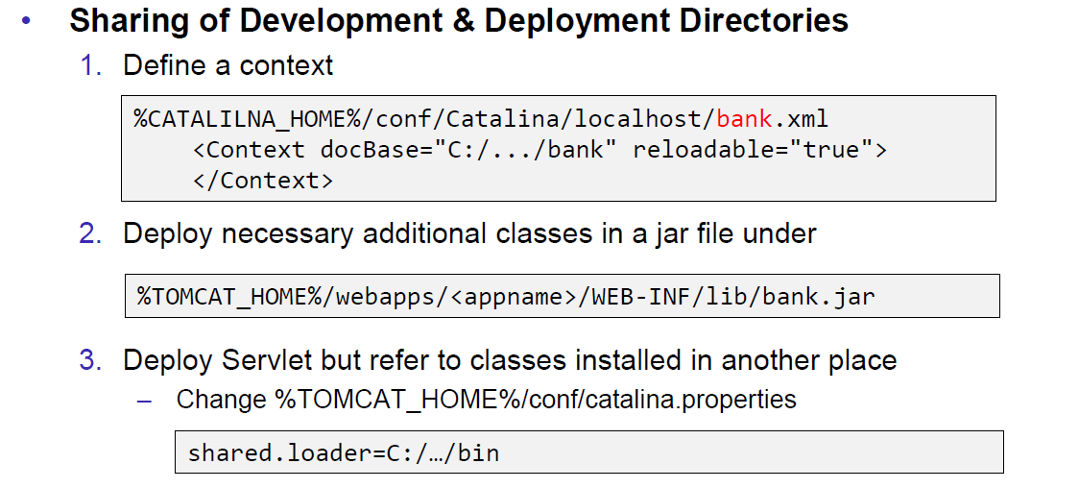

### Eclipse and Servlets (JEE Eclipse Version)

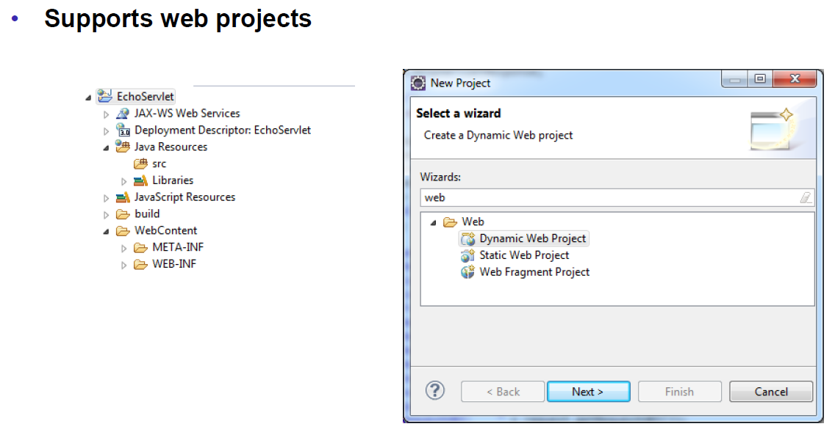

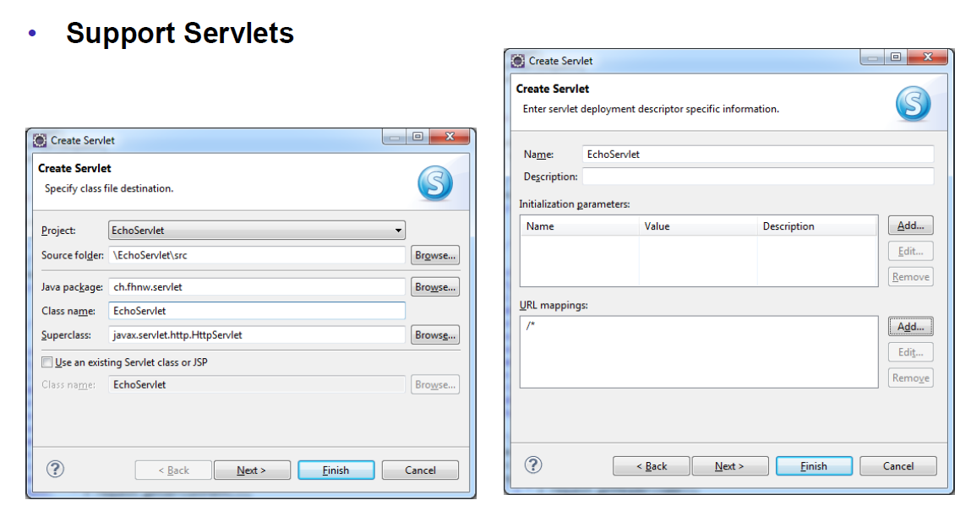

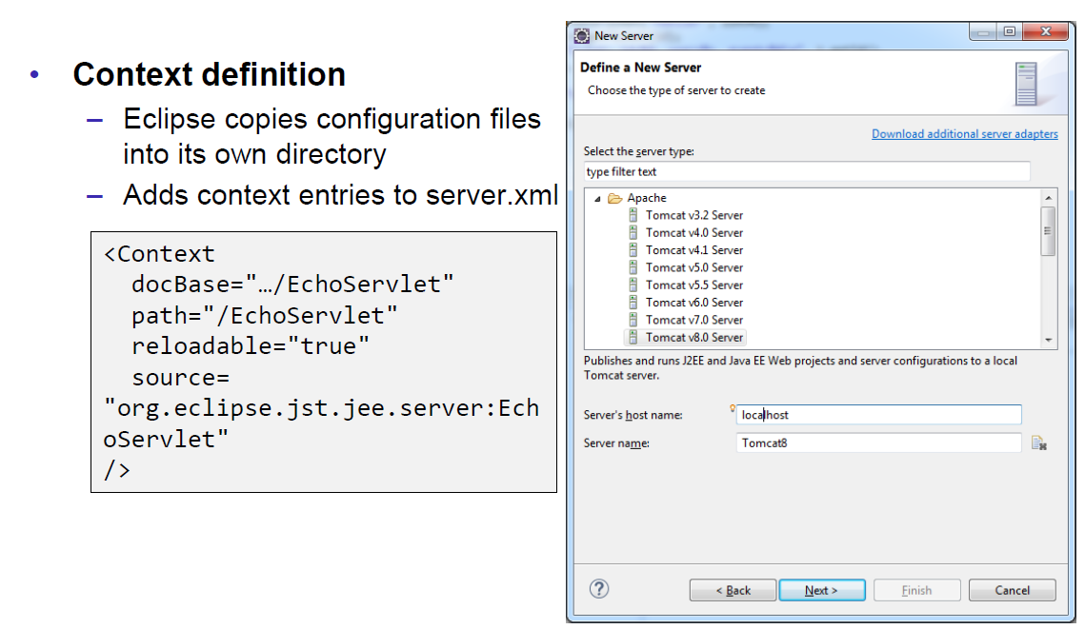

# Woche 5

## Motivation XML-RPX

### Services over HTTP (Currency Converter)

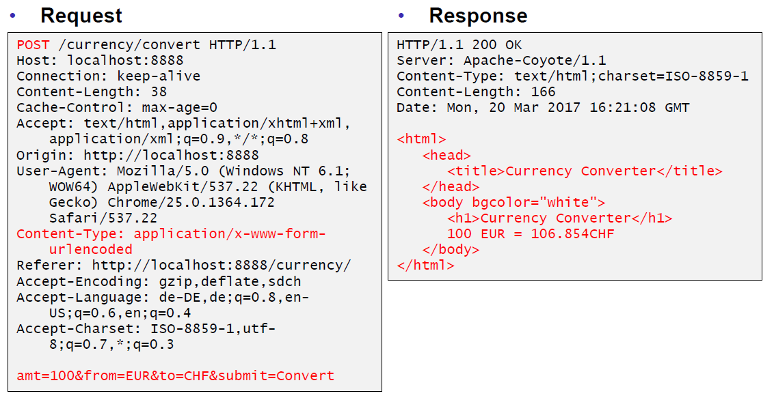

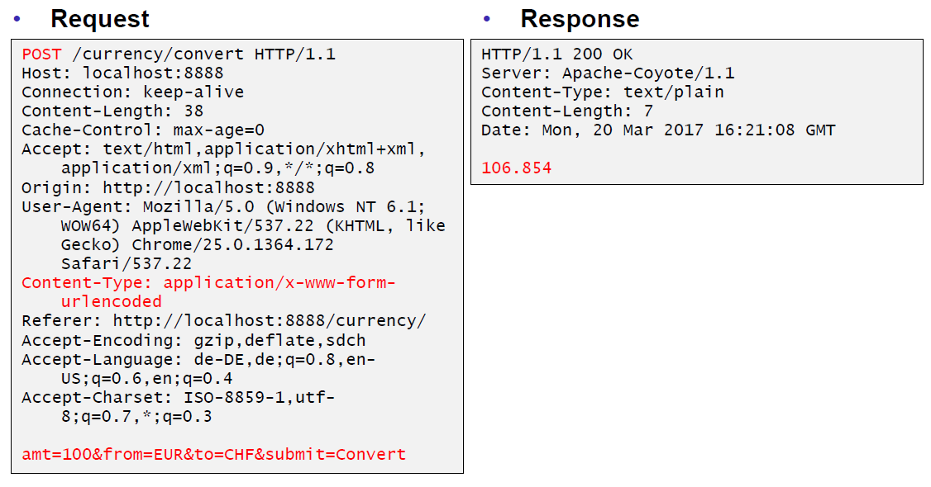

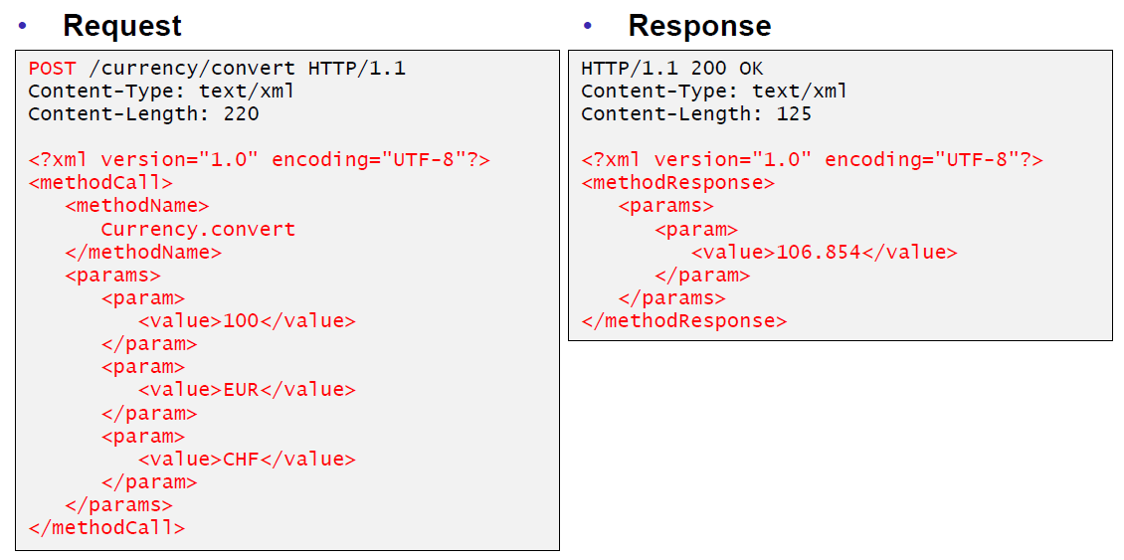

### XML-Remote Procedure Calls

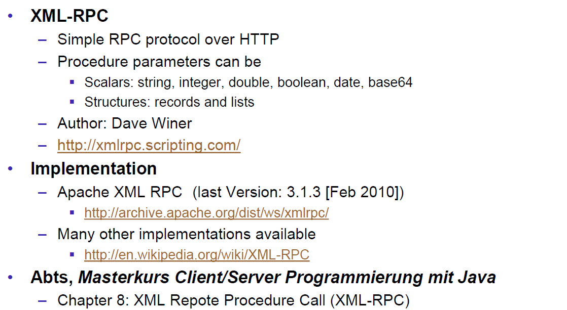

## SOAP und JAX-WS

### SOAP

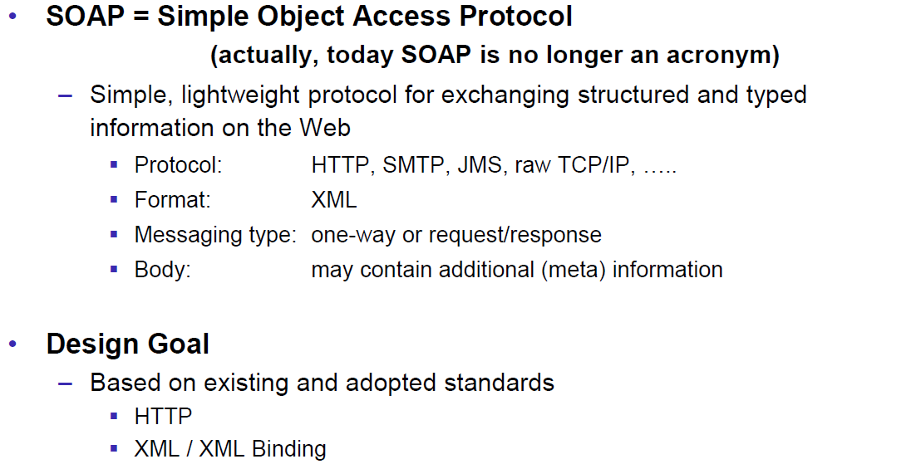

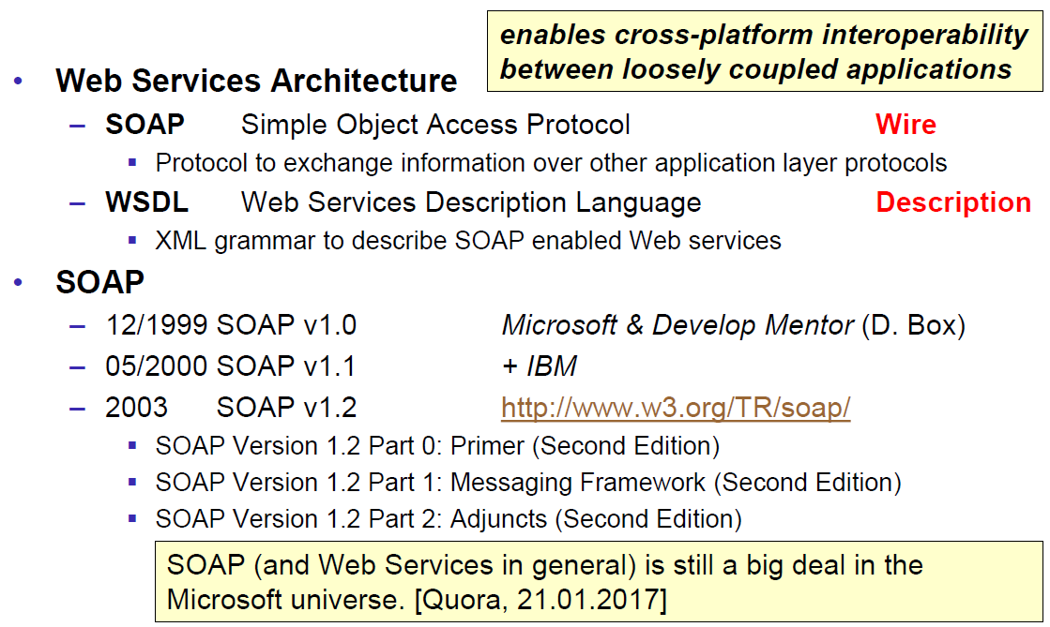

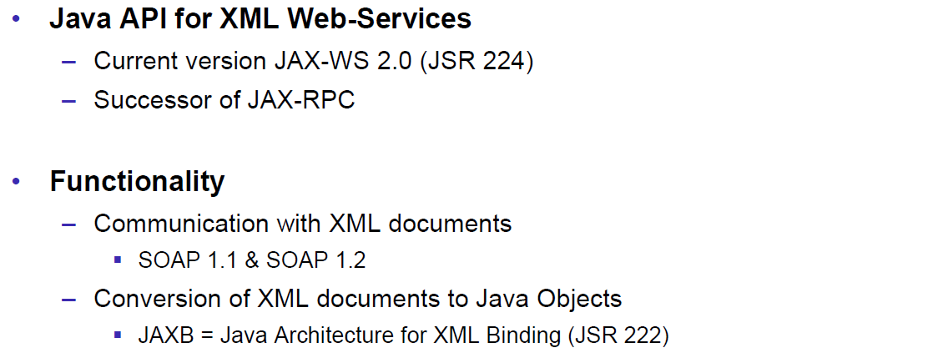

### JAX-WS

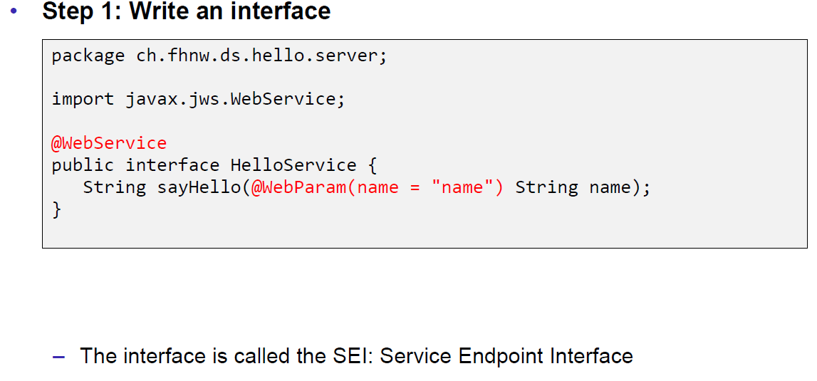

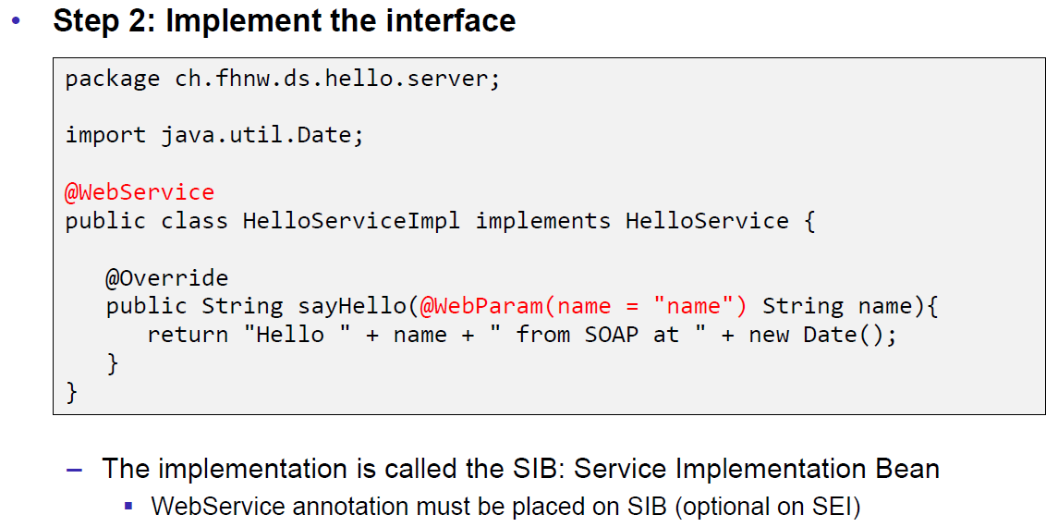

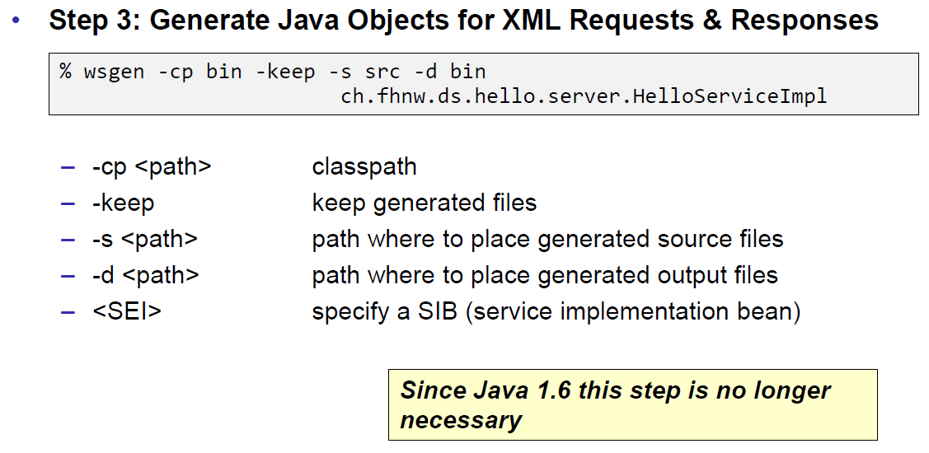

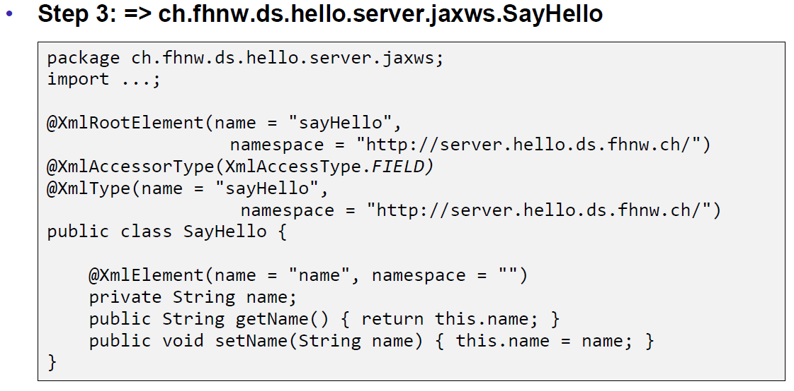

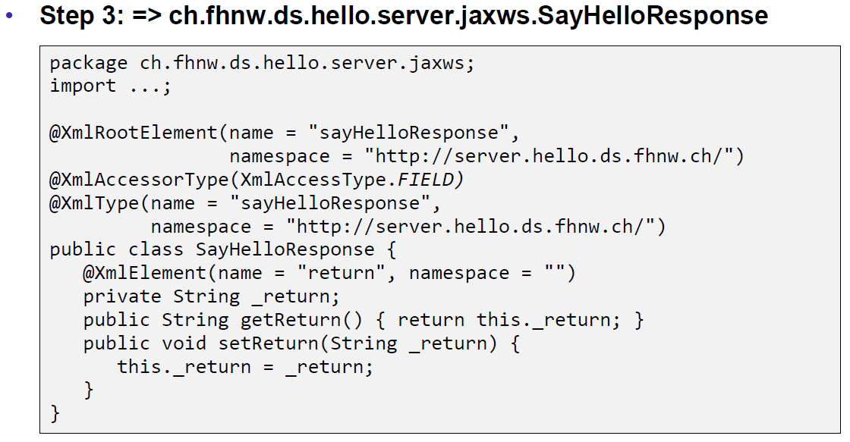

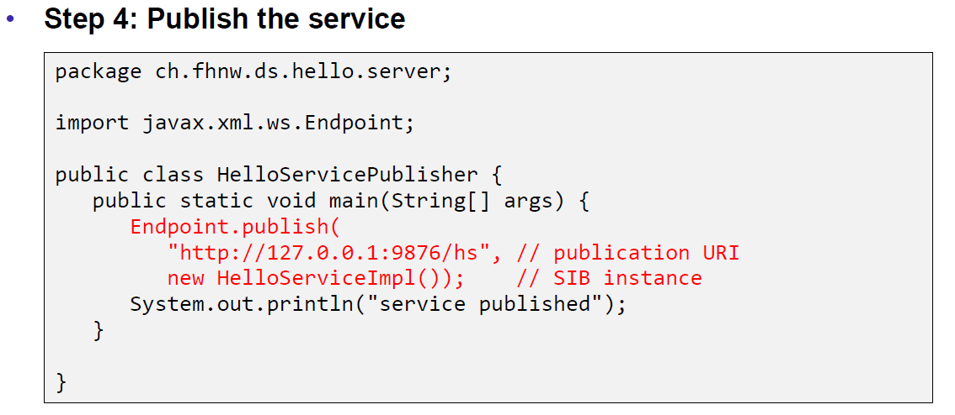

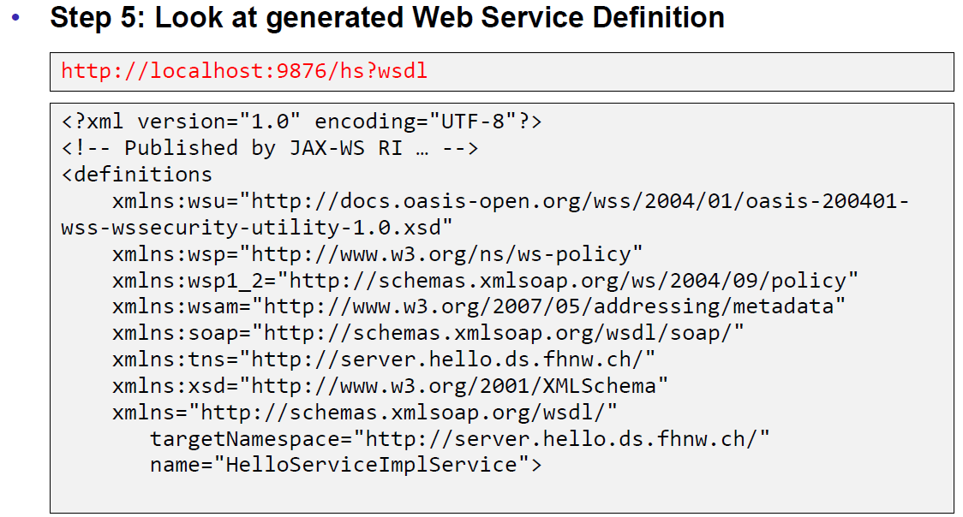

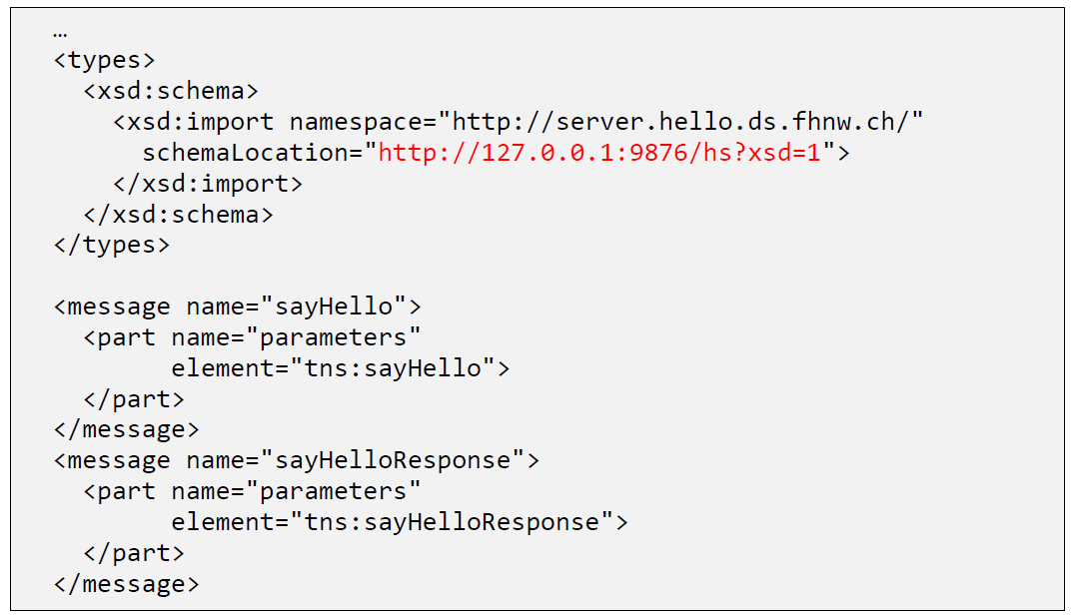

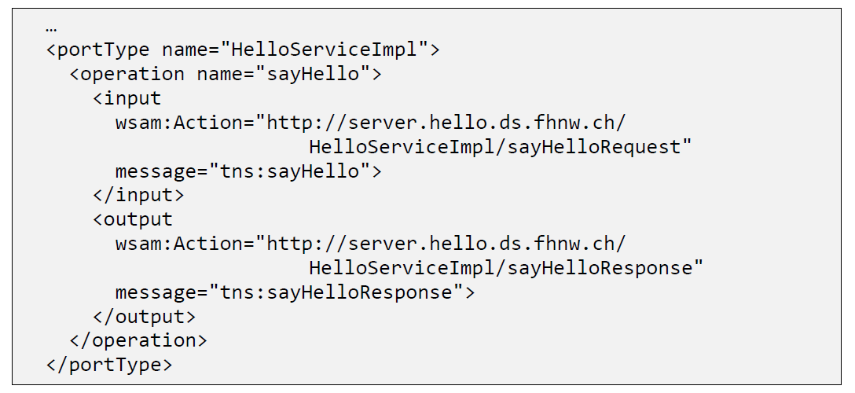

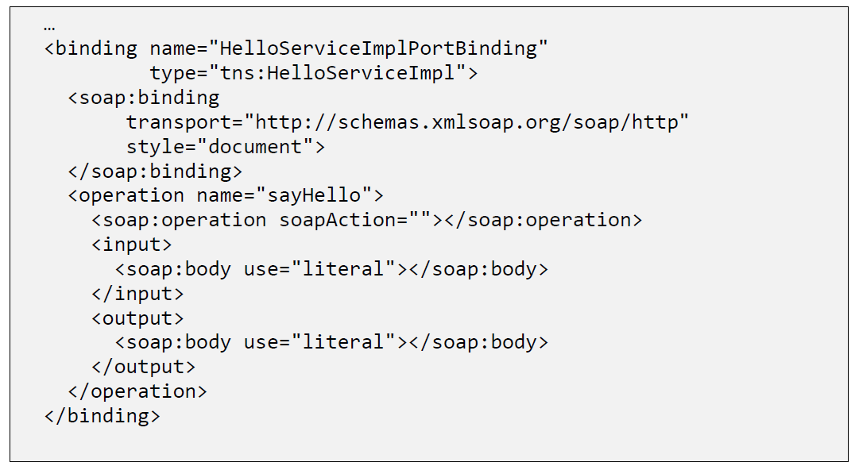

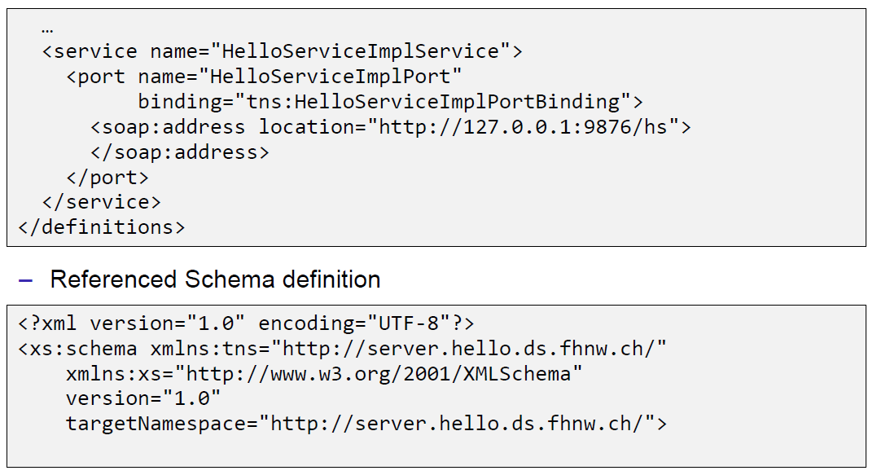

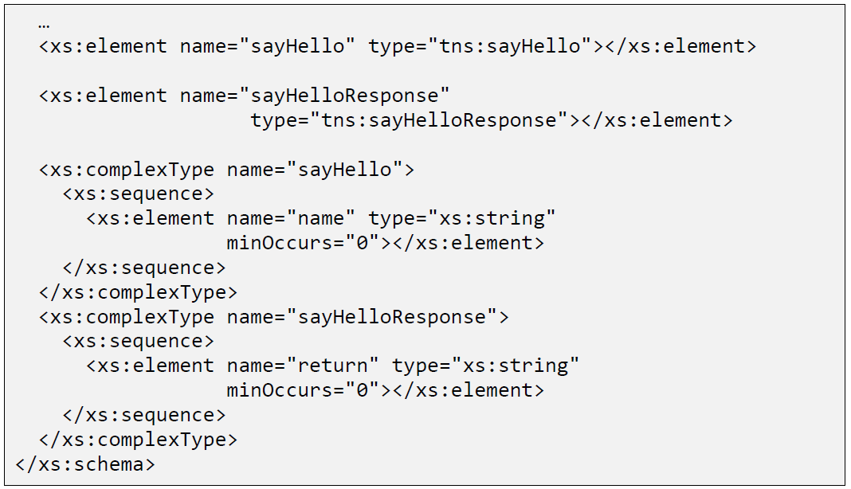

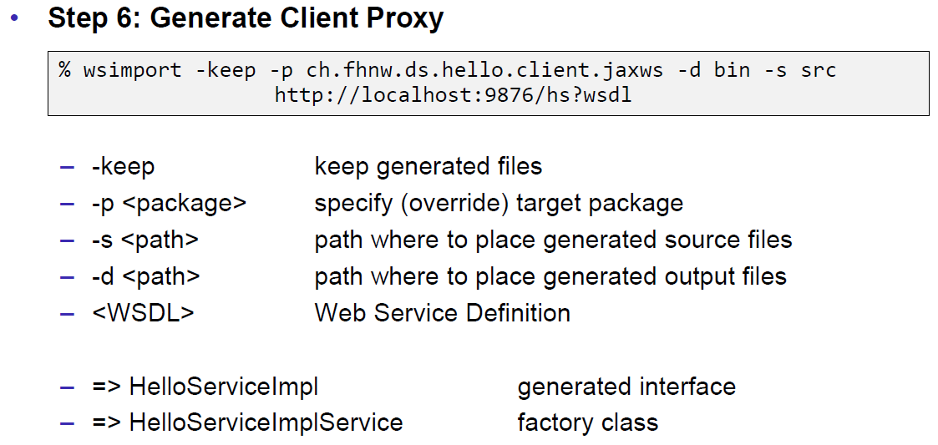

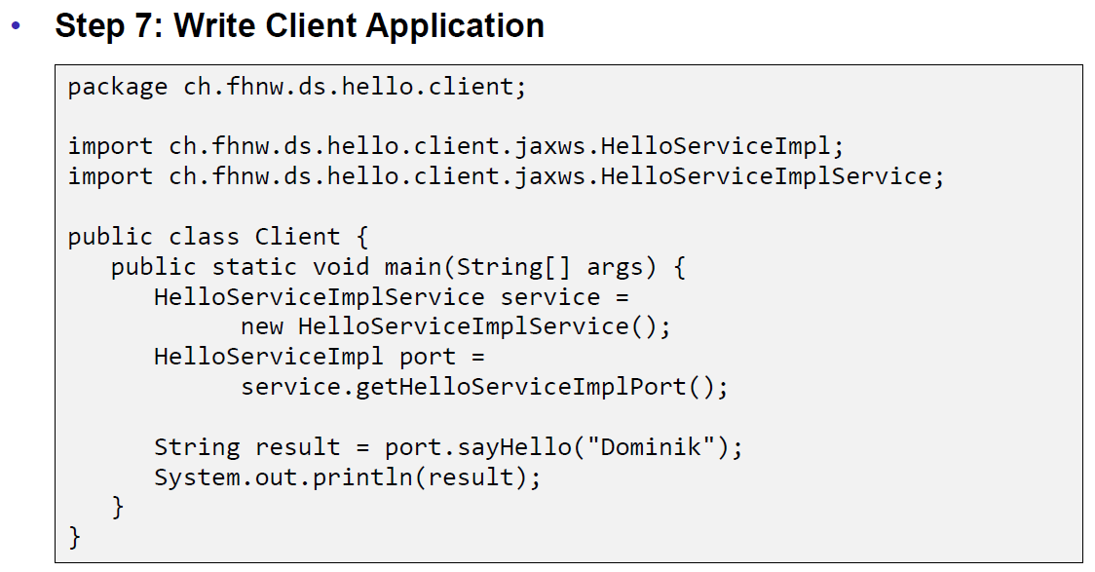

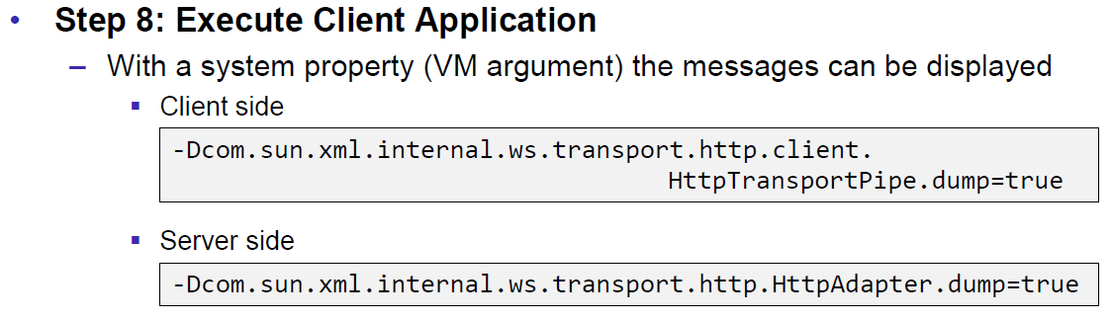

### JAX-WS HTTP Request

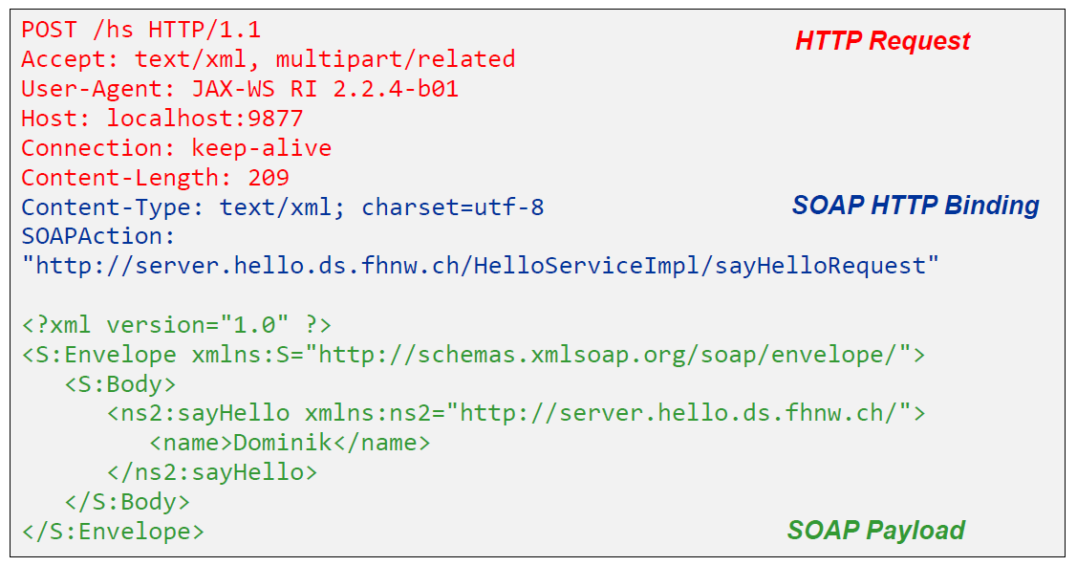

### JAX-WS HTTP Response

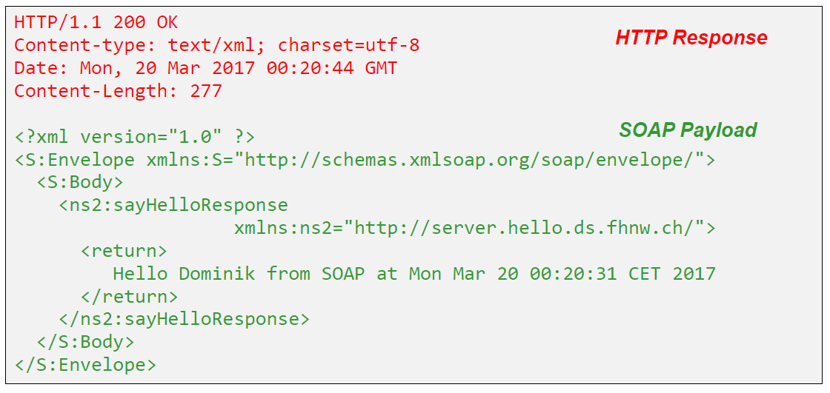

### SOAP Message Structure

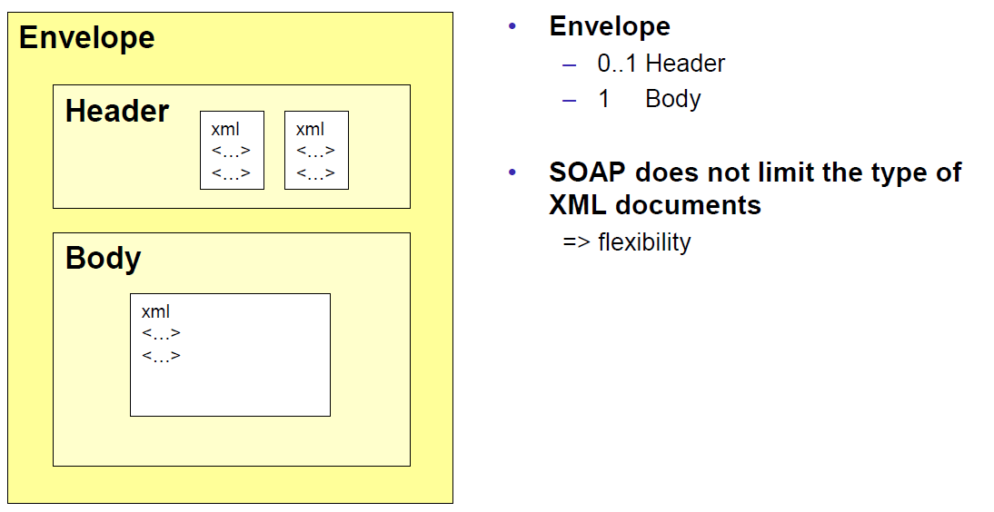

### Tools for SOAP

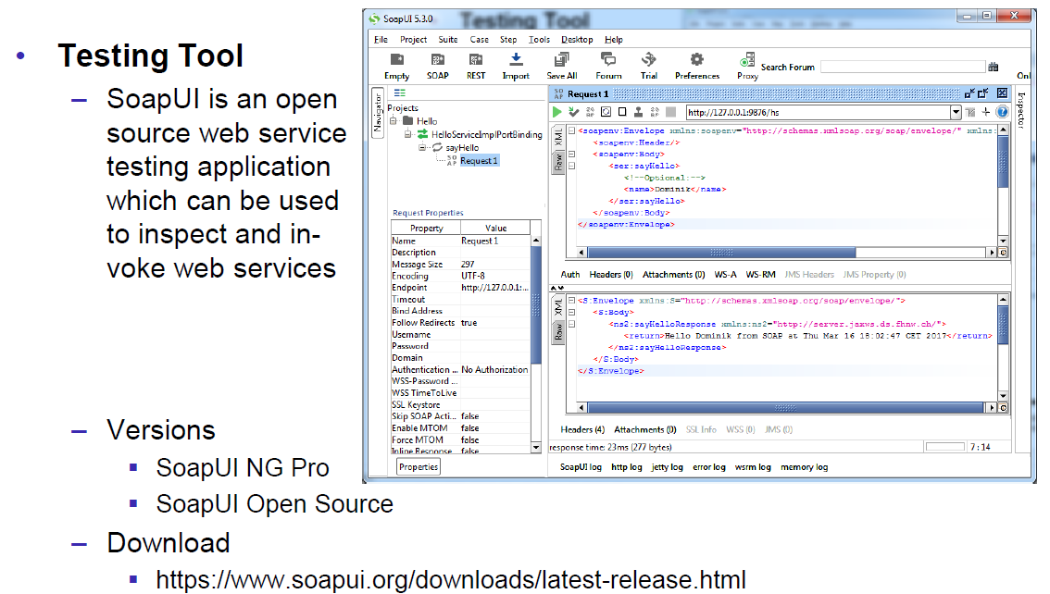

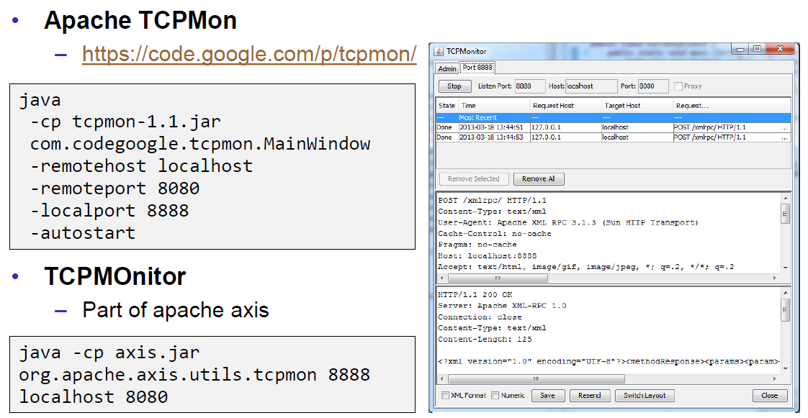

## WSDL

### WSDL

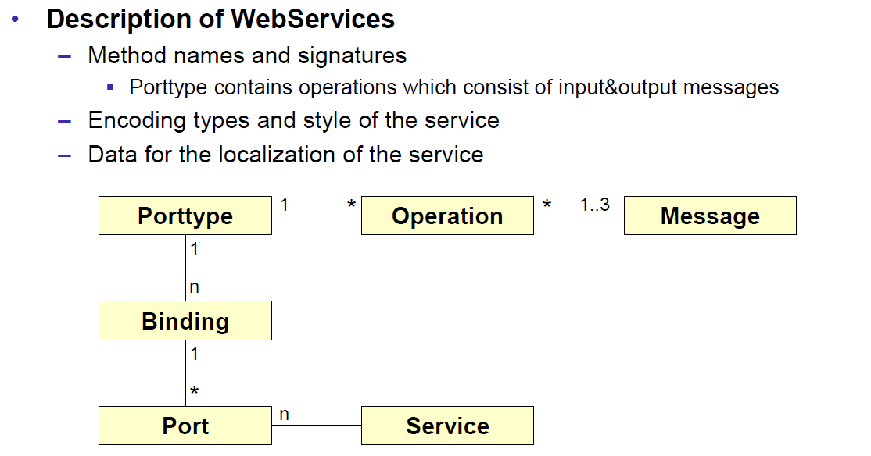

### WSDL Examples

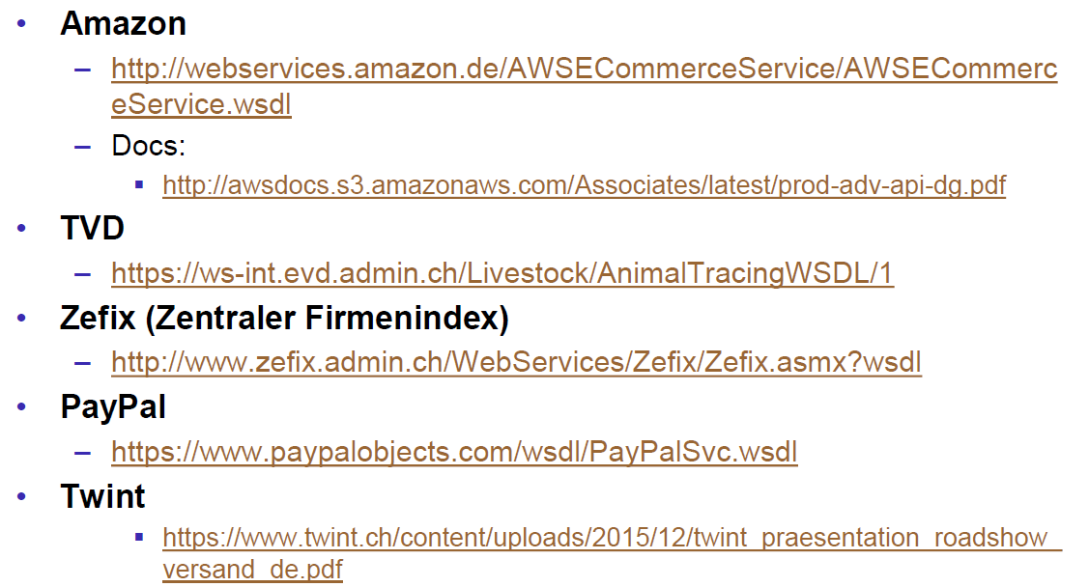

### WSDL Structure

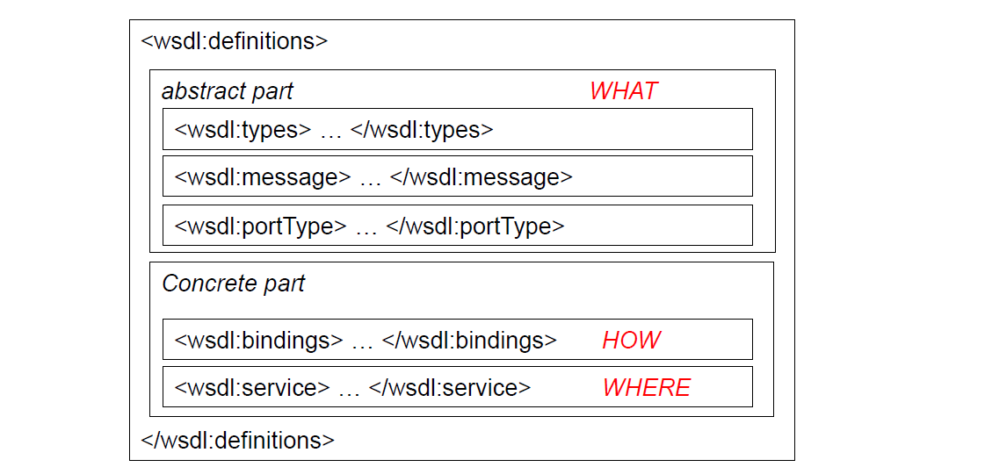

### WSDL Definitions

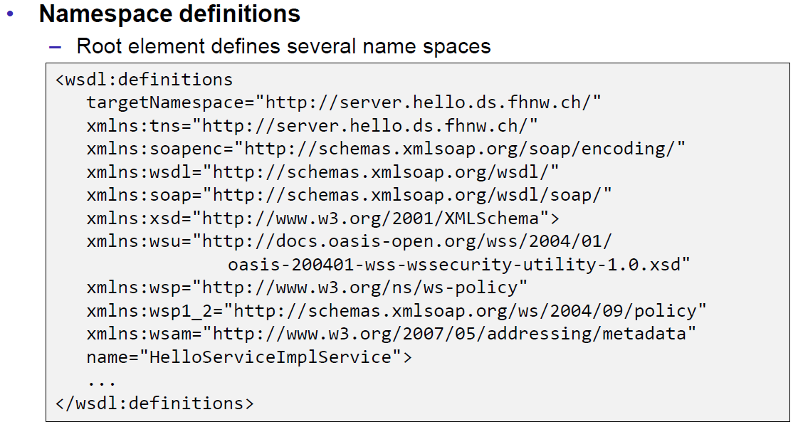

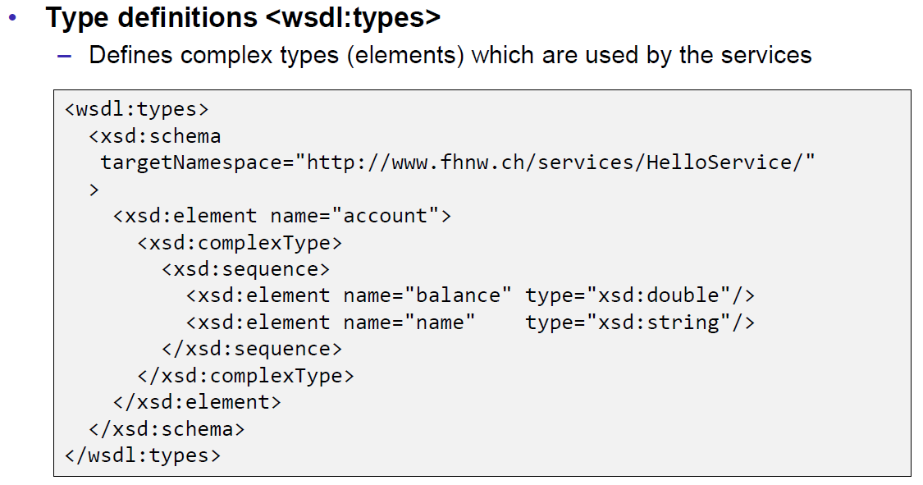

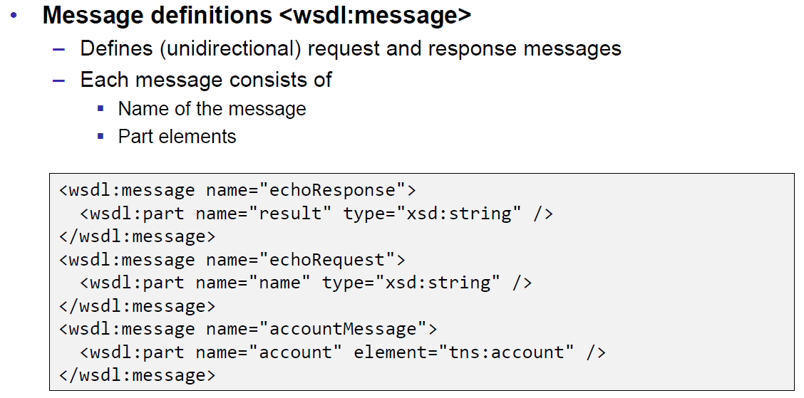

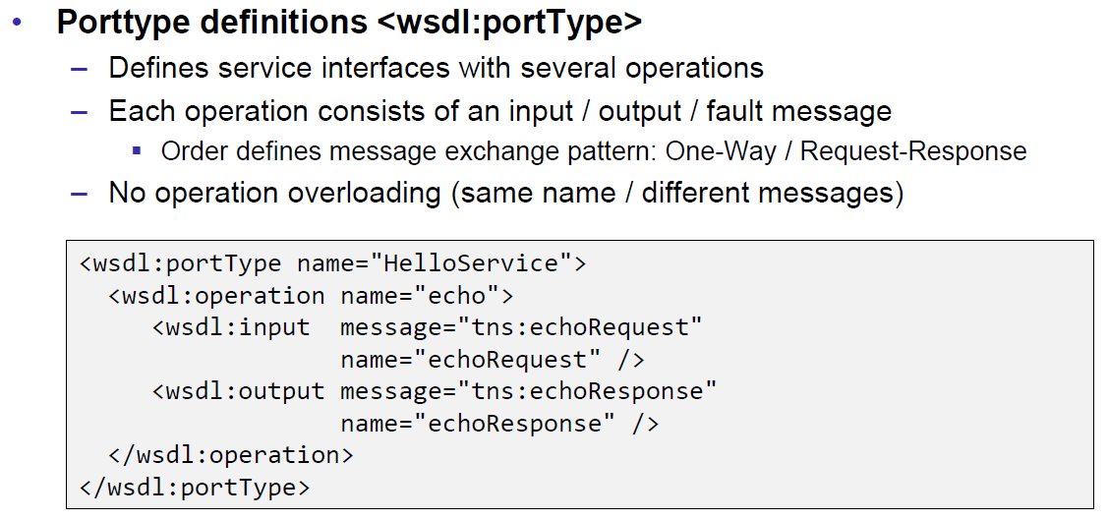

### Message Exchange Patterns (MEP)

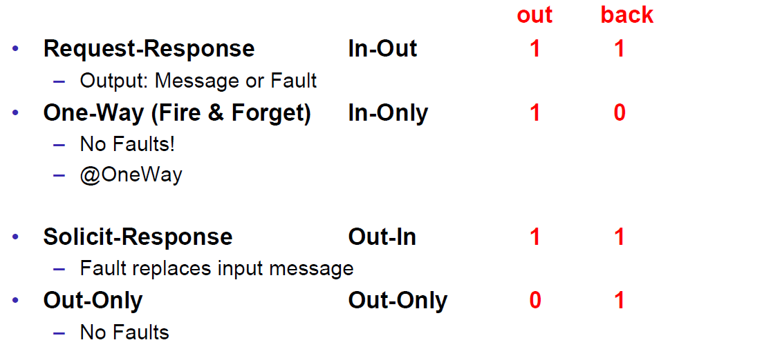

### WSDL Definitions

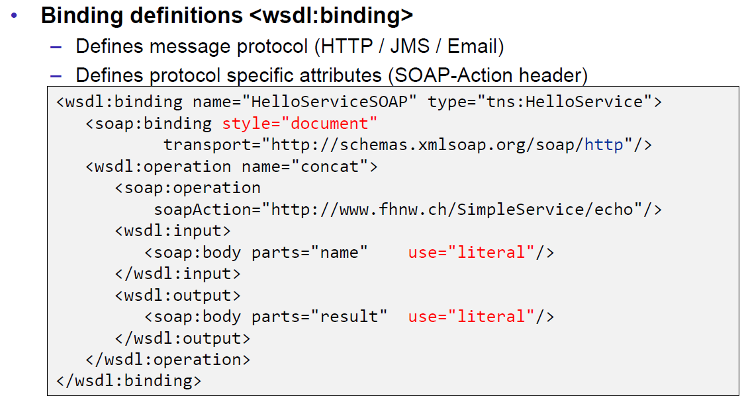

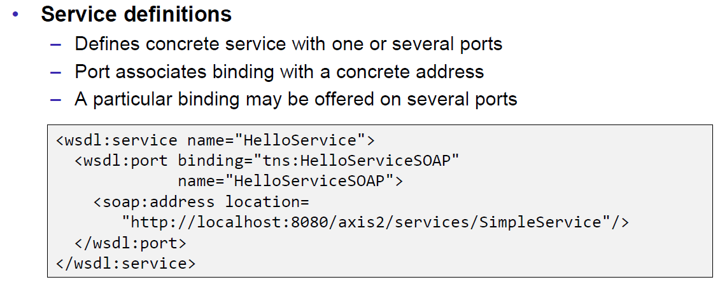

### Web Service Styles

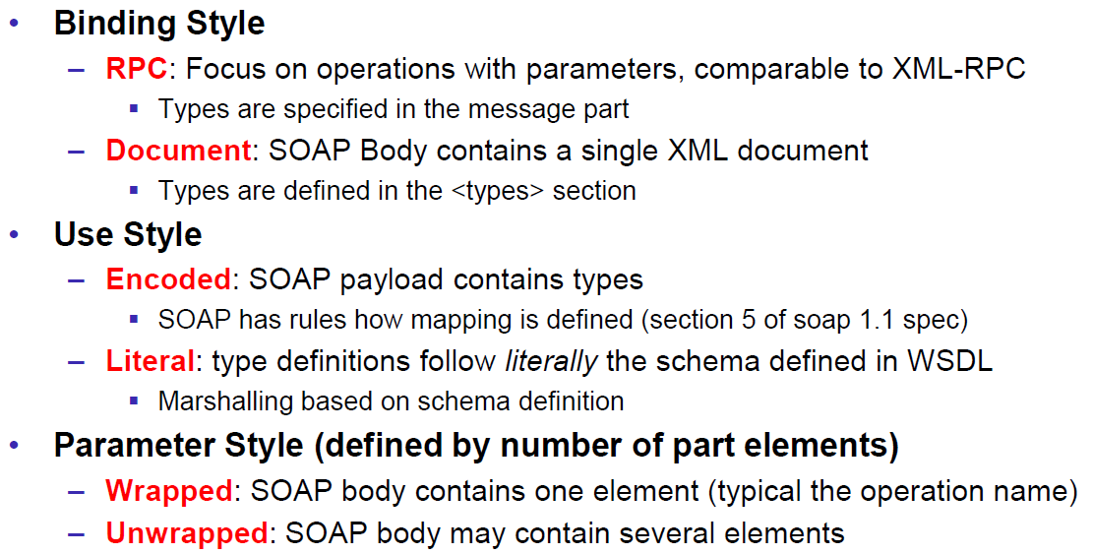

### RPC/Encoded

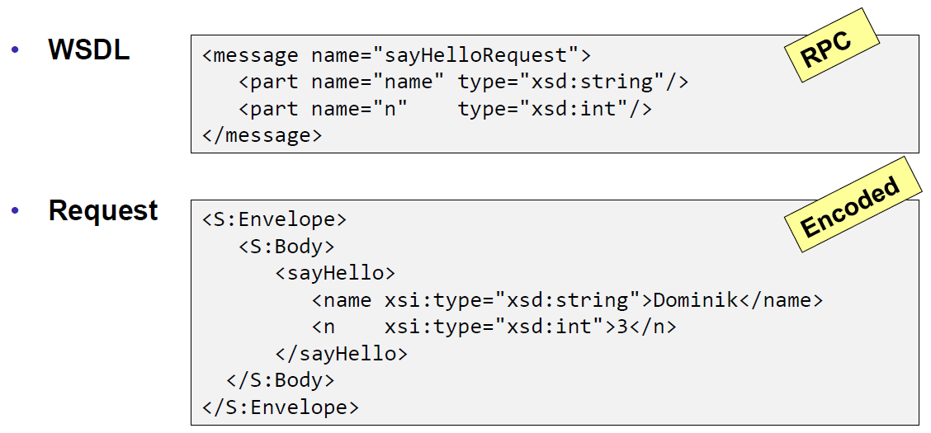

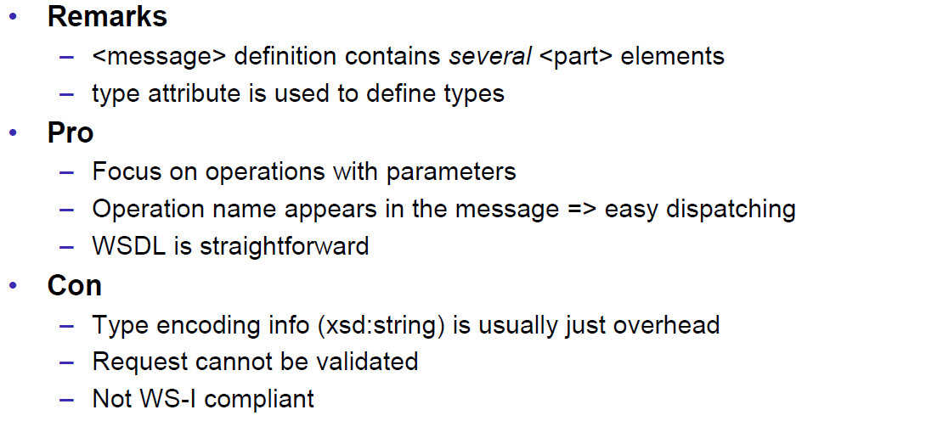

### RPC/Literal

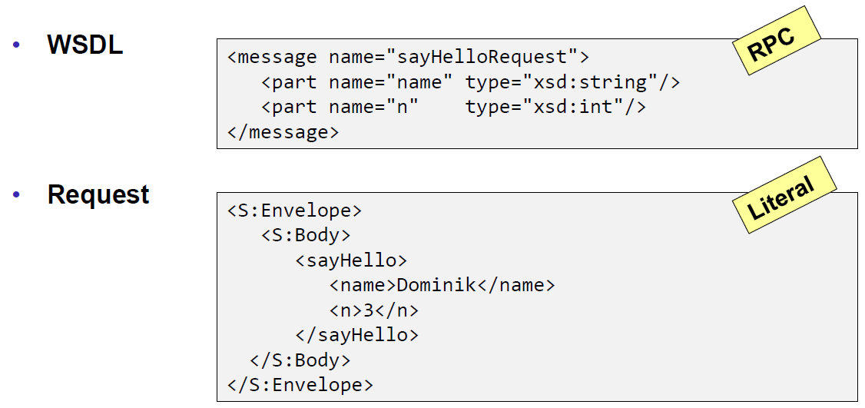

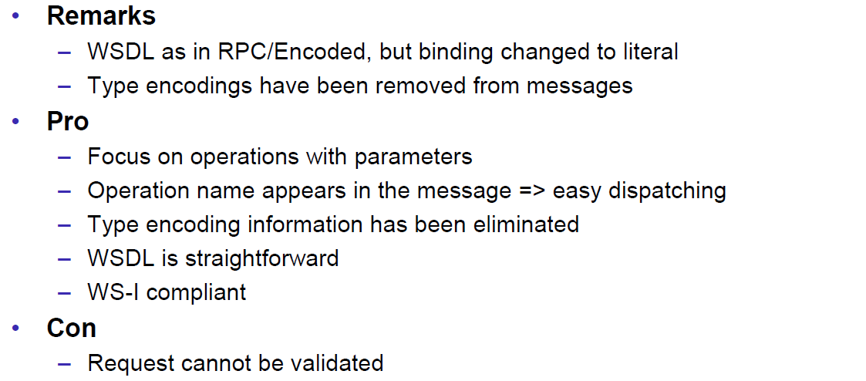

### Document/Literal/Bare

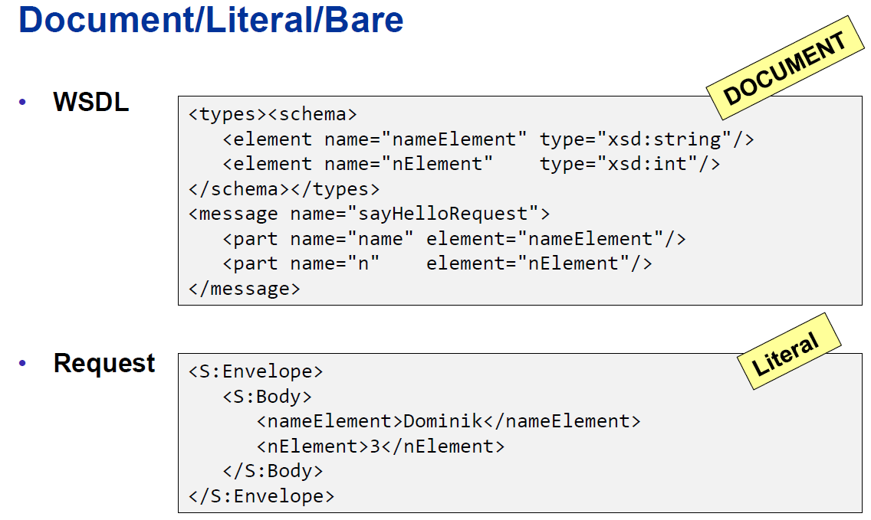

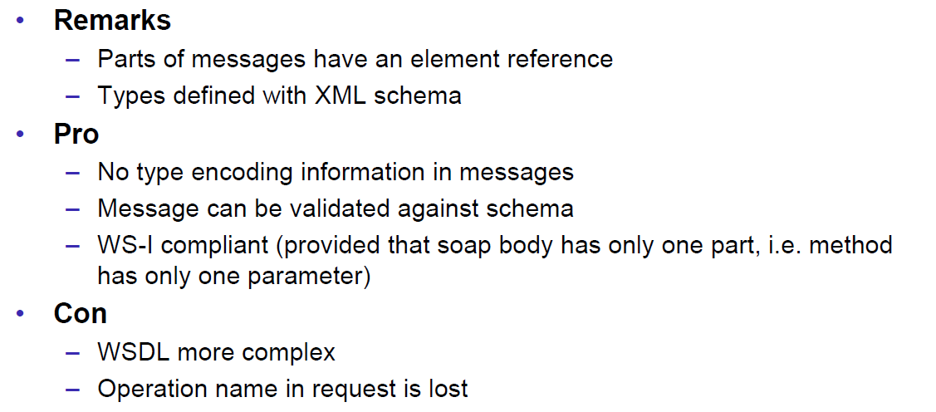

### Document/Literal/Wrapped

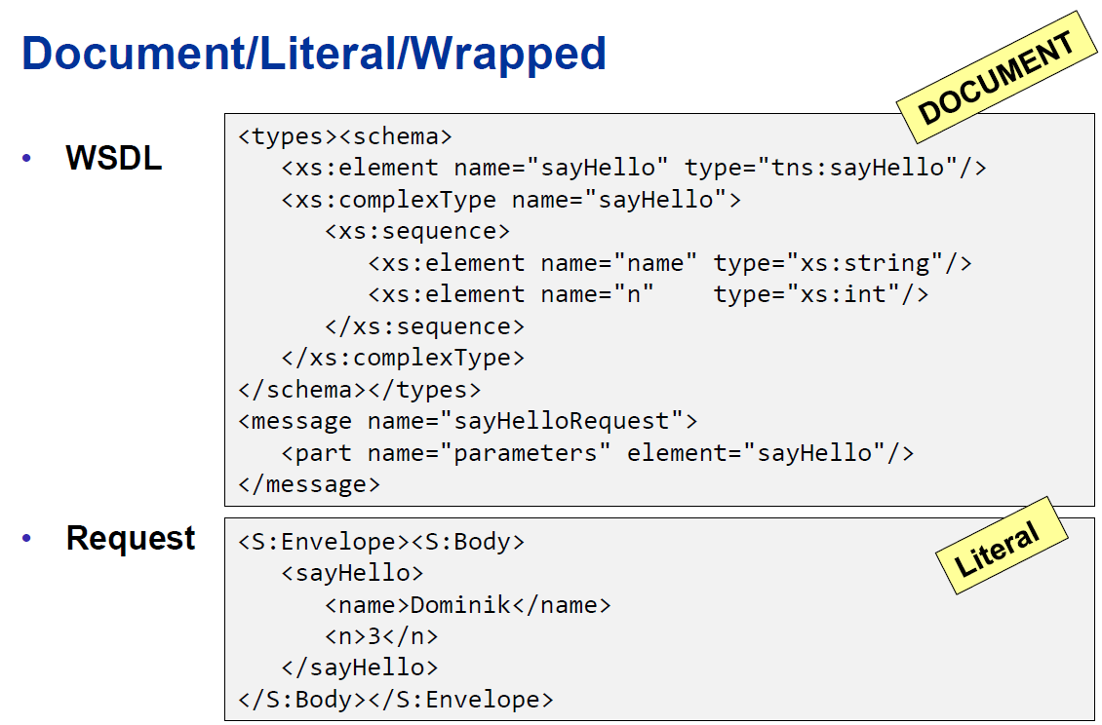

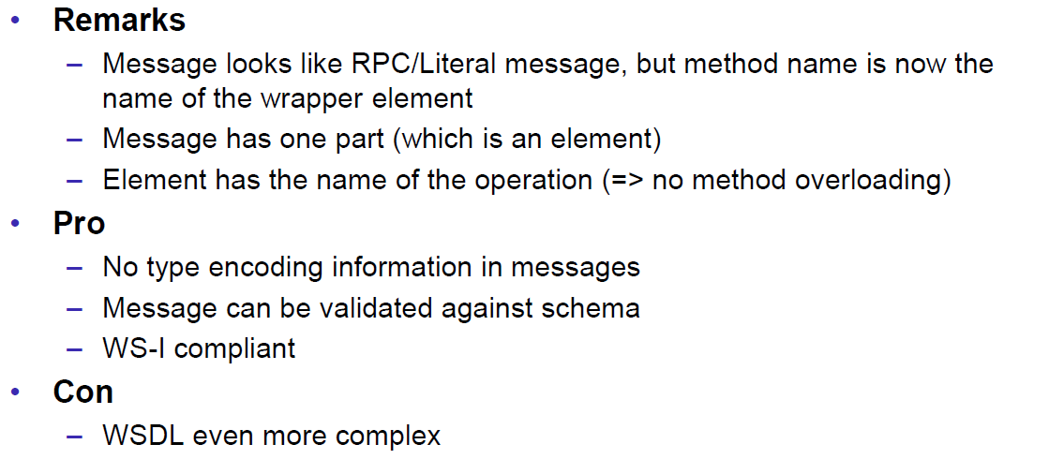

### Web Service Styles

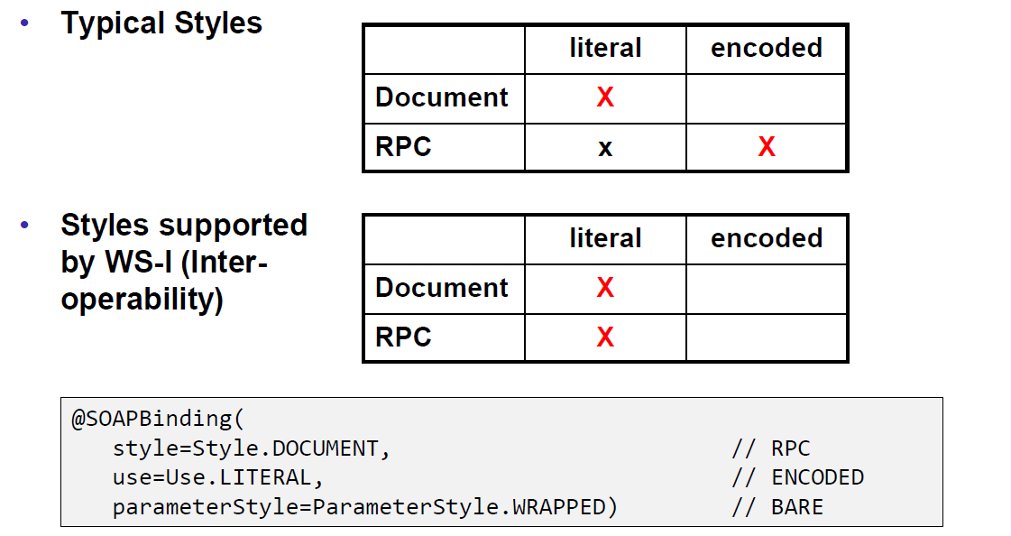

## Resources

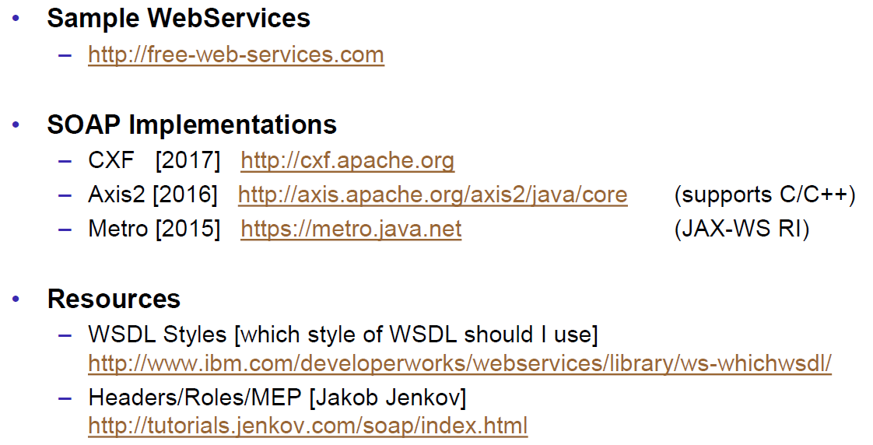

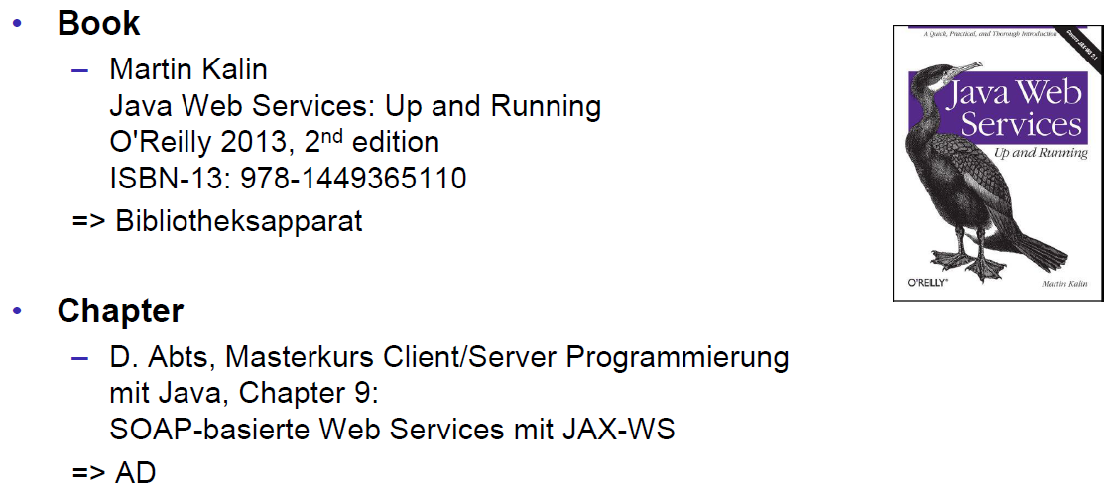

# Woche 6

## REST Concepts

### Representational State Transfer (REST)

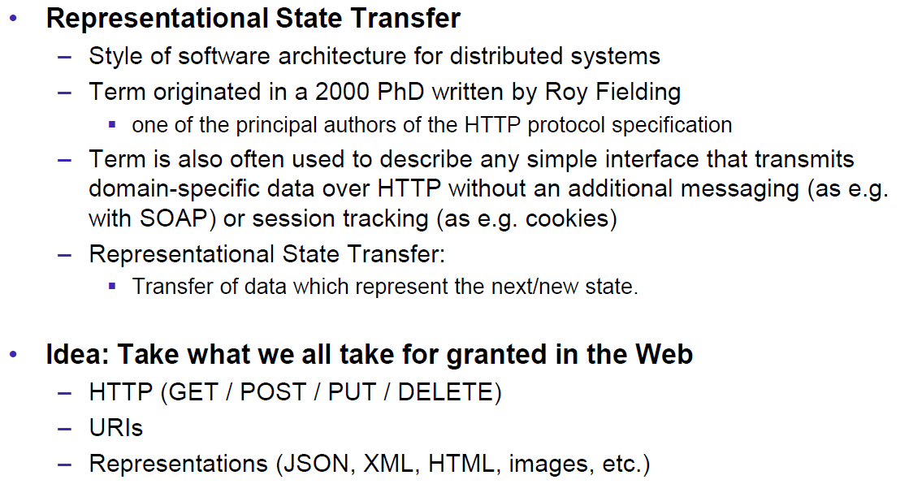

### REST Principles

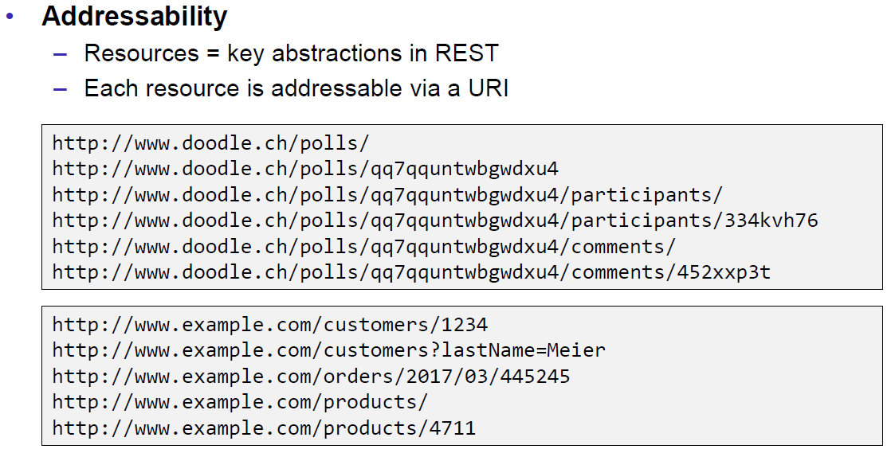

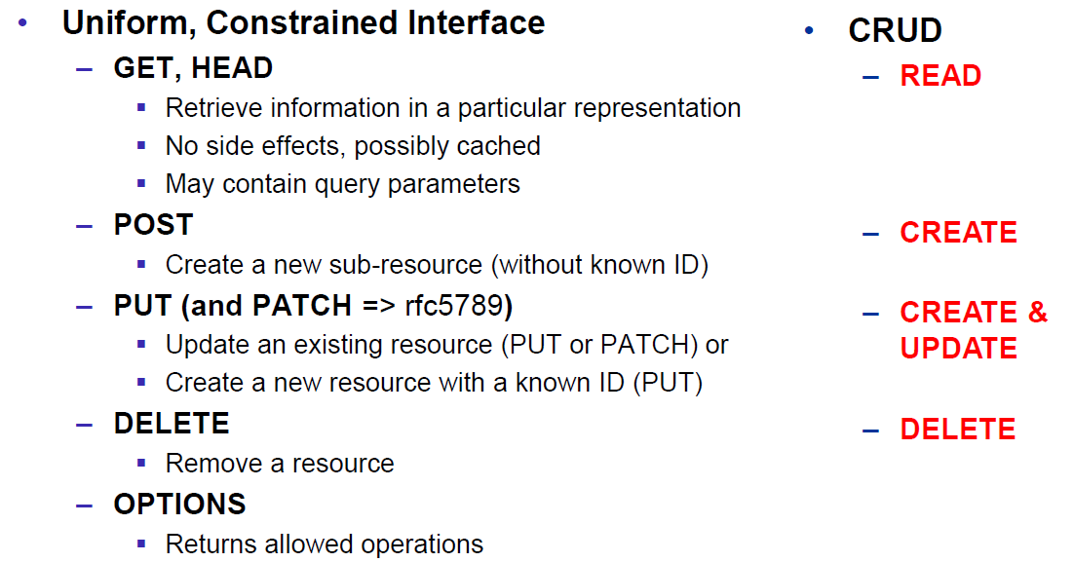

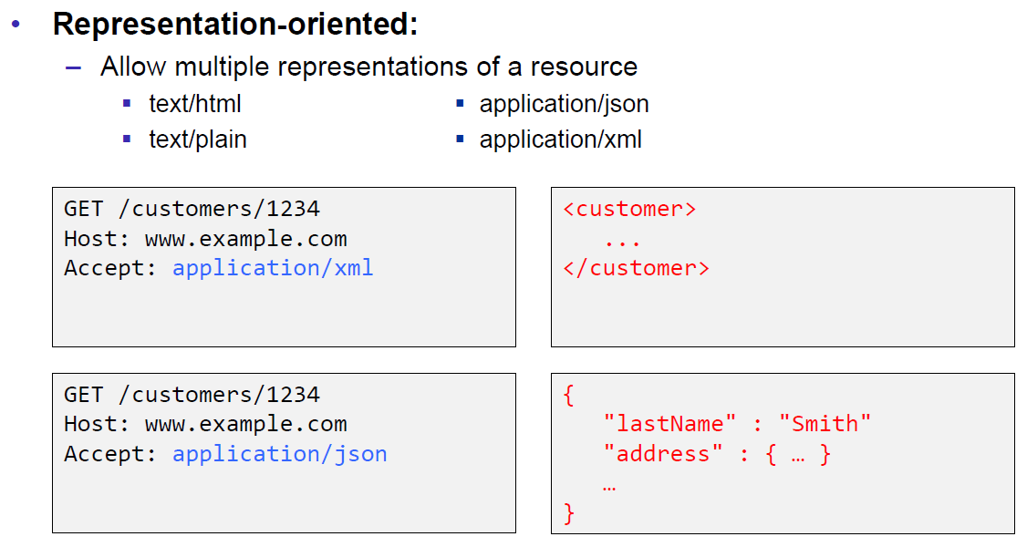

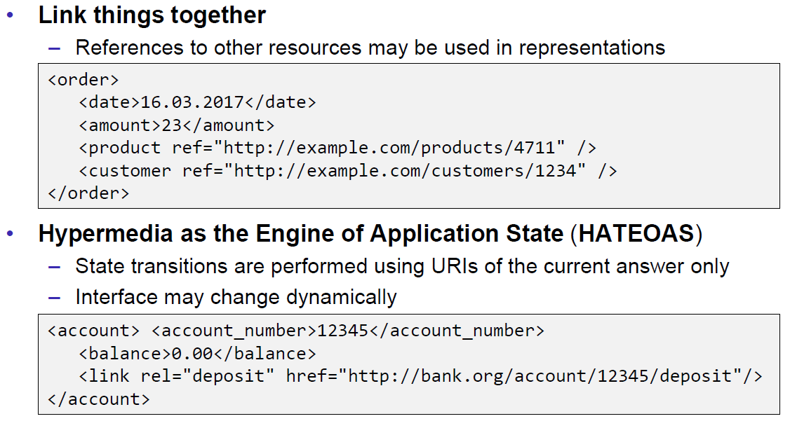

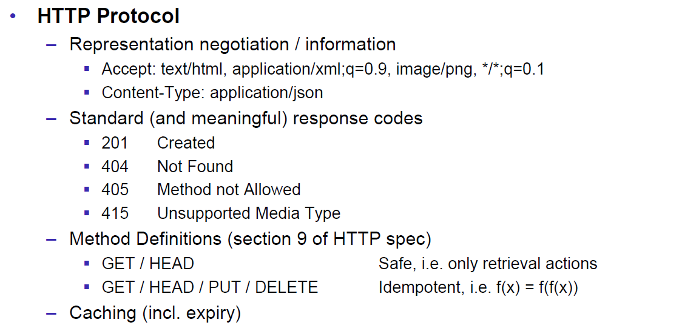

### REST Short Primer

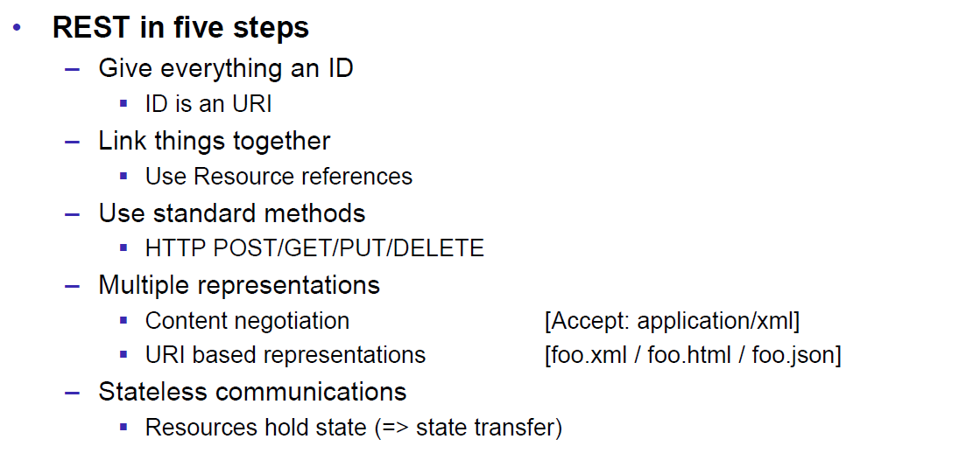

### SOAP versus REST

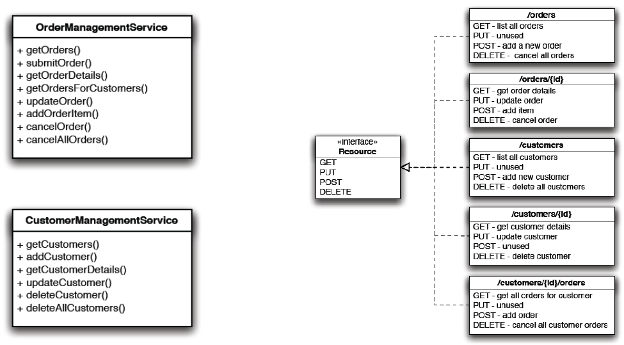

### REST Common Patterns

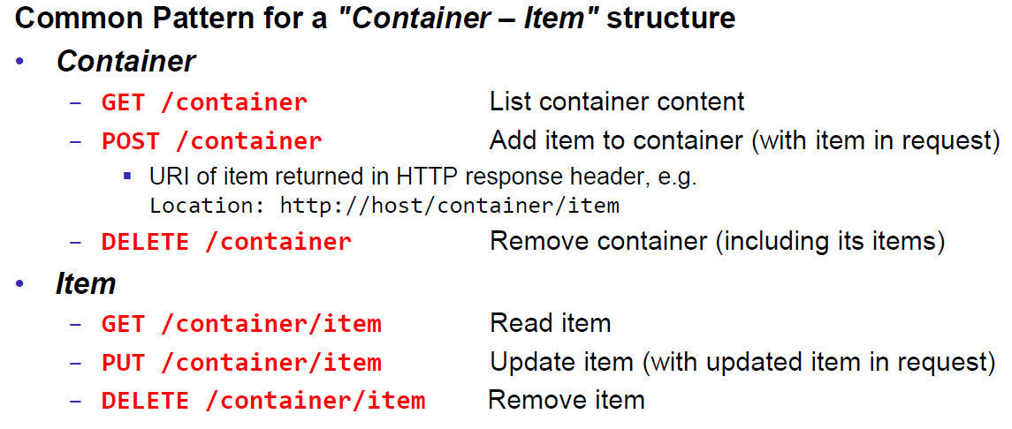

### Example Doodle

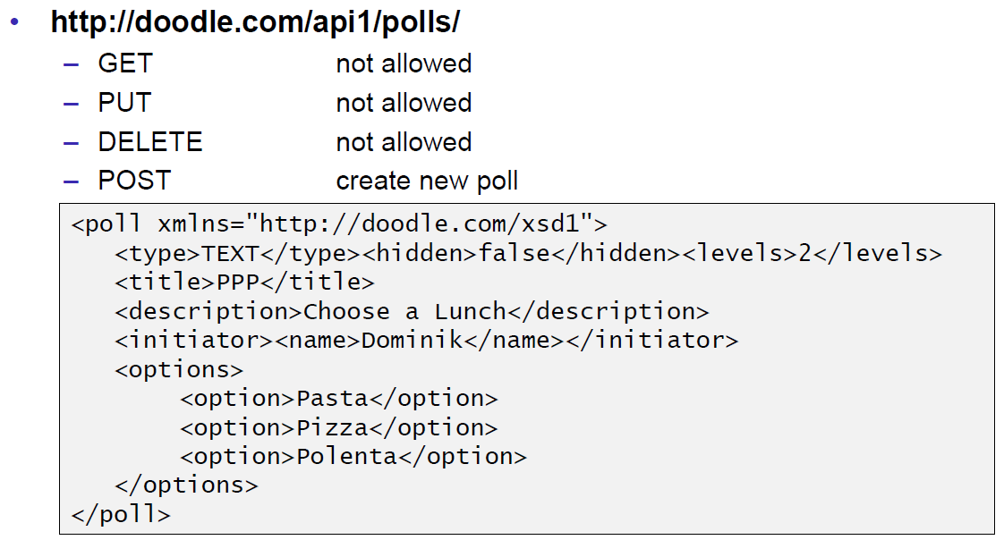

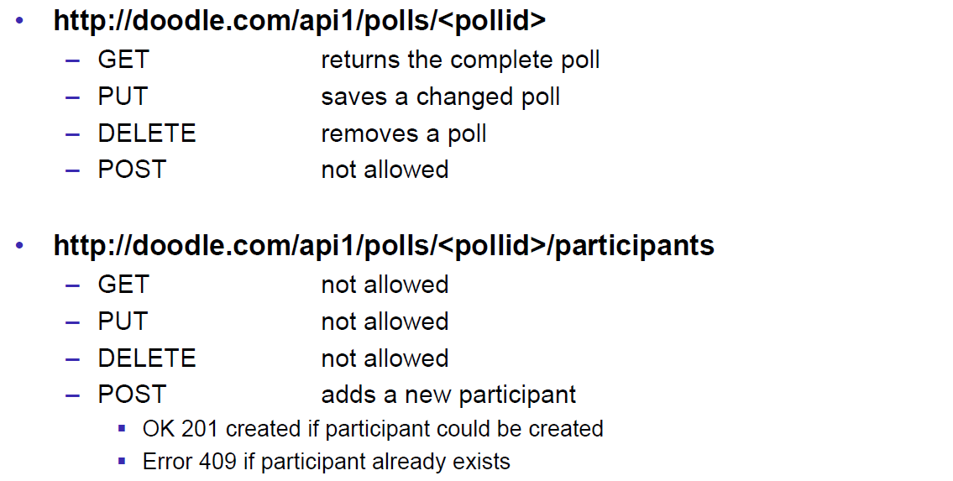

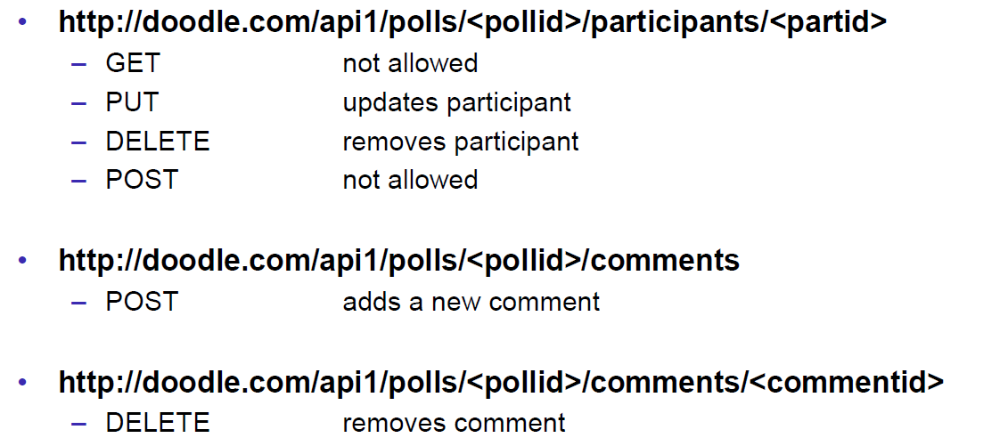

### REST versus SOAP

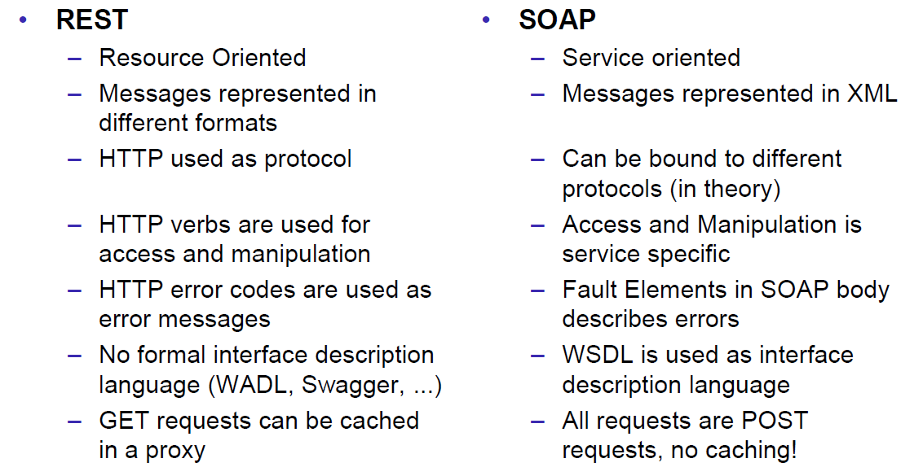

### Client Side

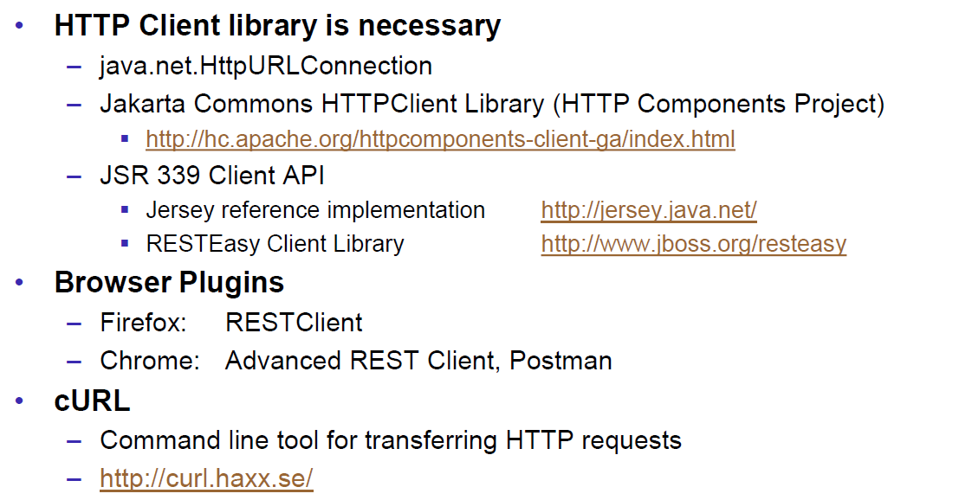

### Web Client Plugins

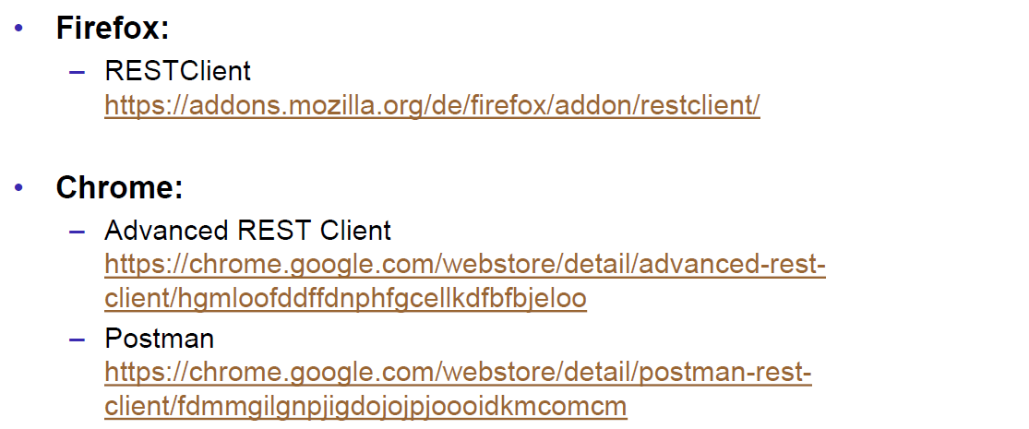

### Client Side via curl

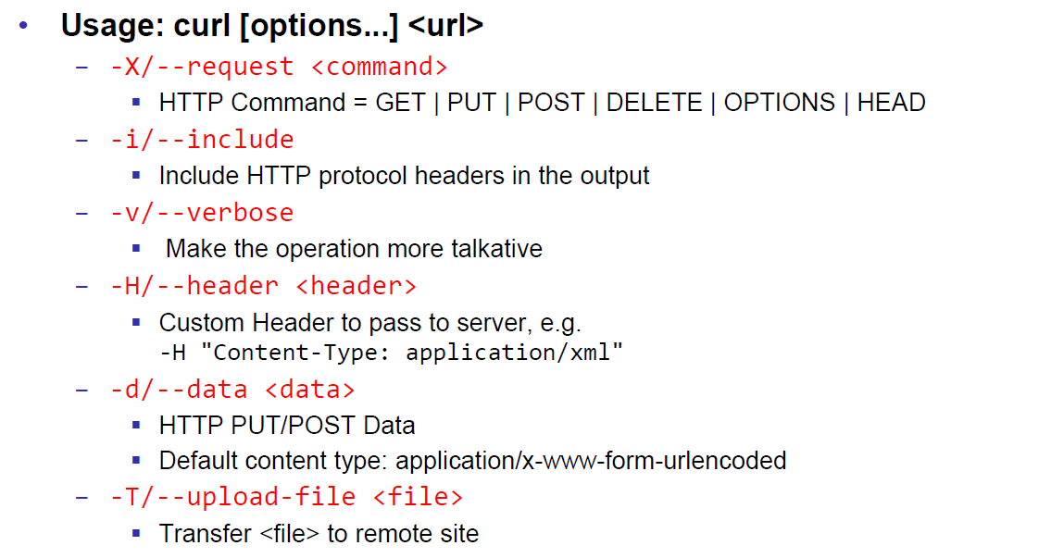

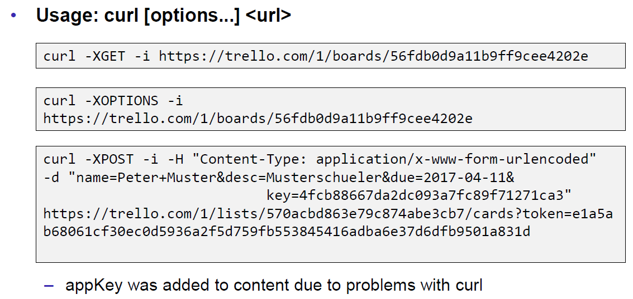

## REST Server Implementations

### Server Side

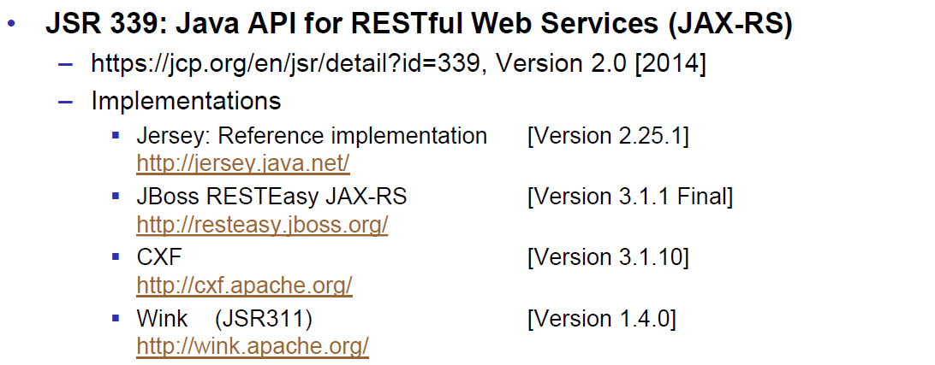

### JAX-RS Services

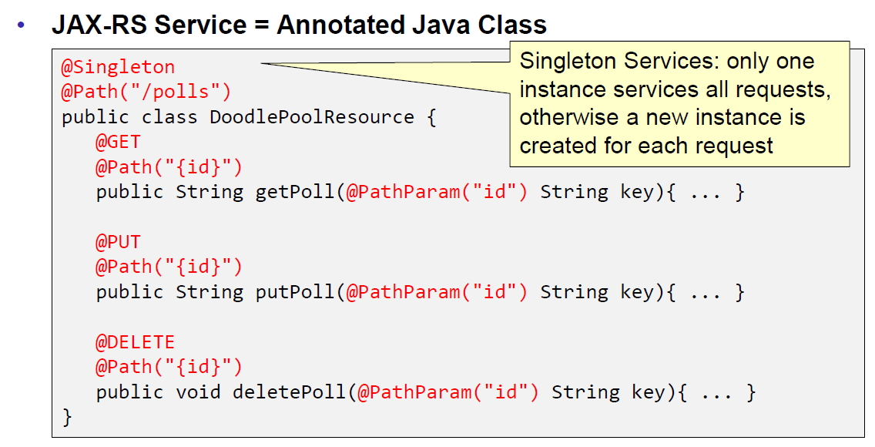

### JAX-RS HTTP Methods

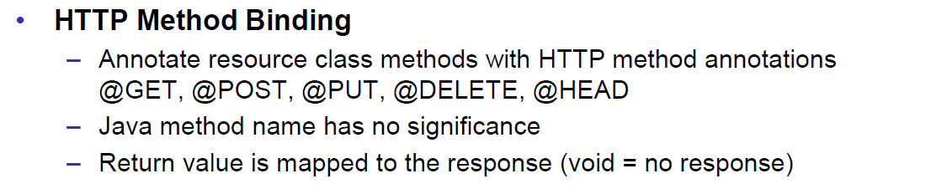

### JAX-RS Injection

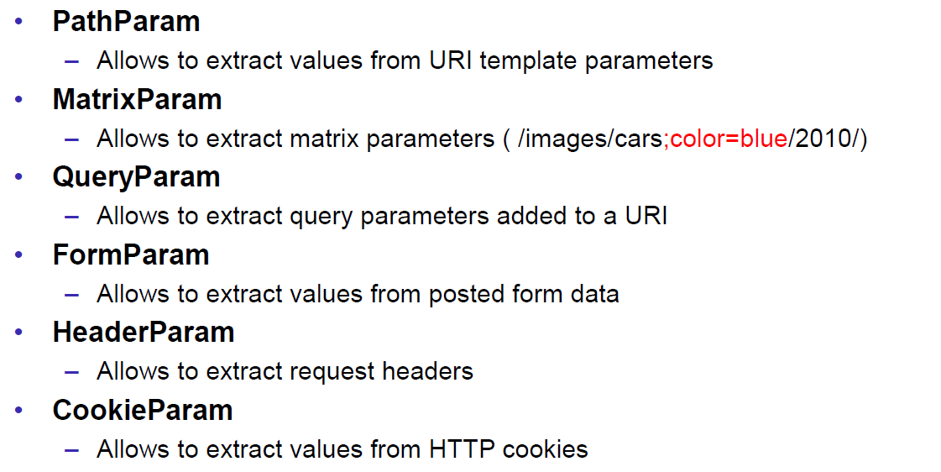

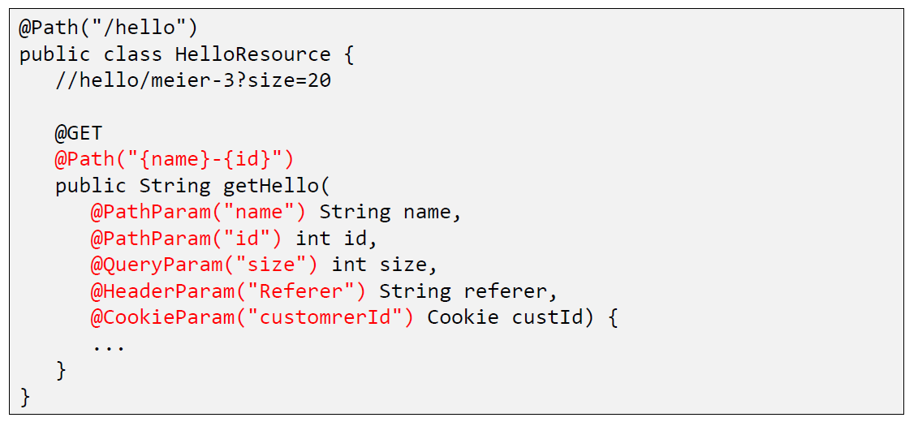

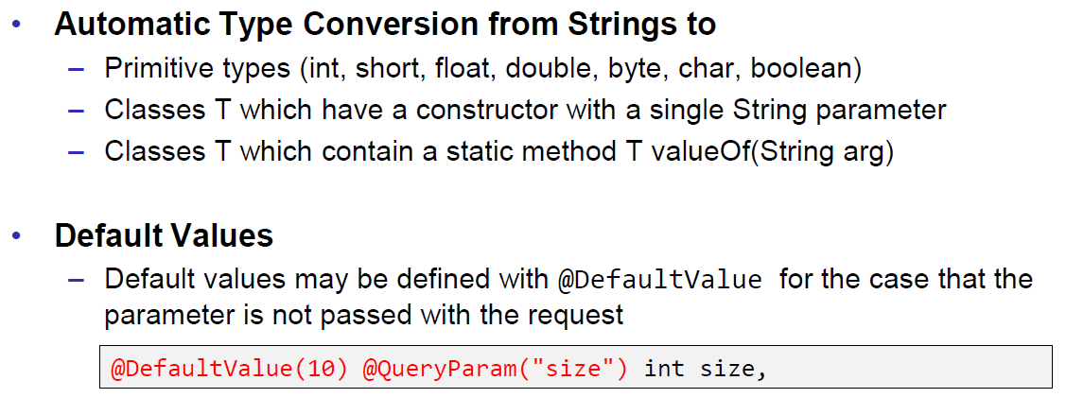

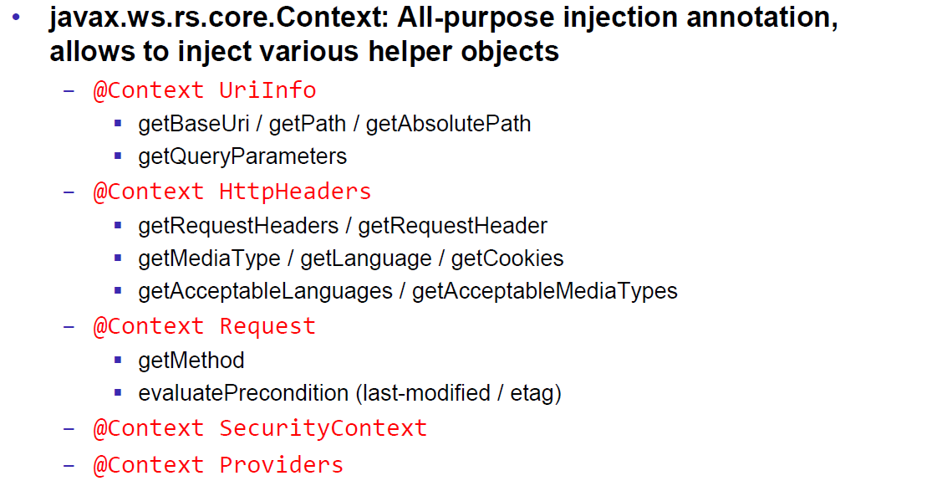

### JAX-RS Content Negotoation

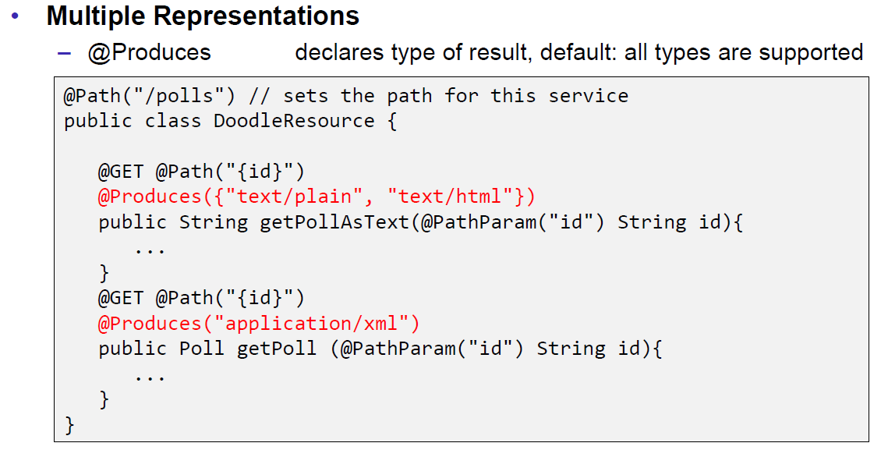

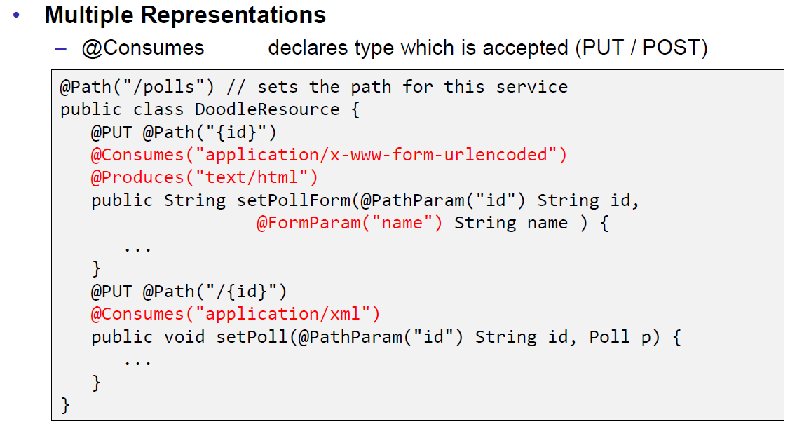

### JAX-RS Content Handlers

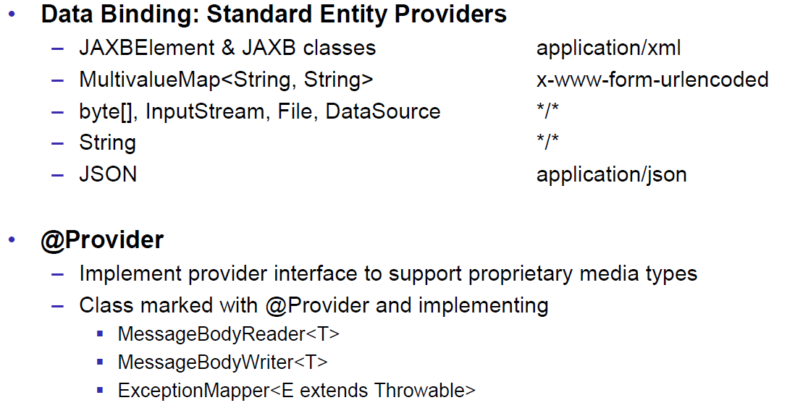

### JAX-RS Responses

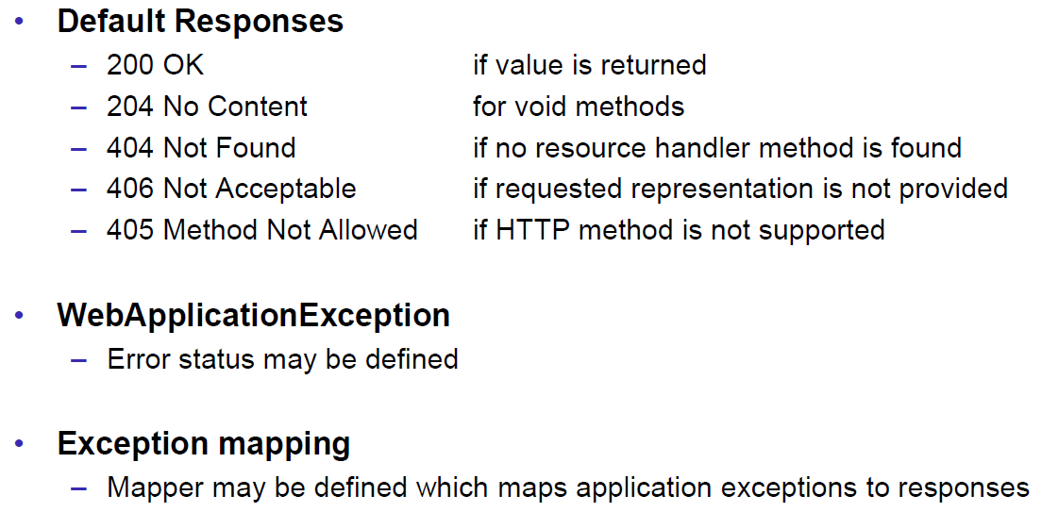

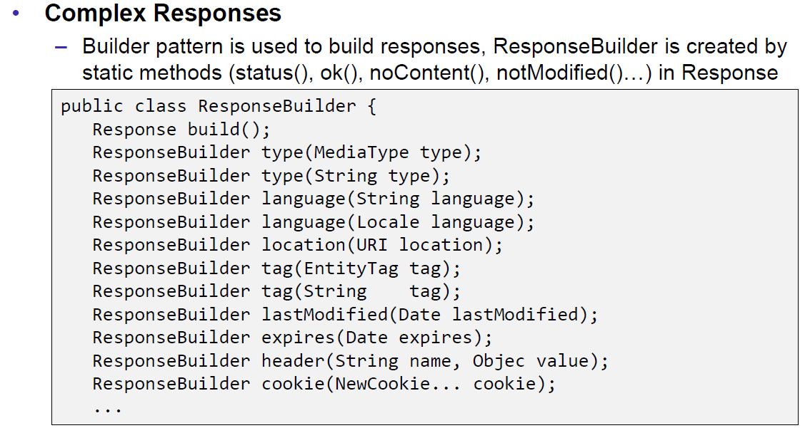

### JAX-RS Conditional GET

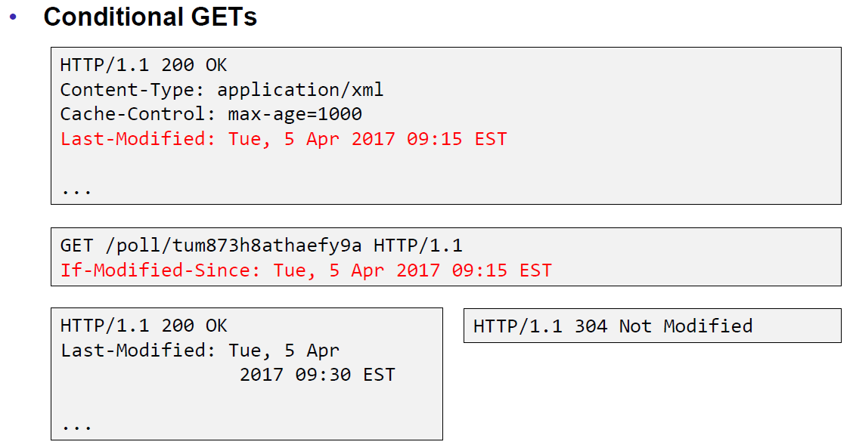

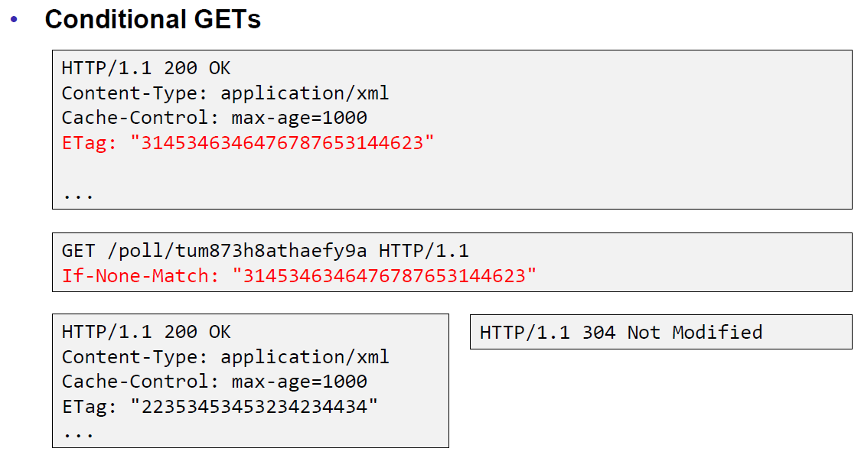

### JAX-RS Cache Control

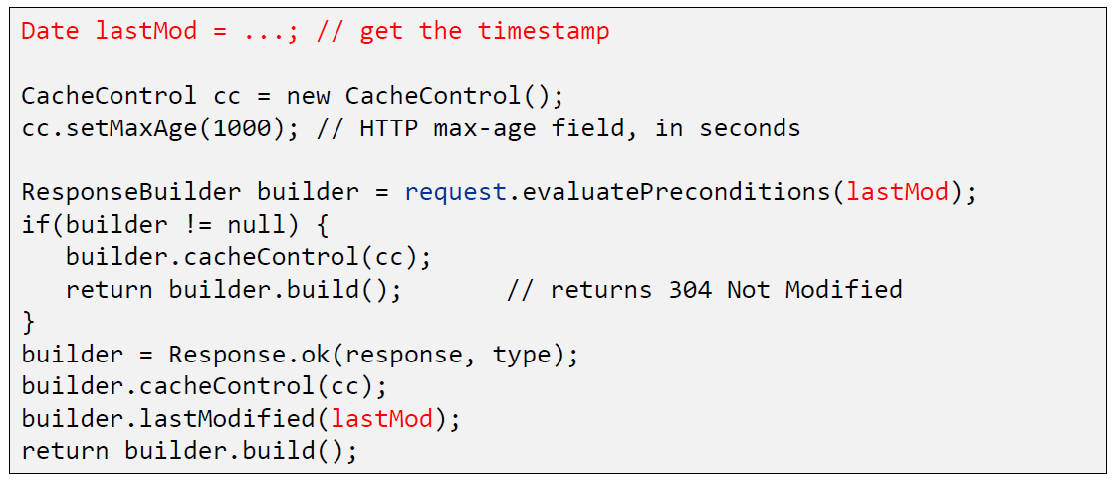

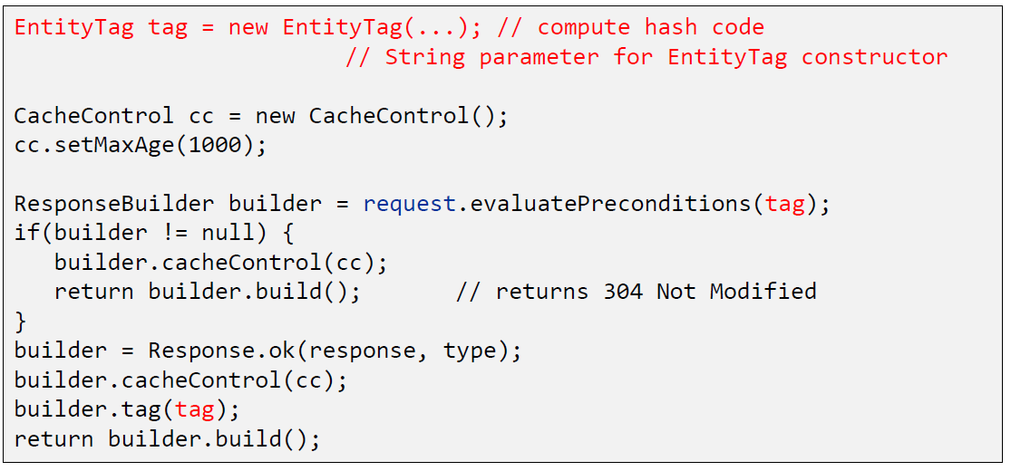

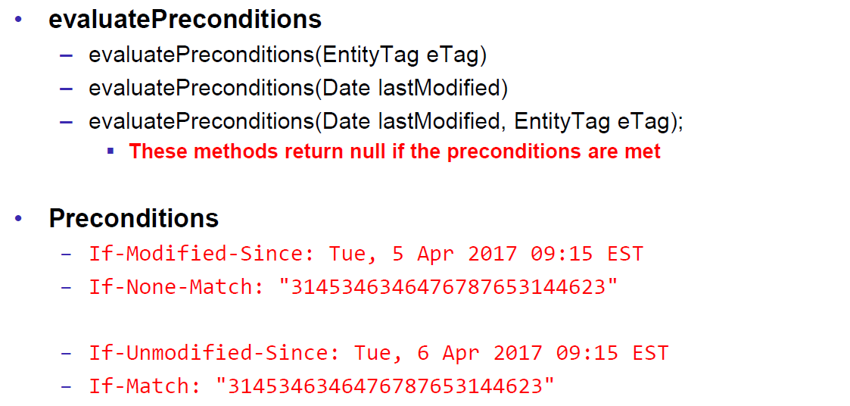

### JAX-RS Optimistic Locking

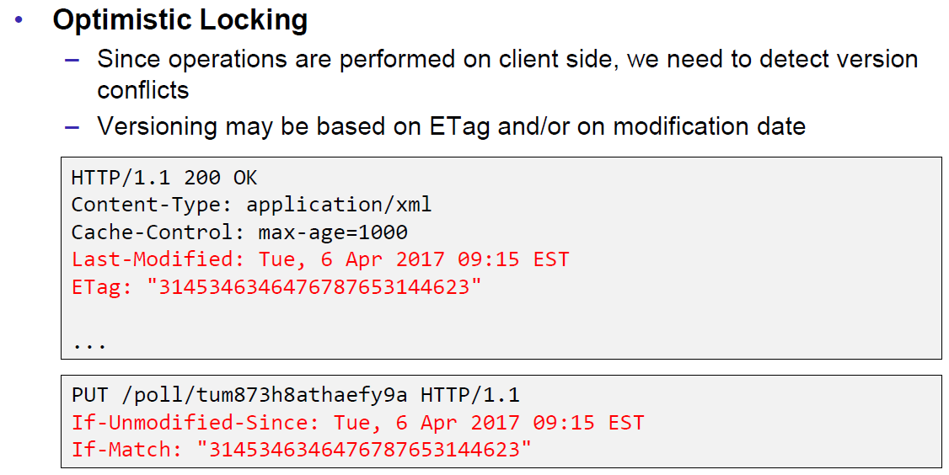

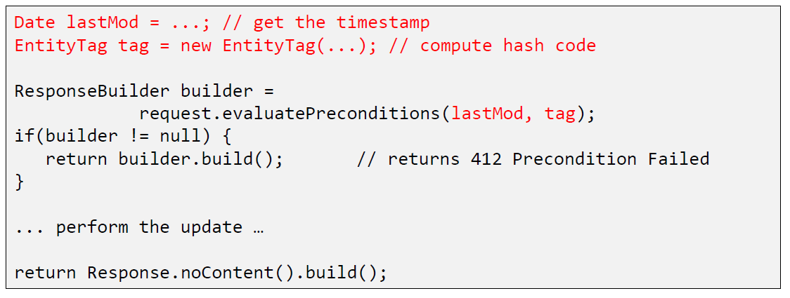

### JAX-RS Deployment

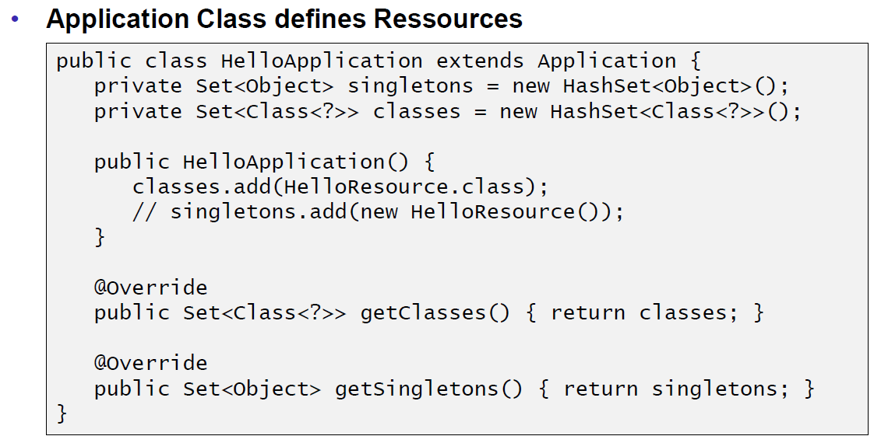

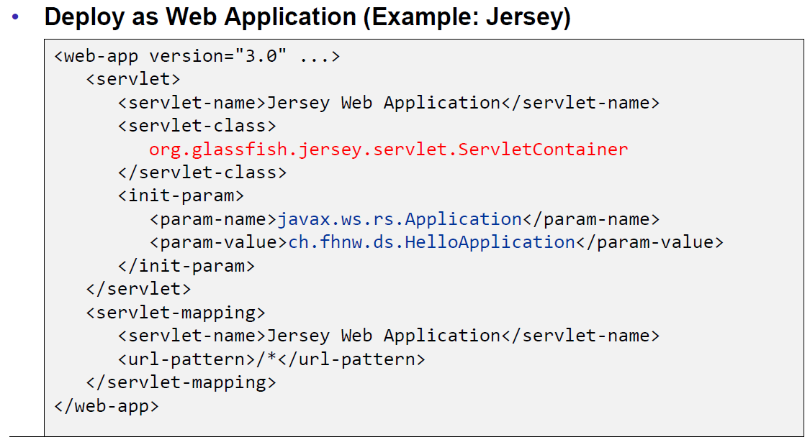

### Deploy Stand Alone via Jersey

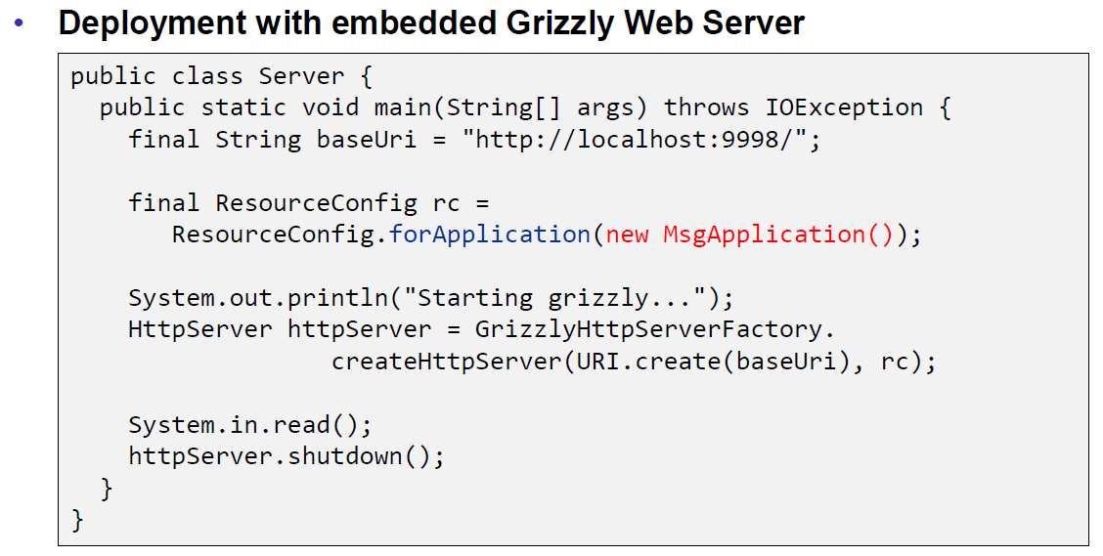

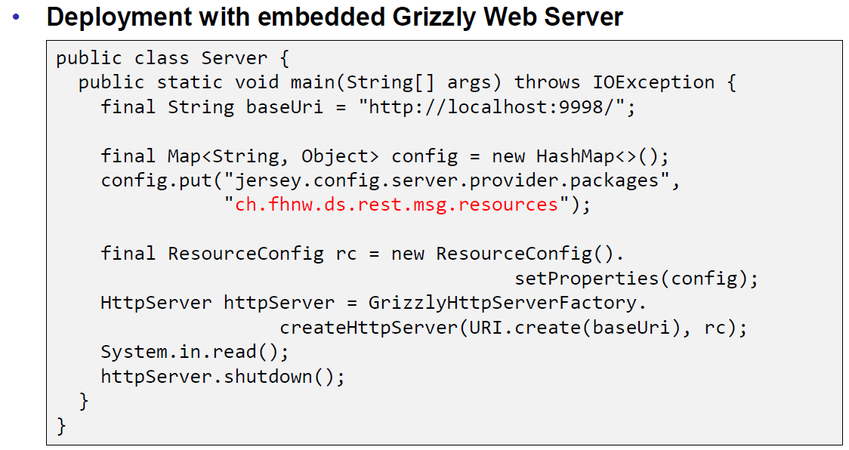

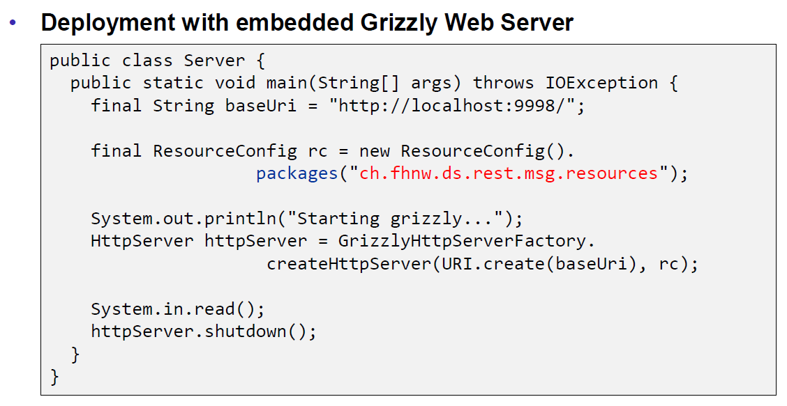

## REST Clients

### JAX-RS Client API

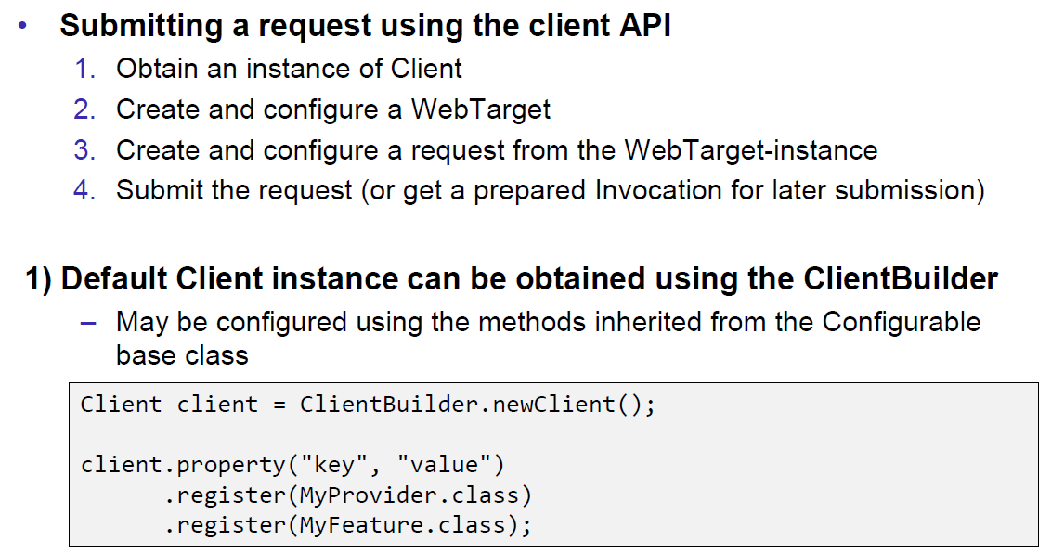

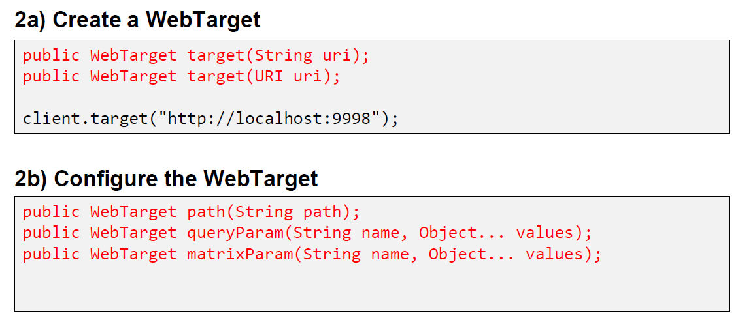

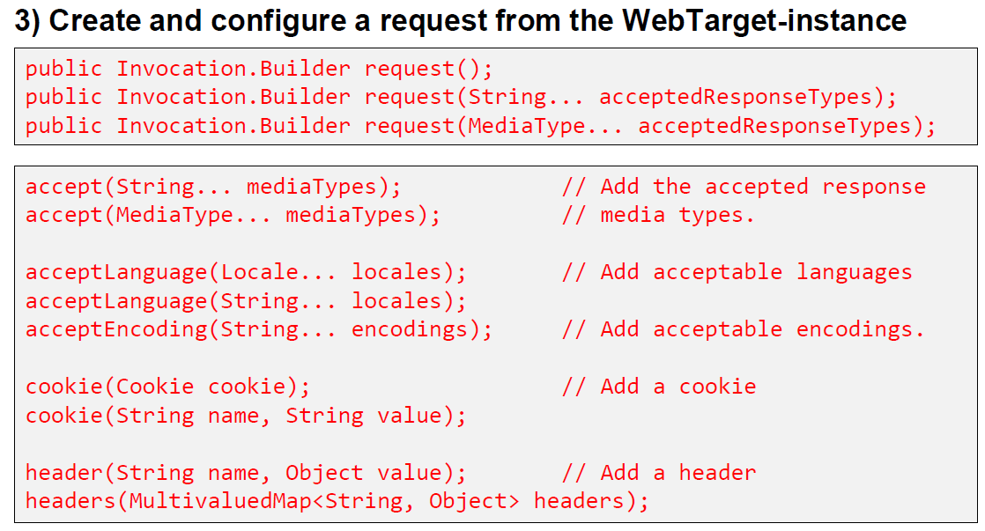

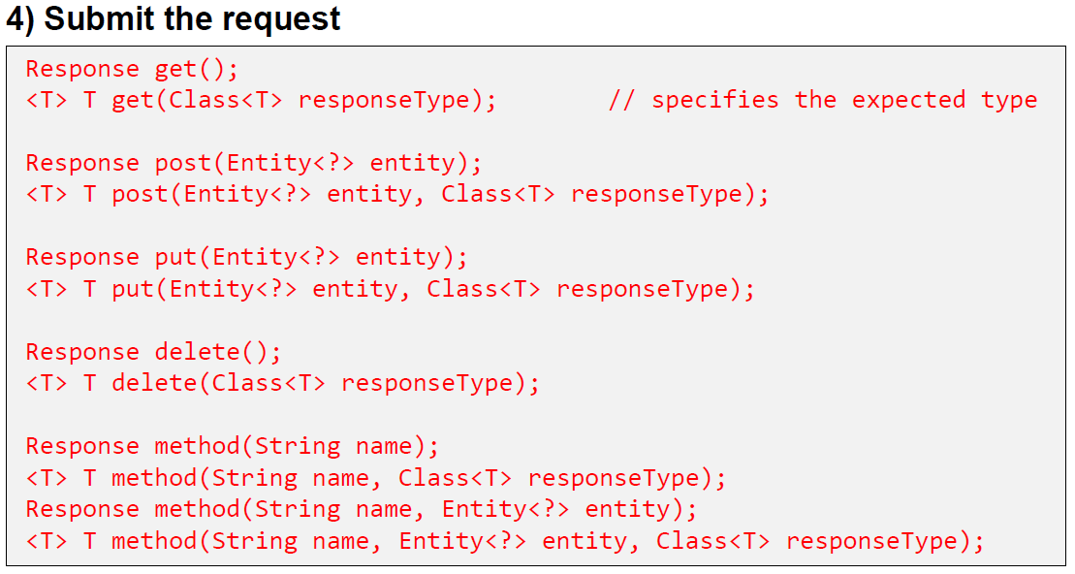

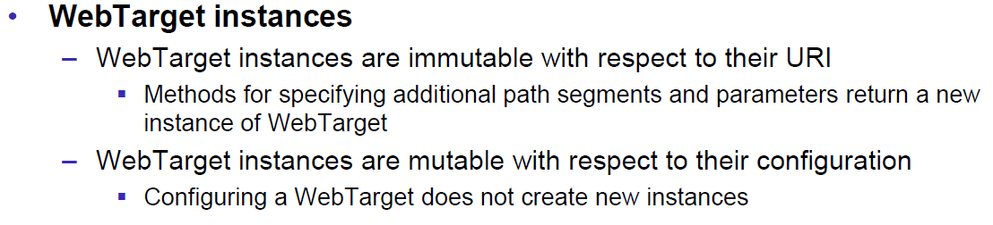

## Resources

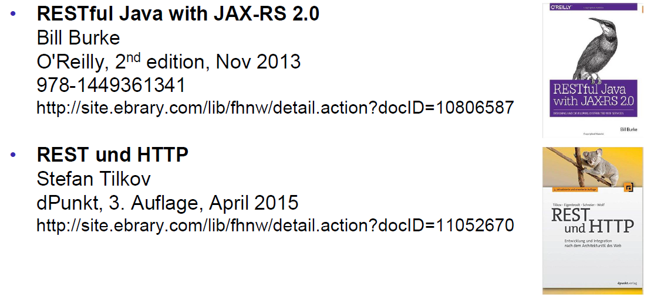

# Woche 7

## REST Data Binding

### JAX-RS Data Binding

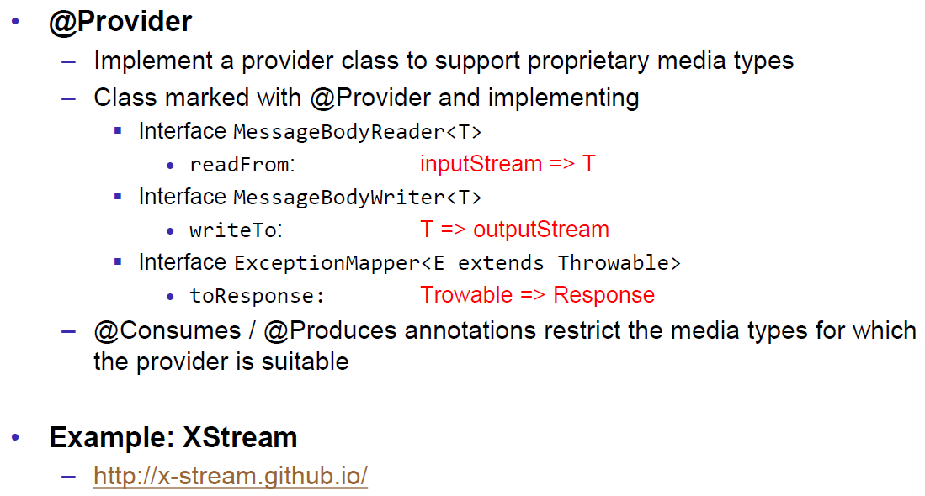

### XStream Provider (Reader)

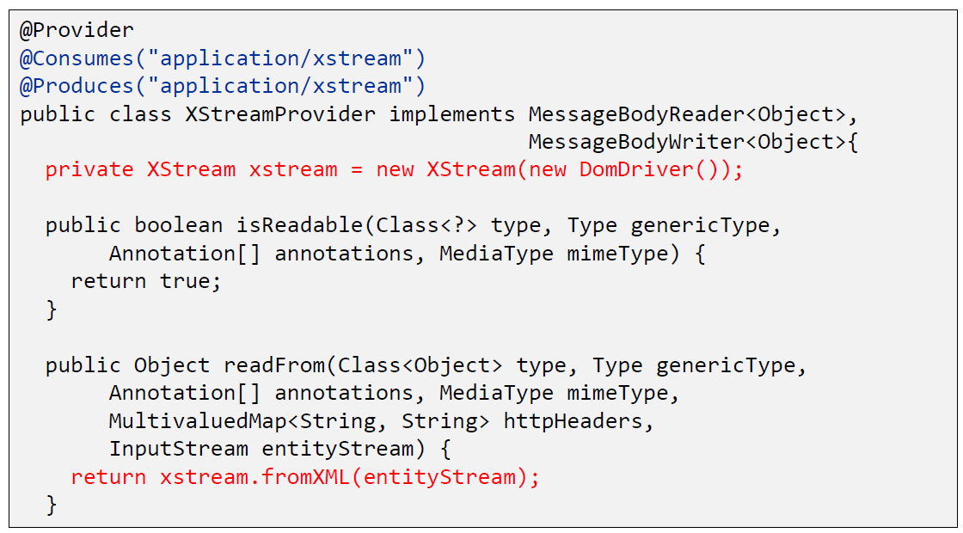

### XStream Provider (Writer)

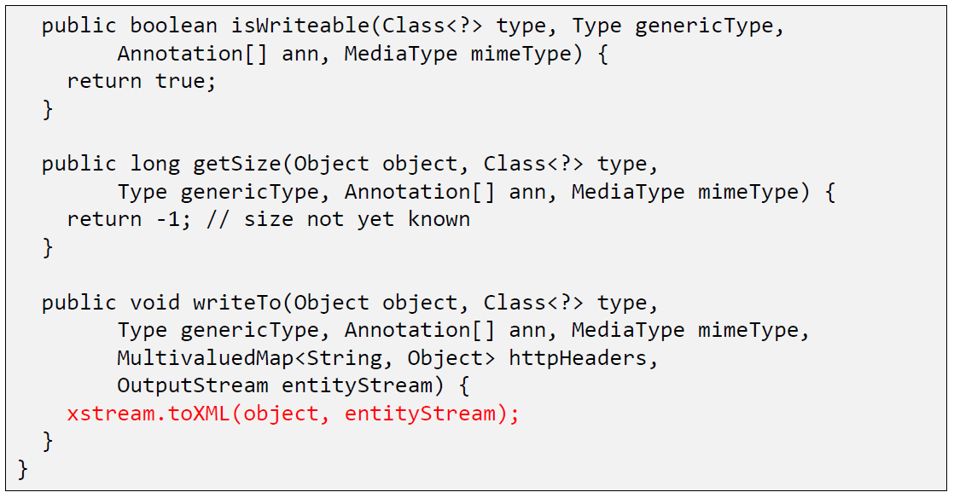

### XStream Example

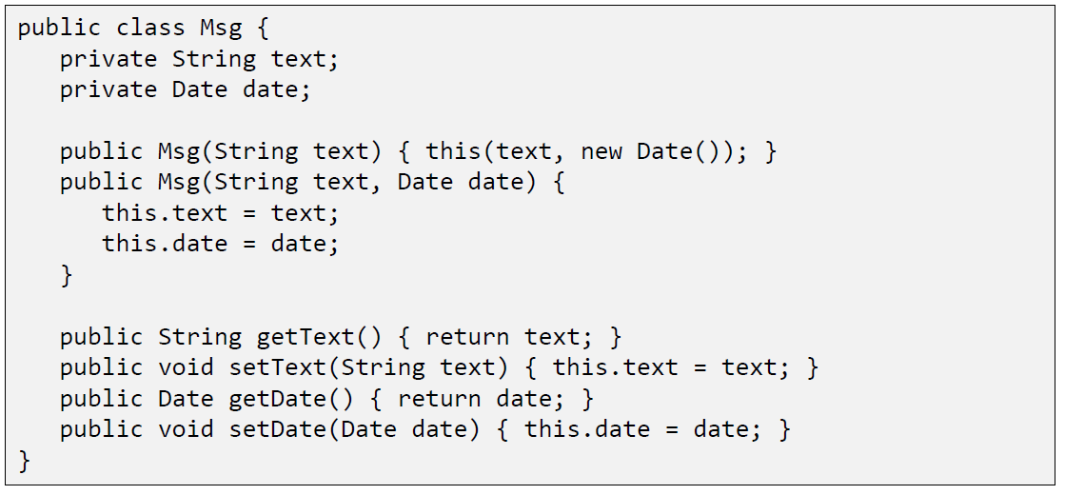

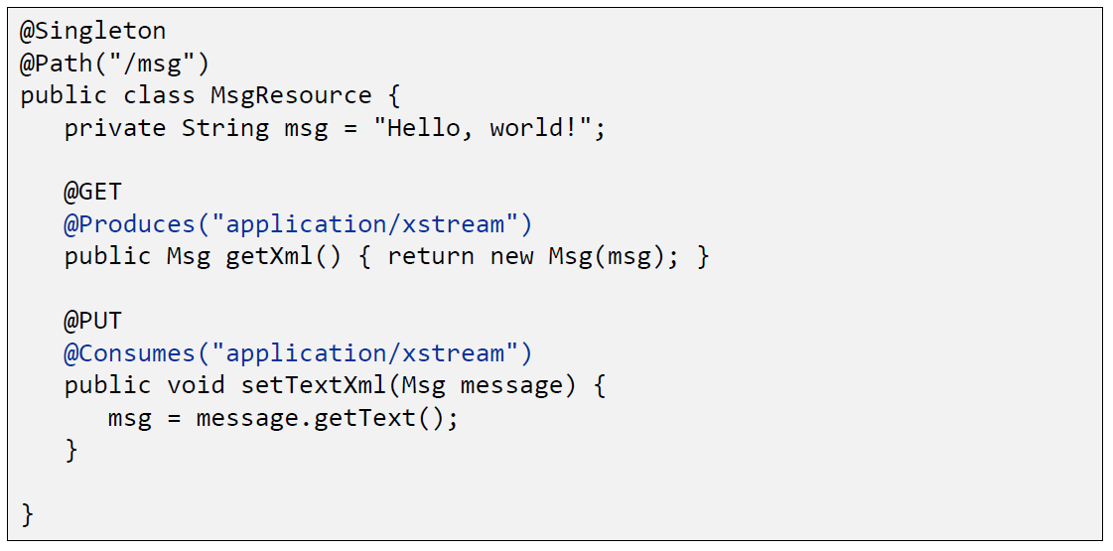

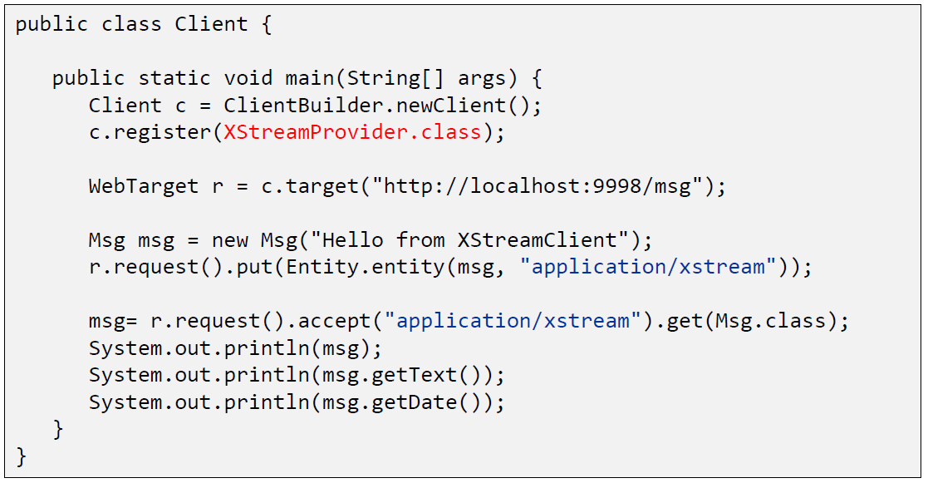

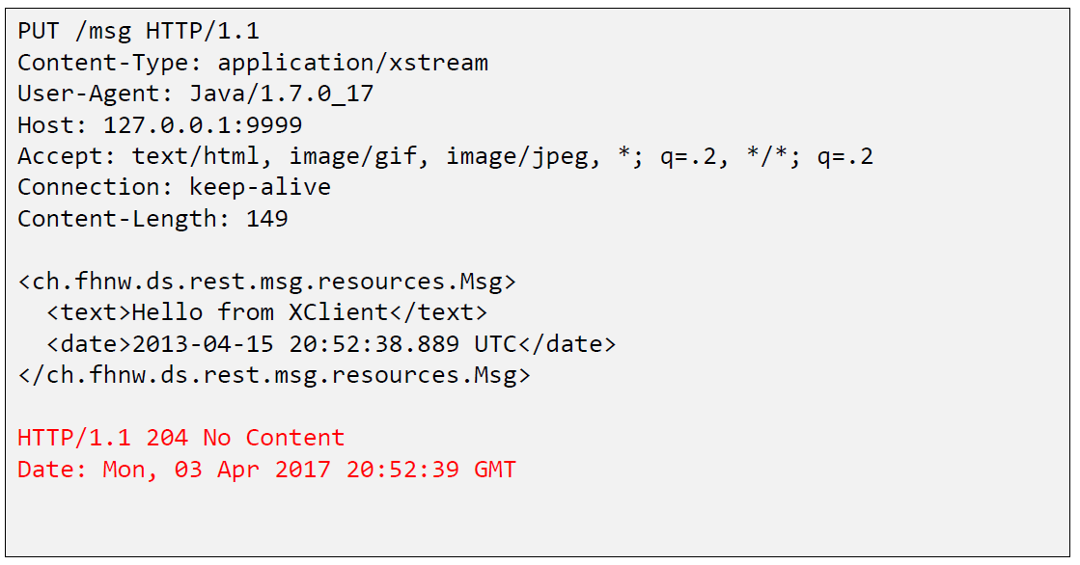

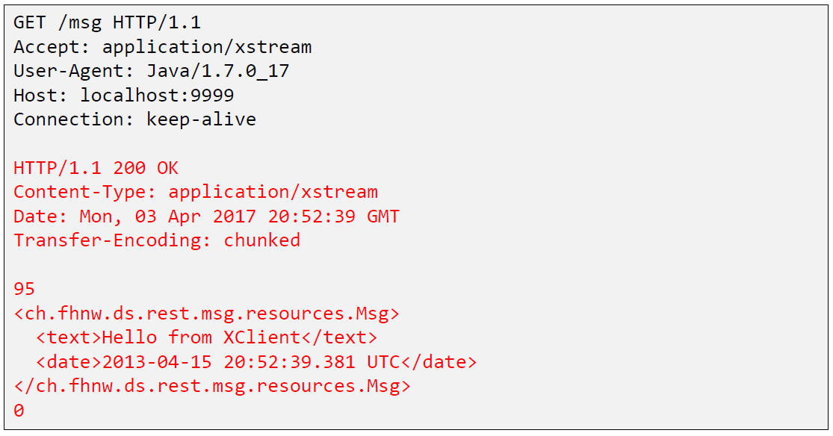

## Java Spark

### Java Spark

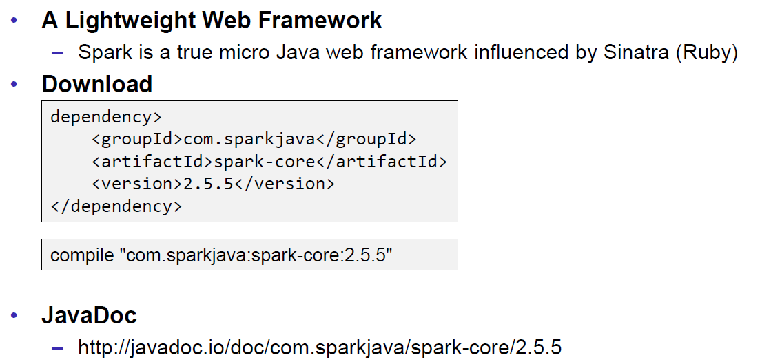

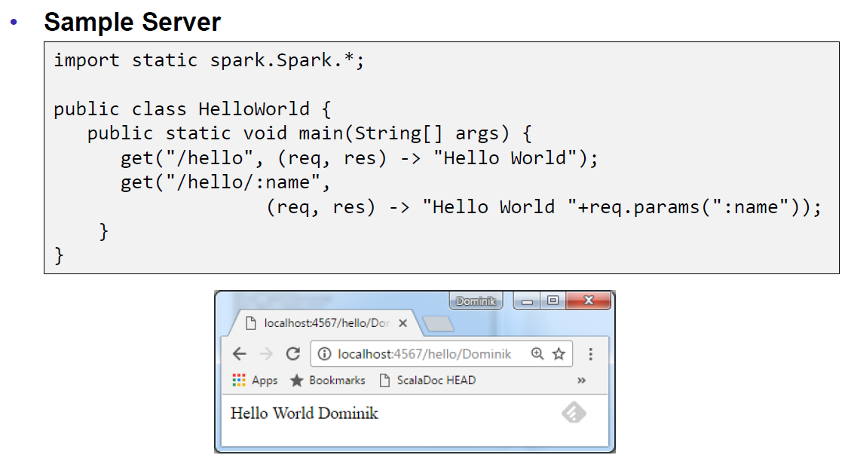

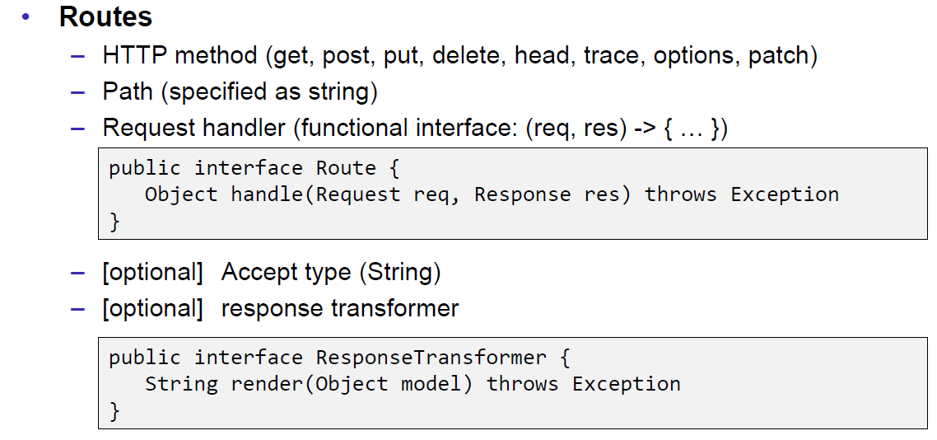

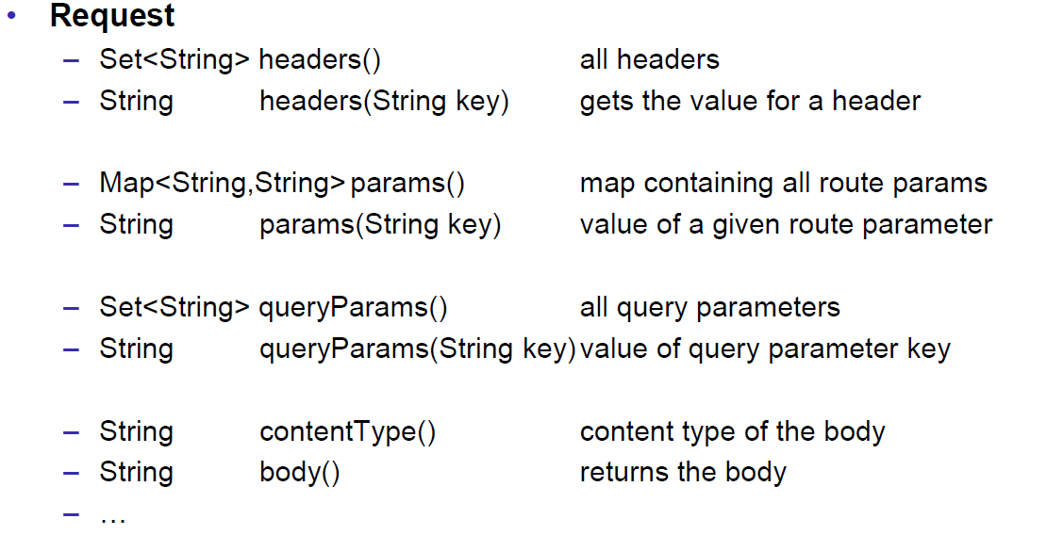

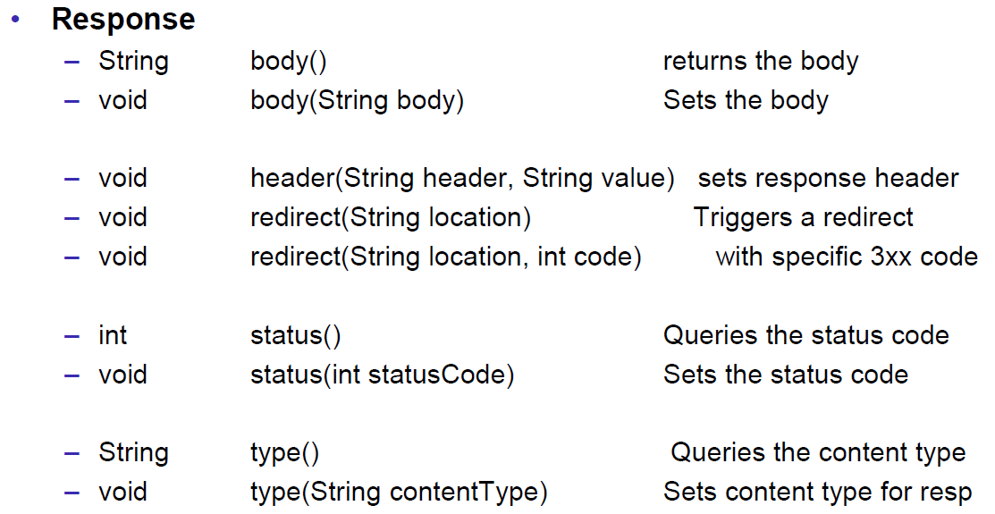

## JAXB

### JAXB Java Architecture for XML Binding

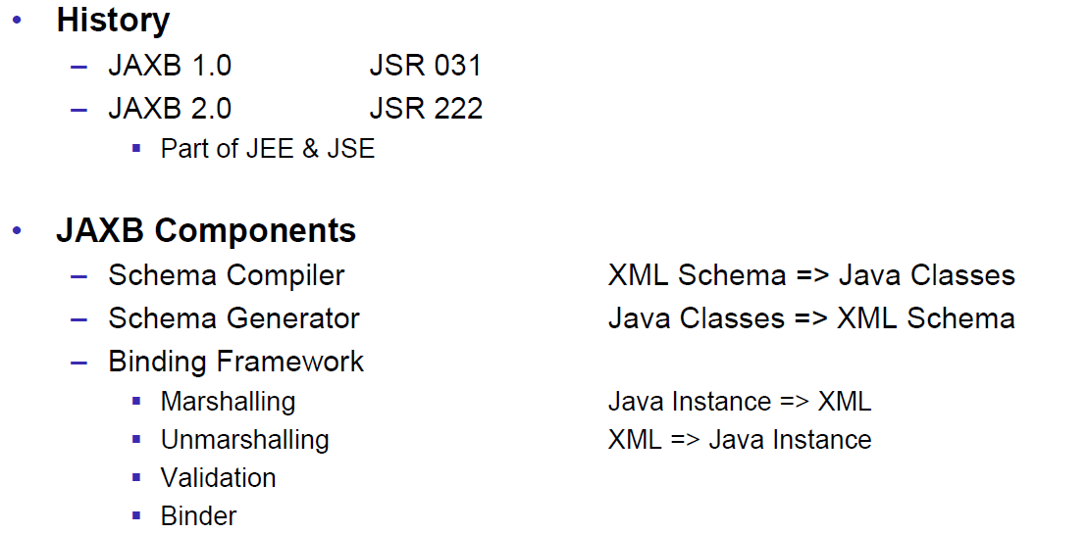

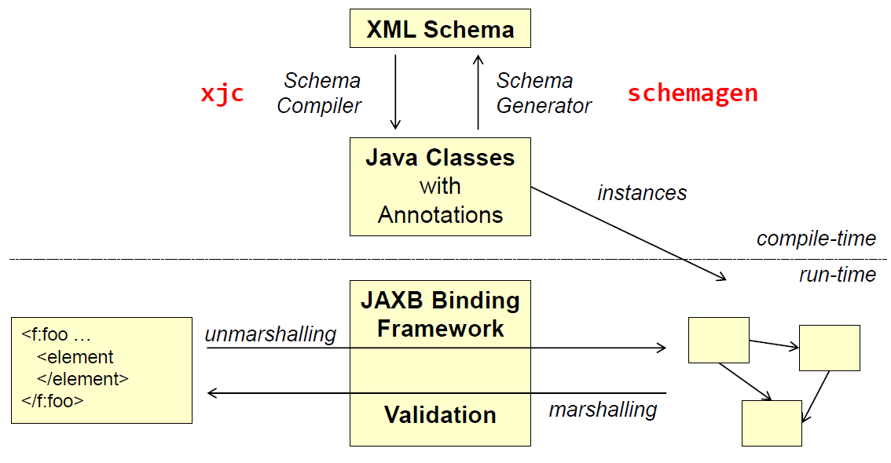

### XML Schema

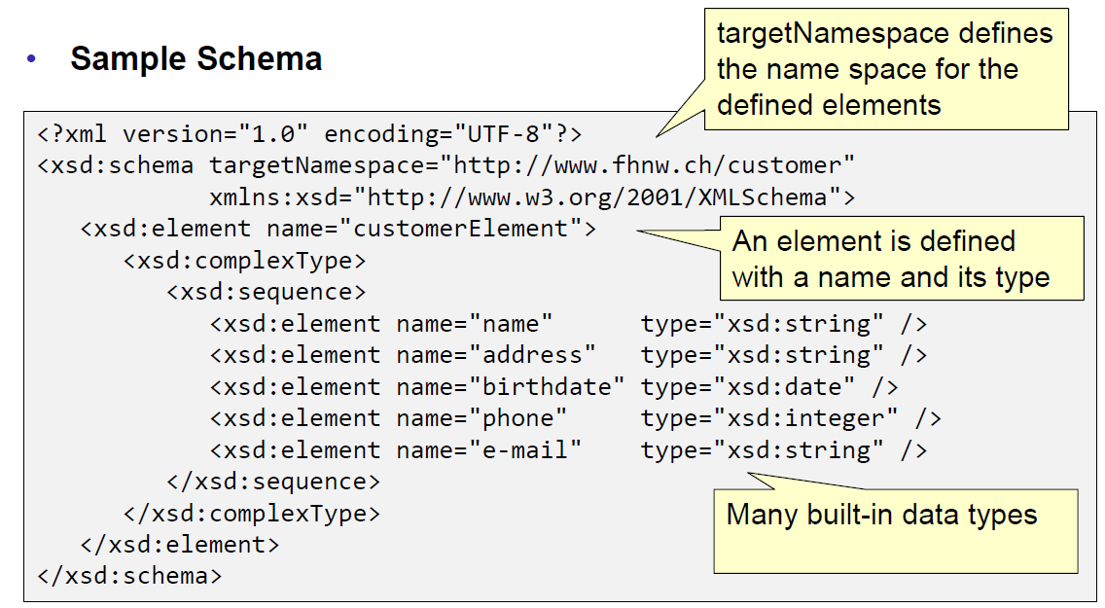

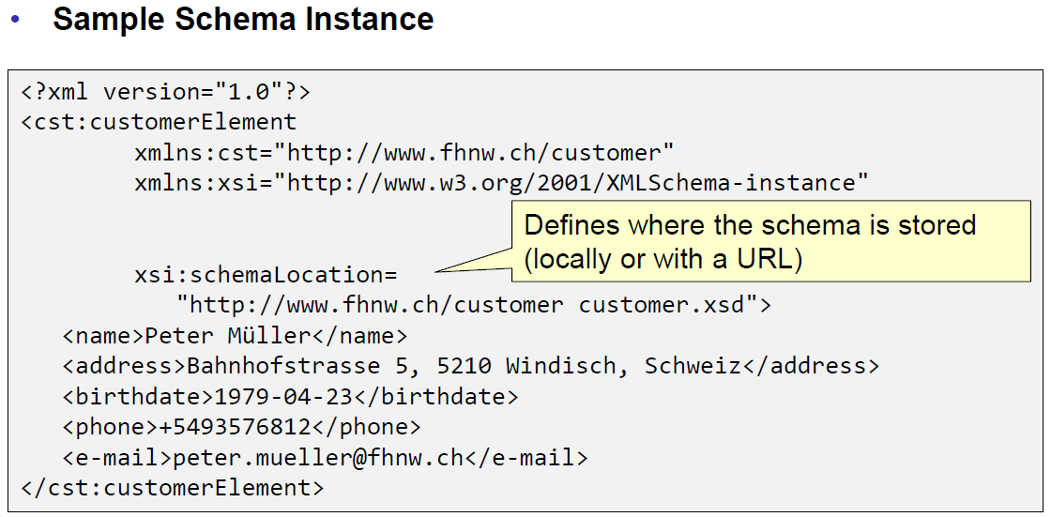

### Schema Compiler & Generator

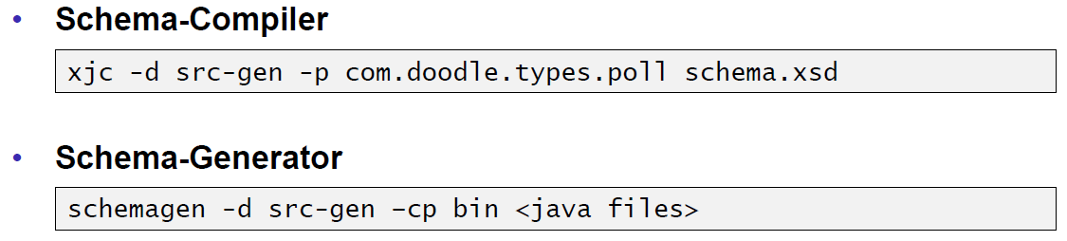

### JAXB Marshaller

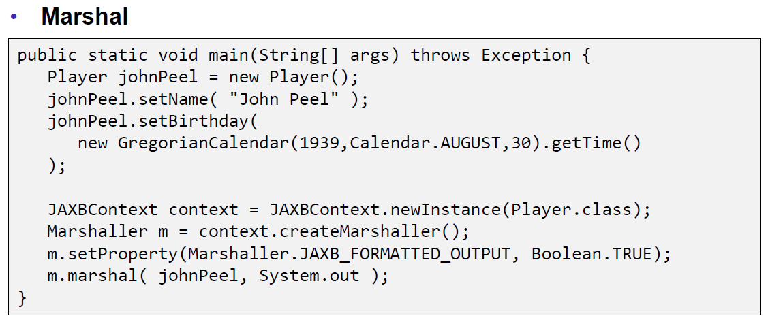

### JAXB Unmarshaller

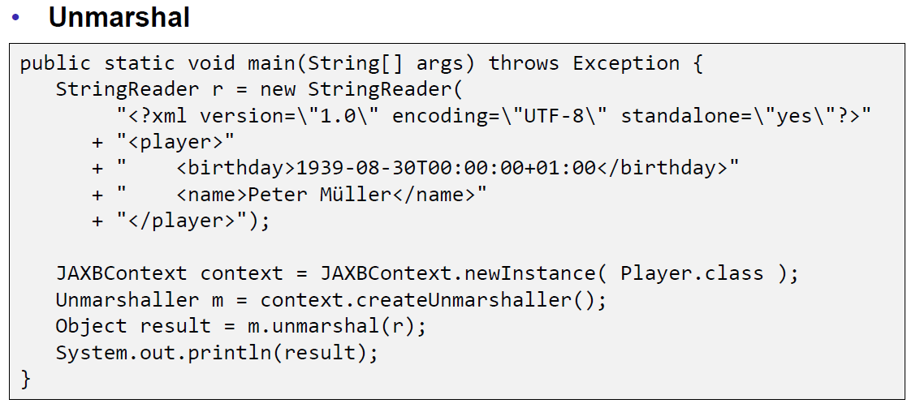

## REST API Description Languages

### Swagger

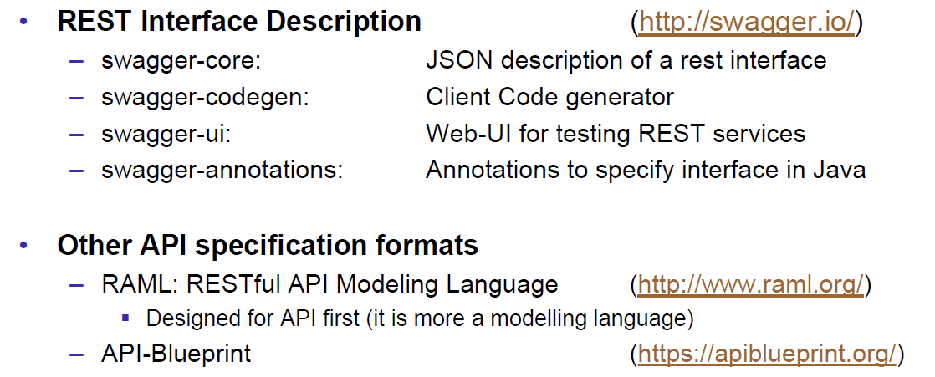

### Swagger Doodle

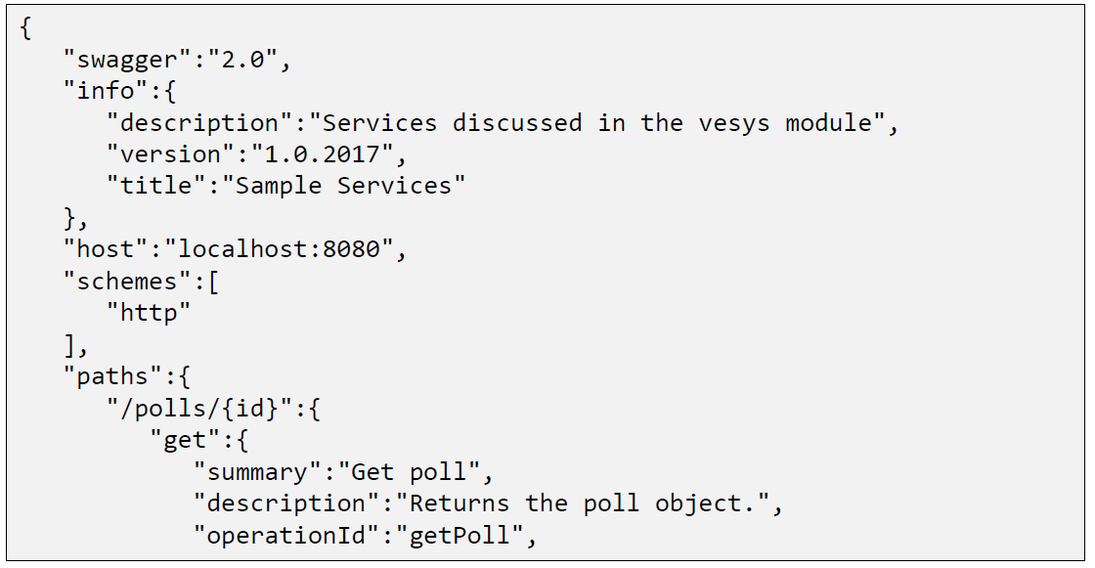

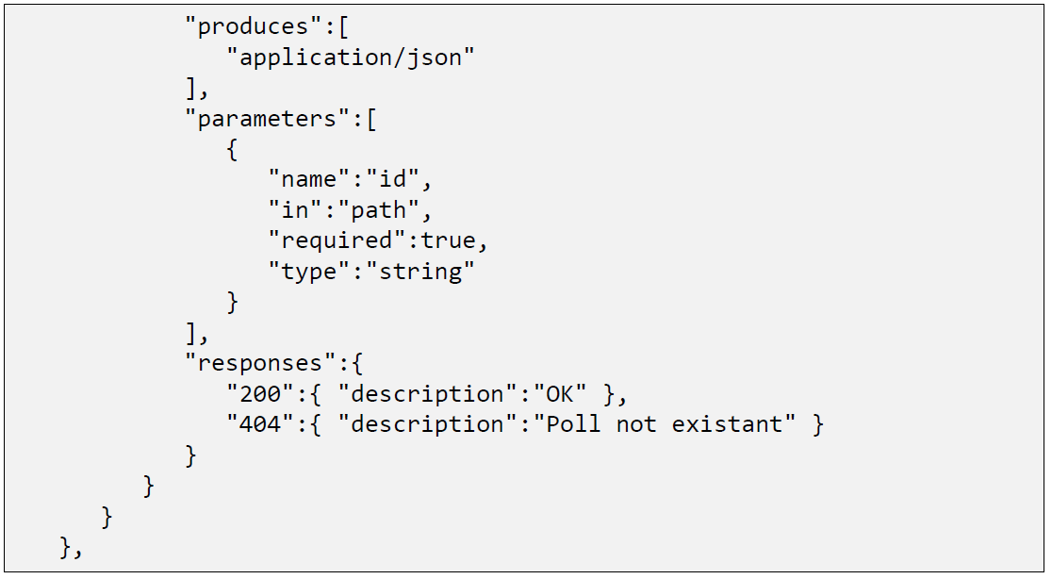

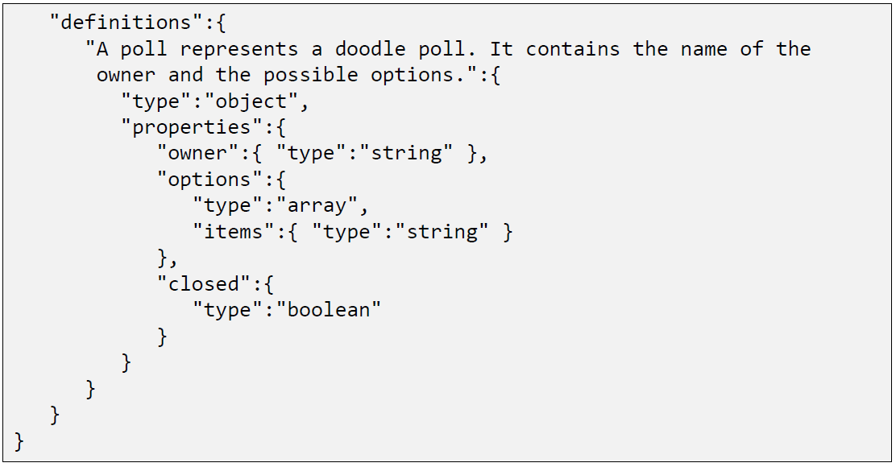

### Swagger Java Annotations

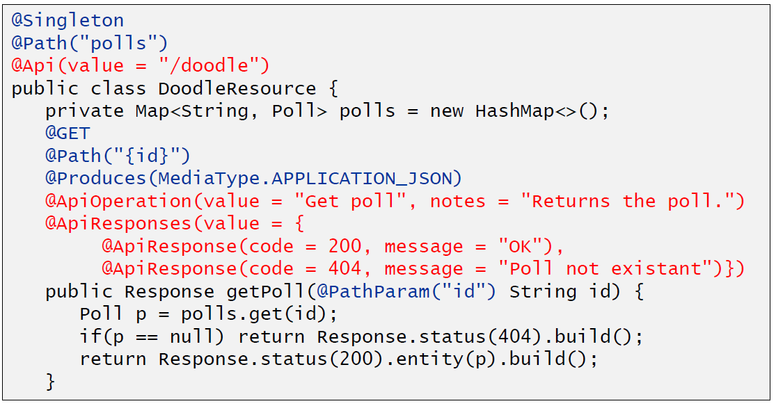

### Swagger GUI

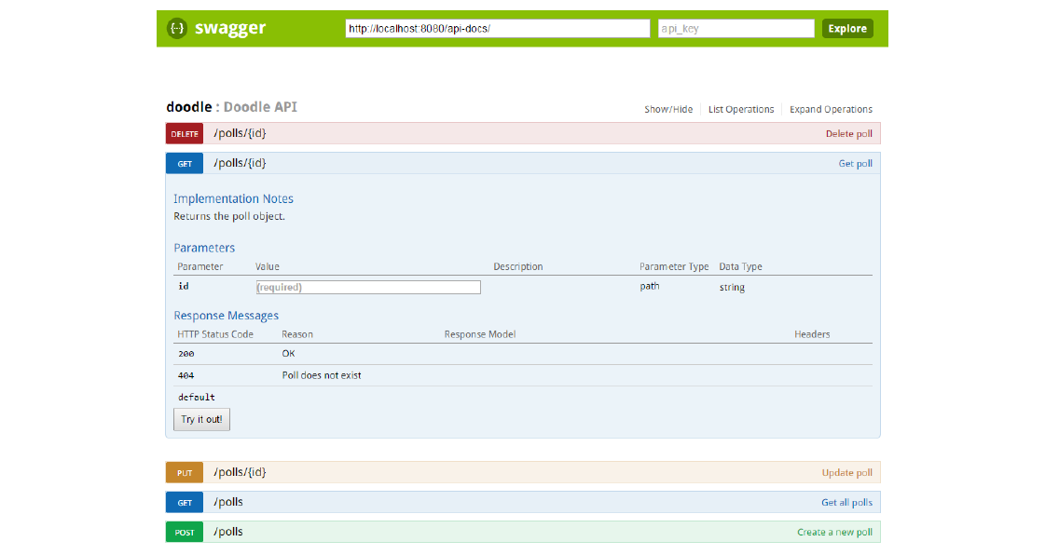

## REST Easy Client Proxy Framework

### RestEasy Client Proxy Framework

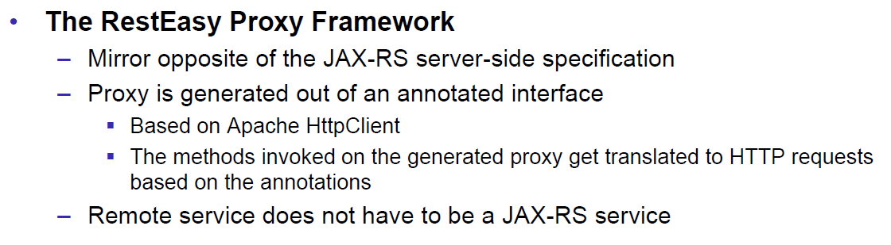

### RestEasy Example

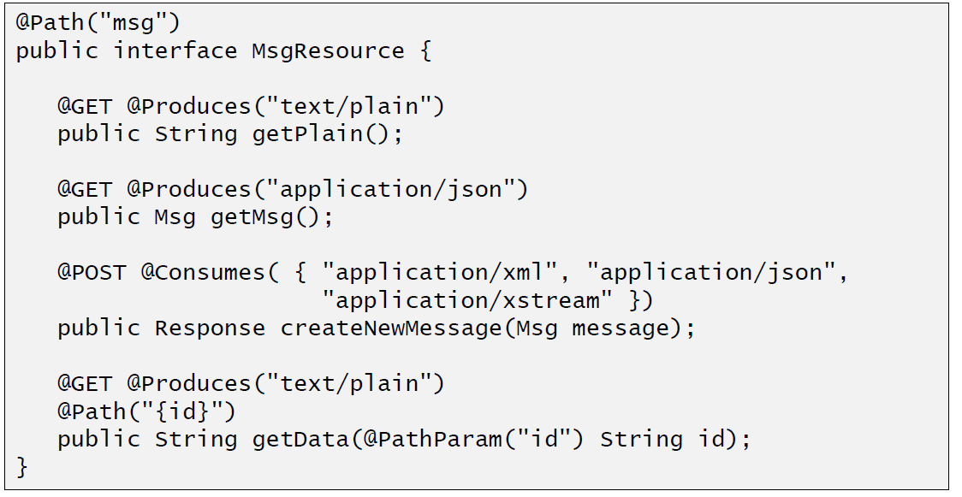

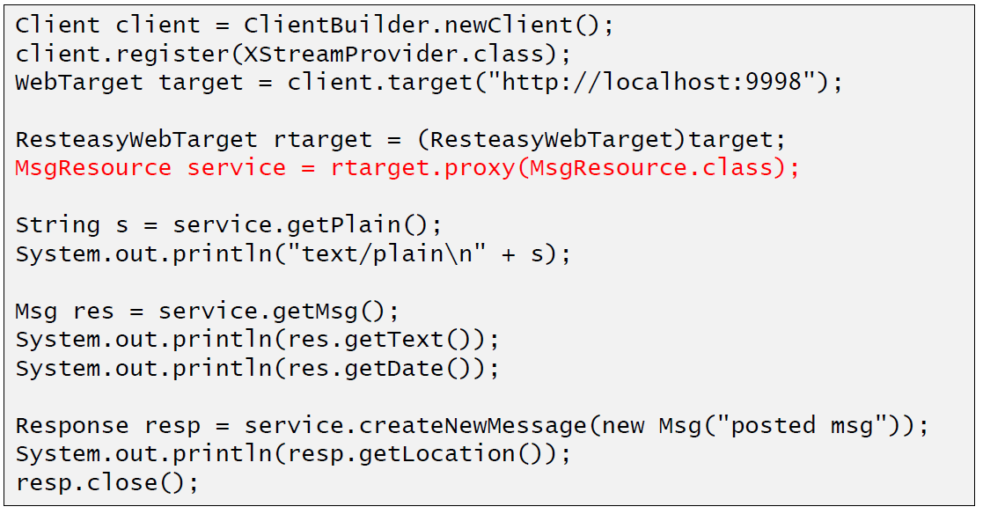

## Resources

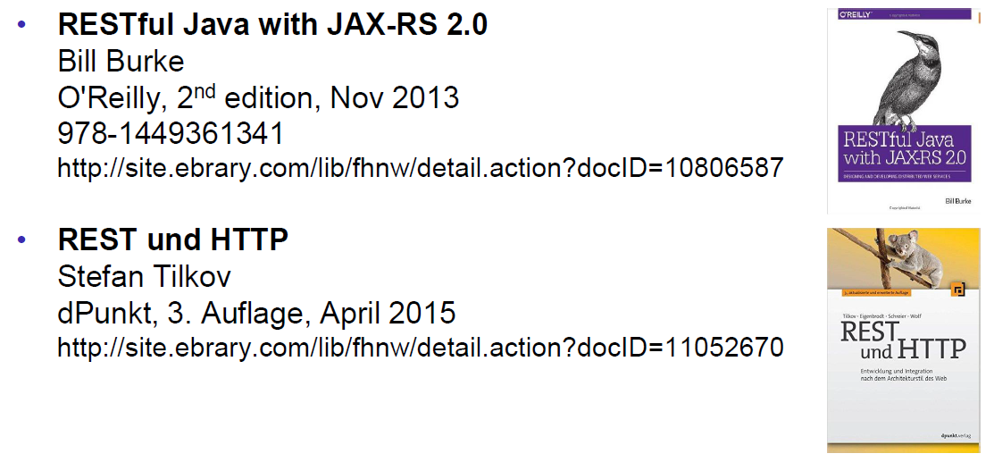

# Woche 8

## RMI Overview

### Communication Technologies

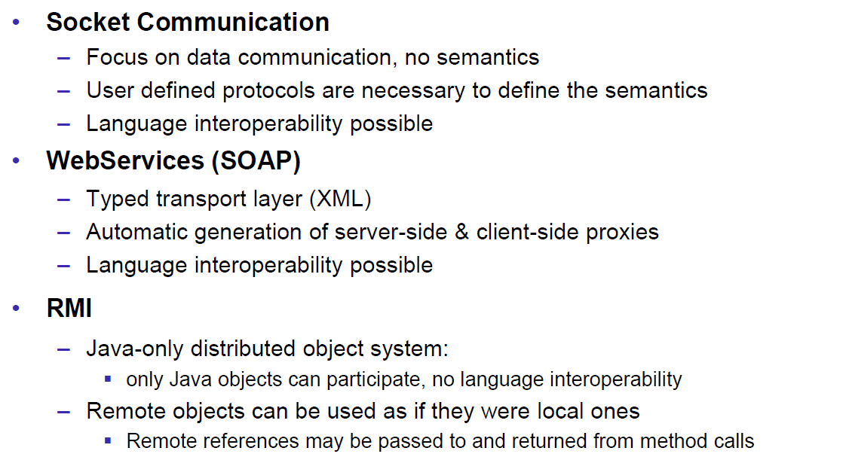

### Communication Architectures

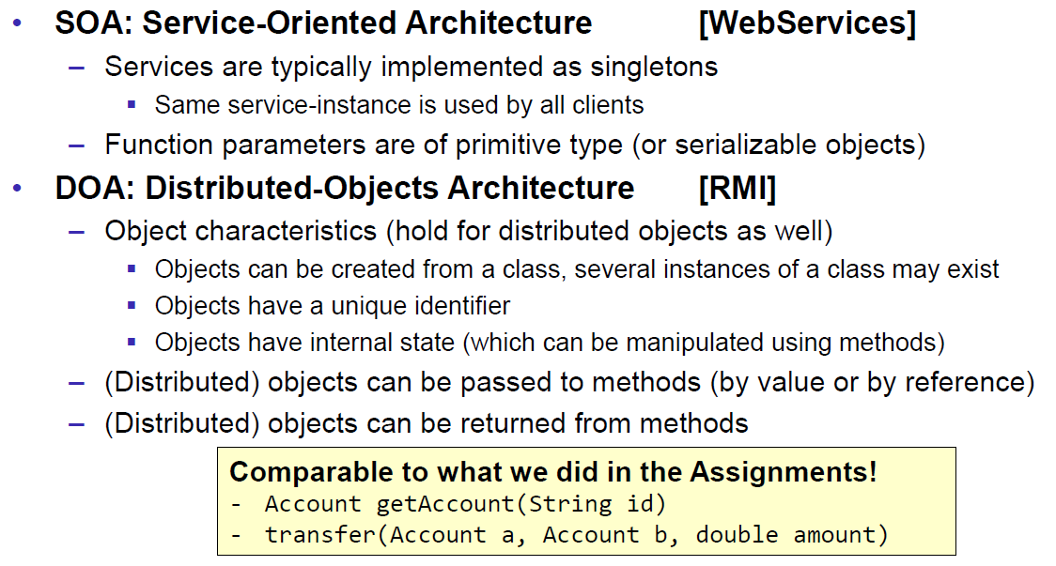

### Excursion: Proxy Pattern

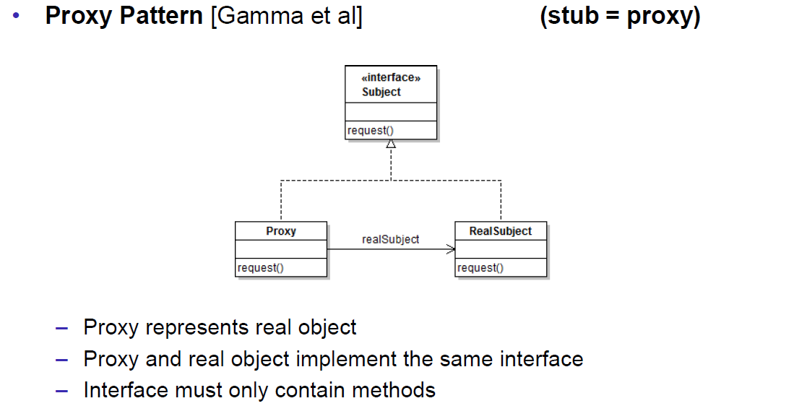

### Proxy Layer Stub and Skeleton

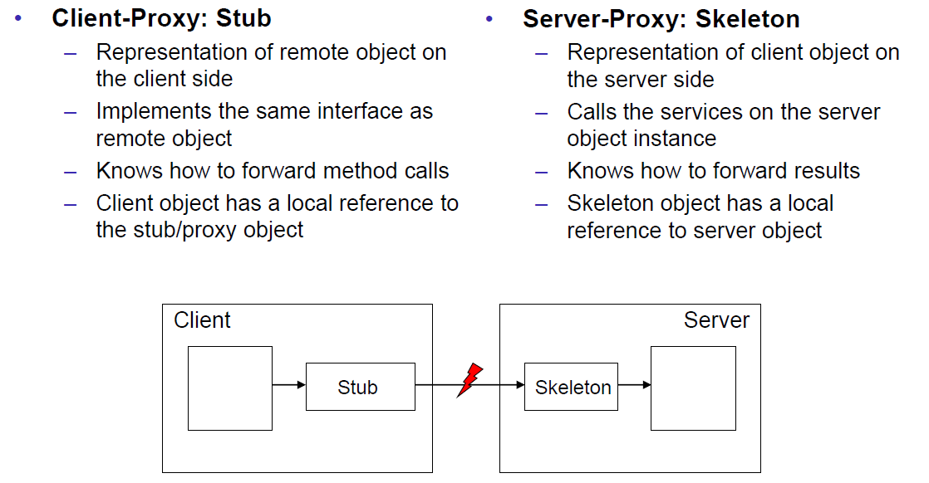

## RMI Step by Step

### Using RMI

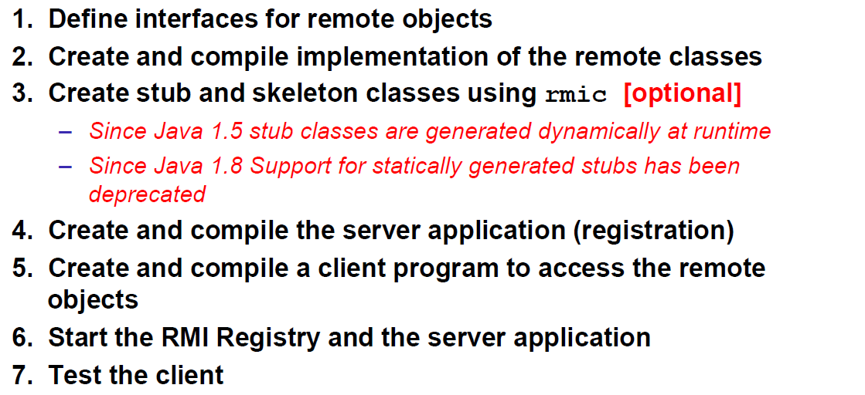

### 1.) Remote Interfaces

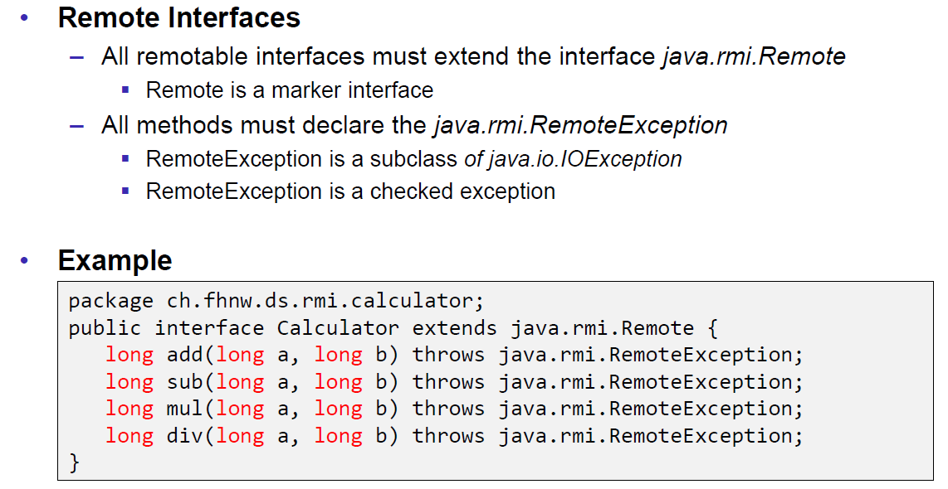

### 2.) Implementation

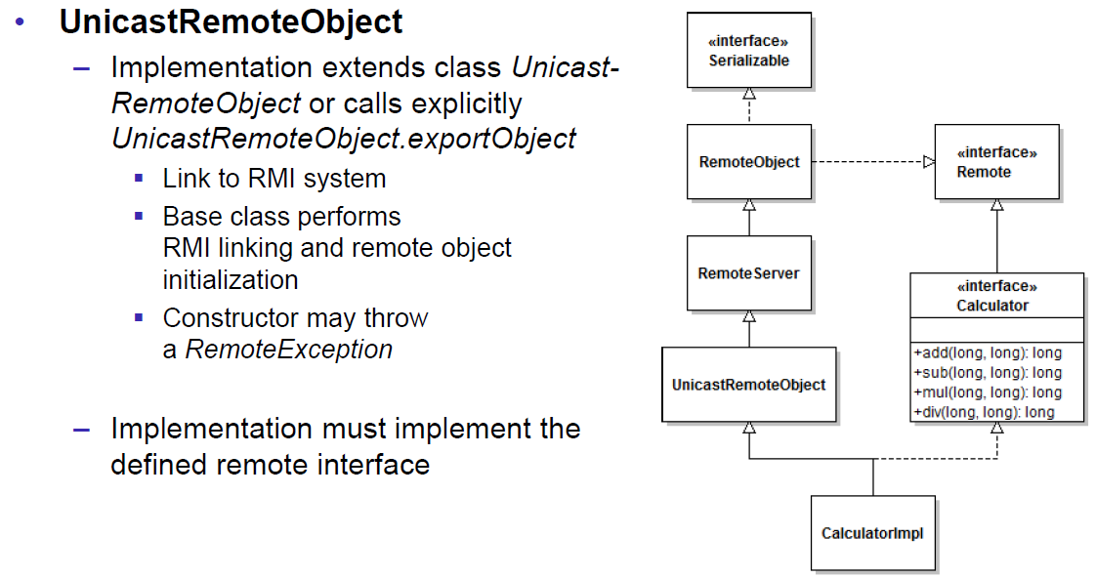

### 2.) Example

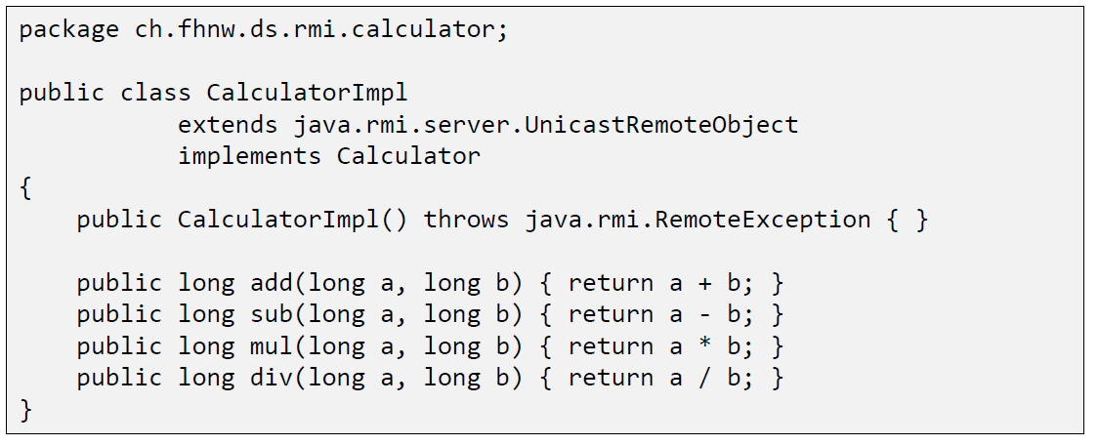

### 3.) Create Stubs and Skeletons (Deprecated)

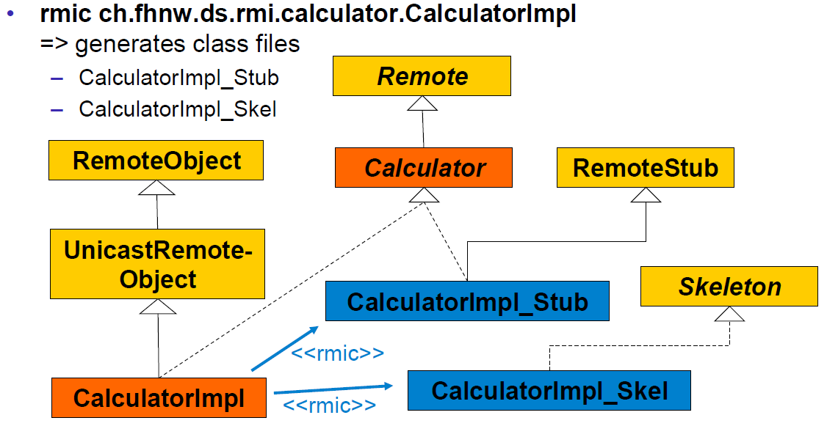

### 3.) Dynamic Stubs since Java 1.5

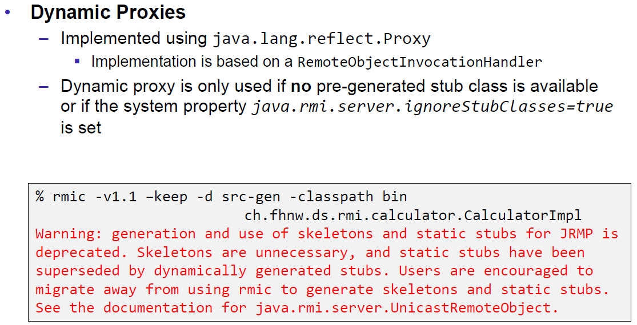

### 4.) Server

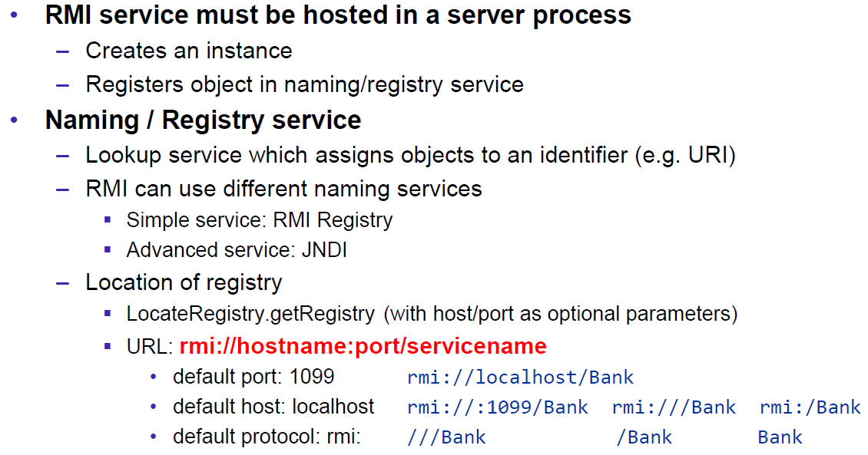

### 4.) Example

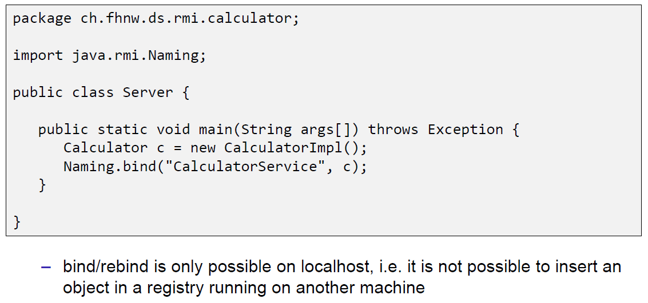

### 4.) and 5.) Naming/Registry

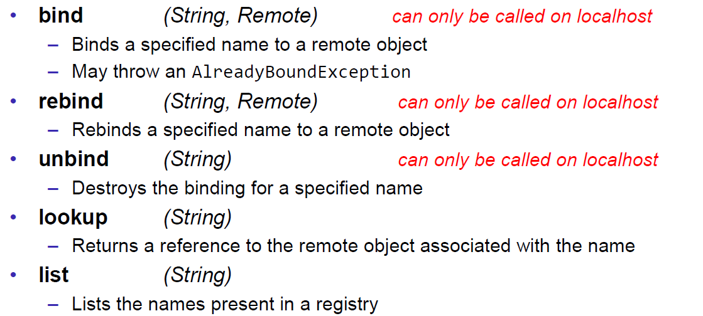

### 5.) Example

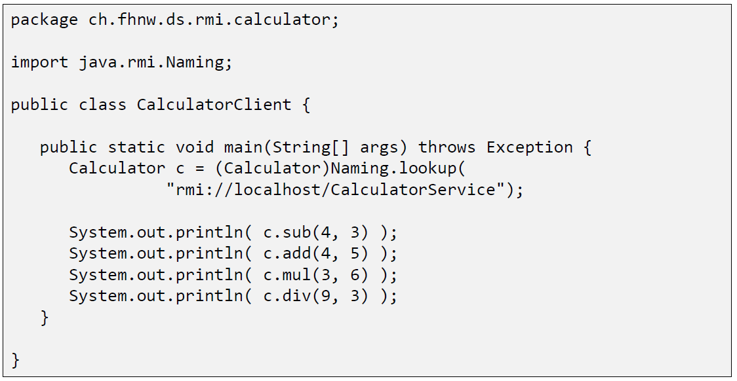

### 6.) Start of RMI Registry & Server

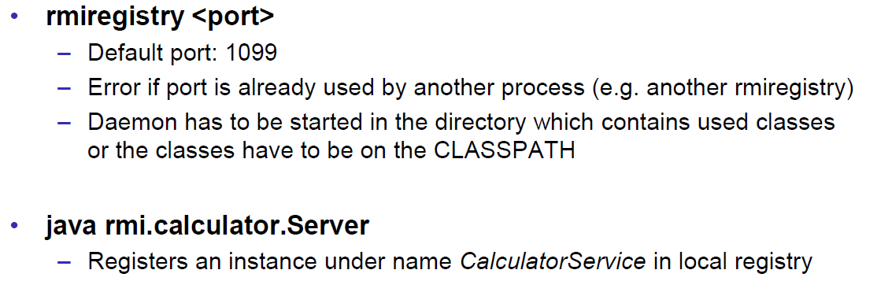

### 6.) Example

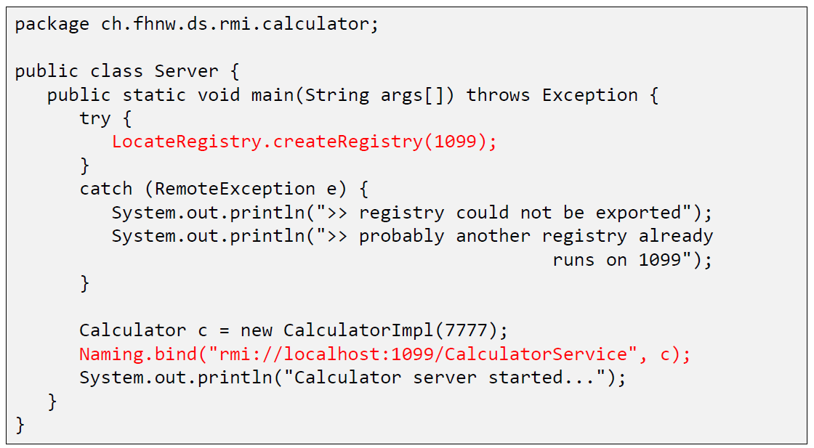

### Example: List of all registered objects

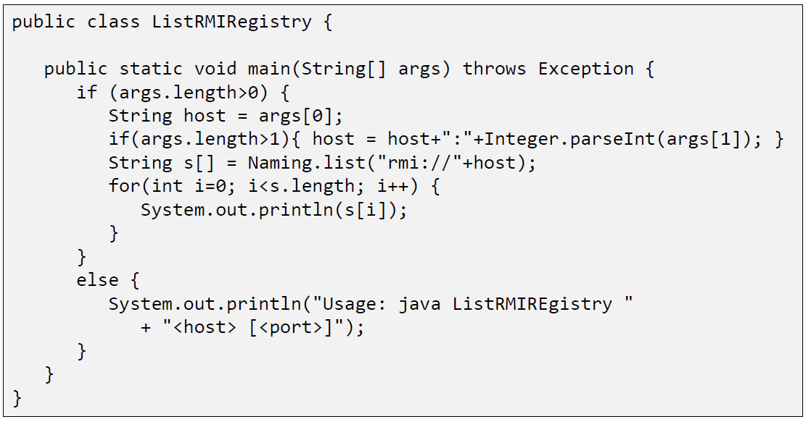

## RMI Marshalling

### Marshalling

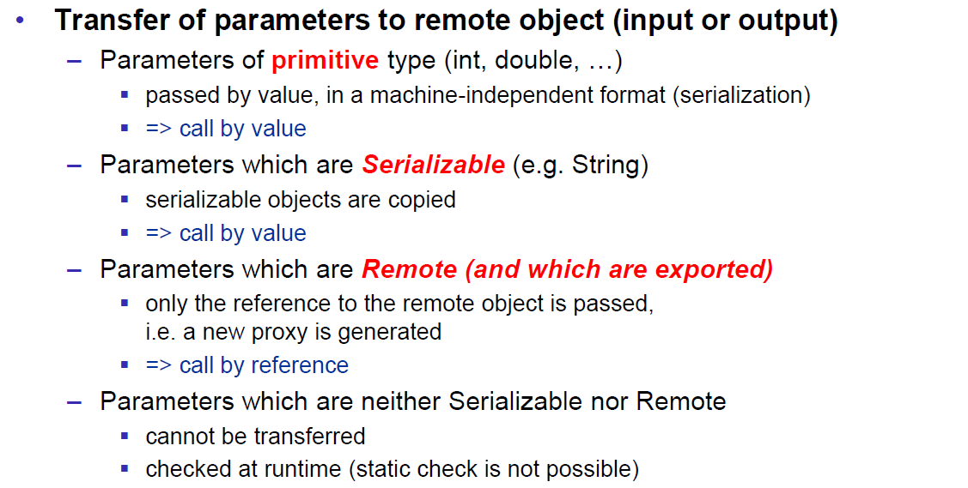

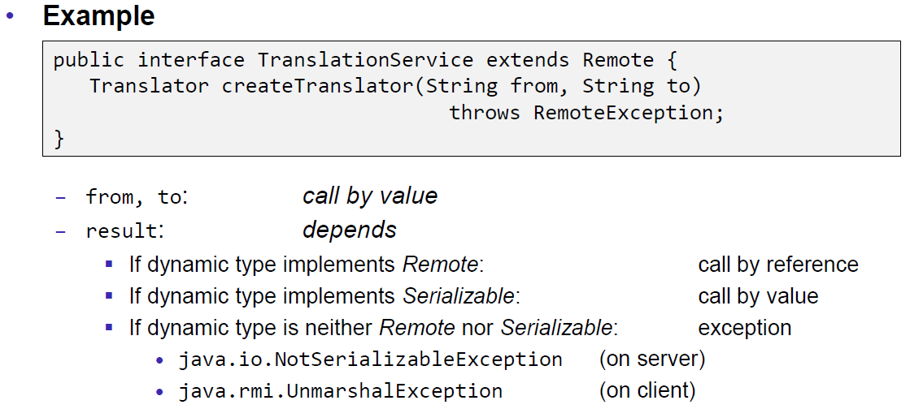

### RMI Stubs

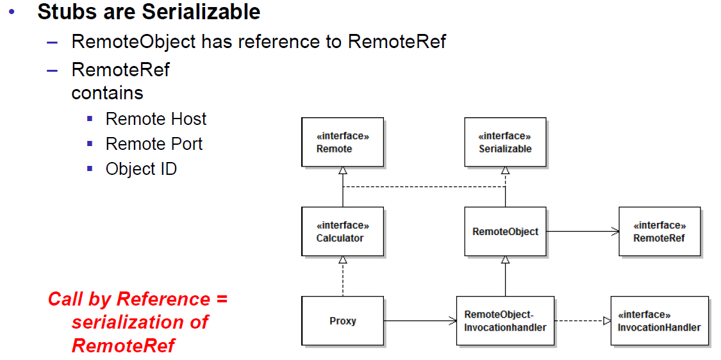

### Remote Reference Applications

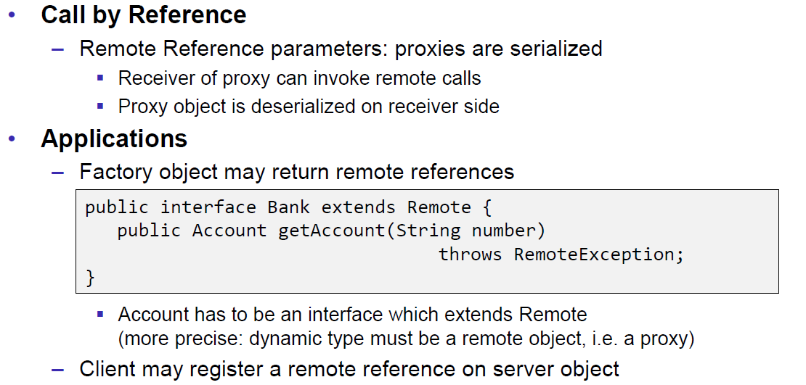

### Callback

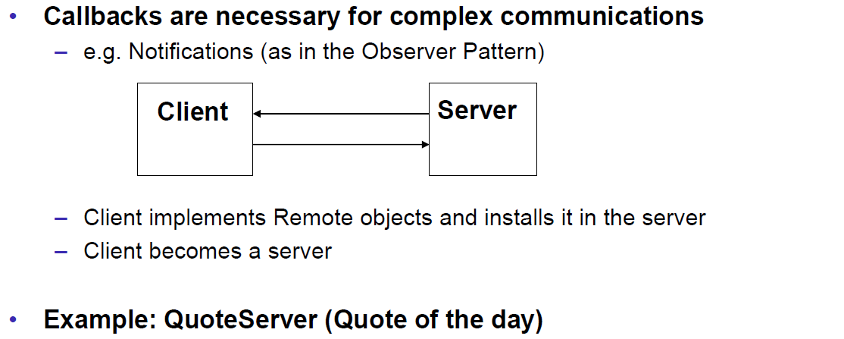

### Example: Quote Server

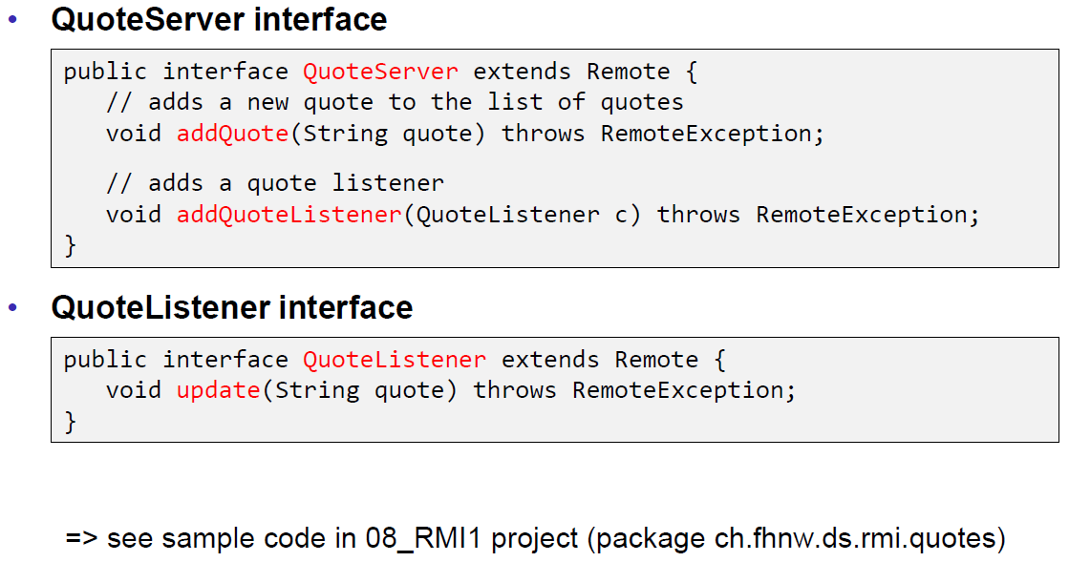

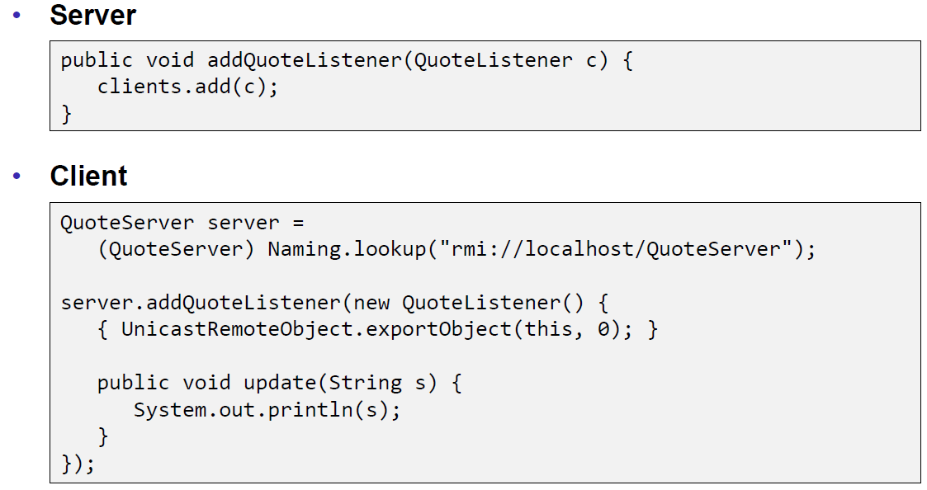

## RMI Architecture

### Summary of the RMI Architecture

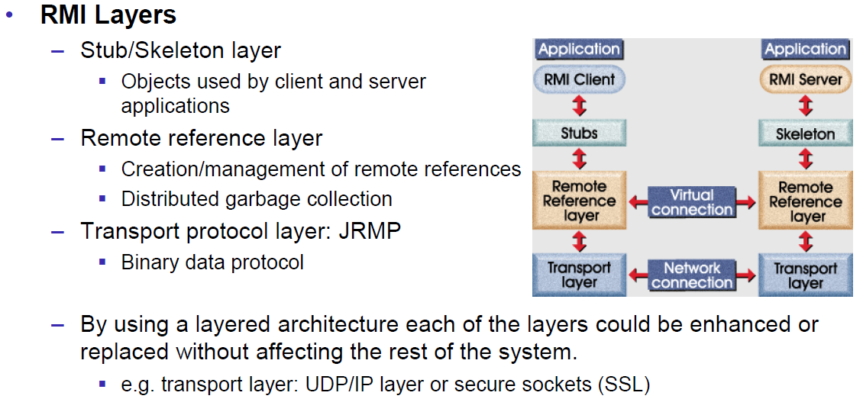

### Remote Reference Layer

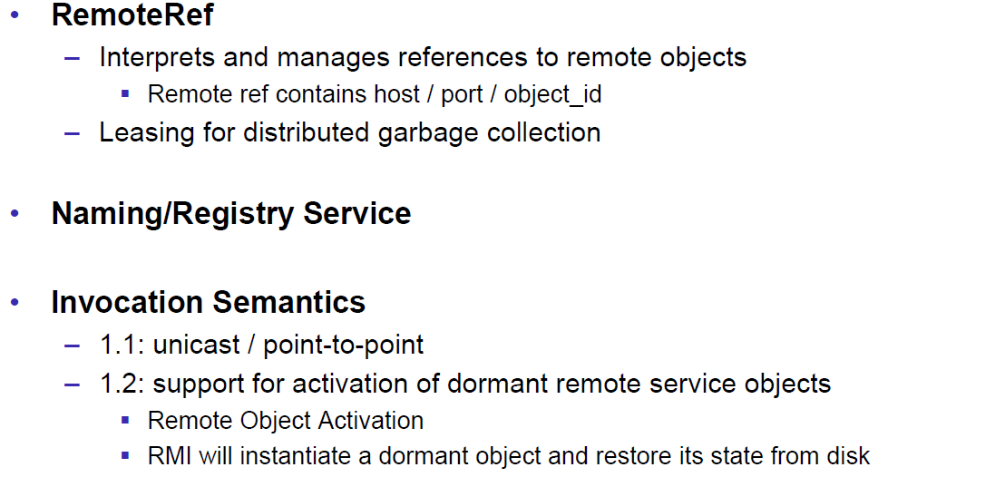

### Transport Layer

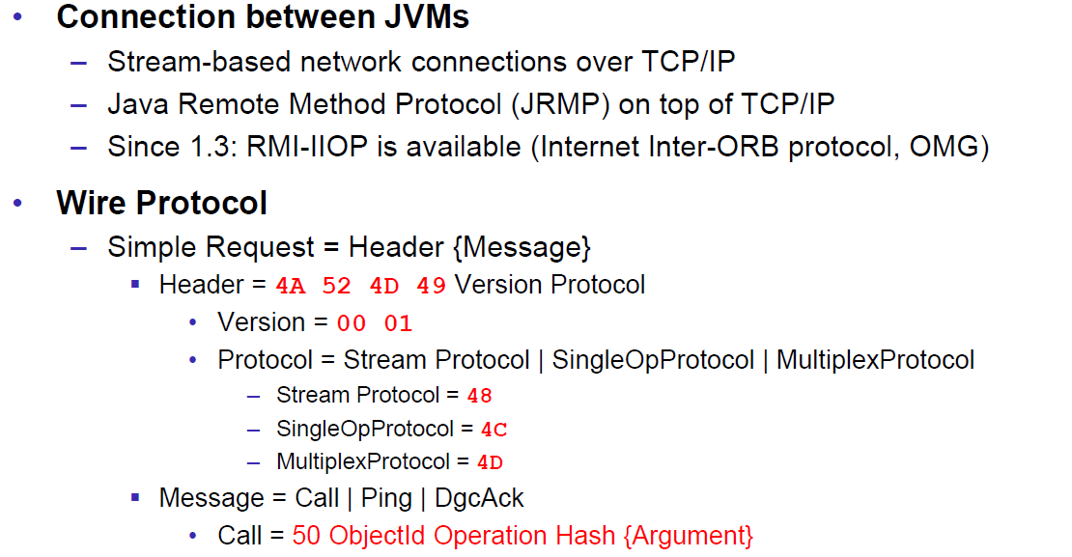

### RMI Server Properties

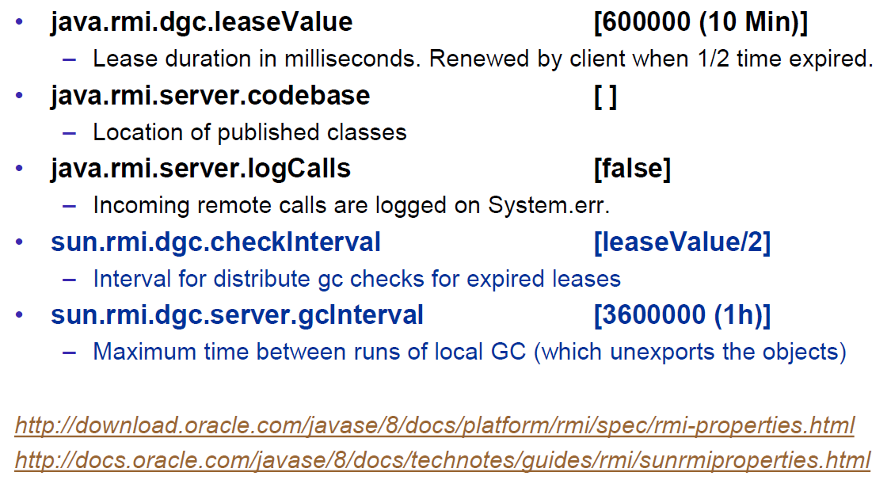

### Client behind a Router/NAT

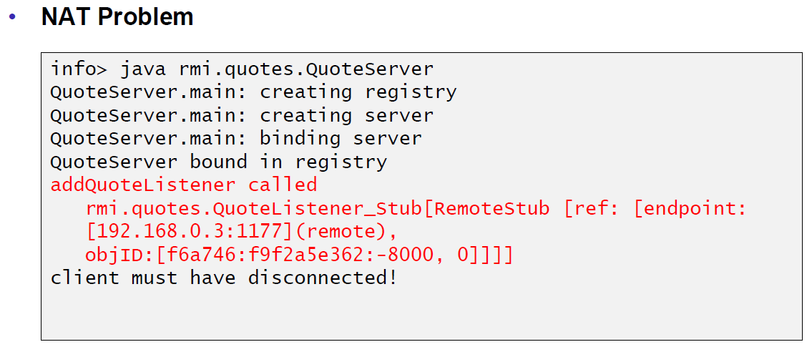

### Conclusion

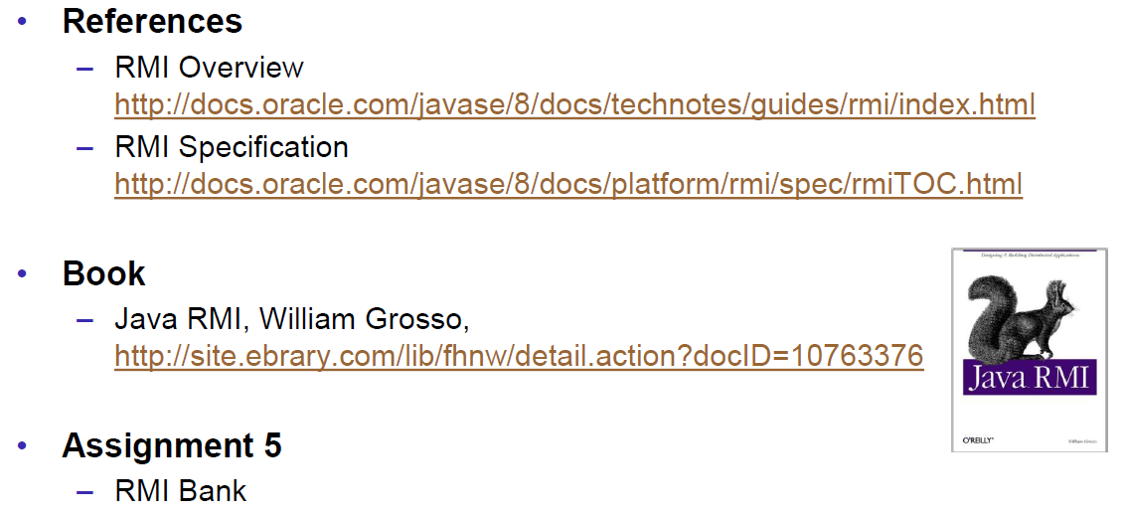

# Woche 9

## UnicastRemoteObject & Proxies

### RMI Object Implmentation Revisited

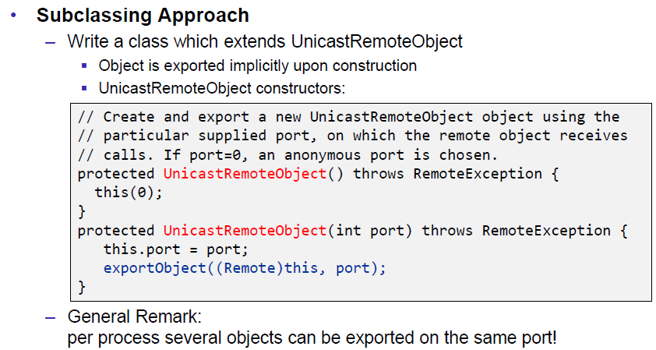

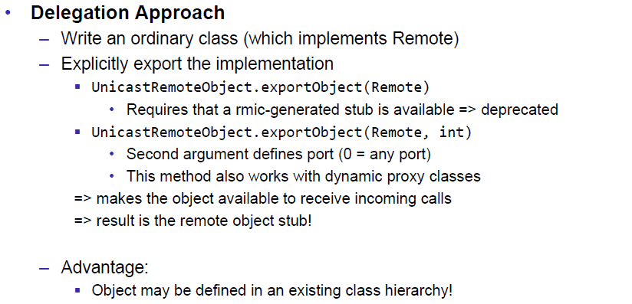

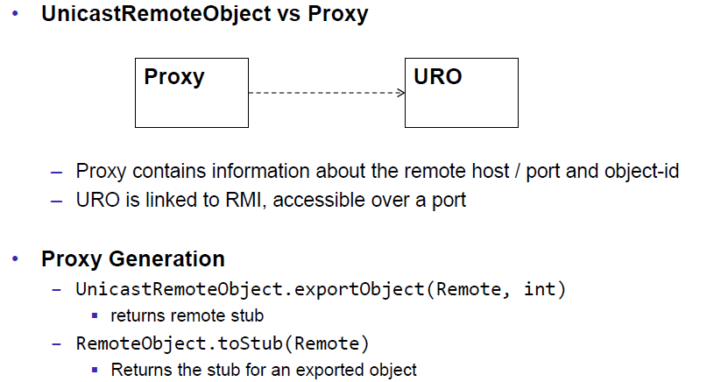

### FileRef Server

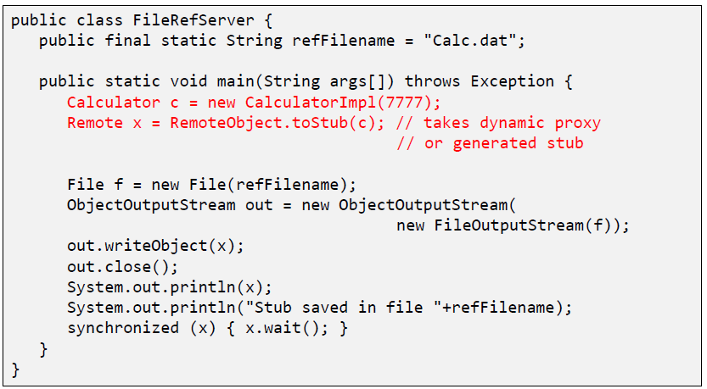

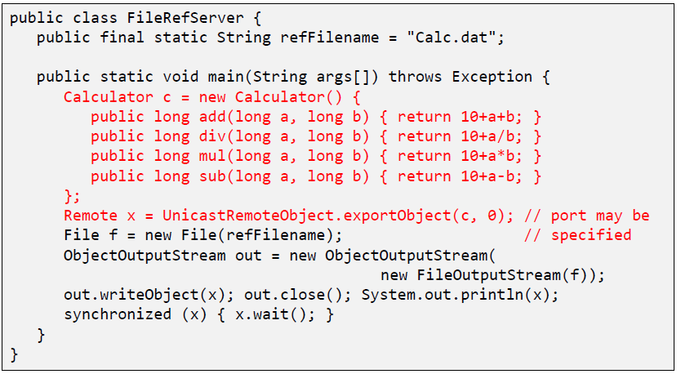

### FileRef Client

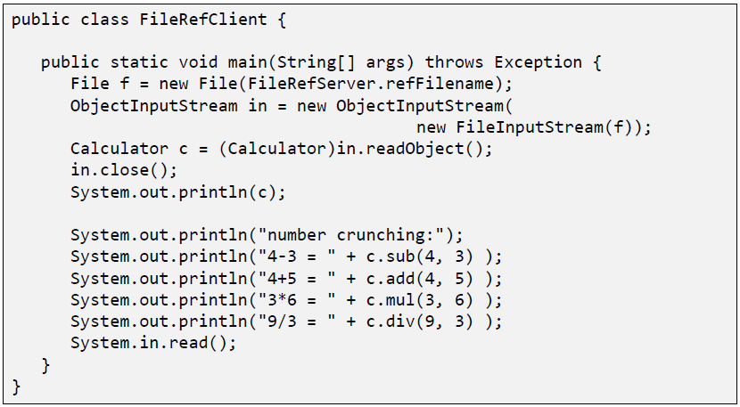

## Export and Unexport

### Exporting and Unexporting

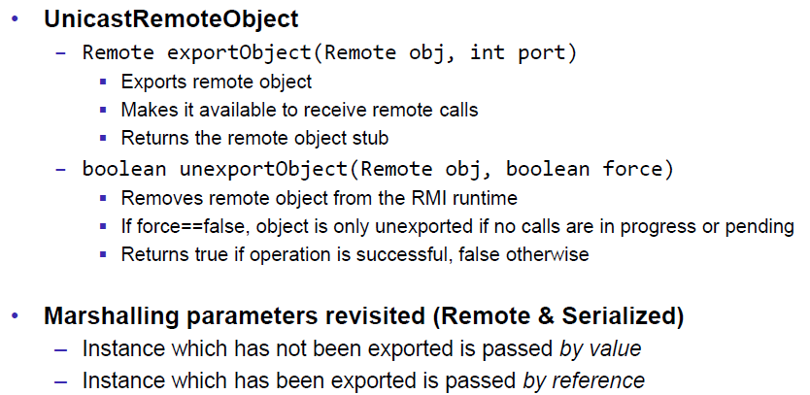

### Migrating Objects

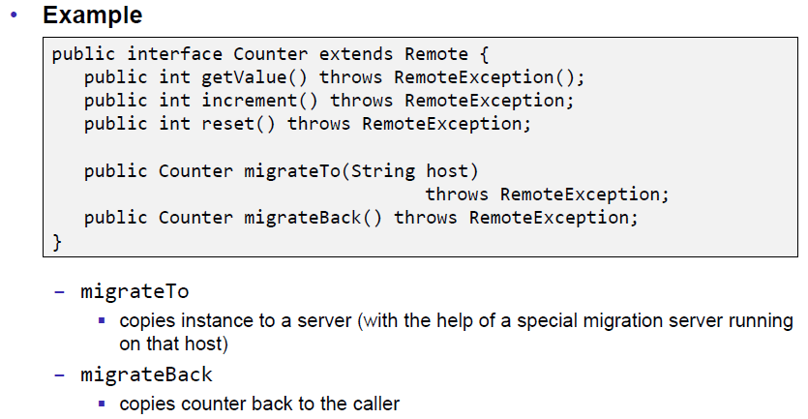

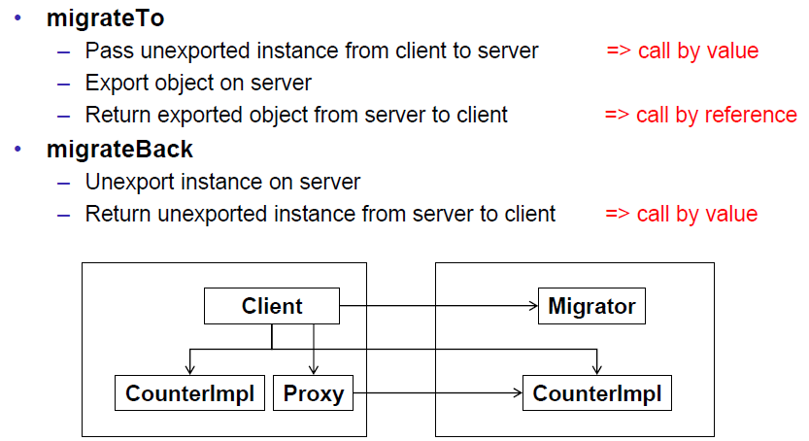

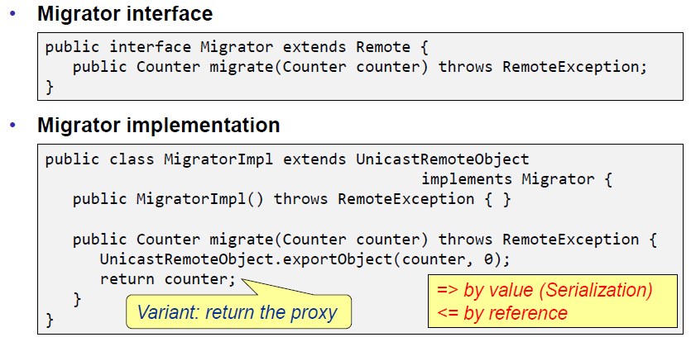

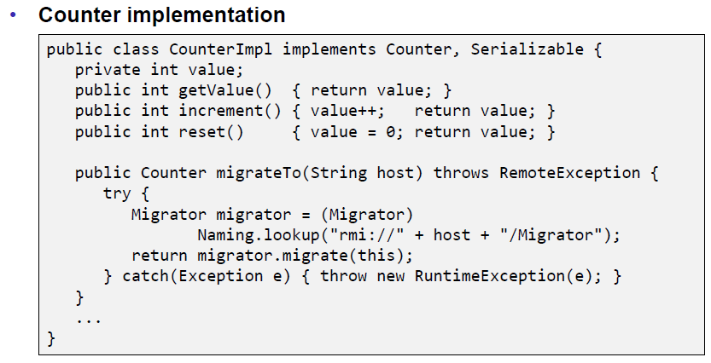

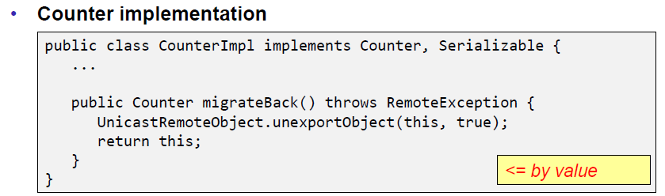

## RMI & Threading

### RMI & Threads

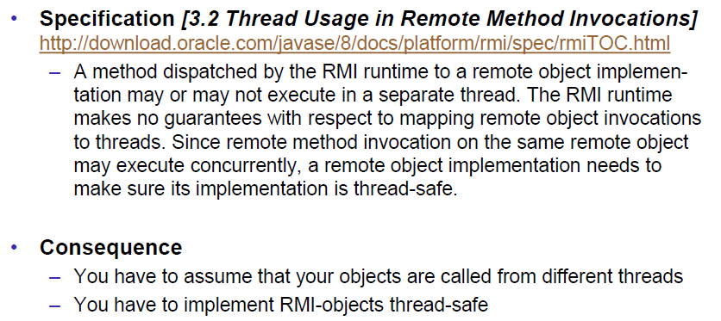

## Remote Class Loading

### Dynamically Loaded Classes

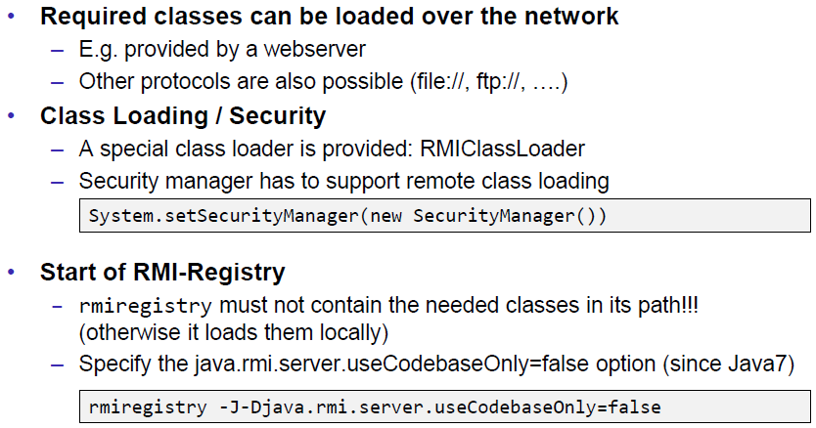

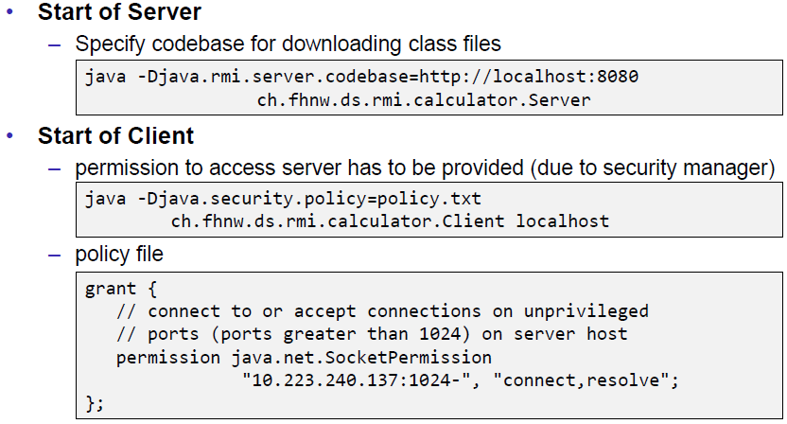

## Socket Factories

### Socket Factories

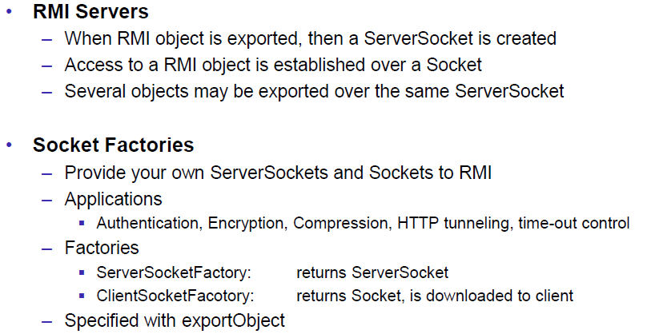

### Example of a Socket Factory

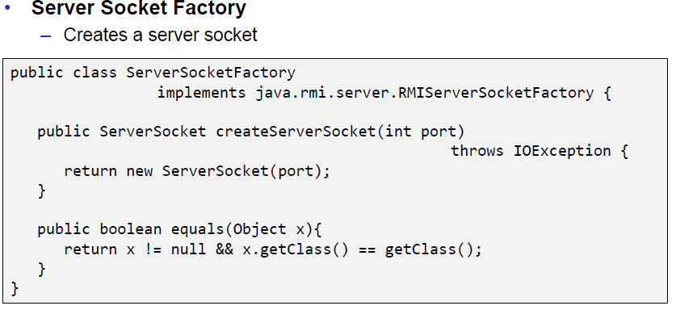

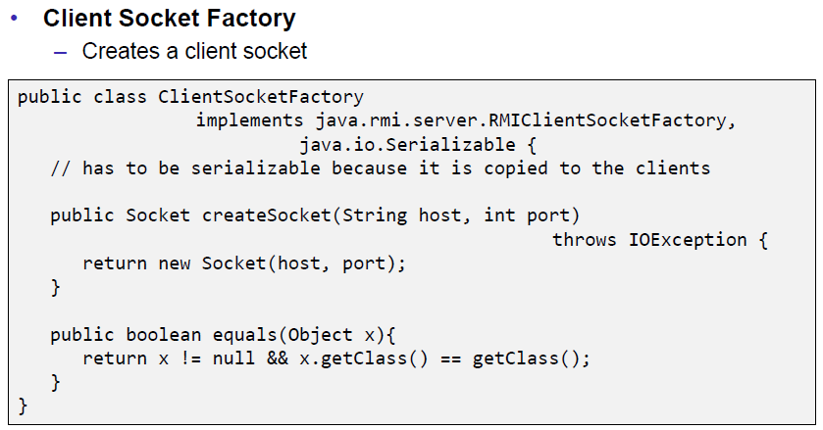

### Example of an XOR encoding

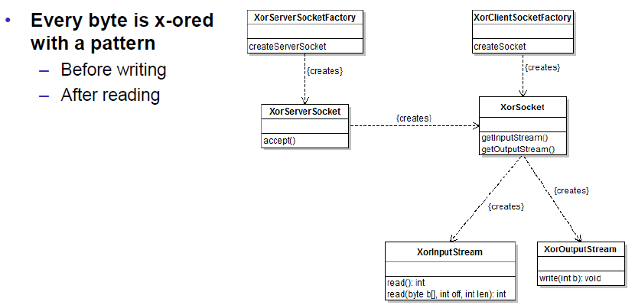

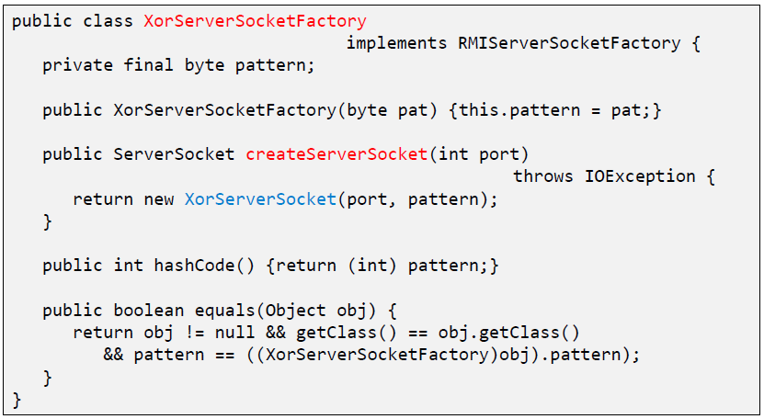

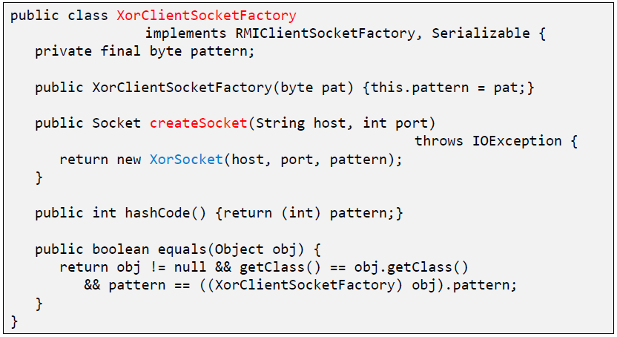

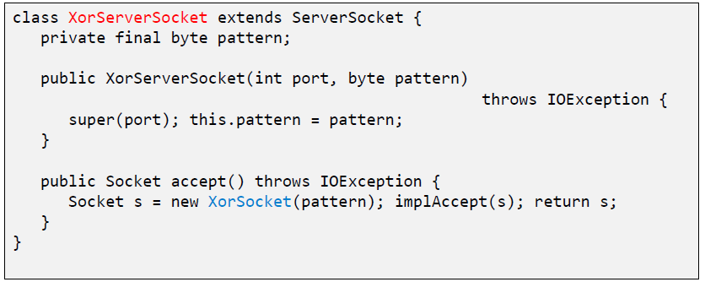

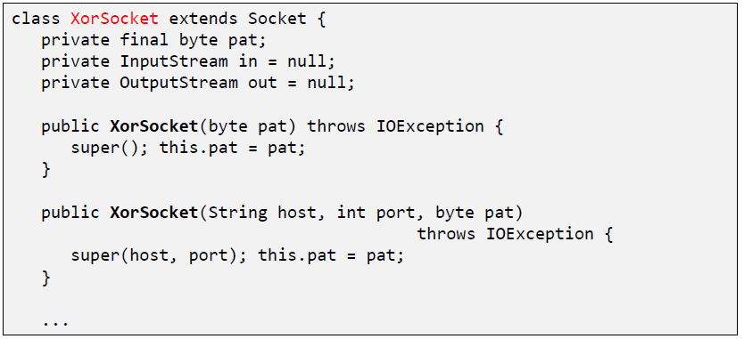

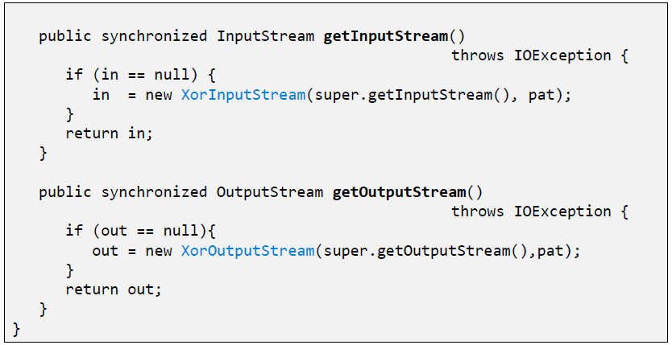

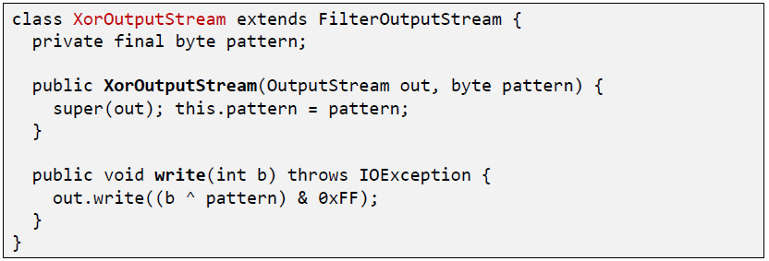

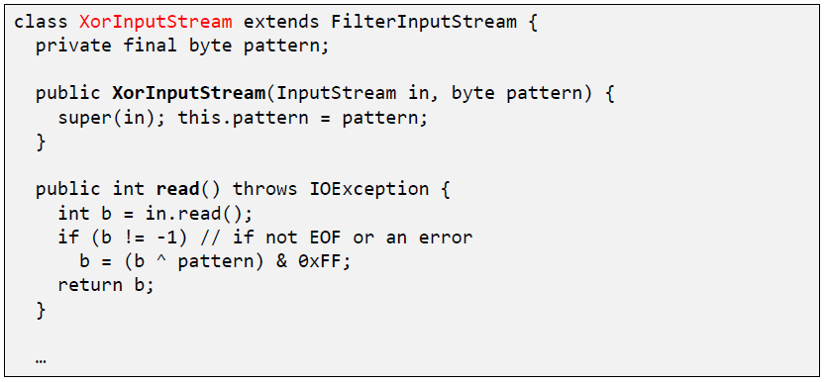

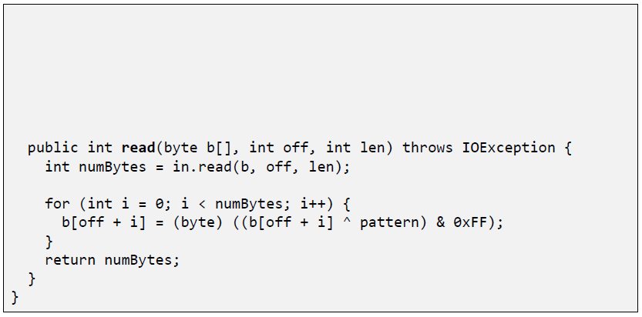

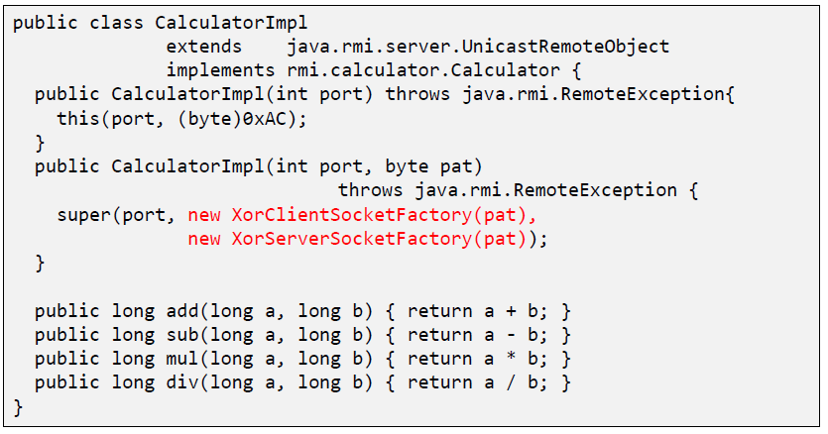

### RMI over SSL

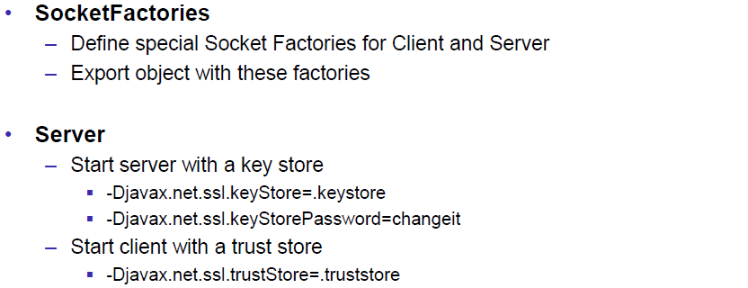

### RMI over SSL in JSE 5.0

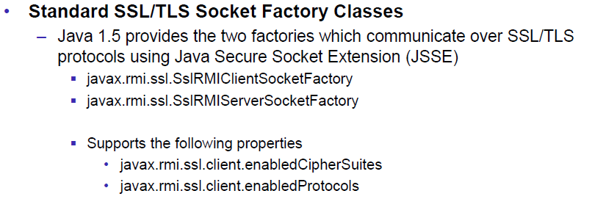

### Example of a SSLClientSocketFactory

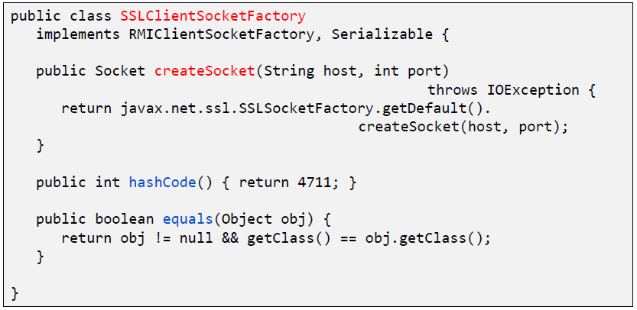

### Example of a SSLServerSocketFactory

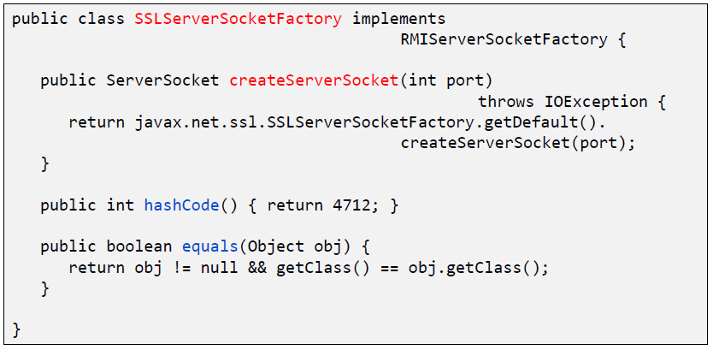

# Woche 10

In Woche 10 fand die Prüfung statt und somit fiel der Unterricht aus.

# Woche 11

In Woche 11 fand die Projektwoche statt und somit fiel der Unterricht aus.

# Woche 12

## Asynchronous Communication

### Asynchronous Communication

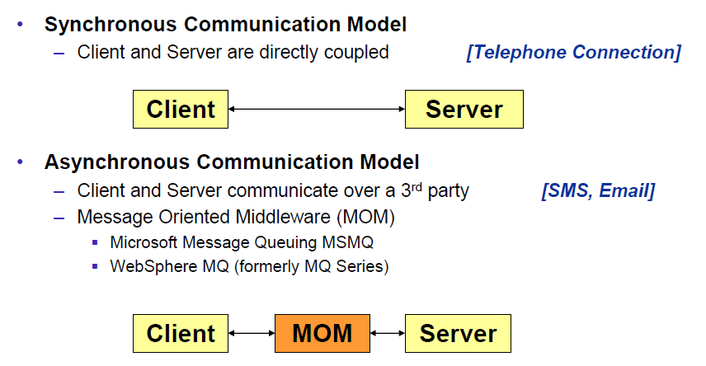

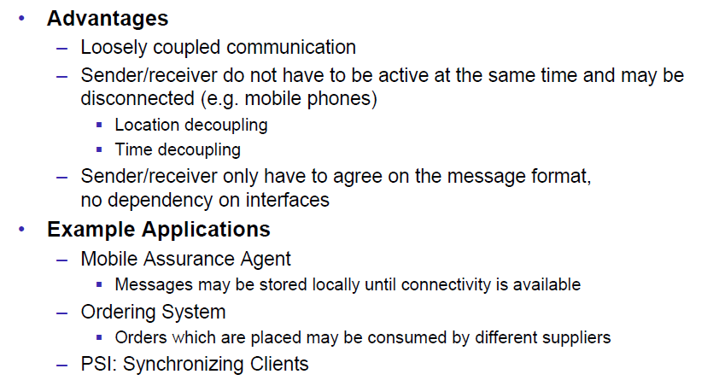

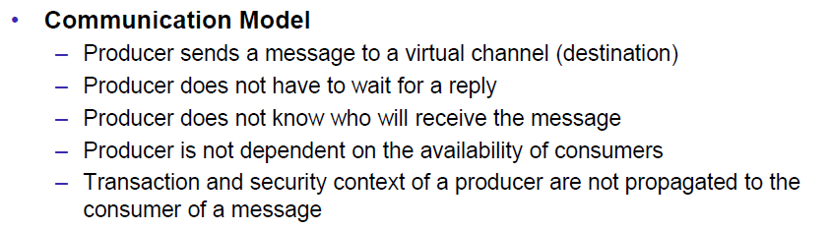

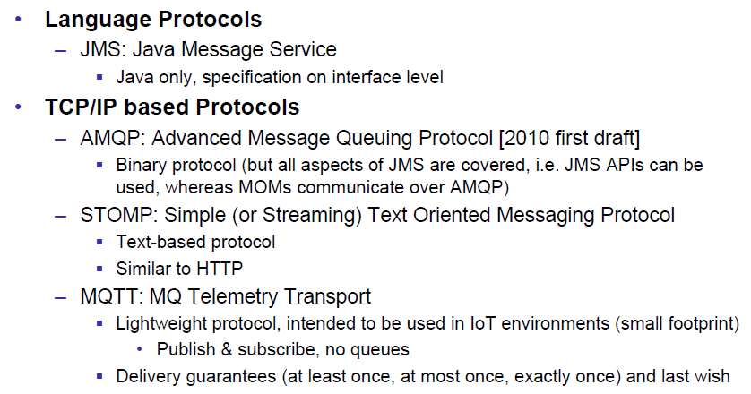

## Java Message Service

### Java Message Service API

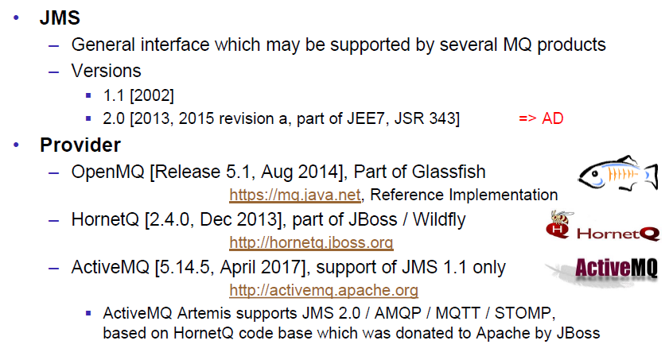

### Point to Point Messaging Domain

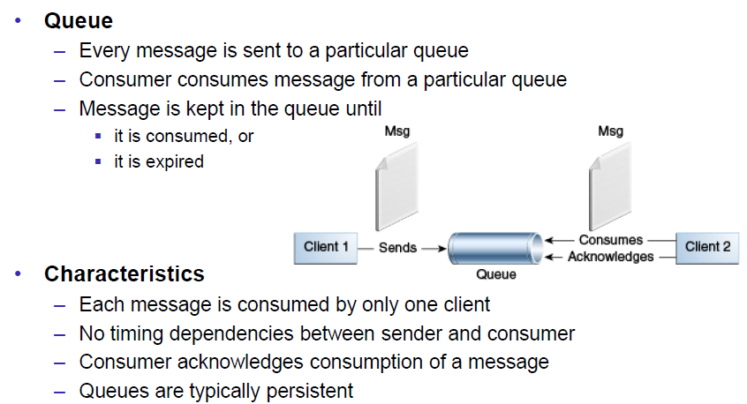

### Publish/Subscribe Messaging Domain

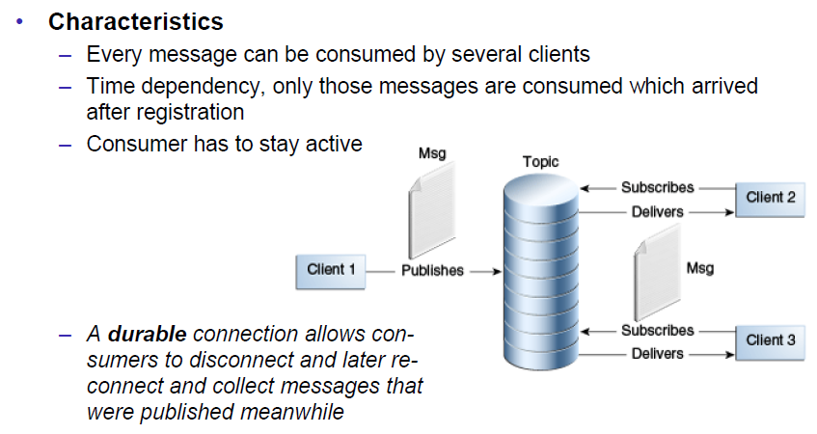

### JMS Destinations

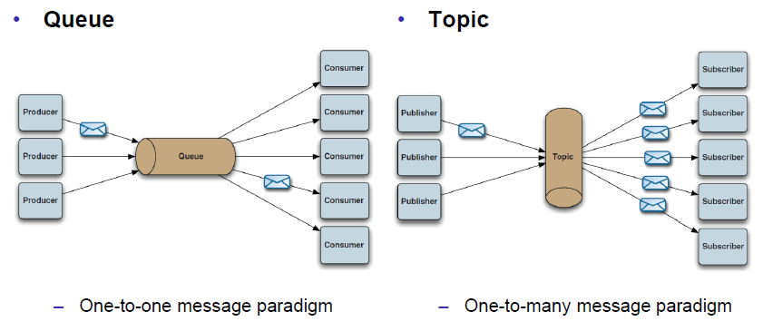

### JMS Architecture

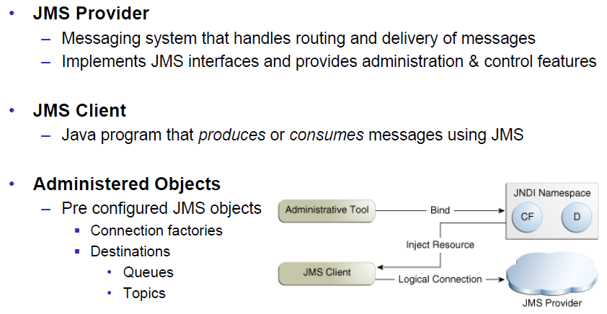

### JMS API: Destinations

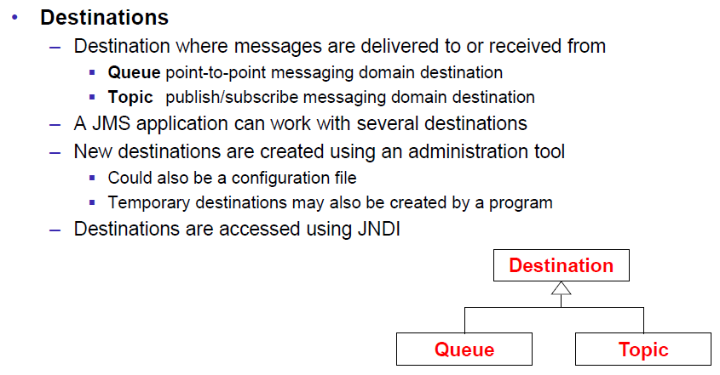

### JMS API: Overview & Programming Model

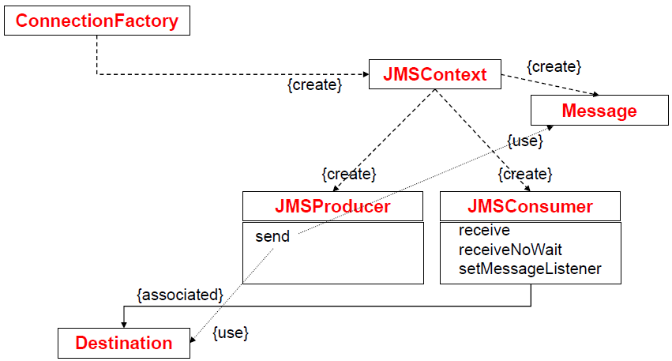

### JMS API: JMSContext

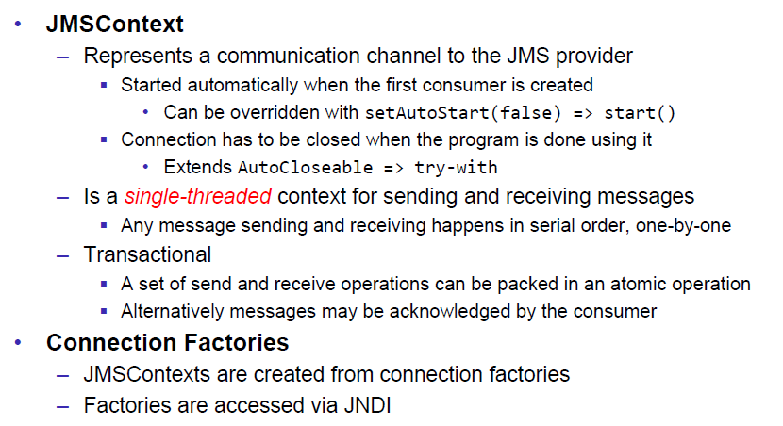

### JMS API: Producers & Consumers

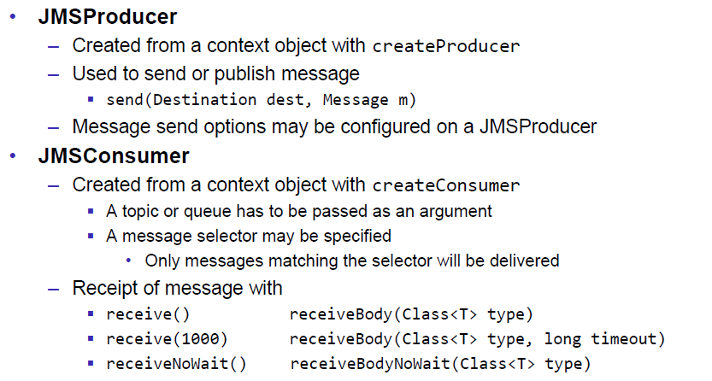

### Message Consumption

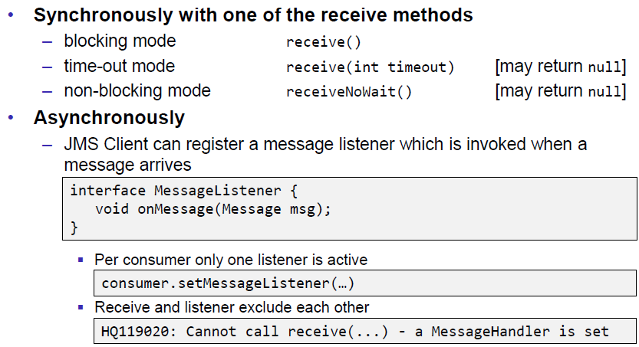

### JMS API: Messages

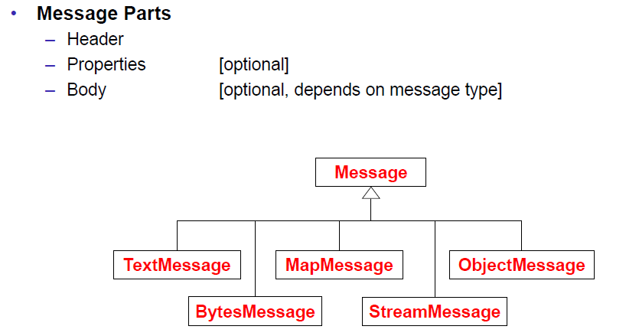

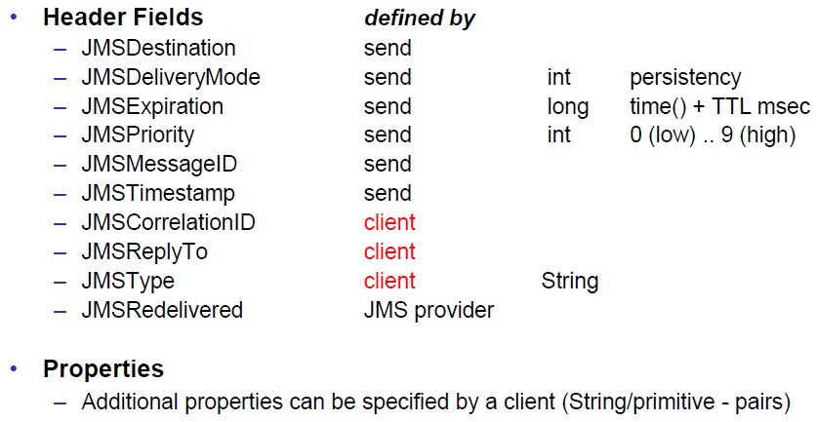

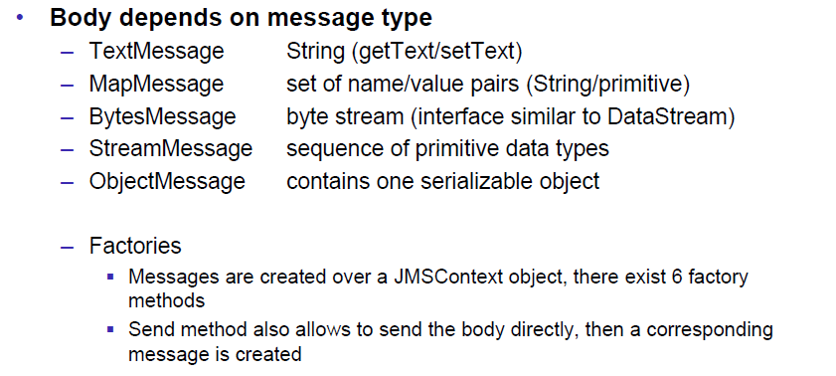

### Message Sending

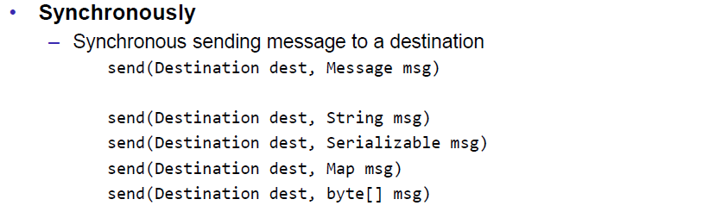

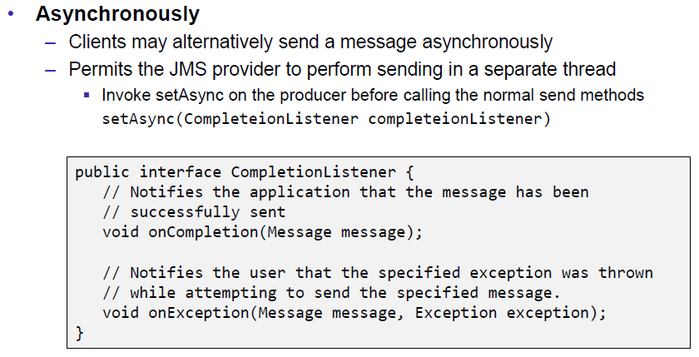

### JMS API: Overview & Programming Model

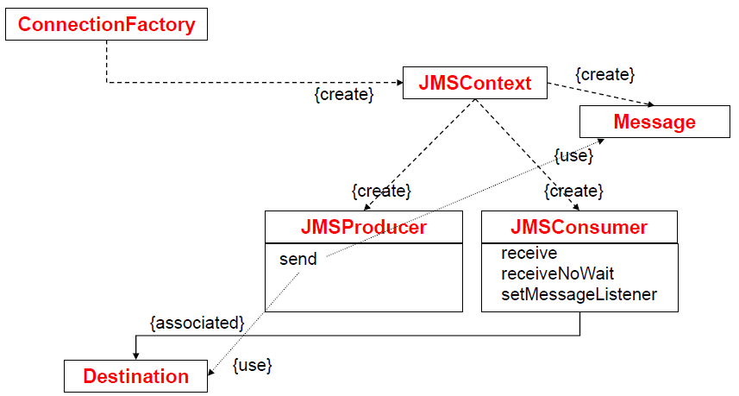

### Simple Example Sender

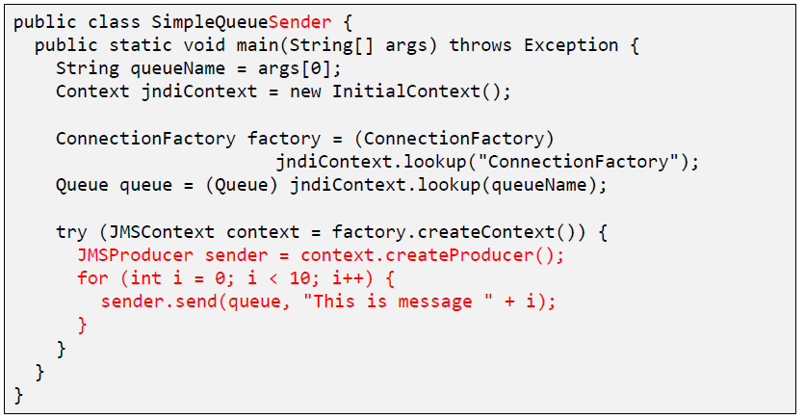

### Simple Example Receiver

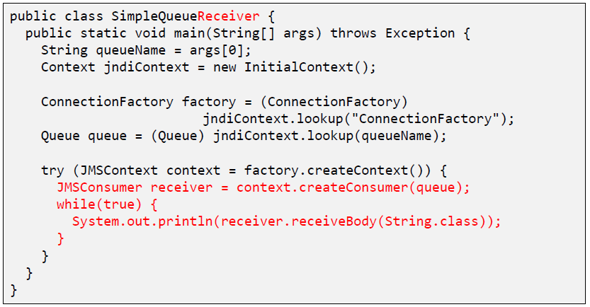

### Sending & Receiving a Message

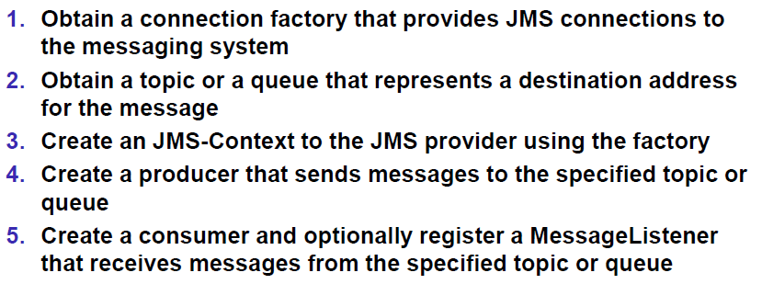

## HornetQ & Echo Example

### HornetQ

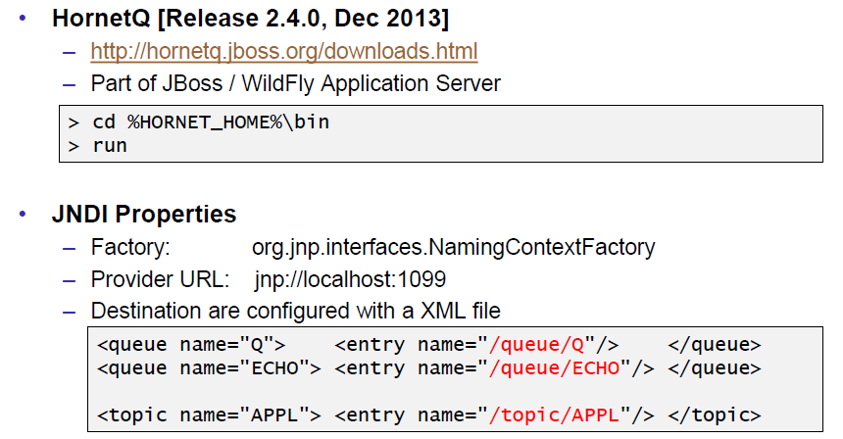

### Example: Echo

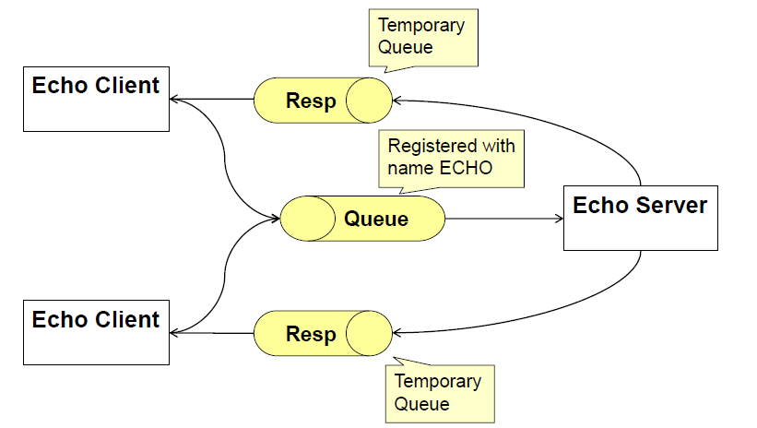

### Echo Client

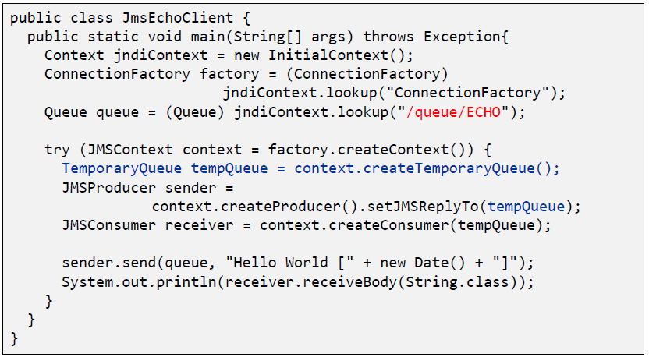

### Echo Server

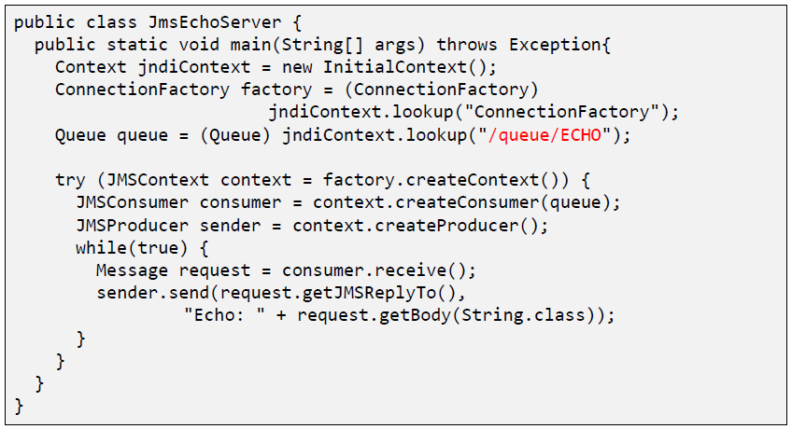

## Guaranteed Messaging and Transactions

### QoS Properties: Delivery Mode

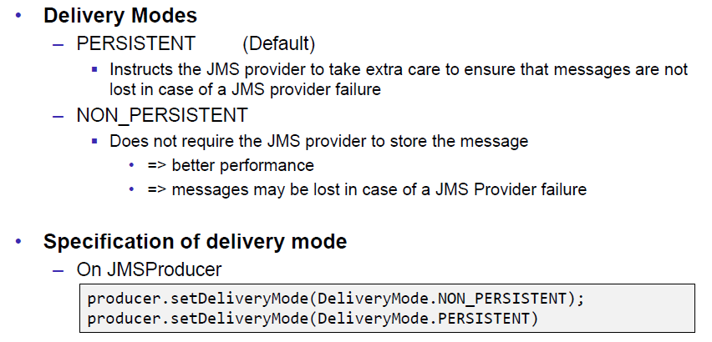

### QoS Properties: TTL and Delay

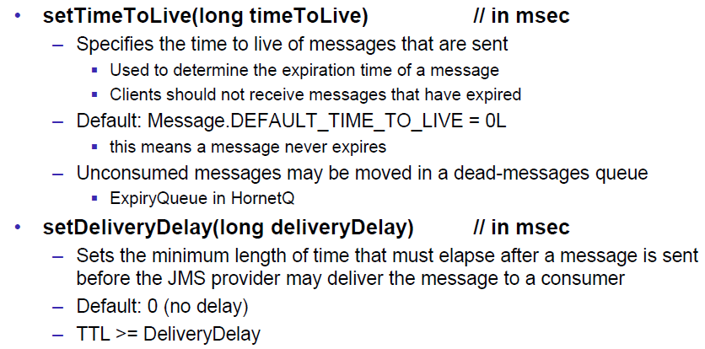

### QoS Properties: Priority

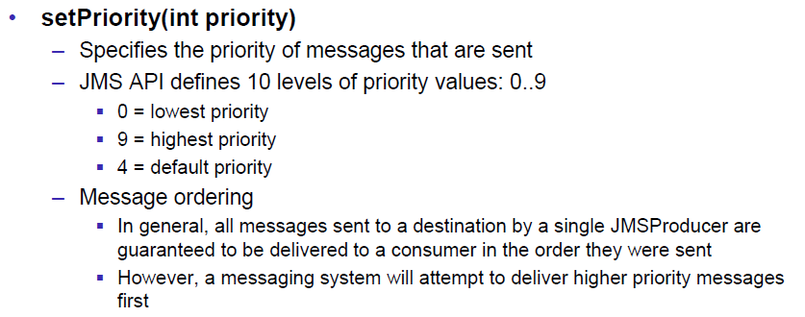

### Message Selection

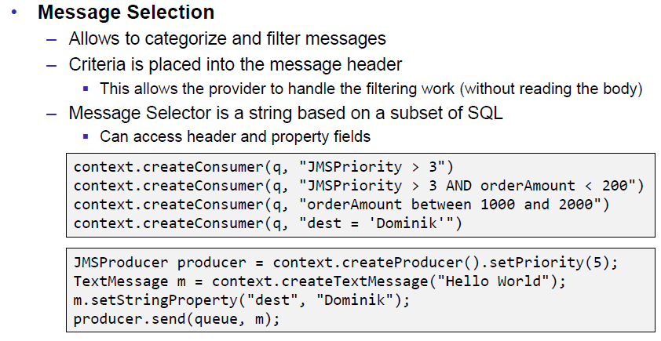

### Durable Consumers

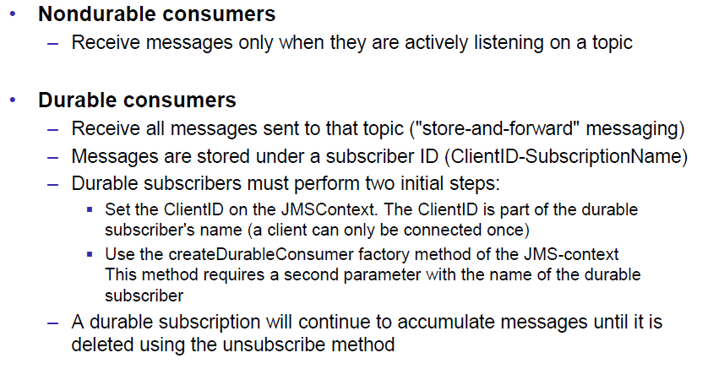

### Message Acknowledgement: Transacted

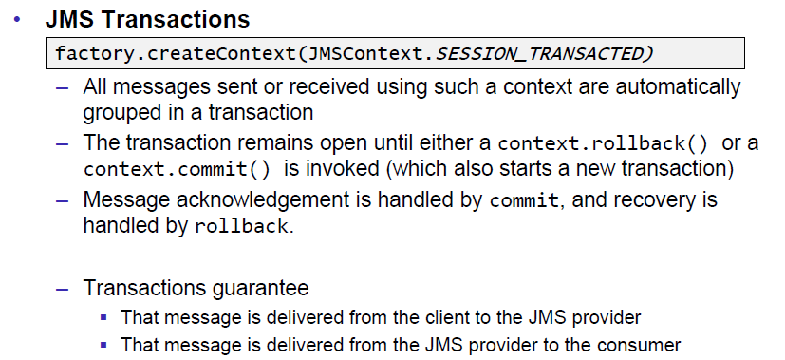

### Message Acknowledgement: Manually

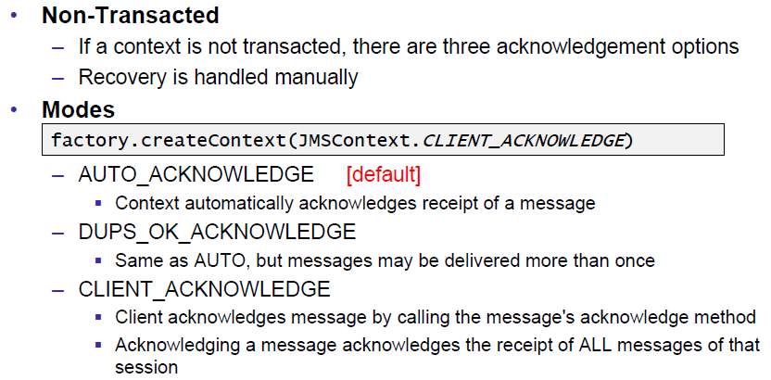

## References

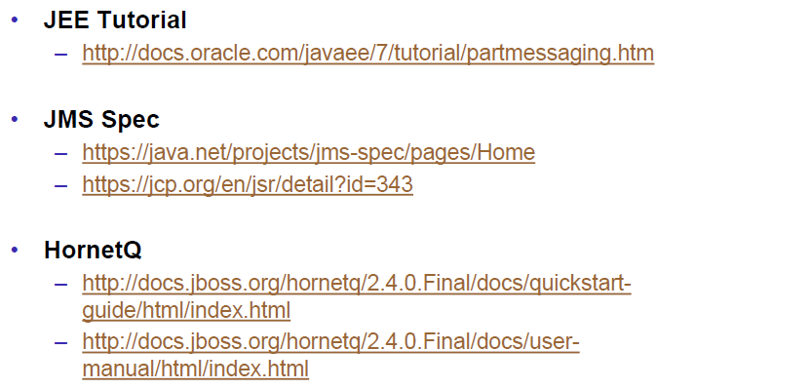

# Woche 13